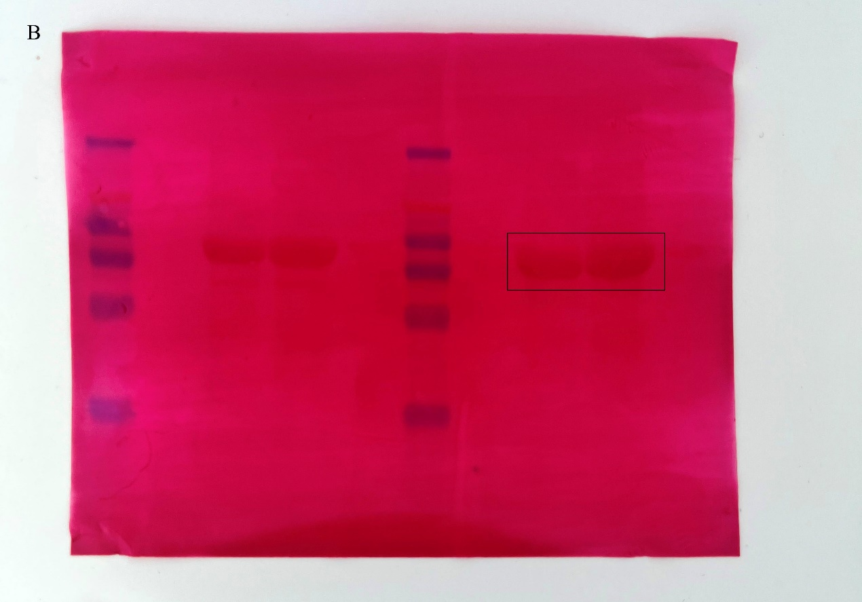
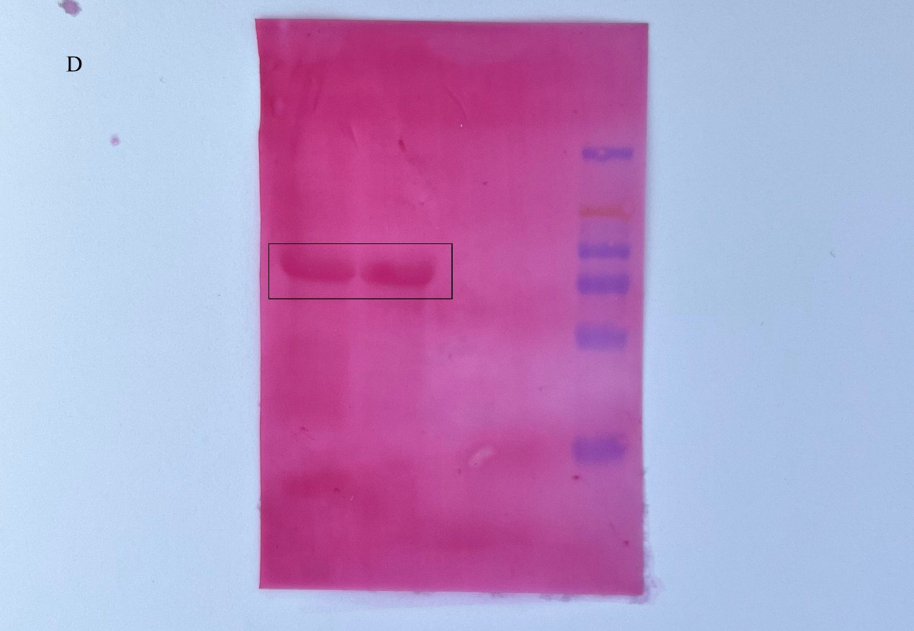
Figure A-D: Supplement of Figure 2B. Figure A: Immunoblot analysis of BxML1 and GFP proteins from N. benthamiana leaves transiently expressing target proteins (The black box indicates the boundary between the gels and rad box indicates the regions used in the main figures). Figure B: Ponceau S of Figure A (The black box indicates the regions used in the main figures). Figure C: Immunoblot analysis of BxCDP1 proteins from N. benthamiana leaves transiently expressing target proteins (The black box indicates the boundary between the gels and rad box indicates the regions used in the main figures). Figure D: Ponceau S of Figure C (The black box indicates the regions used in the main figures).

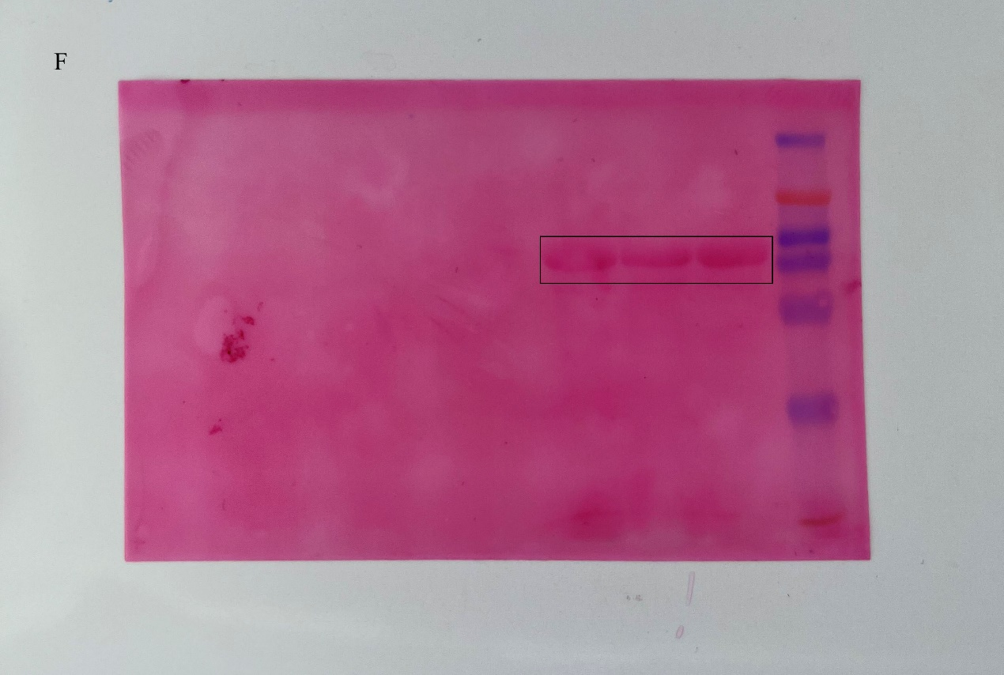
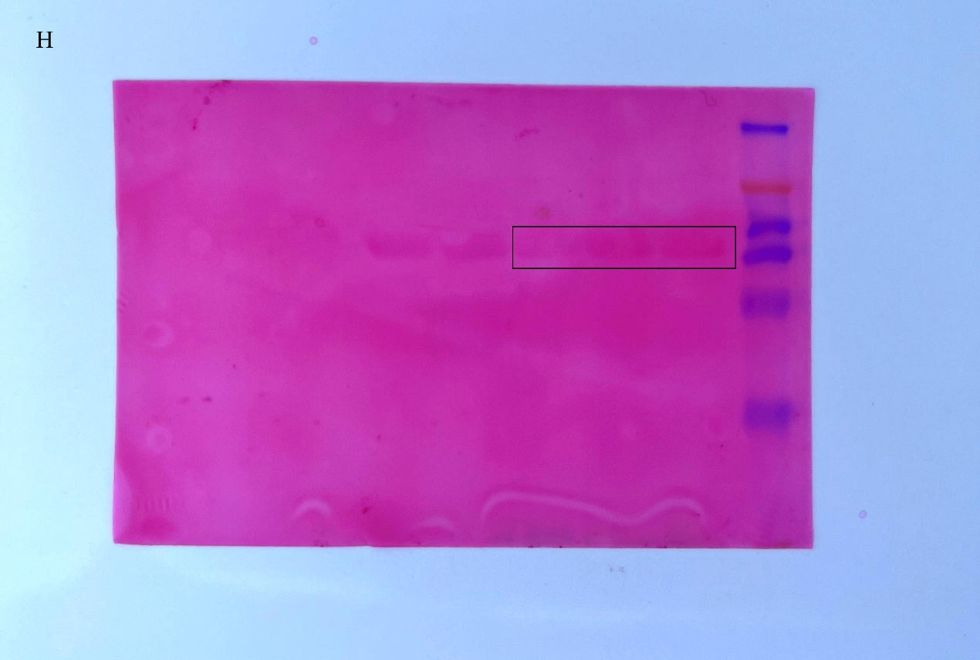

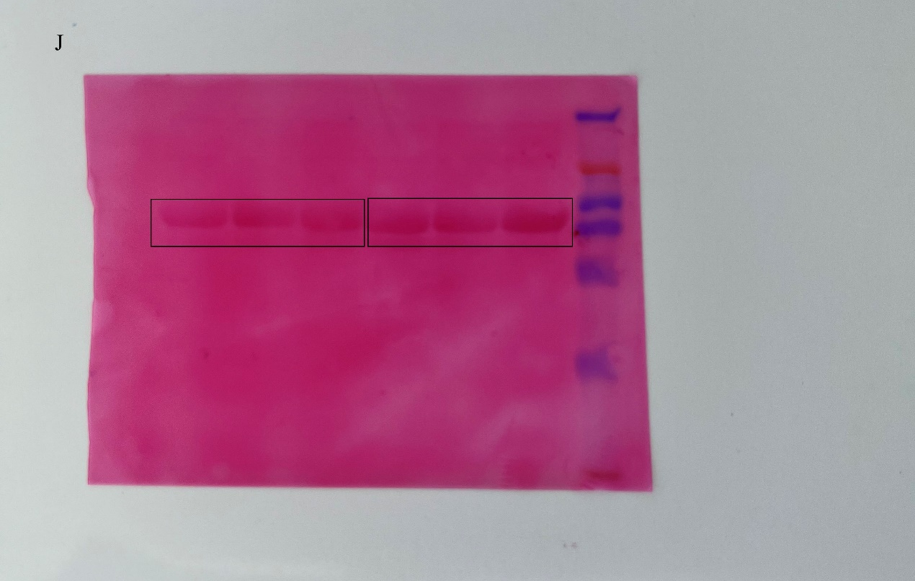
Figure E-J: Supplement of Figure 6B. Figure E: Inpute performed with anti-GFP (The black box indicates the boundary between the gels and rad box indicates the regions used in the main figures). Figure F: Ponceau S of Figure E (The black box indicates the regions used in the main figures). Figure G: Co-IP performed with anti-HA and the isolated protein was detected by Western blotting with an anti-GFP (The black box indicates the boundary between the gels and rad box indicates the regions used in the main figures). Figure H: Ponceau S of Figure G (The black box indicates the regions used in the main figures). Figure I: Inpute performed with anti-HA, Co-IP performed with anti-HA and the isolated protein was detected by Western blotting with an anti-HA (The black box indicates the boundary between the gels and rad box indicates the regions used in the main figures). Figure J: Ponceau S of Figure I (The black box indicates the regions used in the main figures).

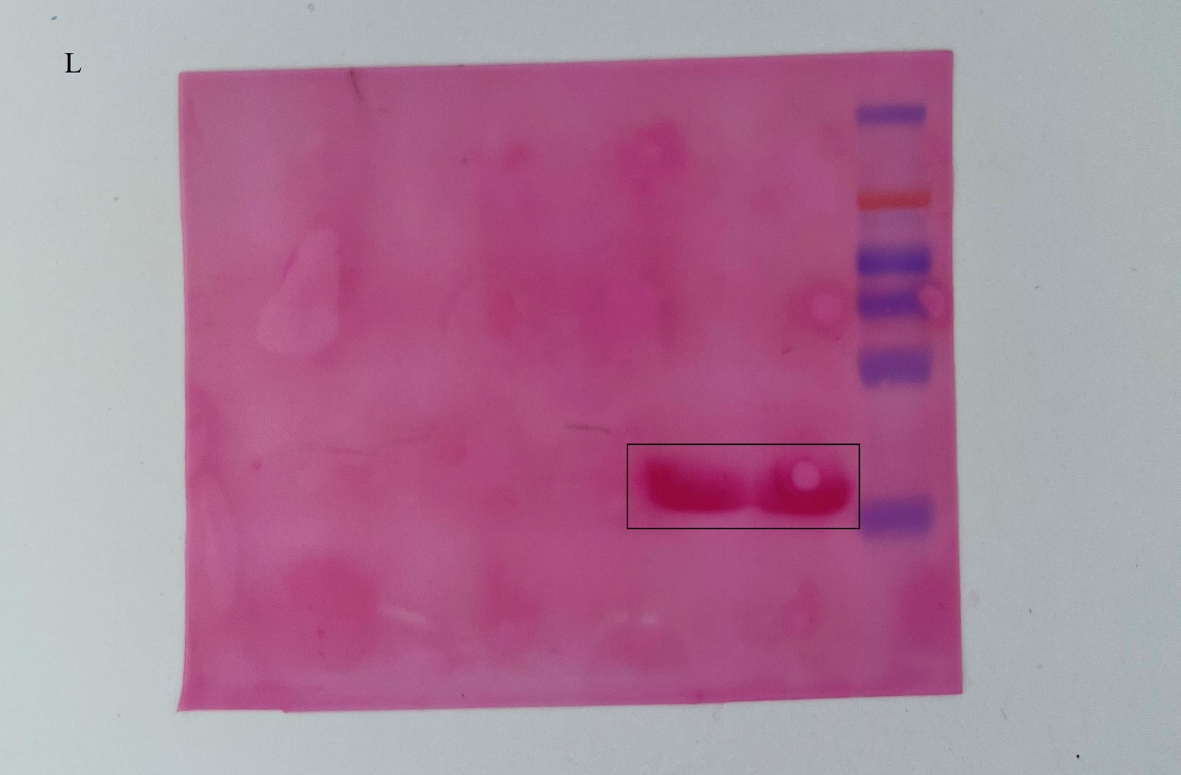
Figure K L: Supplement of Figure 7C. Figure K: Immunoblot analysis of purified BxML1 and GFP protein (The black box indicates the boundary between the gels and rad box indicates the regions used in the main figures). Figure L: Ponceau S of Figure K (The black box indicates the regions used in the main figures).
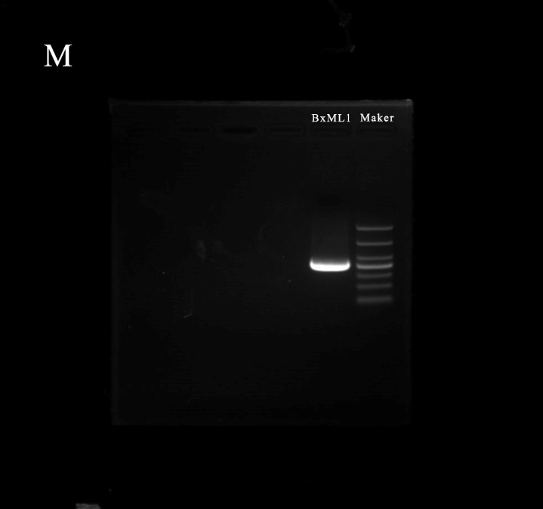
Figure M: Supplement of Figure S1A. Agarose gel electrophoresis of BxML1 gene.
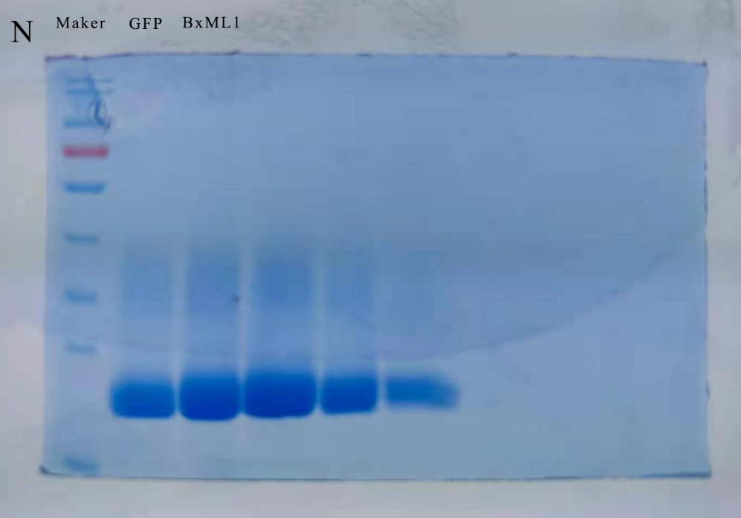
Figure N: Supplement of Figure S3. SDS gel of the purified BxML1 and GFP protein.

