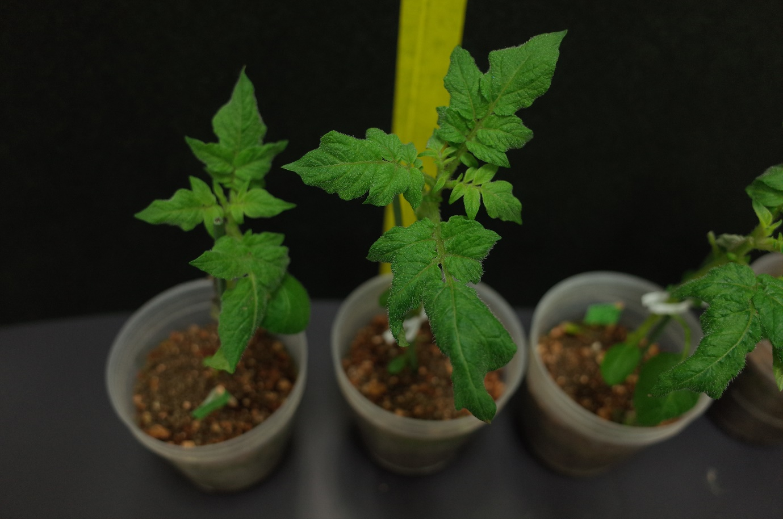
Fig. S5. Comparison of the growth of transgenic (StAPI5-OE) and non-transgenic potato plants (Wild-type) at the same developmental stages (8-week-old plants)
StAPI5-OE
Wild-type

