Fig. S1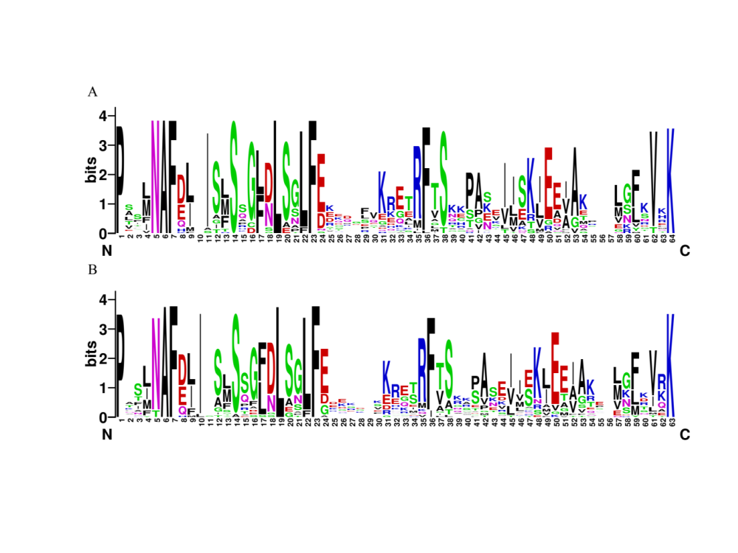
Fig. S1 Highly conserved NAF domain across CIPK proteins in pecan (A) and Arabidopsis (B). Multiple alignment analysis of CIPK domains was presented by ClustalW and sequence logos were generated by Weblogo.
Fig. S2
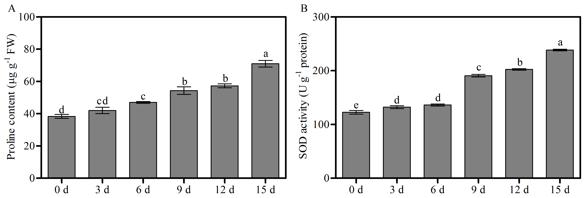
Fig. S2 Analysis of proline content (A) and SOD activity (B) of pecan seedlings in response to drought. Lowercase letters represent significant differences (P < 0.05) according to Duncan’s multiple range test. Error bars indicate the means ± SE obtained from three biological replicates.
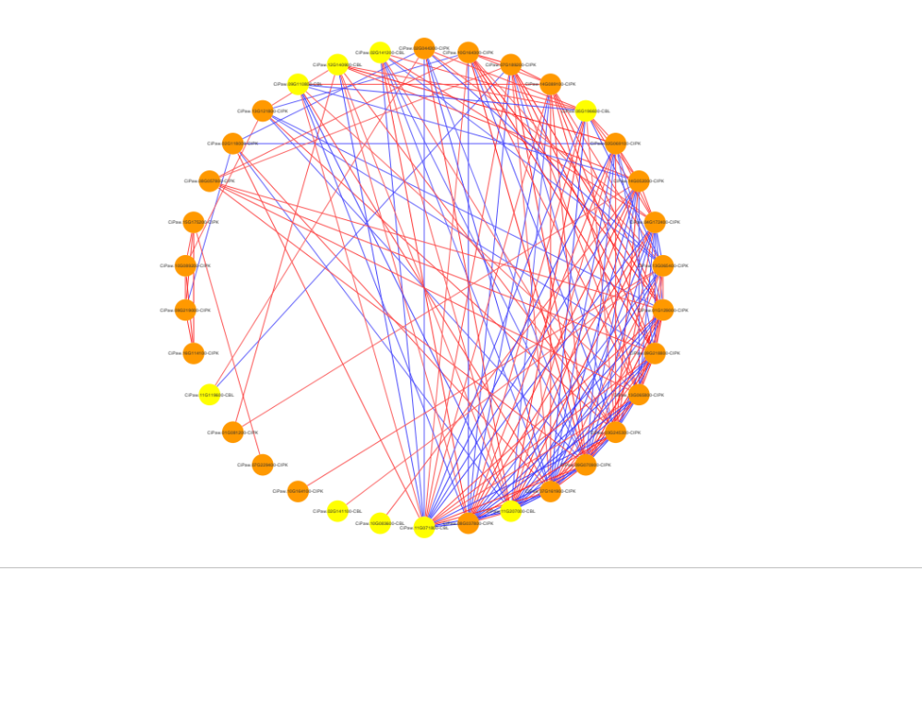
Fig. S3
Fig. S3 The coexpression network of CBL and CIPK genes in response to drought in pecan. The nodes indicate different genes, and the edges between nodes indicate coexpression correlations of gene pairs (P < 0.05). Edge line colours indicate either positive (red, PCC ≥ 0.6) or negative (blue, PCC ≤ -0.6) correlations.

