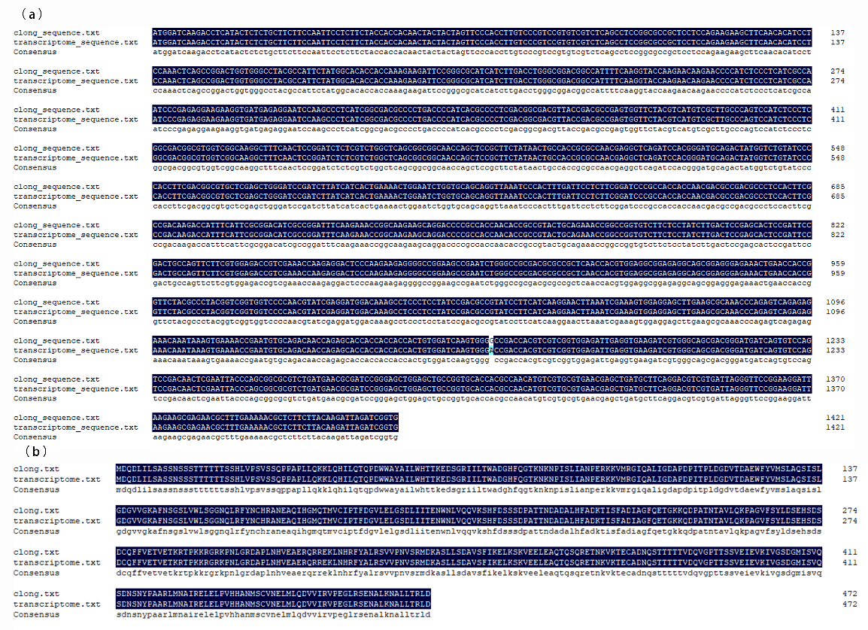
Figure S2 Multiple alignment of nucleotide and amino acid. (a) nucleotide sequence. (b) amino acid sequence.

