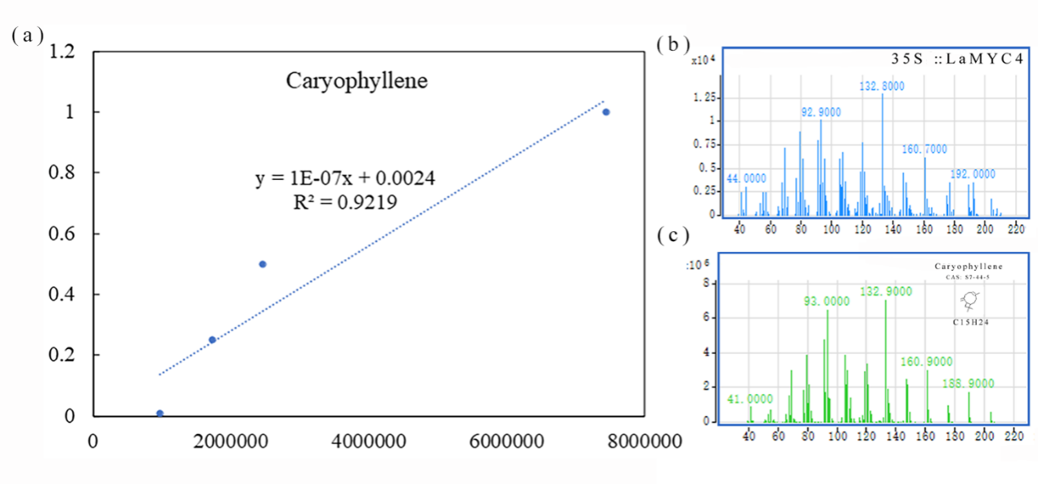
Figure S9 standard curves and mass spectrum. (a) standard curves. (b) Mass spectrum of the product. (c) Mass spectrum of caryophyllene.

