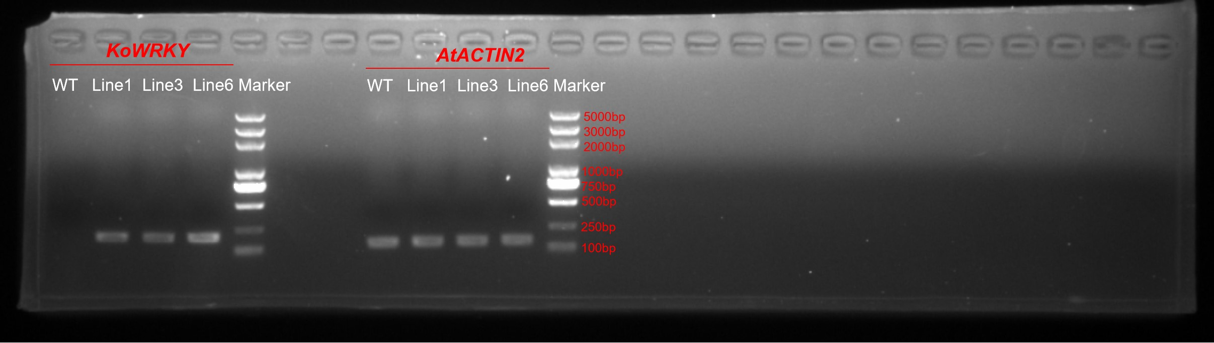
Supplementary Figure S2. Original gel of Figure 6. RT-qPCR identification of KoWRKY40 expression in WT and KoWRKY40 transgenic lines. The AtACTIN2 gene was amplified as a control.

