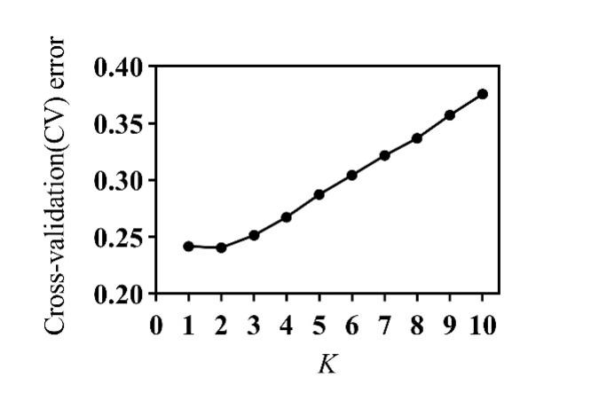
Fig S1 Plot of ADMIXTURE cross-validation error

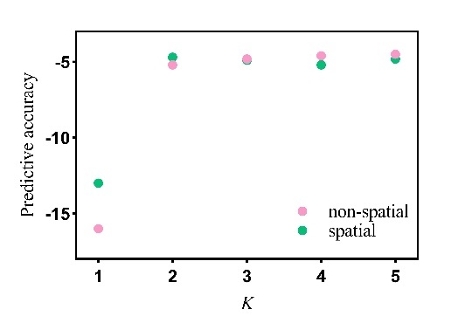
Fig S2 Cross-validation results comparing the non-spatial and spatial models

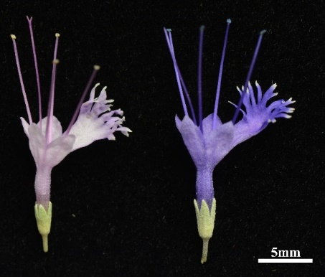
Fig S3 Pink and viole-blue flowers of C. mongholica

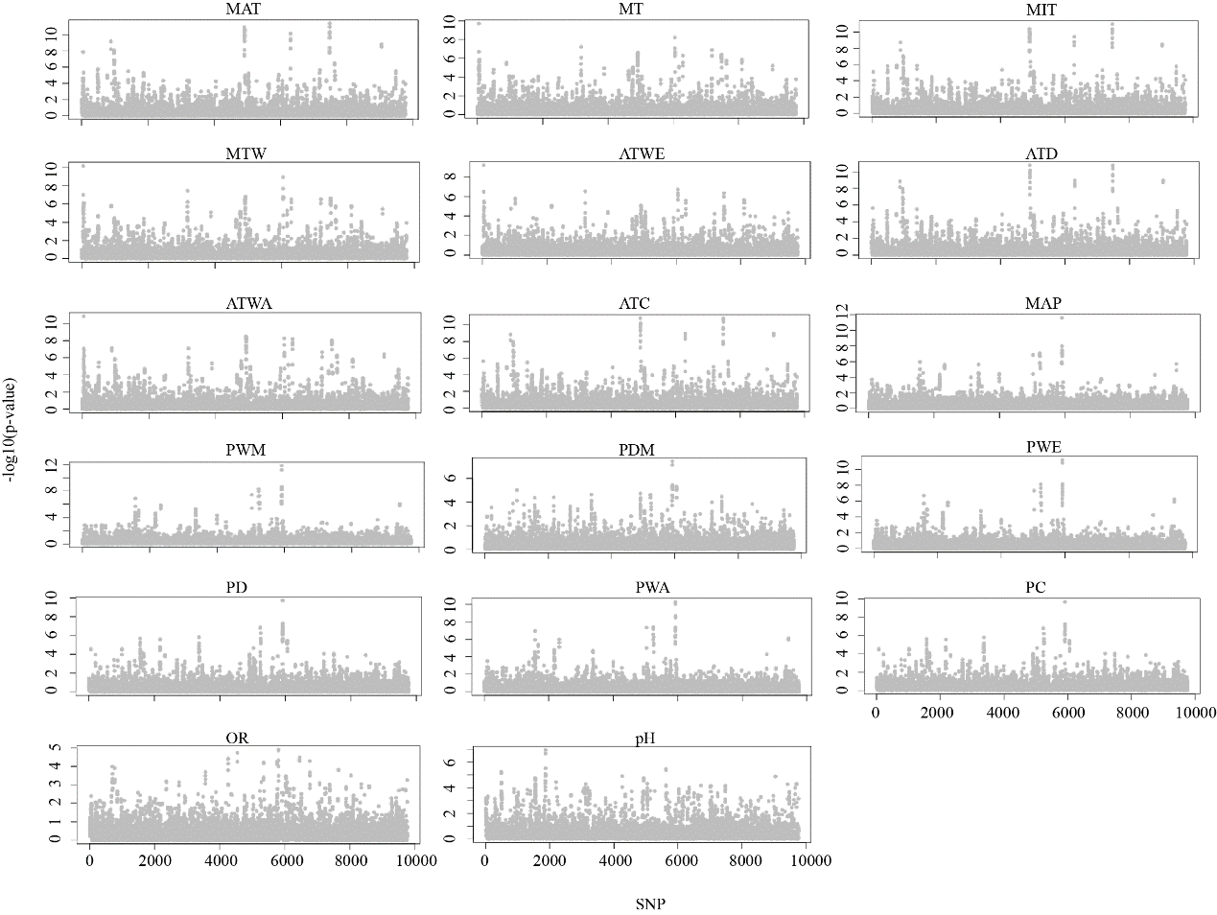
Fig S4 Manhattan plots representing the distribution of significance values -log10(p-value) obtained by the genetic-environment association approach LFMM for 17 bioclimatic variables.

