MdNup62 interactions with MdHSFs involved in flowering and heat-stress tolerance in apple
Chenguang Zhang†, Na An†, Peng Jia†, Wei Zhang, Jiayan Liang, Hua Zhou, Dong Zhang, Juanjuan Ma, Caiping Zhao, Mingyu Han, Xiaolin Ren, Libo Xing*
¹College of Horticulture, Northwest A&F University, 712100 Yangling, Shaanxi, P. R. China
†Equal contributors
*Corresponding author:
Libo Xing
E-mail: libo_xing@nwsuaf.edu.cn ;
Tel.: +8615129227289;
ORCID: https://orcid.org/0000-0002-8918-7128;
Address: 3 Taicheng Road, Yangling 712100, Shaanxi, P. R. Chin
Run title: MdNup62 interactions with MdHSFs regulate flowering and heat-stress tolerance
Table S1. Expression of NPC components in different tissues of several apple varieties
 |  |  | ‘Nagafu No.2’ |  |  |  |  |  |  |  |  |  | ‘Qinguan’ |  |  |  | ‘Nagafu No.2’ |  |  |  | ‘Yanfu No.3’ |  |  |  | ‘Yanfu No.6’ |  |  |  | ‘M9-T337’
Subcomplex | Gene | Gene ID | FLB1 | FLB2 | FLB3 | FSB1 | FSB2 | FSB3 | FYB1 | FYB2 | FYB3 |  | QYB1 | QYB2 | QYB3 |  | FR1 | FR2 | FR3 |  | YF3J1 | YF3J2 | YF3J3 |  | YF6J1 | YF6J2 | YF6J3 |  | T337R1 | T337R2 | T337R3
Nup62 subcomplex | MdNup54 | MD16G1117500 | 4.18 | 4.80 | 4.54 | 4.54 | 5.31 | 4.74 | 4.63 | 4.77 | 4.26 |  | 3.43 | 3.84 | 3.13 |  | 0.47 | 0.24 | 0.66 |  | 8.81 | 8.81 | 7.61 |  | 8.86 | 8.61 | 8.20 |  | 5.69 | 5.88 | 5.13
Nup62 subcomplex | MdNup62 | MD07G1110700 | 15.93 | 16.76 | 15.71 | 17.82 | 16.65 | 18.51 | 17.45 | 18.36 | 16.89 |  | 16.28 | 17.09 | 17.55 |  | 9.84 | 9.53 | 9.60 |  | 18.68 | 18.08 | 18.42 |  | 22.01 | 20.31 | 20.92 |  | 16.77 | 17.75 | 18.30
Nup93 subcomplex | MdNup35a | MD09G1205800 | 14.05 | 13.68 | 12.14 | 12.80 | 14.05 | 13.94 | 14.93 | 15.74 | 15.08 |  | 5.66 | 6.48 | 6.57 |  | 0.00 | 0.00 | 0.00 |  | 11.28 | 10.57 | 11.24 |  | 9.27 | 9.40 | 8.90 |  | 10.52 | 11.28 | 9.18
Nup93 subcomplex | MdNup35b | MD17G1186700 | 13.50 | 10.44 | 13.21 | 14.70 | 13.55 | 15.30 | 15.90 | 13.03 | 15.33 |  | 8.93 | 8.43 | 10.16 |  | 2.88 | 5.71 | 3.94 |  | 15.21 | 16.83 | 17.78 |  | 14.89 | 16.81 | 13.33 |  | 9.73 | 8.95 | 10.32
Nup93 subcomplex | MdNup93a | MD12G1080600 | 9.07 | 9.34 | 8.83 | 9.41 | 8.64 | 9.56 | 10.04 | 8.44 | 9.10 |  | 18.71 | 20.51 | 18.86 |  | 9.07 | 8.39 | 8.89 |  | 17.51 | 14.67 | 15.65 |  | 13.87 | 13.60 | 12.94 |  | 13.40 | 13.92 | 14.00
Nup93 subcomplex | MdNup93b | MD14G1076700 | 8.15 | 7.79 | 8.34 | 7.94 | 8.18 | 8.90 | 8.90 | 8.99 | 9.17 |  | 6.59 | 6.54 | 6.79 |  | 1.37 | 1.17 | 1.24 |  | 10.81 | 10.21 | 9.88 |  | 8.96 | 7.16 | 7.11 |  | 3.46 | 4.32 | 4.07
Nup93 subcomplex | MdNup155 | MD13G1020400 | 10.35 | 10.07 | 9.20 | 10.35 | 10.43 | 9.86 | 11.67 | 11.89 | 11.14 |  | 5.63 | 5.62 | 6.48 |  | 0.00 | 0.00 | 0.00 |  | 8.26 | 8.33 | 7.47 |  | 6.17 | 5.85 | 5.15 |  | 7.02 | 7.04 | 6.35
Nup93 subcomplex | MdNup205 | MD02G1032900 | 9.22 | 11.82 | 8.98 | 10.62 | 9.20 | 10.79 | 12.95 | 12.97 | 10.34 |  | 6.22 | 6.41 | 6.61 |  | 3.23 | 3.22 | 3.04 |  | 10.57 | 10.30 | 9.22 |  | 10.54 | 9.02 | 8.08 |  | 8.03 | 7.60 | 7.59
Nup107 subcomplex | MdNup43 | MD10G1281400 | 10.70 | 12.02 | 10.48 | 13.63 | 14.40 | 11.12 | 12.27 | 11.25 | 12.08 |  | 10.25 | 9.45 | 9.80 |  | 11.86 | 10.51 | 10.98 |  | 22.53 | 20.56 | 21.52 |  | 20.15 | 21.88 | 17.41 |  | 16.60 | 16.31 | 17.28
Nup107 subcomplex | MdNup85 | MD15G1093200 | 15.82 | 16.05 | 15.61 | 16.45 | 17.55 | 17.21 | 17.28 | 17.94 | 17.33 |  | 17.86 | 18.49 | 18.96 |  | 8.14 | 8.92 | 8.94 |  | 17.18 | 17.32 | 16.51 |  | 15.73 | 13.97 | 13.19 |  | 15.95 | 15.66 | 16.16
Nup107 subcomplex | MdNup96a | MD08G1215300 | 9.00 | 9.12 | 8.94 | 8.76 | 8.87 | 9.75 | 10.24 | 10.16 | 10.44 |  | 5.66 | 5.80 | 5.82 |  | 6.81 | 6.96 | 6.58 |  | 6.81 | 6.61 | 5.96 |  | 3.31 | 3.22 | 2.78 |  | 6.78 | 5.54 | 5.31
Nup107 subcomplex | MdNup96b | MD15G1399200 | 5.05 | 5.68 | 5.08 | 4.29 | 5.11 | 5.50 | 5.60 | 6.07 | 6.45 |  | 2.02 | 2.10 | 2.13 |  | 2.79 | 0.60 | 2.33 |  | 5.91 | 7.09 | 5.42 |  | 3.47 | 3.10 | 2.92 |  | 7.94 | 7.29 | 7.57
Nup107 subcomplex | MdNup107a | MD09G1178100 | 5.76 | 5.81 | 5.58 | 6.64 | 6.53 | 7.55 | 6.42 | 6.47 | 7.55 |  | 2.49 | 2.64 | 2.28 |  | 0.00 | 0.00 | 0.00 |  | 8.17 | 8.17 | 7.82 |  | 8.63 | 7.52 | 7.16 |  | 4.54 | 4.05 | 4.18
Nup107 subcomplex | MdNup107b | MD17G1148600 | 9.33 | 9.76 | 8.28 | 9.65 | 9.14 | 9.51 | 10.42 | 10.95 | 10.37 |  | 7.30 | 7.38 | 7.35 |  | 0.00 | 0.00 | 0.00 |  | 10.28 | 10.58 | 9.70 |  | 7.75 | 7.07 | 6.51 |  | 11.17 | 11.05 | 9.96
Nup107 subcomplex | MdNup133 | MD17G1113600 | 12.02 | 11.78 | 11.46 | 10.78 | 11.06 | 12.30 | 12.90 | 13.71 | 13.72 |  | 3.98 | 3.81 | 3.98 |  | 3.49 | 3.41 | 3.60 |  | 6.44 | 6.79 | 6.00 |  | 1.90 | 1.85 | 1.96 |  | 4.81 | 4.77 | 4.04
Nup107 subcomplex | MdNup160 | MD10G1009800 | 11.64 | 12.29 | 10.20 | 12.90 | 11.35 | 12.79 | 14.63 | 13.17 | 12.25 |  | 13.46 | 13.71 | 14.17 |  | 3.99 | 3.71 | 3.96 |  | 10.24 | 10.03 | 10.00 |  | 8.37 | 7.23 | 7.21 |  | 11.69 | 11.23 | 10.23
Nup107 subcomplex | MdSec13a | MD09G1041000 | 92.20 | 82.31 | 92.56 | 98.27 | 109.51 | 105.45 | 98.23 | 96.62 | 105.96 |  | 42.44 | 39.68 | 42.56 |  | 46.21 | 44.03 | 45.67 |  | 62.61 | 63.32 | 60.10 |  | 59.89 | 57.42 | 48.87 |  | 45.40 | 43.26 | 40.43
Nup107 subcomplex | MdSec13b | MD17G1042300 | 33.69 | 30.55 | 32.98 | 30.72 | 31.64 | 28.96 | 33.71 | 32.49 | 30.66 |  | 20.17 | 20.86 | 19.41 |  | 0.02 | 2.56 | 2.97 |  | 25.72 | 27.20 | 25.91 |  | 27.03 | 23.48 | 29.86 |  | 21.04 | 23.06 | 21.46
Nup107 subcomplex | MdSeh1a | MD06G1103700 | 13.39 | 14.90 | 13.27 | 14.55 | 12.41 | 13.05 | 16.42 | 14.52 | 15.63 |  | 7.43 | 9.84 | 10.22 |  | 7.80 | 9.43 | 9.78 |  | 16.73 | 18.03 | 13.27 |  | 12.62 | 11.58 | 12.26 |  | 13.82 | 12.69 | 15.55
Nup107 subcomplex | MdSeh1b | MD14G1122800 | 2.95 | 4.72 | 6.91 | 7.61 | 7.29 | 7.60 | 4.91 | 5.12 | 6.52 |  | 2.51 | 2.14 | 2.51 |  | 0.00 | 2.71 | 0.61 |  | 9.70 | 9.80 | 12.28 |  | 7.72 | 10.06 | 8.45 |  | 5.92 | 6.71 | 5.96
Others subcomplex | MdNup50a | MD09G1214400 | 28.68 | 29.30 | 27.40 | 29.14 | 30.89 | 31.10 | 28.57 | 29.19 | 30.21 |  | 11.51 | 12.06 | 13.47 |  | 13.20 | 11.18 | 14.48 |  | 24.24 | 24.93 | 22.14 |  | 32.26 | 29.69 | 27.13 |  | 26.19 | 25.72 | 24.65
Others subcomplex | MdNup50b | MD17G1196800 | 34.92 | 31.75 | 34.39 | 35.84 | 37.38 | 36.69 | 33.78 | 37.20 | 34.68 |  | 21.14 | 23.41 | 21.73 |  | 20.77 | 20.01 | 22.05 |  | 31.17 | 29.94 | 28.95 |  | 36.48 | 32.02 | 27.73 |  | 22.23 | 25.33 | 25.04
Others subcomplex | MdNup88 | MD01G1152200 | 5.24 | 5.52 | 5.14 | 5.38 | 5.17 | 5.32 | 5.22 | 5.29 | 5.09 |  | 6.33 | 6.15 | 7.09 |  | 2.24 | 3.46 | 2.71 |  | 8.57 | 9.26 | 8.25 |  | 6.65 | 5.76 | 6.67 |  | 9.16 | 9.77 | 9.08
Others subcomplex | MdNup98a | MD06G1126300 | 27.26 | 29.09 | 27.74 | 37.24 | 35.25 | 36.57 | 31.42 | 31.52 | 30.78 |  | 19.94 | 19.37 | 20.18 |  | 14.93 | 16.36 | 15.91 |  | 18.64 | 19.01 | 17.36 |  | 20.39 | 15.87 | 20.61 |  | 22.81 | 23.38 | 24.14
Others subcomplex | MdNup98b | MD14G1142000 | 16.27 | 16.94 | 15.45 | 19.70 | 17.71 | 20.62 | 17.57 | 18.60 | 17.67 |  | 14.71 | 15.02 | 15.24 |  | 13.27 | 14.33 | 13.68 |  | 25.36 | 23.67 | 21.74 |  | 28.63 | 23.75 | 27.38 |  | 25.08 | 26.74 | 27.28
Others subcomplex | MdNup136a | MD02G1257800 | 9.84 | 9.42 | 8.76 | 10.92 | 10.82 | 11.35 | 10.65 | 11.17 | 10.35 |  | 8.20 | 8.04 | 7.53 |  | 5.72 | 5.70 | 5.33 |  | 6.02 | 6.45 | 6.27 |  | 7.75 | 5.94 | 6.66 |  | 8.34 | 10.16 | 9.77
Others subcomplex | MdNup136b | MD07G1063100 | 11.56 | 11.72 | 10.71 | 16.52 | 13.84 | 15.39 | 14.23 | 15.00 | 13.34 |  | 7.58 | 6.72 | 7.29 |  | 0.00 | 1.48 | 0.00 |  | 7.92 | 8.95 | 6.07 |  | 7.16 | 6.73 | 6.17 |  | 13.27 | 12.79 | 11.34
Others subcomplex | MdNDC1a | MD05G1278400 | 9.39 | 9.66 | 11.20 | 10.37 | 10.68 | 10.06 | 10.15 | 10.20 | 10.82 |  | 10.06 | 10.00 | 9.95 |  | 10.40 | 9.83 | 9.36 |  | 13.16 | 13.71 | 14.13 |  | 14.02 | 12.19 | 12.88 |  | 10.90 | 10.59 | 11.85
Others subcomplex | MdNDC1b | MD10G1257000 | 2.06 | 2.17 | 2.36 | 2.42 | 2.38 | 2.50 | 2.49 | 2.99 | 2.19 |  | 1.82 | 1.34 | 1.54 |  | 0.67 | 0.96 | 0.87 |  | 2.72 | 2.77 | 2.68 |  | 2.54 | 2.83 | 1.99 |  | 2.20 | 1.53 | 1.98
Others subcomplex | MdTpr/NUA | MD05G1240600 | 18.00 | 19.40 | 17.09 | 18.86 | 18.44 | 20.75 | 19.98 | 18.68 | 17.76 |  | 12.52 | 12.56 | 12.58 |  | 7.06 | 5.90 | 7.41 |  | 11.76 | 11.20 | 11.45 |  | 9.23 | 8.55 | 9.43 |  | 18.96 | 20.07 | 19.67
Others subcomplex | MdCGI | MD04G1000600 | 15.26 | 15.61 | 15.56 | 18.29 | 16.06 | 18.70 | 16.07 | 16.30 | 16.63 |  | 12.74 | 12.24 | 13.27 |  | 5.08 | 6.95 | 5.80 |  | 12.38 | 11.80 | 13.98 |  | 13.66 | 13.35 | 13.44 |  | 13.72 | 14.37 | 14.62
Others subcomplex | MdRAE1a | MD08G1221600 | 19.08 | 17.14 | 15.84 | 17.71 | 16.53 | 15.51 | 14.66 | 17.57 | 18.78 |  | 22.41 | 22.95 | 23.55 |  | 26.59 | 24.54 | 26.21 |  | 30.25 | 32.27 | 28.46 |  | 46.43 | 39.47 | 38.34 |  | 30.40 | 27.88 | 24.99
Others subcomplex | MdRAE1b | MD15G1412500 | 5.48 | 6.14 | 4.78 | 5.87 | 4.54 | 5.92 | 7.05 | 7.16 | 5.59 |  | 1.41 | 2.19 | 1.68 |  | 6.16 | 6.10 | 5.80 |  | 7.05 | 6.17 | 6.74 |  | 3.63 | 4.39 | 3.58 |  | 5.31 | 4.39 | 4.68
Others subcomplex | MdALADIN | MD12G1112000 | 10.73 | 12.88 | 12.94 | 12.87 | 14.53 | 14.19 | 15.19 | 11.95 | 13.92 |  | 12.54 | 14.05 | 11.47 |  | 0.00 | 0.00 | 0.07 |  | 12.31 | 11.53 | 14.54 |  | 9.80 | 10.79 | 9.63 |  | 9.14 | 9.67 | 10.64
Others subcomplex | MdGP210 | MD17G1026700 | 8.21 | 8.18 | 6.84 | 8.20 | 8.14 | 8.69 | 9.37 | 10.15 | 9.55 |  | 7.37 | 7.98 | 7.85 |  | 1.69 | 1.49 | 2.60 |  | 9.11 | 7.79 | 7.70 |  | 6.98 | 6.47 | 5.79 |  | 7.29 | 7.84 | 6.03
Others subcomplex | MdHOS1 | MD04G1060900 | 9.66 | 12.19 | 9.85 | 12.53 | 11.06 | 12.70 | 13.19 | 12.29 | 12.97 |  | 17.53 | 16.05 | 18.48 |  | 0.00 | 0.00 | 0.00 |  | 12.39 | 12.13 | 13.71 |  | 8.66 | 8.02 | 8.67 |  | 16.83 | 16.51 | 14.57
Others subcomplex | MdGLE1 | MD13G1104500 | 22.07 | 21.93 | 22.27 | 22.11 | 21.64 | 24.65 | 22.17 | 22.33 | 22.44 |  | 13.49 | 15.97 | 15.92 |  | 7.48 | 7.31 | 7.99 |  | 15.06 | 16.08 | 16.15 |  | 17.01 | 15.32 | 14.31 |  | 12.28 | 10.23 | 11.06
Note: The full names of the different abbreviations are as follows, ‘Nagafu No.2’ long branches flower buds (FLB), ‘Nagafu No.2’ short branches flower buds (FSB), ‘Nagafu No.2’ axillary buds (FYB), ‘Qinguan’ axillary buds (QYB), ‘Nagafu No.2’ fruit (FR), ‘Yanfu No.3’ stem tip (YF3J), ‘Yanfu No.6’ stem tip (YF6J), and ‘M9-T337’ root (T337R). Each number after the abbreviation represents a biological repetition. The same below.

Table S2. Expression of MdHSFs in different tissues of several apple varieties
 |  | ‘Nagafu No.2’ |  |  |  |  |  |  |  |  |  | ‘Qinguan’ |  |  |  | ‘Nagafu No.2’ |  |  |  | ‘Yanfu No.3’ |  |  |  | ‘Yanfu No.6’ |  |  |  | ‘M9-T337’
Gene | Gene ID | FLB1 | FLB2 | FLB3 | FSB1 | FSB2 | FSB3 | FYB1 | FYB2 | FYB3 |  | QYB1 | QYB2 | QYB3 |  | FR1 | FR2 | FR3 |  | YF3J1 | YF3J2 | YF3J3 |  | YF6J1 | YF6J2 | YF6J3 |  | T337R1 | T337R2 | T337R3
MdHSFA9b | MD15G1209400 | 7.33 | 7.97 | 7.57 | 8.9 | 9.03 | 7.49 | 8.19 | 8.9 | 7.7 |  | 0.66 | 1.25 | 1.17 |  | 0.46 | 0.37 | 0 |  | 0.61 | 0.53 | 0.22 |  | 0.84 | 0.51 | 0.38 |  | 2.15 | 2.84 | 3.14
MdHSFA9a | MD02G1082000 | 10.27 | 7.57 | 8.1 | 8.94 | 8.1 | 8.18 | 7.2 | 7.66 | 7.2 |  | 11.55 | 11.2 | 10.74 |  | 0.24 | 0.07 | 0.14 |  | 3.32 | 2.61 | 2.6 |  | 1.77 | 2.35 | 0.71 |  | 0.47 | 0.26 | 0.29
MdHSFA1d | MD16G1271200 | 8.21 | 6.14 | 7.23 | 6.67 | 7.47 | 7.4 | 8.19 | 8.16 | 8.75 |  | 5.43 | 5.86 | 5.42 |  | 2.05 | 2.3 | 2.52 |  | 8.65 | 8.38 | 8.24 |  | 9.12 | 7.85 | 7.73 |  | 8.78 | 9.56 | 8.7
MdHSFA1a | MD06G1037900 | 8.86 | 8.05 | 8.33 | 10.02 | 8.14 | 10.01 | 9.75 | 9.16 | 9.33 |  | 13.64 | 13.45 | 12.68 |  | 0 | 0 | 0 |  | 10.4 | 11.12 | 13.84 |  | 22.18 | 19.95 | 20.12 |  | 14.98 | 14.09 | 13.31
MdHSFA1e | MD05G1213800 | 10.79 | 11.47 | 11.23 | 9.75 | 10.59 | 11.79 | 10.54 | 12.22 | 11.6 |  | 7.05 | 7.43 | 7.98 |  | 1.66 | 1.59 | 1.53 |  | 4.78 | 4.75 | 5.44 |  | 4 | 3.99 | 3.89 |  | 4.48 | 6.28 | 6.04
MdHSFA1b | MD10G1197700 | 14.12 | 12.87 | 14.52 | 13.74 | 13.08 | 14.61 | 15.63 | 15.46 | 15.24 |  | 6.68 | 7.07 | 6.09 |  | 2.39 | 1.89 | 2.22 |  | 3.86 | 2.92 | 3.5 |  | 3.43 | 3.1 | 2.86 |  | 6.7 | 7.78 | 6.88
MdHSFB4b | MD15G1080700 | 2.53 | 1.12 | 1.27 | 1.35 | 1.62 | 1.88 | 0.96 | 1.15 | 1.19 |  | 2.24 | 2.81 | 2.28 |  | 0 | 0.03 | 0 |  | 12.52 | 9.17 | 14.78 |  | 3.44 | 4.18 | 2.73 |  | 5.54 | 5.89 | 6.03
MdHSFB4a | MD08G1098200 | 0.95 | 0.56 | 0.87 | 0.72 | 0.65 | 0.95 | 0.55 | 0.46 | 0.36 |  | 0.28 | 0.81 | 0.82 |  | 0 | 0 | 0 |  | 2.84 | 2.02 | 3.37 |  | 2.45 | 1.35 | 1.15 |  | 6.96 | 8.09 | 7.03
MdHSFA8b | MD16G1016700 | 12.41 | 12.7 | 12.57 | 12.61 | 13.79 | 13 | 11.74 | 13.61 | 15.21 |  | 30.07 | 31.32 | 30.15 |  | 4.65 | 4.92 | 4.56 |  | 20.75 | 24.33 | 18.33 |  | 20.25 | 15.22 | 17.93 |  | 10.63 | 9.94 | 8.95
MdHSFA8a | MD13G1018800 | 0.93 | 1.37 | 1.1 | 0.84 | 1.24 | 1.3 | 1.38 | 1 | 1.19 |  | 8.87 | 8.83 | 8.77 |  | 0 | 0 | 0 |  | 9.38 | 10.53 | 11.31 |  | 3.79 | 3.14 | 4.33 |  | 3.75 | 3.07 | 3.15
MdHSFA2a | MD08G1064100 | 3.68 | 4.41 | 4.58 | 5.8 | 4.37 | 6.41 | 6.65 | 7.43 | 6.63 |  | 20.92 | 20.96 | 20.59 |  | 0 | 0 | 0 |  | 5.92 | 8.07 | 2.69 |  | 8.93 | 20.42 | 11.26 |  | 0.36 | 0.07 | 0.35
MdHSFA2b | MD15G1057700 | 30.46 | 32.36 | 29.64 | 38.76 | 38.65 | 41.64 | 38.8 | 34.15 | 35.52 |  | 277.52 | 278.88 | 286.54 |  | 0.79 | 0.88 | 0.85 |  | 245.14 | 271.68 | 144.21 |  | 1070.79 | 1313.29 | 910.96 |  | 13.2 | 12.15 | 12.2
MdHSFB3 | MD12G1079300 | 0.25 | 0.69 | 0.4 | 0 | 0.16 | 0.15 | 0.48 | 0.37 | 0.35 |  | 1.81 | 1.96 | 1.8 |  | 0 | 0 | 0 |  | 0.68 | 1.55 | 0.31 |  | 2.74 | 1.36 | 1.01 |  | 27.81 | 27.46 | 26.8
MdHSFA6b | MD16G1199800 | 0 | 0.13 | 0 | 0 | 0 | 0 | 0 | 0.07 | 0 |  | 0.55 | 1.25 | 0.63 |  | 0 | 0 | 0 |  | 0.36 | 0.16 | 0 |  | 0 | 0.05 | 0 |  | 3.45 | 3.6 | 3.31
MdHSFA6a | MD13G1199700 | 0 | 0 | 0 | 0 | 0 | 0 | 0 | 0 | 0 |  | 0 | 0 | 0 |  | 0 | 0 | 0 |  | 0.05 | 0 | 0 |  | 0 | 0 | 0 |  | 0.21 | 0.58 | 0.38
MdHSFC1a | MD02G1046900 | 35.78 | 32.6 | 38.12 | 33.67 | 40.12 | 33.25 | 36.28 | 32.73 | 36.76 |  | 1.03 | 1.06 | 0.54 |  | 0.15 | 0.45 | 0.33 |  | 0.38 | 0.24 | 0.21 |  | 0.81 | 0.3 | 0.45 |  | 2.6 | 2.72 | 2.99
MdHSFC1b | MD15G1185400 | 213.4 | 214.37 | 222.53 | 144.33 | 144.32 | 144.15 | 160.56 | 158.46 | 159.27 |  | 16.54 | 14.8 | 16.55 |  | 5.78 | 4.53 | 5.39 |  | 26.69 | 26.75 | 28.8 |  | 4.45 | 4.25 | 10.1 |  | 6.08 | 6.7 | 5.22
MdHSFA7a | MD03G1258300 | 0.79 | 0.64 | 1.24 | 1.26 | 0.98 | 0.87 | 0.82 | 0.87 | 1.17 |  | 4.08 | 4.64 | 4.34 |  | 0.39 | 0.51 | 0.48 |  | 10.43 | 9.26 | 6.28 |  | 59.49 | 76.01 | 44.19 |  | 18.14 | 19.59 | 17.98
MdHSFA7b | MD11G1278900 | 0.18 | 0.33 | 0.1 | 0.06 | 0.09 | 0.16 | 0.17 | 0.11 | 0.05 |  | 1.38 | 1.45 | 1.45 |  | 0 | 0 | 0 |  | 5.71 | 7.42 | 8.29 |  | 12.76 | 11.2 | 9.71 |  | 5.77 | 5.24 | 4.79
MdHSFB2b | MD04G1064700 | 14.61 | 13.15 | 13.22 | 15 | 12.72 | 13.91 | 12.57 | 10.14 | 10.57 |  | 58.76 | 54.05 | 56.15 |  | 32.29 | 31.88 | 35.58 |  | 47.44 | 47.8 | 47.73 |  | 113.57 | 95.71 | 105.18 |  | 5.08 | 5.34 | 5.82
MdHSFB2c | MD07G1266500 | 8.13 | 8.38 | 9.09 | 6.33 | 5.89 | 6.12 | 7.77 | 9.39 | 8.67 |  | 82.92 | 84.12 | 84.4 |  | 0.73 | 0.5 | 0.7 |  | 55.62 | 52.55 | 60.47 |  | 118.39 | 104.62 | 92.83 |  | 2.36 | 1.66 | 1.89
MdHSFB2a | MD01G1198700 | 9.6 | 9.55 | 10.47 | 10.82 | 10.59 | 8.3 | 10.56 | 9.57 | 12.37 |  | 9.88 | 9.85 | 11.57 |  | 0 | 0.11 | 0.05 |  | 10.33 | 10.6 | 8.22 |  | 51.55 | 44.51 | 34.33 |  | 0.23 | 0.29 | 0.25
MdHSFA5a | MD00G1118600 | 8.51 | 9.54 | 8.91 | 8.17 | 7.96 | 9.01 | 9.07 | 9.39 | 9.51 |  | 14.37 | 14 | 15.08 |  | 1.42 | 1.32 | 1.51 |  | 6.9 | 6.99 | 6.67 |  | 18.75 | 15.18 | 15.42 |  | 8.08 | 8.75 | 9.17
MdHSFA5b | MD04G1017400 | 8.84 | 10.05 | 10.38 | 7.53 | 8.49 | 7.1 | 6.9 | 7.31 | 8.66 |  | 12.36 | 12.34 | 13.12 |  | 0 | 1.48 | 1.79 |  | 7.67 | 7.47 | 7.11 |  | 24.54 | 17.01 | 19.61 |  | 9.06 | 10.44 | 11.17
MdHSFA4b | MD10G1274400 | 8.52 | 6.91 | 7.76 | 7.86 | 8.82 | 8.47 | 6.61 | 8.19 | 7.79 |  | 4.27 | 3.47 | 4.34 |  | 2.92 | 2.89 | 2.48 |  | 2.97 | 2.64 | 3.3 |  | 1.41 | 1.59 | 1.57 |  | 4.45 | 3.49 | 3.32
MdHSFA4a | MD00G1007800 | 10.74 | 10.46 | 10.76 | 10.39 | 11.17 | 10.68 | 9.05 | 9.91 | 9.85 |  | 26.39 | 28.04 | 27.88 |  | 3.96 | 2.88 | 3.98 |  | 12.16 | 14.72 | 14.22 |  | 9.2 | 7.09 | 10.51 |  | 18.85 | 19.63 | 19.29
MdHSFB1a | MD02G1171800 | 7.41 | 7.48 | 7.25 | 3.54 | 4.78 | 4.23 | 5.36 | 5.56 | 5.05 |  | 79.39 | 79.04 | 79.75 |  | 0.42 | 0.35 | 0.52 |  | 9.57 | 8.44 | 5.81 |  | 15.73 | 17.84 | 10.86 |  | 74.02 | 73.4 | 84.21
MdHSFB1b | MD15G1283700 | 45.95 | 41.31 | 45.29 | 21.06 | 24.83 | 20.53 | 36.77 | 32.46 | 34.44 |  | 51.7 | 49.68 | 51.16 |  | 78.57 | 70.63 | 73.83 |  | 2.19 | 4.84 | 1.57 |  | 5.43 | 2.55 | 3.47 |  | 103.93 | 104.08 | 117.66
MdHSFA3 | MD14G1015900 | 3.84 | 2.9 | 2.95 | 2.71 | 3.44 | 2.86 | 3.23 | 2.77 | 3.76 |  | 7.13 | 8.23 | 8.28 |  | 0.55 | 0.57 | 0.4 |  | 1.4 | 1.5 | 0.97 |  | 78.01 | 69.57 | 114.86 |  | 7.41 | 7.24 | 5.67

Table S3. MdNup62 yeast double-hybridization screening results
NCBI GenBank ID | Annotation
LOC103436919 | Malus x domestica heat shock factor protein HSF8-like
LOC103440772 | Malus x domestica heat shock factor protein HSF30-like
NM_001294365.1 | Malus x domestica Heat shock transcription factor 1 (HSF1)
LOC103453152 | Malus x domestica heat stress transcription factor A-1-like (HSFA1E)
LOC103403678 | Malus x domestica heat stress transcription factor A-1d
LOC103425010 | Malus x domestica heat stress transcription factor A-2-like
LOC103440054 | Malus x domestica myb-like protein V
LOC103404780 | Malus x domestica transcription factor MYC2-like
LOC103439016 | Malus x domestica nuclear pore complex protein NUP62
LOC103422860 | Malus x domestica GATA transcription factor 11-like
LOC103455855 | Malus x domestica squalene monooxygenase
LOC103455002 | Malus x domestica HVA22-like protein in response to cold stress, salt stress, ABA treatment or dehydration.
LOC103428433 | Malus x domestica MATH domain and coiled-coil domain-containing protein At3g58210-like
LOC103450707 | Malus x domestica patellin-6-like
LOC103433685 | Malus x domestica ferritin-4, chloroplastic-like
LOC103448276 | Malus x domestica B3 domain-containing protein Os01g0234100-like
LOC103419975 | Malus x domestica A BAK1-interacting receptor-like kinase named BIR1.
LOC103438249 | Malus x domestica acetyl-CoA carboxylase 1-like
LOC103408896 | Malus x domestica calcyclin-binding protein-like
NM_001294052.1 | Malus domestica transcription factor MYB21 (MYB7)
LOC103409074 | Malus x domestica TMV resistance protein N-like
LOC103454691 | Malus x domestica protein PHR1-LIKE 1-like（myb-like HTH transcriptional regulator family protein）
LOC103438971 | Malus x domestica E3 ubiquitin-protein ligase BRE1-like 1
LOC103414336 | Malus x domestica nuclear pore complex protein NUP54-like
LOC103433332 | Malus x domestica probable LRR receptor-like serine/threonine-protein kinase
LOC103409229 | Malus x domestica MATH domain and coiled-coil domain-containing protein At3g58270-like
LOC103438633 | Malus x domestica MATH domain and coiled-coil domain-containing protein At3g44800-like
LOC103424391 | Malus x domestica flagellar attachment zone protein 1-like
LOC103452265 | Malus x domestica CDP-diacylglycerol--serine O-phosphatidyltransferase 1
LOC103452902 | Malus x domestica kinesin-13A-like
LOC103400469 | Malus x domestica U1 small nuclear ribonucleoprotein 70 kDa
LOC103451871 | Malus x domestica uncharacterized LOC103451871 AtPTST2
LOC110601849 | Manihot esculenta putative leucine-rich repeat-containing protein DDB_G0290503
LOC103448737 | Malus x domestica basic leucine zipper 34-like
LOC103447177 | Malus x domestica WEB family protein At5g55860
LOC103442489 | Malus x domestica protein CROWDED NUCLEI 1
LOC108171634 | Malus x domestica uncharacterized LOC108171634
LOC108173799 | Malus x domestica 50S ribosomal protein L27-like
LOC103452600 | Malus x domestica 1,4-dihydroxy-2-naphthoyl-CoA thioesterase 1
LOC103445122 | Malus x domestica kinesin-like protein KIN-7D, mitochondrial
LOC103444128 | Malus x domestica uncharacterized
LOC103442480 | Malus x domestica protein FLX-like 2
LOC103446377 | Malus x domestica dnaJ homolog subfamily B member 1-like
LOC103444557 | Malus x domestica uncharacterized
LOC103447261 | Malus x domestica protein NETWORKED 4B
LOC103400142 | Malus x domestica uncharacterized
LOC103432650 | Malus x domestica uncharacterized
LOC103428182 | Malus x domestica glucosamine 6-phosphate N-acetyltransferase-like
LOC103403542 | Malus x domestica aldehyde dehydrogenase 22A1
LOC103424142 | Malus x domestica RWD domain-containing protein 1-like
LOC103432529 | Malus x domestica uncharacterized
LOC103423350 | Malus x domestica UDP-glycosyltransferase 86A1-like
LOC103410066 | Malus x domestica acyl-CoA-binding domain-containing protein 4-like
LOC103432980 | Malus x domestica deSI-like protein At4g17486
LOC103443038 | Malus x domestica vacuolar protein sorting-associated protein 53 A-like
LOC103404478 | Malus x domestica chorismate mutase 1, chloroplastic
LOC103411108 | Malus x domestica alpha-mannosidase-like
LOC103412154 | Malus x domestica 40S ribosomal protein SA-like
LOC103448513 | Malus x domestica U1 small nuclear ribonucleoprotein 70 kDa-like
LOC103423604 | Malus x domestica zinc finger CCCH domain-containing protein ZFN-like
LOC103453633 | Malus x domestica subtilisin-like protease SBT1.4

Table S4. Primers used for qRT-PCR
Gene name | Gene ID | Primer sequences
AtFT-F | AT1G65480 | GGTGACTAATGGCTTGGAT
AtFT-R | AT1G65480 | GGACTTGGAACATCTGGAT
AtSOC1-F | AT2G45660 | GCAACAAGCAGACAAGTG
AtSOC1-R | AT2G45660 | CTTAGTATGCCTCAGATAACG
AtLFY-F | AT5G61850 | CCGTGAGTTCCTTCTTCAG
AtLFY-R | AT5G61850 | CTTCTTCGTCTAGGCAGTG
AtAP1-F | AT1G69120 | GGCAATGAGGAGGAATGAT
AtAP1-R | AT1G69120 | GAGCCTAGCCACTATTTATATG
AtActin-F | AT2G37620 | GCGATTCCGTTGTCCTGAGGTTC
AtActin-R | AT2G37620 | TTCCACCACTGAGCACAATGTTACC
AtHSP101-F | AT1G74310 | AAGATGGTTGTGCGTGAG
AtHSP101-R | AT1G74310 | CTGACTTCTTGCCTGTTGA
AtHSP22-ER-F | AT4G10250 | ACCAGAGAATTGAGACTAACC
AtHSP22-ER-R | AT4G10250 | GCTCCTATGAAGAAGATGCT
AtHSP70T-2-F | AT2G32120 | ACAGCAGCAGATGACTAC
AtHSP70T-2-R | AT2G32120 | TAGCAGTAACCGCAACAT
AtHSP21-F | AT4G27670 | GGCTTCTACACTCTCATTTGC
AtHSP21-R | AT4G27670 | GGTCTTGAGCCCTGATCC
SlActin-F | Solyc11g005330 | GTCCTCTTCCAGCCATCCATGA
SlActin-R | Solyc11g005330 | ACCACTGAGCACAATGTTACCG
SlHSP70T-2-F | Solyc09g075950 | TAAGATTGATGCCTGAACCA
SlHSP70T-2-R | Solyc09g075950 | ACCTGCTGTAGCTGTTATG
SlHSP101-F | Solyc03g115230 | GCCATCCAAGAAGTAGAATC
SlHSP101-R | Solyc03g115230 | TCTATCAGCAAGACCAATCA
SlHSP22.0-ER-F | Solyc11g020330 | CGCAGATGGGTCATCACTTG
SlHSP22.0-ER-R | Solyc11g020330 | ACTCTCGCGAGCAGAGTG
SlHSP21-F | Solyc03g082420 | GACACTATGGACAGATTATTCG
SlHSP21-R | Solyc03g082420 | TACATCTTCCTTGGACAGTC
MdActin-F | MD04G1127400 | CAACTCATCCGAACCTCAAACC
MdActin-R | MD04G1127400 | CGCTGTCCGCCATCTTCTACT
MdHSFA9b-F | MD15G1209400 | AAGAAGAAGTGACCGAACTGAA
MdHSFA9b-R | MD15G1209400 | CATCCTCCACAACCACAACAT
MdHSFA1d-F | MD16G1271200 | ACTTCTTGATTGGTGATGGTTC
MdHSFA1d-R | MD16G1271200 | CCGCAGAGGAGATTGTGTT
MdNUP62-F | MD07G1110700 | GGCTTCCTCCGCTTCACAATCC
MdNUP62-R | MD07G1110700 | CGGTGCTAGGAGCCTGAGAAGT

Table S5. Primers used for plasmid construction
Gene name | Gene ID | Primer sequences
MdNup62-F | MD07G1110700 | CCTCTCAATCACATAGAGCAGCAG
MdNup62-R | MD07G1110700 | GGAATTGAAGGTGGTTTACAATTCC
MdNUP62508-613-pGBKT7-F | MD07G1110700 | ATGGCCATGGAGGCCGAATTCGTCAACACTACAGTATC
MdNUP62508-613-pGBKT7-R | MD07G1110700 | CCGCTGCAGGTCGACGGATCCCTTGTATATACGCTCAG
MdNUP62-NLUC-F | MD07G1110700 | GCTCTAGAATGTCGGGATTTTCATCCGG
MdNUP62-NLUC-R | MD07G1110700 | CGCGGATCCCGACATCCAGTATTTTGGAGC
MdHSFA9a-pGADT7-F | MD02G1082000 | GCCATGGAGGCCAGTGAATTCATGGTGGATCCTGACGTT
MdHSFA9a-pGADT7-R | MD02G1082000 | CAGCTCGAGCTCGATGGATCCGCCAATGCAGCCAGCTTG
MdHSFA9b-pGADT7-F | MD15G1209400 | GCCATGGAGGCCAGTGAATTCATGGTGGTTCCCGACGG
MdHSFA9b-pGADT7-R | MD15G1209400 | CAGCTCGAGCTCGATGGATCCAGGCACTGAGCCAATGCA
MdHSFA1a-pGADT7-F | MD06G1037900 | GCCATGGAGGCCAGTGAATTCATGGGGGGCGCTGATAAC
MdHSFA1a-pGADT7-R | MD06G1037900 | CAGCTCGAGCTCGATGGATCCTACCCCTTTGGTATCTGA
MdHSFA1b-pGADT7-F | MD10G1197700 | GCCATGGAGGCCAGTGAATTCATGCAAACAACCATGGAG
MdHSFA1b-pGADT7-R | MD10G1197700 | CAGCTCGAGCTCGATGGATCCACCAATTCTGCTCCCTGAT
MdHSFA1d-pGADT7-F | MD16G1271200 | GCCATGGAGGCCAGTGAATTCATGGAGGGTGCTAATAAC
MdHSFA1d-pGADT7-R | MD16G1271200 | CAGCTCGAGCTCGATGGATCCCACCCCTTTGGTCTCTGA
MdHSFA1e-pGADT7-F | MD05G1213800 | GCCATGGAGGCCAGTGAATTCATGCAAACAACCATGGAG
MdHSFA1e-pGADT7-R | MD05G1213800 | CAGCTCGAGCTCGATGGATCCACCAATTCTGCTCCCTGA
MdNup62-PC2300-F | MD07G1110700 | ACGAGCTCGGTACCATGTCGGGATTTTCATCCGG
MdNup62-PC2300-R | MD07G1110700 | CATGGTGTCGACTCTAGACGACATCCAGTATTTTGGAGC
MdHSFA9b-PC2300-F | MD15G1209400 | ACGAGCTCGGTACCATGGTGGTTCCCGACGG
MdHSFA9b-PC2300-R | MD15G1209400 | CATGGTGTCGACTCTAGAAGGCACTGAGCCAATGCA
MdHSFA1d-PC2300-F | MD16G1271200 | ACGAGCTCGGTACCATGGAGGGTGCTAATAAC
MdHSFA1d-PC2300-R | MD16G1271200 | CATGGTGTCGACTCTAGACACCCCTTTGGTCTCTGA
MdNUP54-CLUC-F | MD16G1117500 | GCTCTAGAATGTTCGGAGCTCAATCTTCG
MdNUP54-CLUC-R | MD16G1117500 | CGCGGATCCGCTCCCGTTCTGTGTTGTT
MdHSFA9b-CLUC-F | MD15G1209400 | GATCGCCGTGTCTAGAATGGTGGTTCCCGACGG
MdHSFA9b-CLUC-R | MD15G1209400 | GCTTGATATCGAATTCAGGCACTGAGCCAATGCA
MdHSFA1d-CLUC-F | MD16G1271200 | GATCGCCGTGTCTAGAATGGAGGGTGCTAATAAC
MdHSFA1d-CLUC-R | MD16G1271200 | GCTTGATATCGAATTCCACCCCTTTGGTCTCTGA
MdHSFA9b-GST-F | MD15G1209400 | TGTTCCAGGGGCCCCTGGGATCCGTGGTTCCCGACGGTGG
MdHSFA9b-GST-R | MD15G1209400 | GCTCGAGTCGACCCGGGAATTCAGGCACTGAGCCAATGCA
MdNup62-HIS-F | MD07G1110700 | atgggtcgcggatccATGTCGGGATTTTCATCCGG
MdNup62-HIS-R | MD07G1110700 | gtggtgctcgagCGACATCCAGTATTTTGGAGC

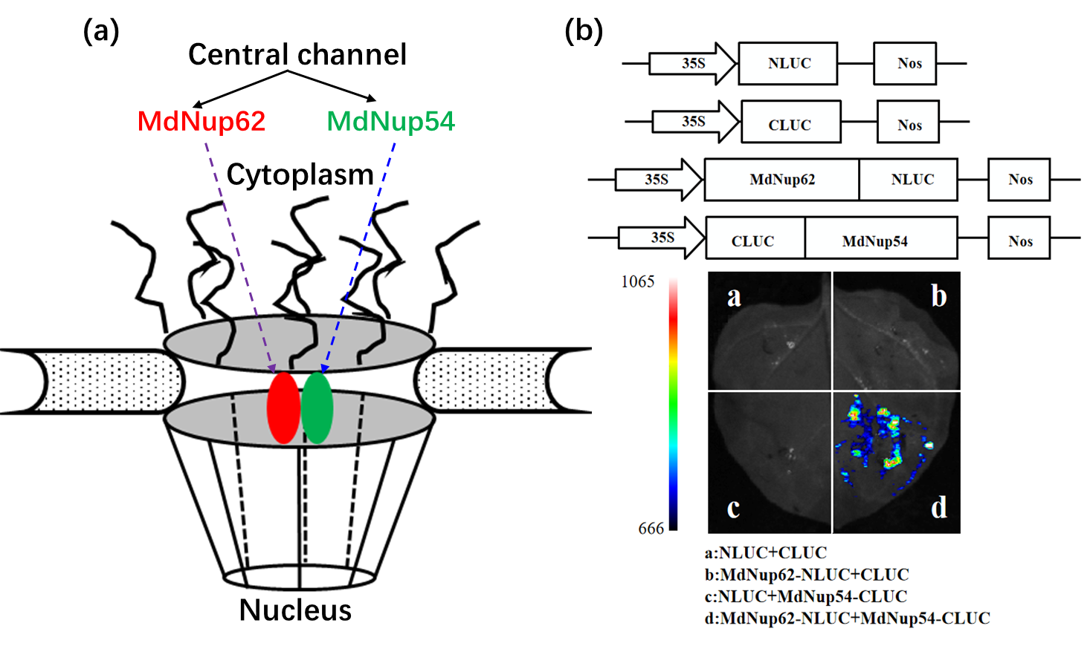
Figure S1. Interactions between MdNup62 and MdNup54 in a luciferase (LUC) complementation experiment.
(a) A schematic of the nuclear pore with the cytoplasmic side at the top and the nuclear basket at the bottom for Vertebrate (left) and Malus (right). MdNup62 interacts with MdNup54 forming the central NPC channel. (b) Interactions between MdNup62 and MdNup54 in a luciferase (LUC) complementation experiment, as well as in our previous study¹⁸. Empty NLUC and empty CLUC, MdNup62-NLUC plus empty CLUC, empty NLUC plus MdNup54-CLUC were used as controls.

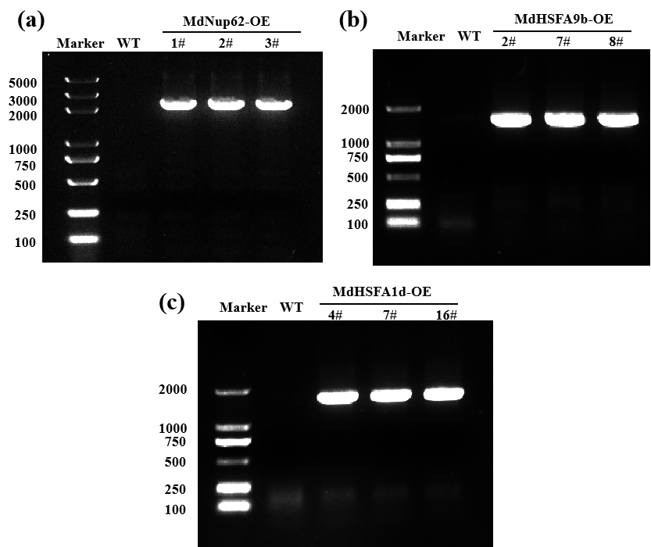
Figure S2. Genomic PCR analyses of MdNup62 (a), MdHSFA9b (b), and MdHSFA1d (c) in transgenic Arabidopsis lines
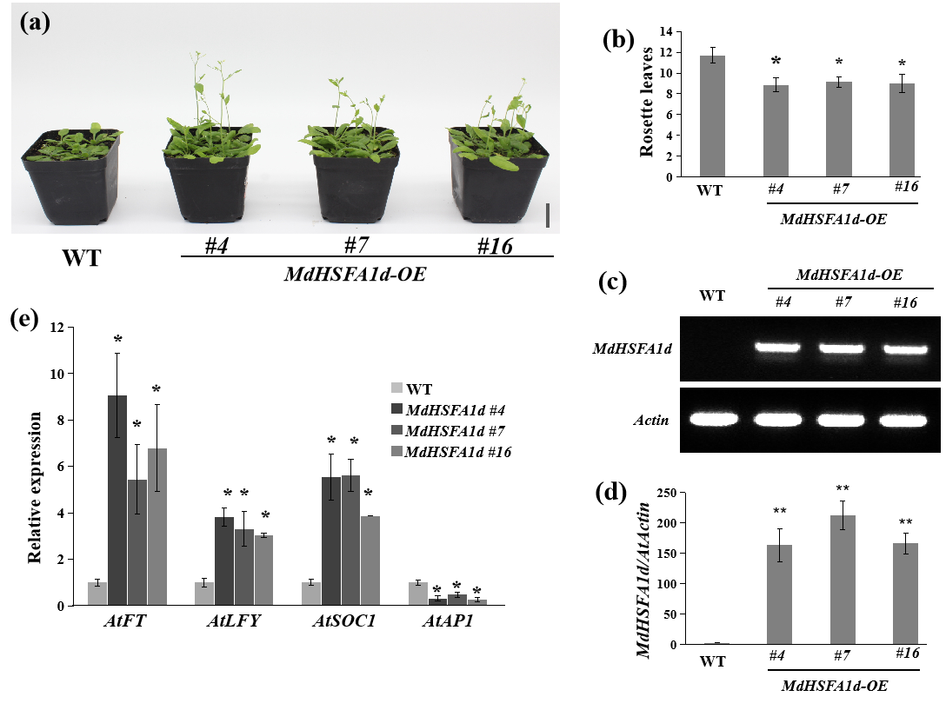
Figure S3. MdHSFA1d promotes flowering in Arabidopsis.
(a) Phenotype of the MdHSFA1d-overexpression Arabidopsis line for flowering time. Bar = 2 cm. (b) Statistical analysis of rosette leaves of Arabidopsis thaliana during bolting. (c) Semi-quantitative RT-PCR analysis of MdHSFA1d expression in Arabidopsis samples. (d) qRT-PCR analysis of MdHSFA1d expression in Arabidopsis samples. (e) Relative expression levels of flowering genes (AtFT, AtLFY, AtSOC1, and AtAP1) in WT and MdHSFA1d-overexpression lines.
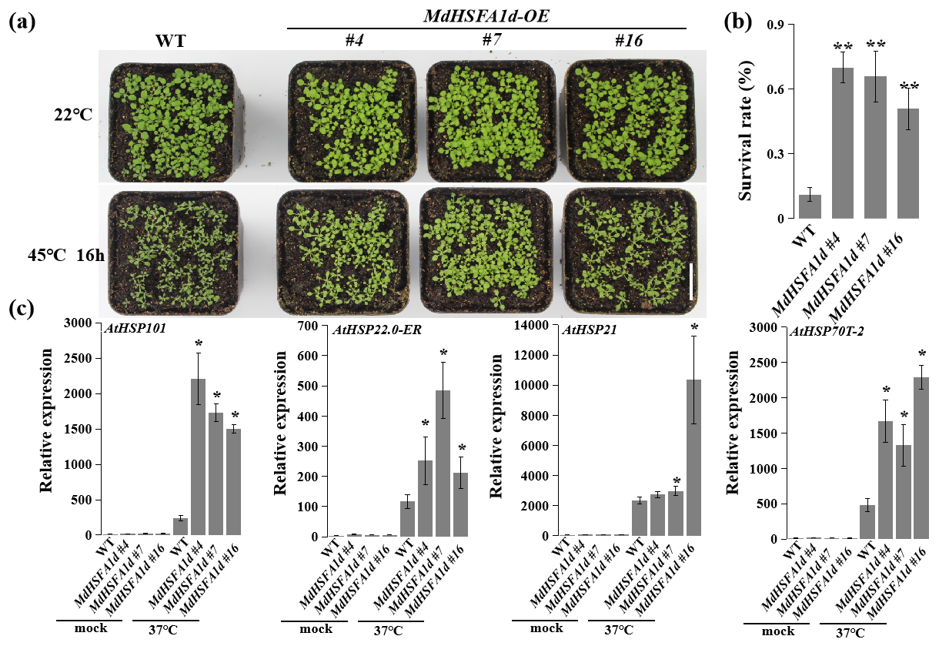
Figure S4. MdHSFA1d enhanced high-temperature resistance in Arabidopsis.
(a) Phenotype of the MdHSFA1d-overexpression Arabidopsis line for high-temperature resistance. Bar = 2 cm. (b) Survival rates of WT and MdHSFA1d-overexpression Arabidopsis lines after the high-temperature treatment. (c) Relative expression levels of high-temperature resistance-related genes (AtHSP101, AtHSP22.0-ER, AtHSP21, and AtHSP70T-2) in WT and MdHSFA1d-overexpression lines at the normal temperature (22°C) and 1 h after exposure to the high-temperature (37°C) treatment.

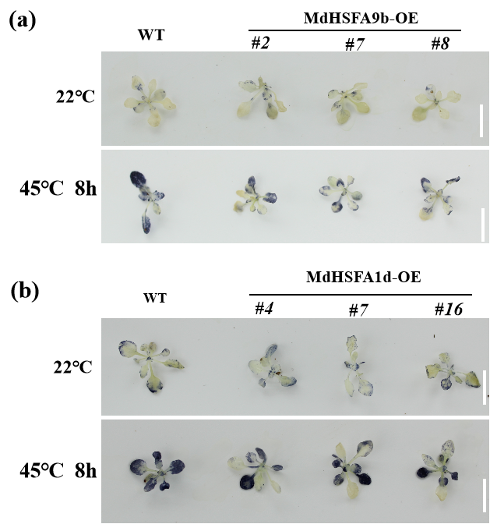
Figure S5. Changes in the levels of accumulated ROS in Arabidopsis leaves under heat-stress conditions.
(a) and (b) In situ accumulations of MdHSFA9b (a), MdHSFA1d (b), and superoxide radicals (O²⁻) before (upper panels) and after (lower panels) the heat treatment as revealed by nitro blue tetrazolium staining. Bar = 1 cm.

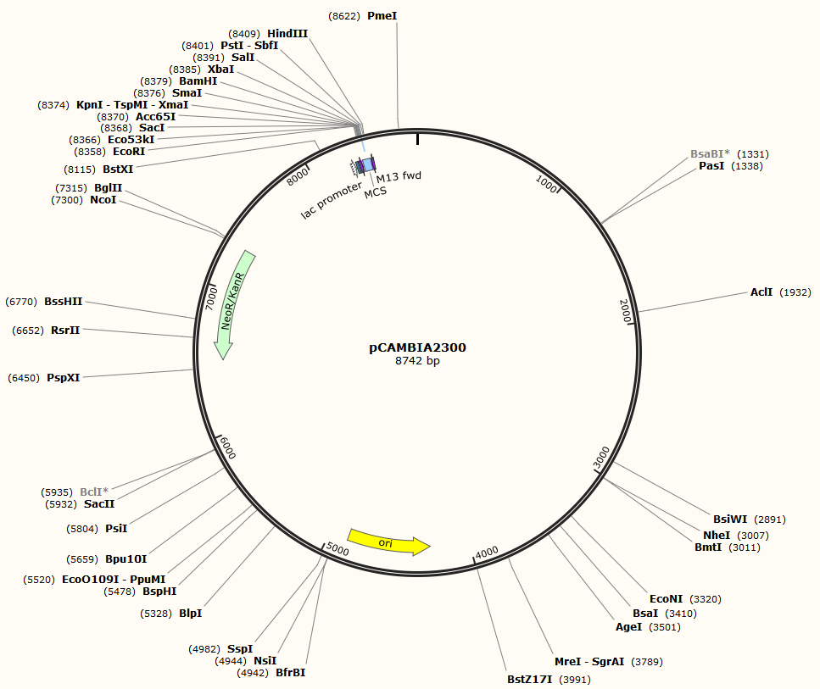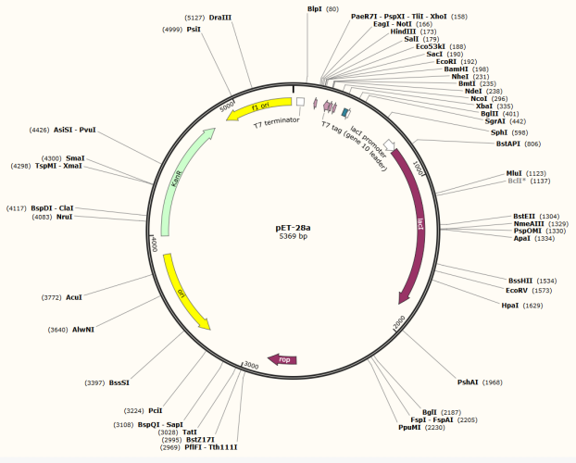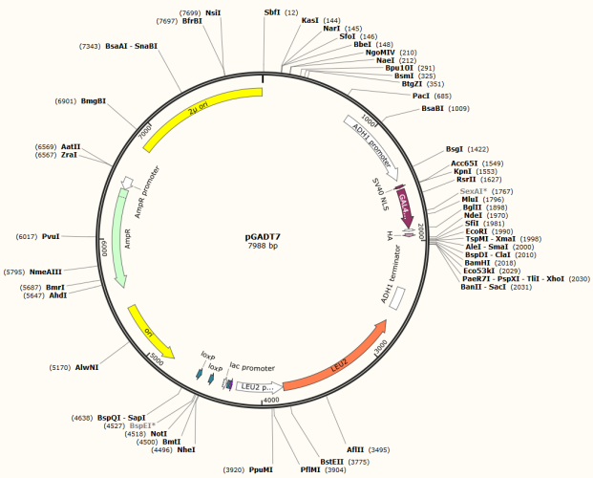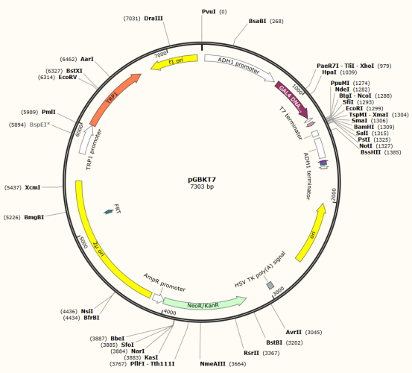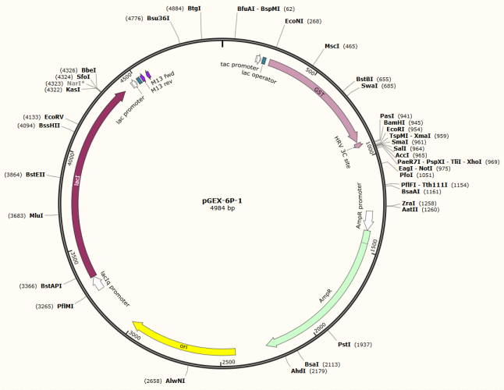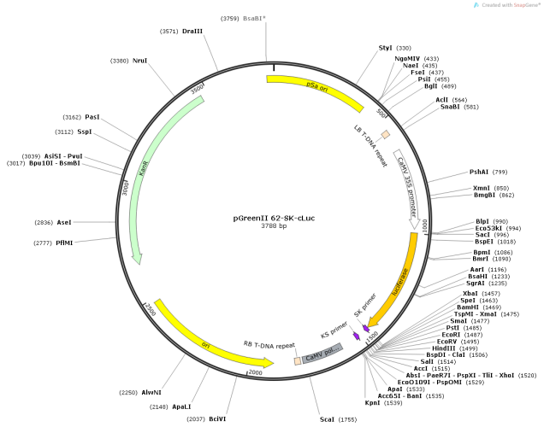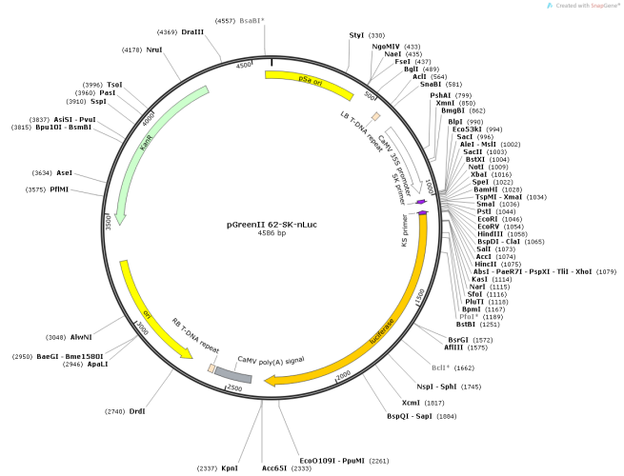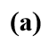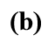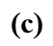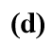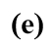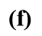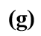

Figure S6. Schematic diagram of vector.
(a) pCAMBIA2300: using KpnⅠ and XbaⅠ for cloning of constructs. (b) pET28a: BamHⅠ and XhoⅠ. (c) pGEX-6P-1: BamHⅠ and EcoRⅠ. (d) pGBKT7: BamHⅠ and EcoRⅠ. (e) pGreenⅡ 62-SK-cluc: XbaⅠ and EcoRⅠ. (f) pGADT7: BamHⅠ and EcoRⅠ. (g) pGreenⅡ 62-SK-nluc: XbaⅠ and BamHⅠ.

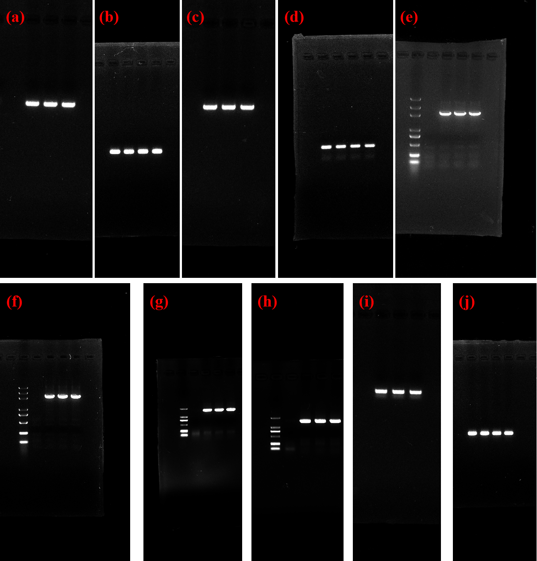
Figure S7. Original image of nucleic acid electrophoresis.
(a) Figure 3c: “MdNup62”. (b) Figure 3c: “AtActin”. (c) Figure 9c: “MdHSFA9b”. (d) Figure 9c: “AtActin”. (e) Figure 6d. (f) Figure S2a. (g) Figure S2b. (h) Figure S2c. (i) Figure S3c: “MdHSFA1d”. (j) Figure S3c: “AtActin”.

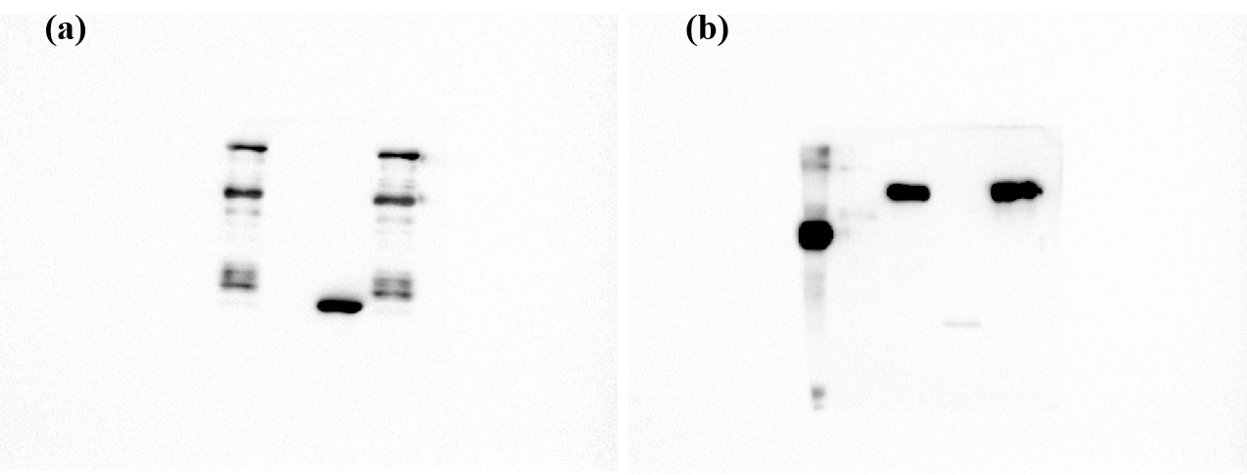
Figure S8. Original image of Figure 7b.
(a)Anti-GST. The channels from left to right are “GST-MdHSFA9b”, “His-MdNup62”, “GST+His-MdNup62”, and “GST-MdHSFA9b+His-MdNup62”. (b)Anti-His. The channels from left to right are “Marker”, “GST-MdHSFA9b”, “His-MdNup62”, “GST+His-MdNup62”, and “GST-MdHSFA9b+His-MdNup62”.

