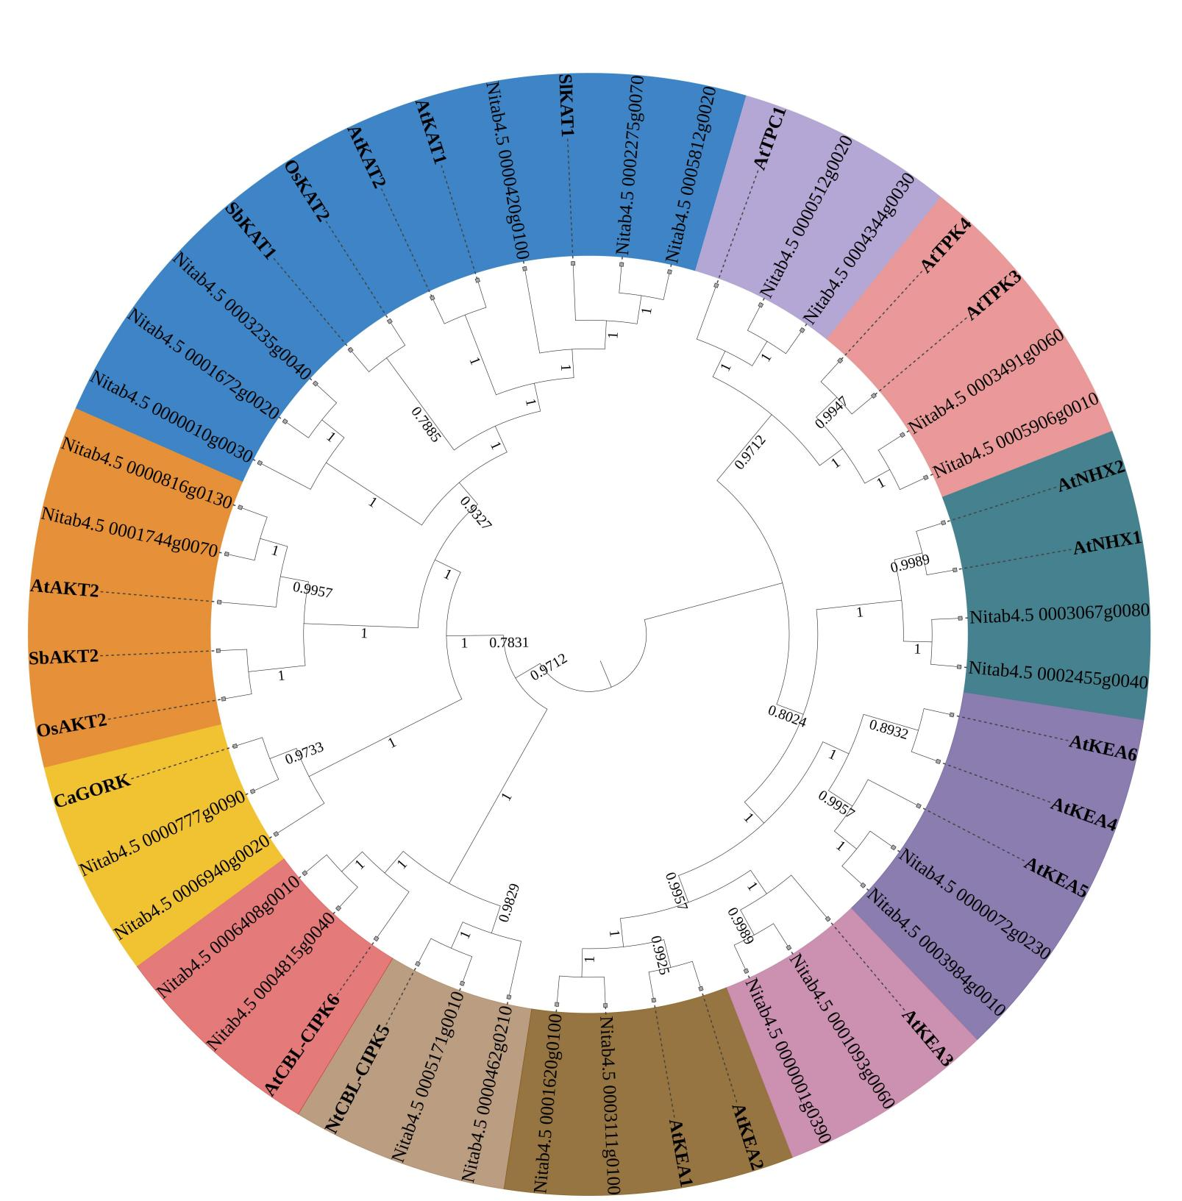

Fig. S1. Phylogenetic analysis of potassium channel proteins. Phylogenetic tree was reconstructed by full-length protein sequences of potassium channel proteins, using Bootstrap method as the test of phylogeny and 1000 replicates. The supporting values (bootstrap value) were shown on branches. Proteins in other crops (Solanum lycopersicum L., Arabidopsis thaliana, Capsicum annuum L., and Oryza sativa Linn.) are marked in bold.

