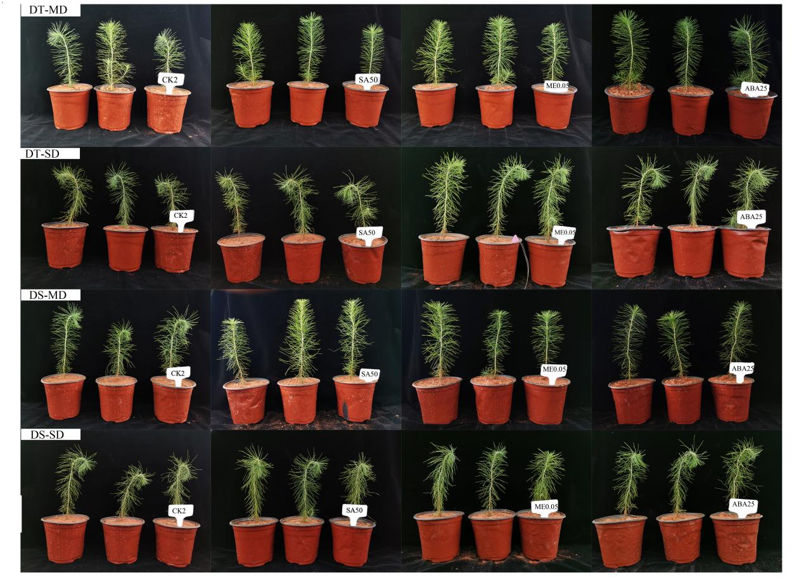
Supplementary Fig 2. The phenotypic changes of P. massoniana seedlings treated with different concentrations of exogenous hormones.

