Additional file 1
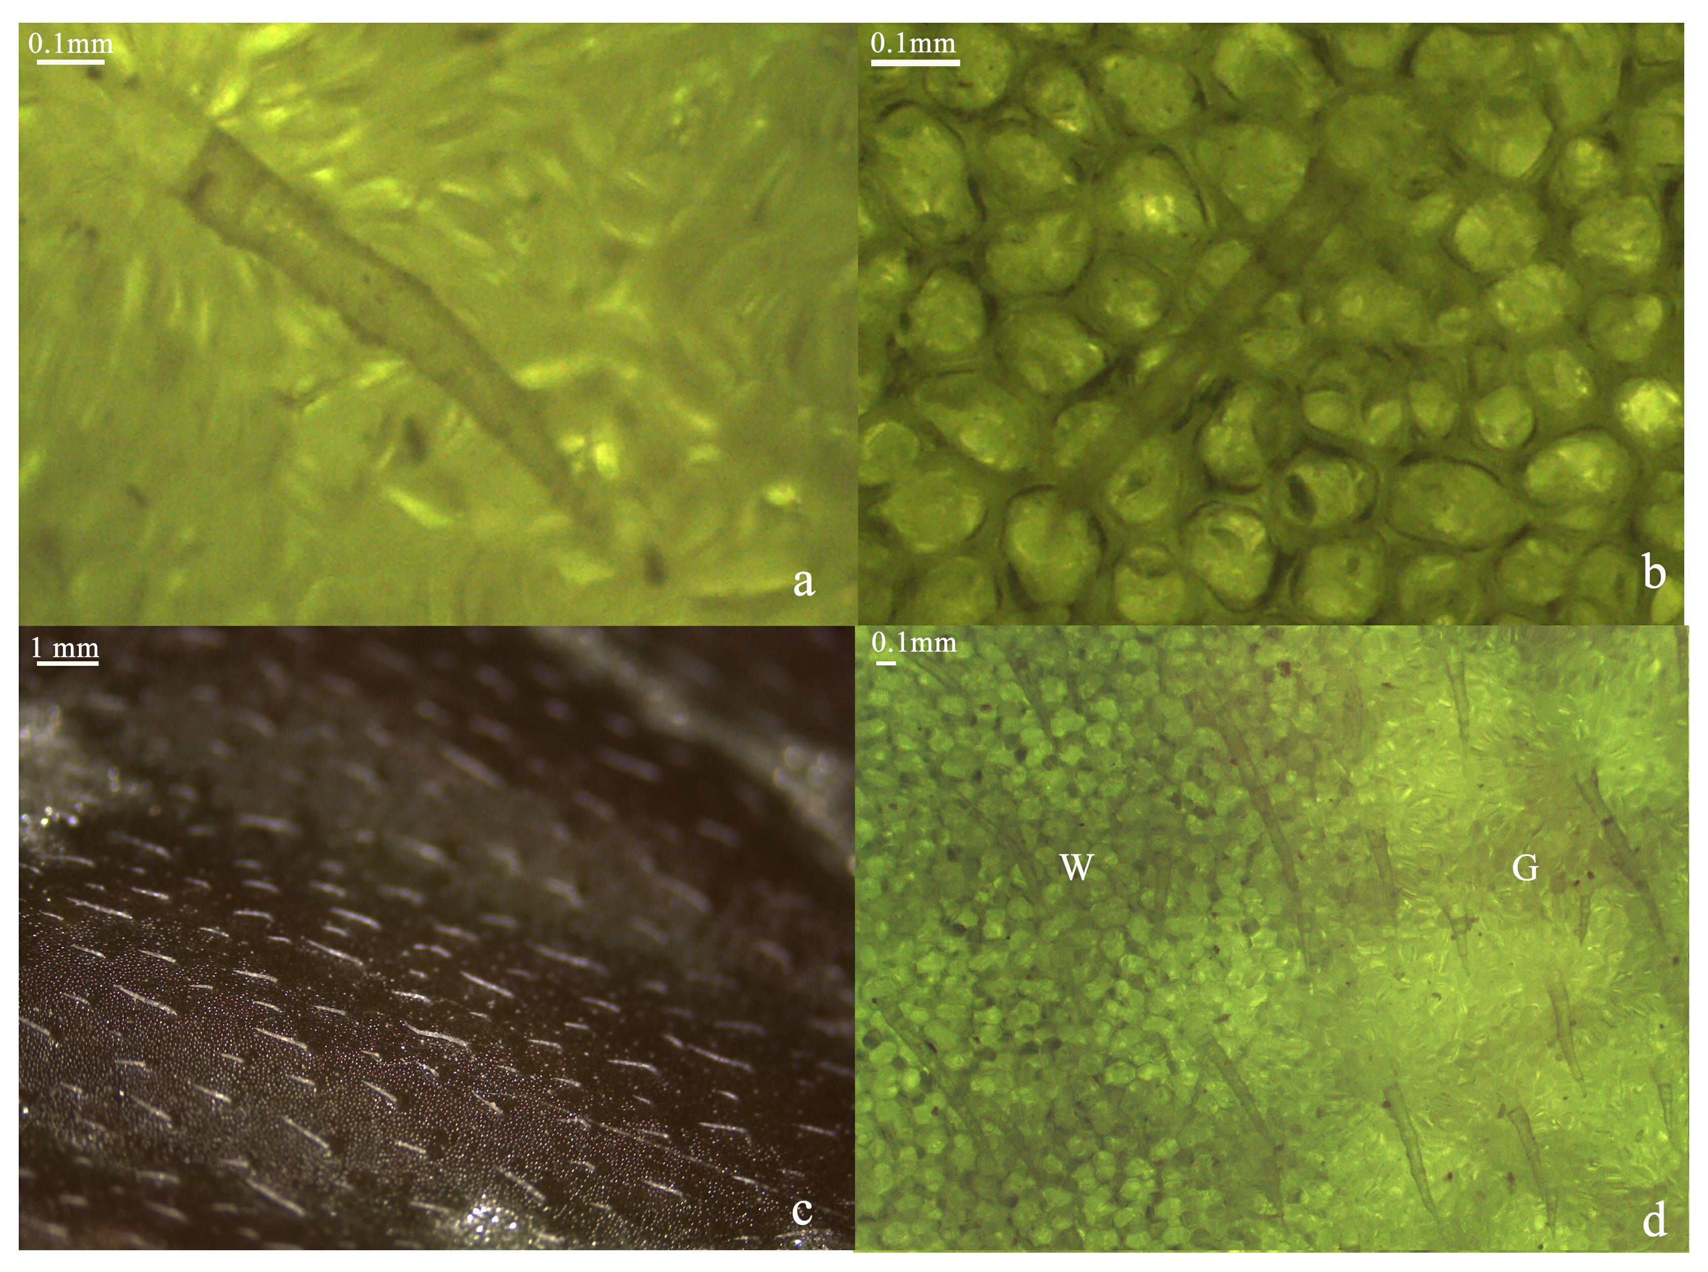
Figure S1. Adaxial surface patterns of leaves. (a-b): the enlarged picture of Fig. 2D and 2E in the manuscript, both of which have clear trichomes. (c): the trichomes on the leaf, which are closely attached to the leaf epidermis cells and almost in the same focus as the epidermal cells. (d): adaxial surface patterns of variegated leaves under transmitted light. The white leaf variegation still has dark cell edges, while the green one does not. These evidences can prove that the observation regarding darker cellular edges in white type do exist. W: the white sector; G: the green sector.

Figure S2. The length distribution of assembled unigenes.

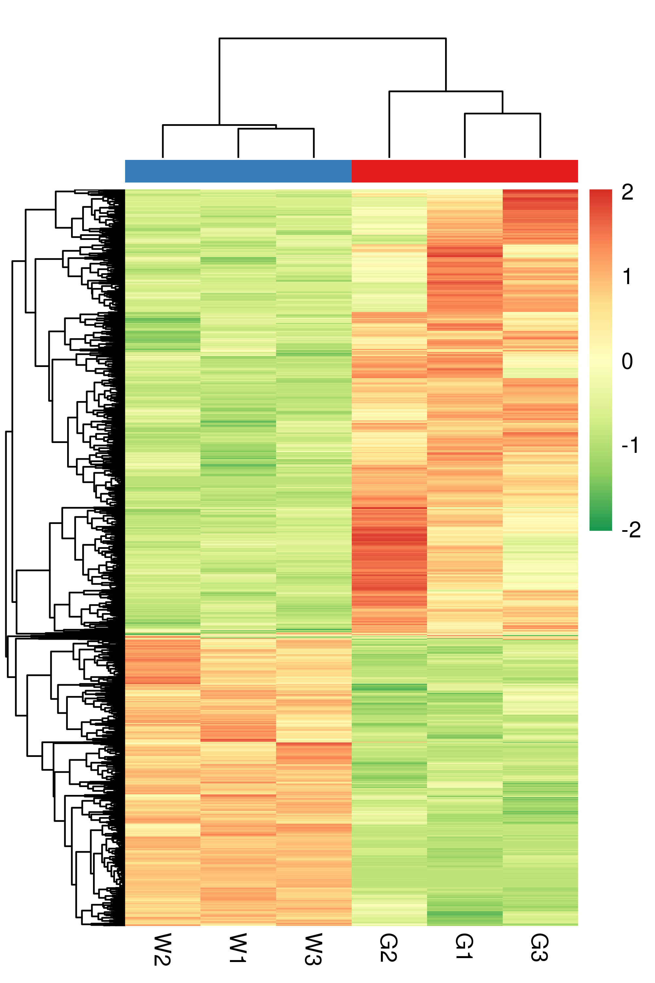
Figure S3. Cluster of DEGs

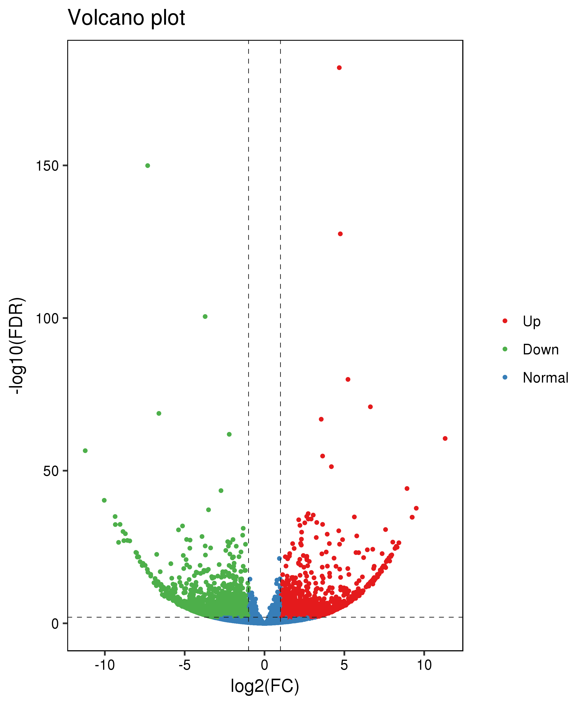
Figure S4. Volcano plot of DEGs

Table S1. An overview of the RNA-Seq data
Sample | Raw Reads | Clean Reads | Raw Base(G) | Clean Base(G) | Effective Rate(%) | Error Rate(%) | Q20(%) | Q30(%) | GC Content(%) | Mapped Reads | Mapped Ratio(%)
G1 | 23 616 335 | 22 560 312 | 7.08 | 6.77 | 95.53 | 0.03 | 97.43 | 92.61 | 44.37 | 14060071 | 68.82
G2 | 23 813 002 | 22 883 384 | 7.14 | 6.87 | 96.1 | 0.03 | 97.78 | 93.55 | 44.99 | 15808565 | 70.07
G3 | 21 229 962 | 20 430 288 | 6.37 | 6.13 | 96.23 | 0.03 | 97.6 | 93.16 | 45.17 | 16066032 | 70.21
W1 | 19 757 500 | 18 652 487 | 5.93 | 5.6 | 94.41 | 0.03 | 97.42 | 92.67 | 44.7 | 13661218 | 67.68
W2 | 21 125 523 | 19 818 691 | 6.34 | 5.95 | 93.81 | 0.03 | 97.69 | 93.33 | 44.56 | 13588566 | 68.56
W3 | 20 883 408 | 19 847 115 | 6.27 | 5.95 | 95.04 | 0.03 | 97.72 | 93.33 | 44.53 | 13431085 | 67.67

Table S2. The primers for qRT-PCR analysis.
DEGs | Primer sequences
TRINITY_DN6903_c0_g1-F | TTGAGTGCCAACCATCTCC
TRINITY_DN6903_c0_g1-R | TTGAAAGGGAACAAAGGAAG
TRINITY_DN8967_c0_g1-F | GAACCTAACTTTCGTGGACAT
TRINITY_DN8967_c0_g1-R | CGGAGGCTGAACTGCTAAT
TRINITY_DN27781_c0_g1-F | TGATGGGTGCTGTTGAGGG
TRINITY_DN27781_c0_g1-R | CGAAGAACCCGAACATTGAG
TRINITY_DN7086_c0_g1-F | TCCGATTTATGAAGCAGAGC
TRINITY_DN7086_c0_g1-R | TCCTAGCCCCAAAGCAGAC
TRINITY_DN6080_c0_g1-F | CTAAGTTCAGACGGACGGC
TRINITY_DN6080_c0_g1-R | CCTCACTGGATACTATGTTTTGC
TRINITY_DN7812_c0_g1-F | AGTAATGTTCCCCTCTTTTCAC
TRINITY_DN7812_c0_g1-R | TACCTTGGCTGTTGTCTCG
TRINITY_DN13428_c0_g1-F | TCACTTCTTTCGGAACCACG
TRINITY_DN13428_c0_g1-R | GGTGAATCCGCAGTGTAAGA
TRINITY_DN6896_c1_g1-F | GTTGAGGGCTACCGTATTGC
TRINITY_DN6896_c1_g1-R | TCAACTCAGCGAATGCCTC
TRINITY_DN17252_c0_g1-F | GCGATTACCGTGTTCAGTT
TRINITY_DN17252_c0_g1-R | GTTAAGATTCGGGCTGTTG
TRINITY_DN511_c0_g1-F | AAGCAGTAAAACCCACGAGT
TRINITY_DN511_c0_g1-R | CAAATCGAAGTCCCTGTGAG
Actin7-F | AACCACCGCTGAGCACGAT
Actin7-R | TTCCGTTGCCCTGAAGTCC

