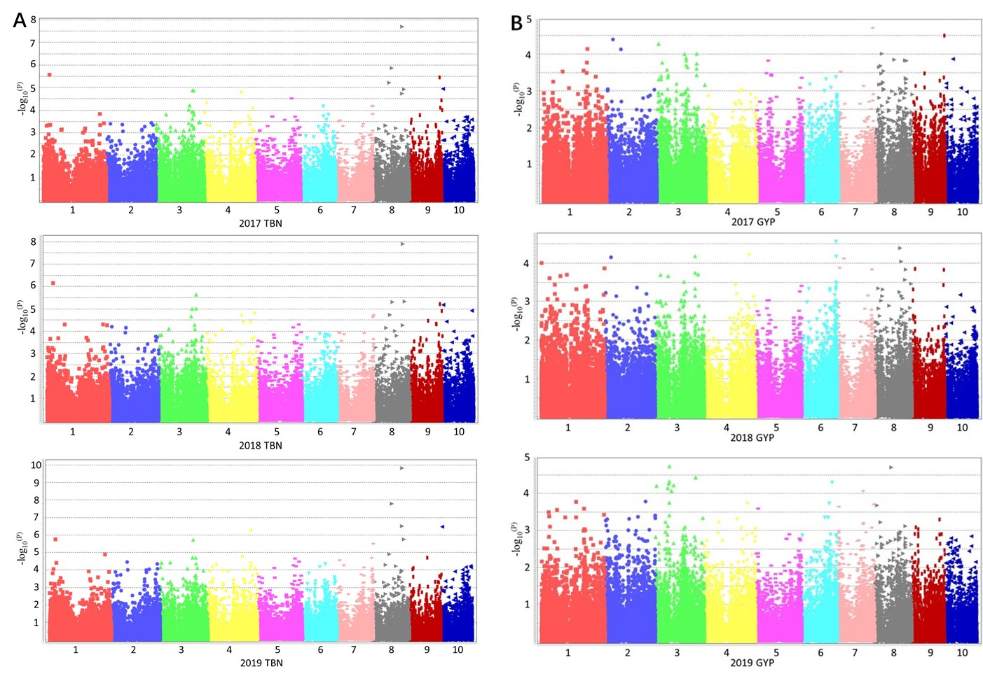
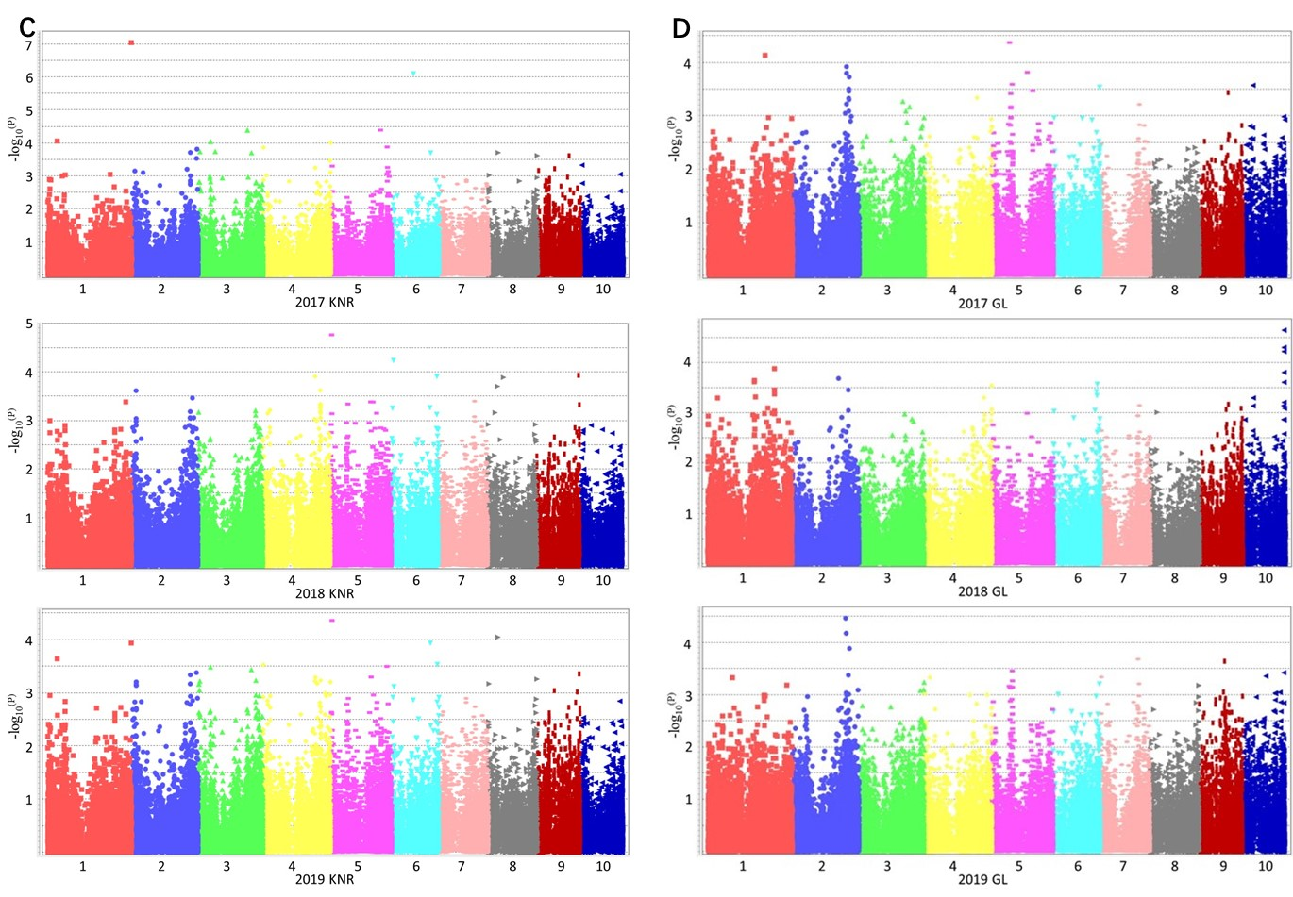
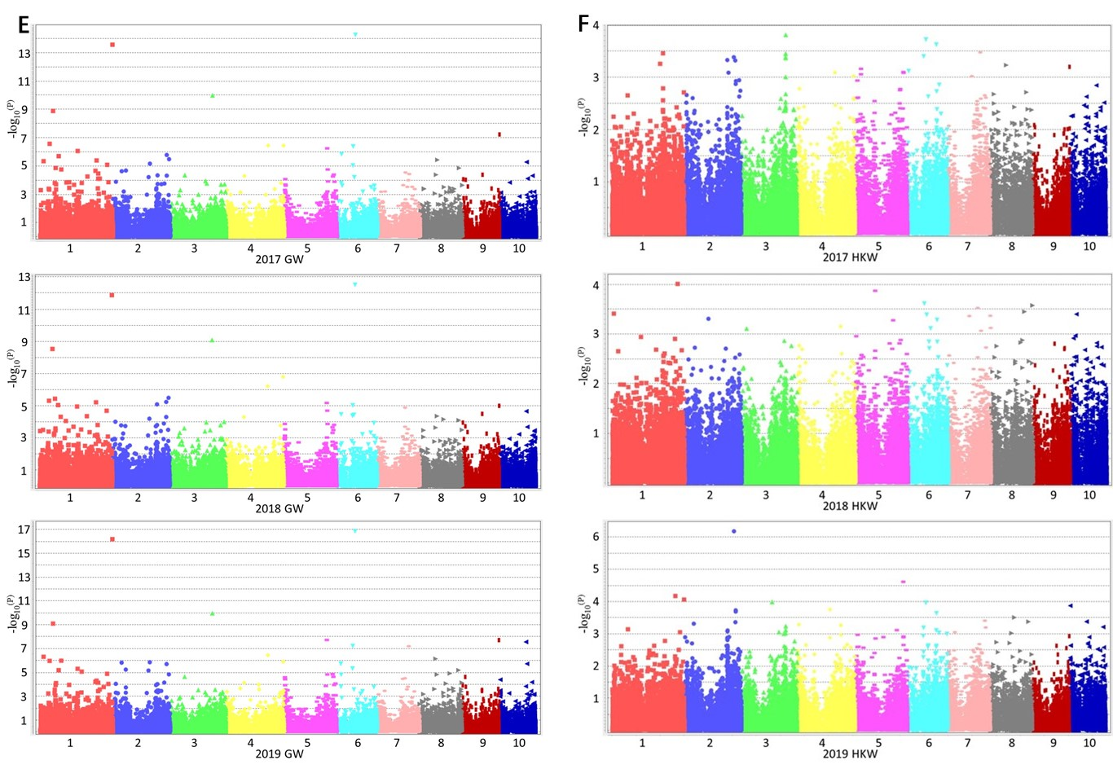
Fig S2 Manhattan plot for genome-wide association study of maize yield related traits in 2017, 2018 and 2019. GYP: grain yield per plant (g); GW: grain width (cm); GL: grain length (cm); KNR: kernel number per row; HKW: 100-kernel weight (g); TBN: tassel branch number.

