Comparative physiological and co-expression network analyses to provide hub candidates of drought tolerance in peanut

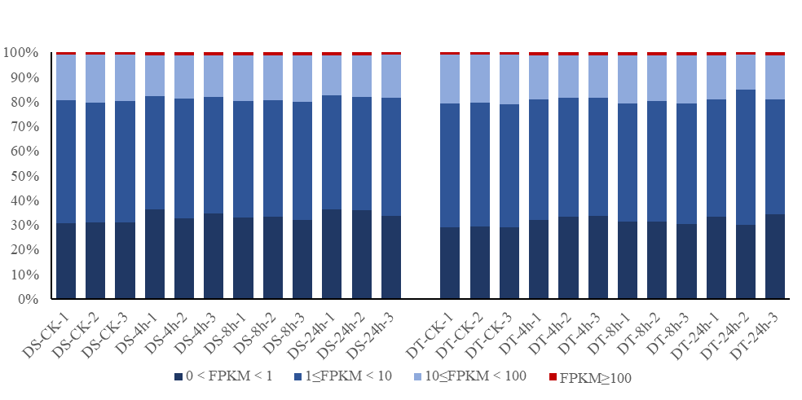 Supplementary Figure S1 Numbers of expressed genes in each sample in two peanut varieties.

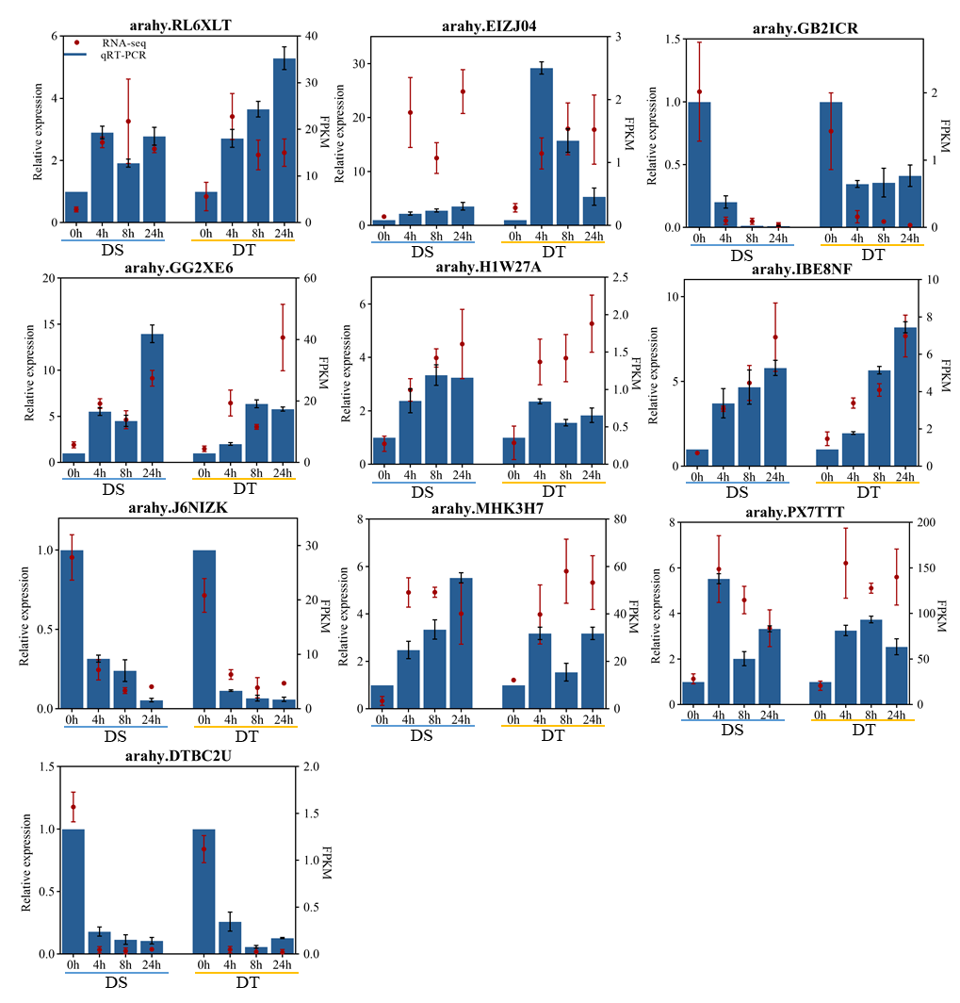
Supplementary Figure S2 Validation of differentially expressed genes in the RNA-Seq database by quantitative real-time PCR

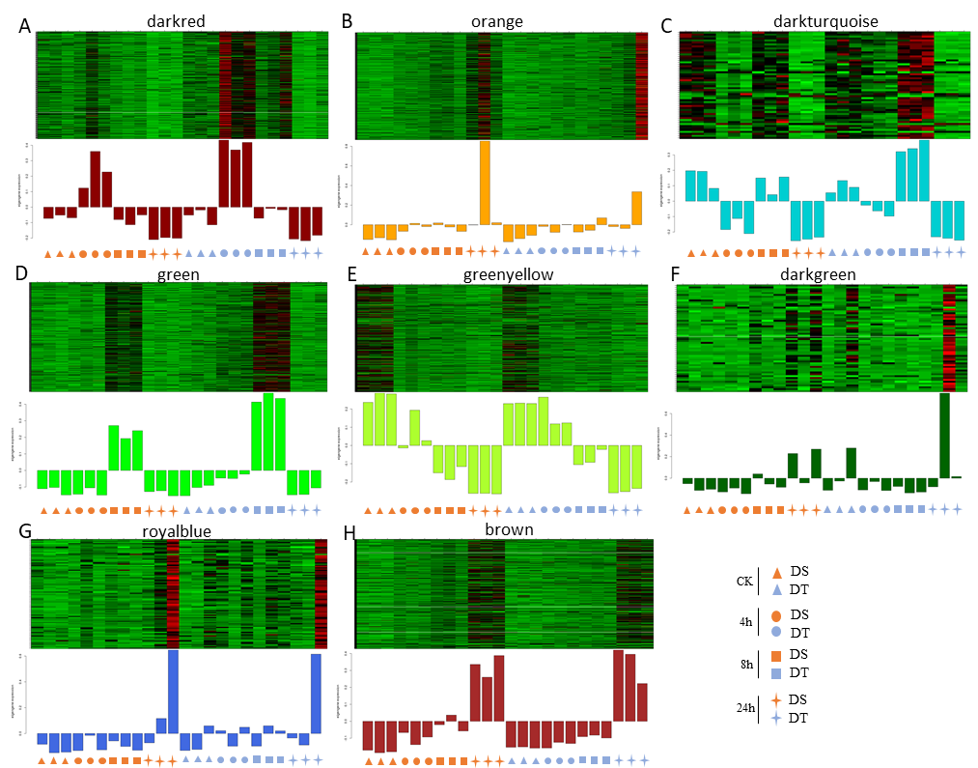
Supplementary Figure S3 Expression profiles of genes in nine co-expression modules with biological significance. (A) The darkred module; (B) The orange module; (C) The darkturquoise module; (D) The green module; (E) The greenyellow module; (F) The darkgreen module; (G)The royalblue module; (H) The brown module. Heatmaps show the expression profiles of all the co-expressed genes in each module. Bar graphs show the expression pattern of module eigengenes in each module.

