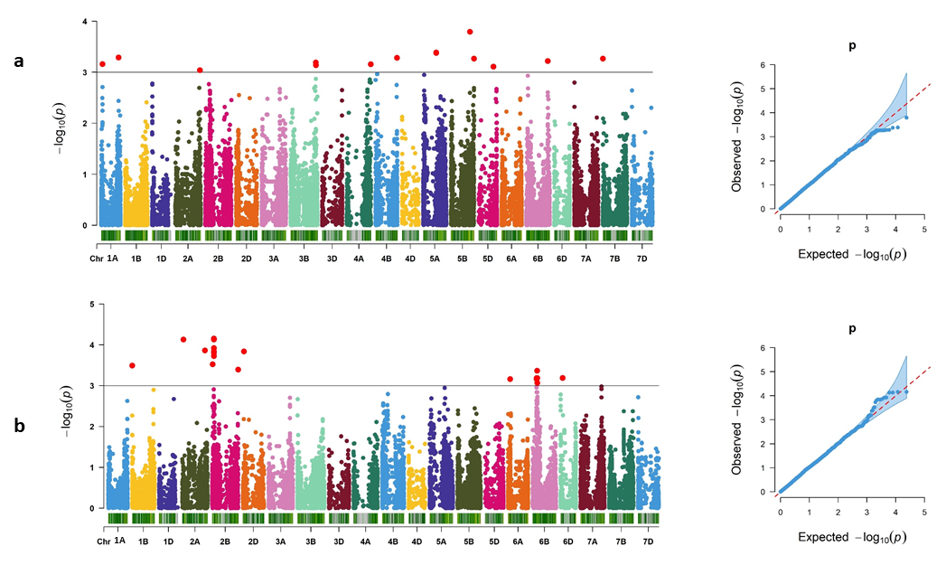
Supplementary Fig. S1 Manhattan plots of GWAS conducted on Pro and H₂O₂ accumulation. (a) Manhattan plot (left) and QQplot (right) of Pro content under control condition, (b) Manhattan plot (left) and QQplot (right) of H₂O₂ content under control condition. − log₁₀ (P) =3.0 is the significant threshold level for marker-trait association represented by a horizontal grey line on Manhattan plots. Red dots above the horizontal grey line are representing significant markers

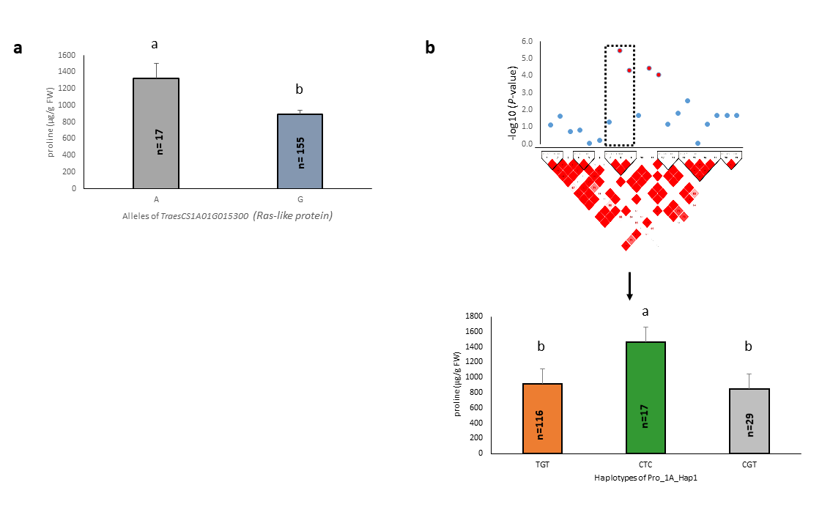
Supplementary Fig. S2 Alleles of candidate gene and haplotype block Pro_1A_Hap1 linked with Pro content under drought. (a) Two allelic forms of the candidate gene TraesCS1A01G015300 that located on 1A chromosome and harbored significant SNP AX-158569423 in the 4th intron. (b) Three haplotypes for Pro_1A_Hap1 haplotype block that were linked with four serine/threonine-protein kinase coding genes. n, number of cultivars possessing the allele or haplotype. Different letters on the bar plots indicating the significant statistical difference.

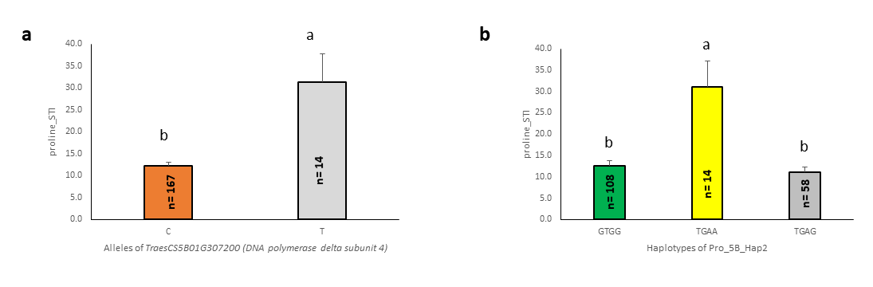

Supplementary Fig. S3 Alleles of candidate gene and haplotype block Pro_5B_Hap2 linked with STI of Pro. (a) Two allelic forms of the candidate gene TraesCS5B01G307200 that located on 5B chromosome and harbored significant SNP AX-158525047 in the promoter region. (b) Three haplotypes for Pro_5B_Hap2 haplotype block that was nested with the promoter regions of TraesCS5B01G321800. n, number of cultivars possessing the allele or haplotype. Different letters on the bar plots indicating the significant statistical difference.

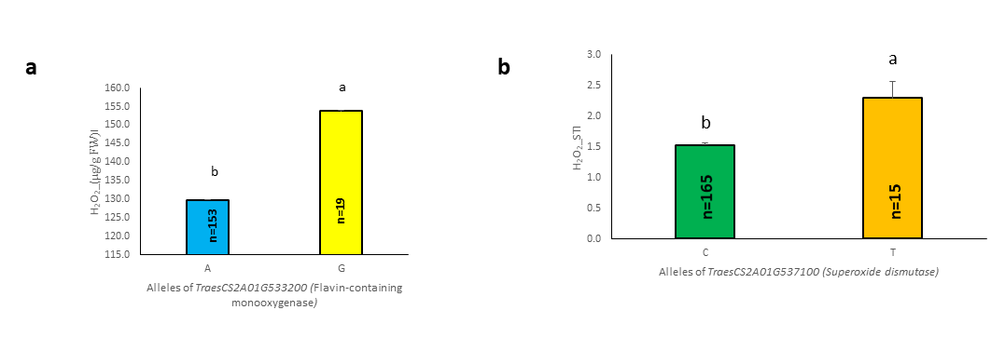

Supplementary Fig. S4 Alleles of two candidate genes, TraesCS2A01G533200 and TraesCS2A01G537100 linked with drought and STI of H₂O_{2,} respectively. (a) Two allelic forms of the candidate gene TraesCS2A01G533200 that located on 2A chromosome and harbored significant SNP AX-158557366 in the promoter region (697 bp downstream). (b) Two allelic forms of the candidate gene TraesCS2A01G537100 that located on 2A chromosome and harbored significant SNP AX-158596005 in the first exon. n, number of cultivars possessing the allele. Different letters on the bar plots indicating the significant statistical difference.

