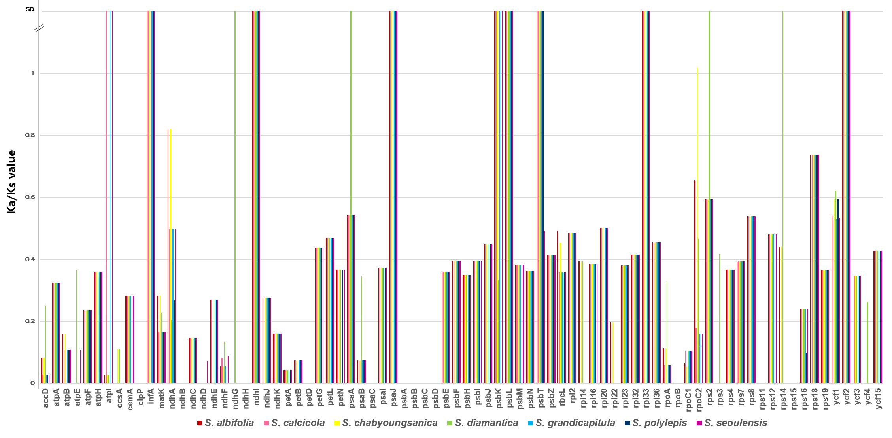
Figure S3 The Ka/Ks values of 80 protein-coding genes from seven Korean Saussurea plastomes

