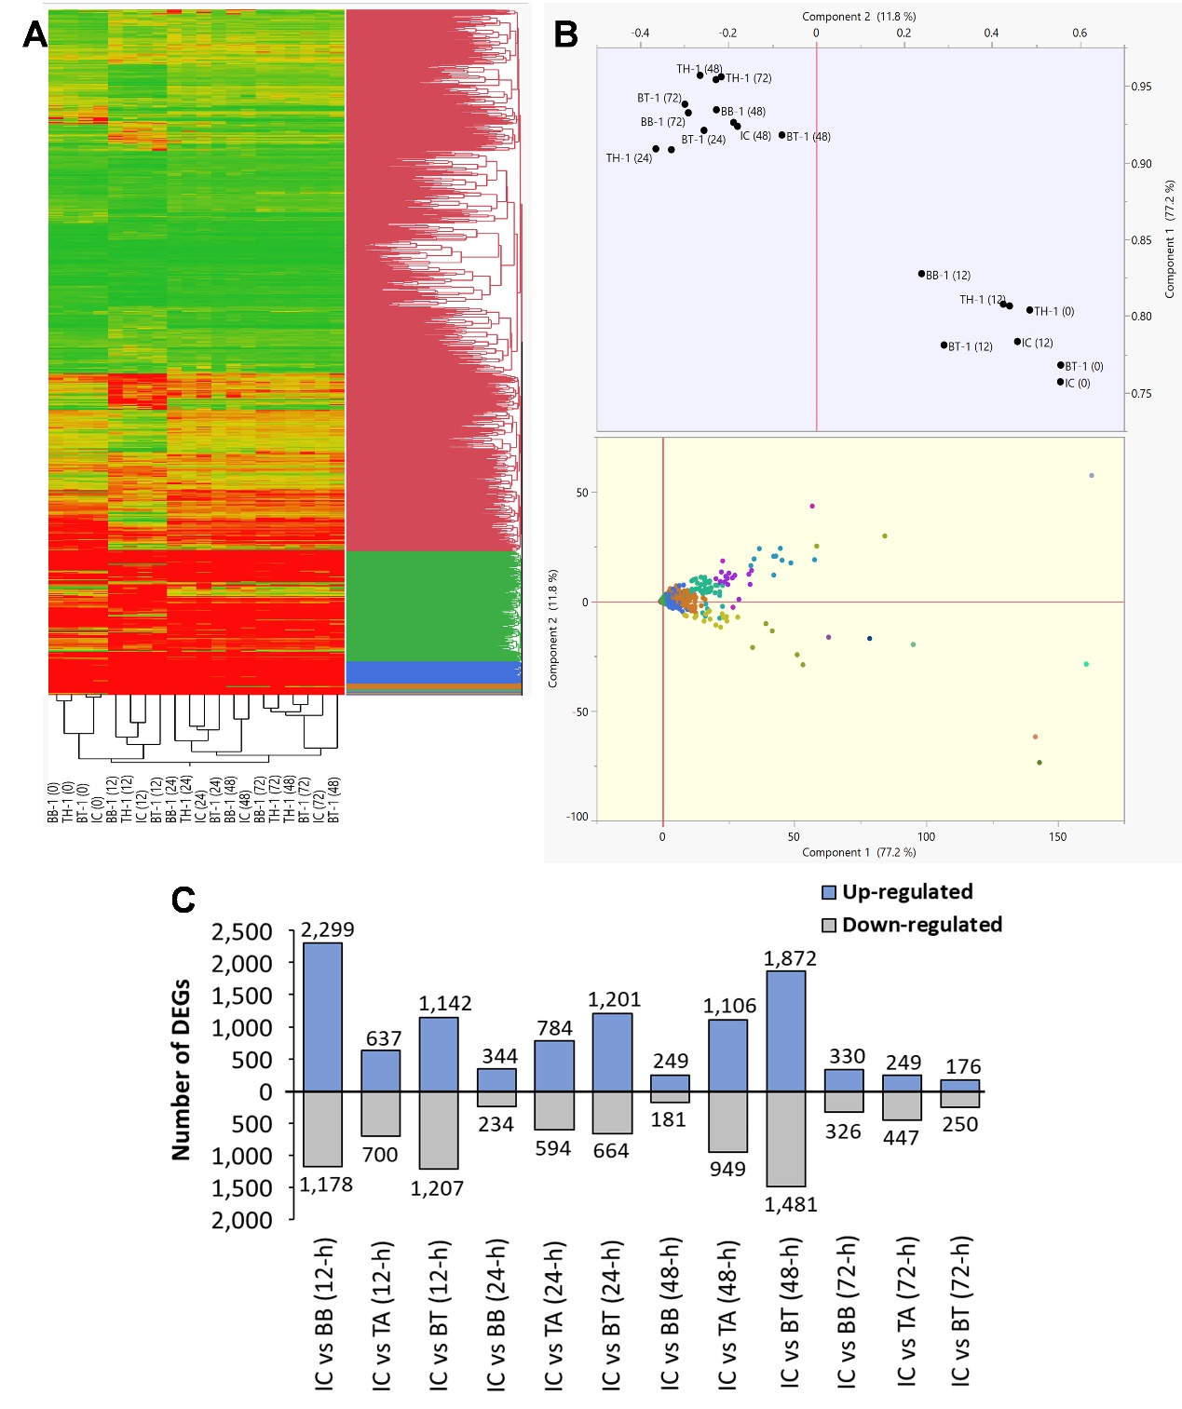
Figure S1. Transcriptome response of maize inoculated with single and consortium of B. bassiana OFDH1-5 and T. asperellum GDFS1009 to O. furnacalis (A) Hierarchical Cluster dendrogram of differentially expressed genes, difference in color indicate high (red) and low (green) expression; (B) PCA plot showing variability of transcriptome data. (C) Number of up- and down-regulated differentially expressed genes (DEGs) in each treatment compared to control.

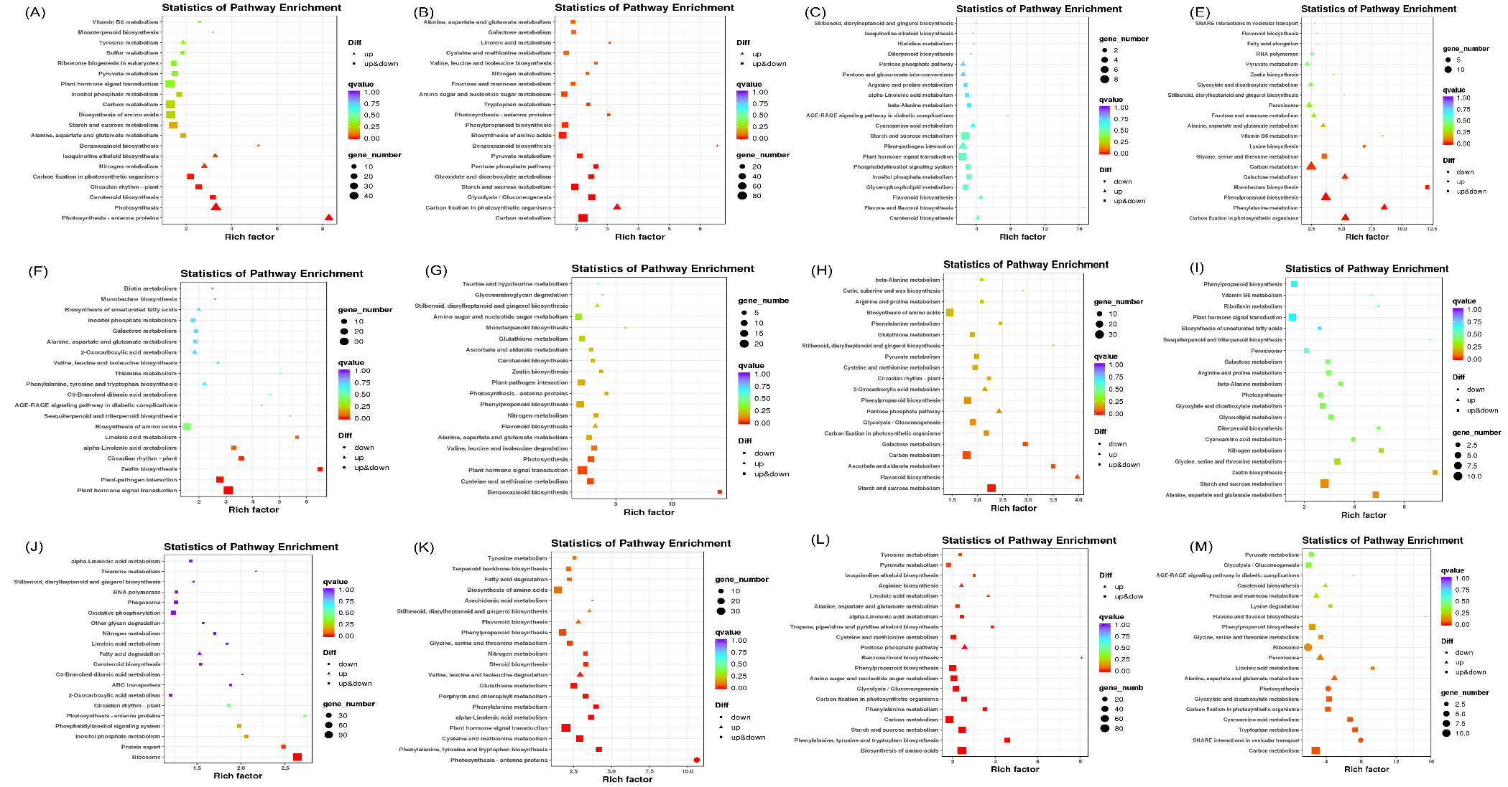
Figure S2. KEGG pathway enrichment analysis of DEG's in single and consortium of B. bassiana OFDH1-5 and T. asperellum GDFS1009 inoculated maize leaves induces by O. furnacalis feeding for (A) IC vs BB-1(12-h): (B) IC vs BB-1 (24-h); (C) IC vs BB-1 (48-h): (D) IC vs BB-1 (72-h): (E) IC vs TH-1 (12-h); (F) IC vs TH-1 (24-h); (G) IC vs TH-1 (48-h); (H) IC vs TH-1 (72-h); (I) IC vs BT-1 (12-h); (J) IC vs BT-1 (24-h); (K) IC vs BT-1 (48-h); (L) IC vs BT-1 (72-h) (www.kegg.jp/kegg/kegg1.html).

Table S1. Weather data during crop growth season in 2018 and 2019.
Date | Average temperature (℃) |  | Average humidity (%) |  | Wind speed (m/s)
Date | 2018 | 2019 | 2018 | 2019 | 2018 | 2019
6th May | --- | 11.02 | --- | 74.34 | --- | 0.38
7th May | --- | 10.32 | --- | 78.56 | --- | 0.94
8th May | --- | 15.63 | --- | 78.15 | --- | 0.20
9th May | --- | 12.45 | --- | 77.19 | --- | 0.86
10th May | --- | 13.32 | --- | 81.79 | --- | 0.35
11th May | 15.34 | 14.43 | 72.73 | 80.64 | 0.85 | 1.02
12th May | 16.02 | 13.93 | 80.22 | 81.67 | 0.97 | 1.11
13th May | 14.62 | 14.01 | 81.80 | 81.11 | 1.62 | 1.38
14th May | 15.44 | 15.00 | 79.39 | 82.83 | 1.98 | 2.34
15th May | 16.72 | 16.66 | 87.43 | 79.34 | 1.38 | 0.64
16th May | 17.01 | 16.54 | 81.22 | 81.18 | 0.96 | 0.38
17th May | 17.22 | 16.20 | 85.03 | 79.25 | 1.66 | 1.34
18th May | 15.54 | 15.32 | 80.12 | 77.35 | 1.78 | 1.68
19th May | 15.55 | 16.03 | 75.52 | 75.46 | 1.40 | 2.35
21st May | 16.03 | 16.93 | 79.45 | 74.66 | 1.69 | 3.24
22nd May | 17.77 | 16.45 | 80.29 | 78.28 | 1.44 | 1.25
23rd May | 17.02 | 17.03 | 73.36 | 74.25 | 2.45 | 0.04
24th May | 17.70 | 17.83 | 74.33 | 77.45 | 1.96 | 0.34
25th May | 18.32 | 16.99 | 74.67 | 78.34 | 2.18 | 1.29
26th May | 19.01 | 16.92 | 72.70 | 71.28 | 3.49 | 1.57
27th May | 19.32 | 17.94 | 72.84 | 79.28 | 3.95 | 2.31
28th May | 19.92 | 17.99 | 80.95 | 77.31 | 2.68 | 2.94
29th May | 21.23 | 17.89 | 87.77 | 78.35 | 3.69 | 3.54
30th May | 18.43 | 21.32 | 84.16 | 81.21 | 4.36 | 1.03
31st May | 19.05 | 22.92 | 75.26 | 88.23 | 2.38 | 4.31
1st June | 21.21 | 21.57 | 79.96 | 87.24 | 0.50 | 0.08
2nd June | 17.72 | 22.91 | 81.33 | 8134 | 1.58 | 2.31
3rd June | 19.92 | 21.21 | 88.03 | 79.35 | 2.21 | 2.95
4th June | 18.88 | 20.93 | 78.65 | 77.25 | 3.20 | 2.19
Date | Average temperature (℃) |  | Average humidity (%) |  | Wind speed (m/s)
Date | 2018 | 2019 | 2018 | 2019 | 2018 | 2019
5th June | 18.92 | 24.32 | 74.26 | 89.32 | 1.84 | 2.37
6th June | 21.20 | 25.69 | 85.37 | 88.24 | 5.40 | 3.31
7th June | 21.92 | 22.20 | 86.15 | 78.32 | 5.46 | 3.46
8th June | 22.21 | 25.93 | 86.02 | 75.32 | 4.39 | 5.37
9th June | 24.42 | 24.76 | 79.18 | 82.14 | 2.41 | 2.41
10th June | 24.21 | 25.54 | 73.98 | 88.21 | 3.25 | 4.61
11th June | 24.92 | 25.64 | 82.25 | 84.35 | 3.32 | 5.26
12th June | 25.62 | 27.43 | 84.39 | 84.31 | 2.21 | 2.38
13th June | 27.81 | 27.77 | 79.99 | 78.32 | 2.11 | 3.45
14th June | 29.91 | 27.83 | 78.29 | 82.31 | 2.14 | 3.82
15th June | 28.86 | 27.34 | 89.94 | 82.31 | 2.54 | 3.16
16th June | 28.88 | 27.93 | 86.57 | 77.21 | 2.79 | 2.19
17th June | 29.72 | 28.88 | 81.29 | 73.21 | 0.37 | 2.17
18th June | 26.82 | 27.63 | 81.53 | 79.56 | 3.14 | 3.54
19th June | 25.09 | 28.03 | 79.34 | 84.21 | 1.19 | 5.64
20th June | 25.92 | 27.95 | 85.56 | 88.54 | 1.11 | 2.37
21st June | 28.02 | 27.02 | 86.34 | 85.34 | 1.28 | 1.34
22nd June | 27.31 | 27.74 | 86.66 | 79.25 | 2.97 | 3.21
23rd June | 25.53 | 29.93 | 87.95 | 78.32 | 2.99 | 1.65
24th June | 25.01 | 29.99 | 86.41 | 72.96 | 3.85 | 3.14
25th June | 26.03 | 29.83 | 84.67 | 74.47 | 4.97 | 2.31
26th June | 26.02 | 29.03 | 91.35 | 79.84 | 2.54 | 2.54
27th June | 26.73 | 28.84 | 95.17 | 76.31 | 1.21 | 2.28
28th June | 25.54 | 27.98 | 91.34 | 77.28 | 2.54 | 1.34
29th June | 27.65 | 28.99 | 89.33 | 78.25 | 2.75 | 1.33
1st July | 29.88 | 29.47 | 87.34 | 75.64 | 1.44 | 2.64
2nd July | 29.32 | 28.94 | 79.34 | 76.24 | 1.21 | 1.19
3rd July | 26.73 | 28.83 | 87.21 | 77.54 | 2.61 | 3.56
4th July | 26.03 | 27.98 | 85.63 | 74.21 | 2.34 | 4.38
5th July | 26.59 | 27.47 | 86.24 | 71.25 | 1.35 | 4.54
Date | Average temperature (℃) |  | Average humidity (%) |  | Wind speed (m/s)
Date | 2018 | 2019 | 2018 | 2019 | 2018 | 2019
6th July | 27.82 | 28.88 | 88.98 | 75.34 | 1.24 | 4.94
7th July | 26.93 | 29.97 | 96.75 | 74.48 | 2.64 | 6.42
8th July | 27.63 | 27.49 | 91.25 | 77.32 | 4.71 | 8.64
9th July | 28.43 | 27.83 | 89.33 | 79.28 | 1.46 | 9.41
10th July | 28.01 | 27.53 | 89.25 | 74.74 | 1.54 | 8.31
11th July | 27.02 | 28.02 | 95.61 | 75.64 | 1.84 | 9.31
12th July | 26.93 | 28.00 | 94.68 | 89.94 | 1.44 | 1.86
13th July | 26.77 | 27.90 | 91.34 | 87.56 | 2.97 | 11.34
14th July | 28.52 | 27.06 | 86.29 | 87.70 | 2.85 | 9.47
15th July | 27.82 | 28.93 | 91.32 | 81.34 | 2.46 | 5.31
16th July | 28.84 | 29.03 | 98.34 | 76.31 | 1.94 | 8.32
17th July | 28.66 | 29.95 | 89.66 | 84.21 | 5.46 | 9.41
18th July | 27.54 | 29.83 | 86.54 | 88.34 | 7.89 | 6.57
19th July | 28.02 | 28.65 | 92.74 | 91.34 | 5.61 | 6.28
20th July | 28.63 | 27.88 | 96.34 | 94.37 | 8.94 | 10.27
21st July | 27.95 | 28.13 | 89.33 | 89.34 | 4.56 | 11.34
22nd July | 27.66 | 28.06 | 87.28 | 82.25 | 7.92 | 9.37
23rd July | 27.07 | 27.79 | 85.29 | 94.31 | 7.10 | 8.51
24th July | 28.83 | 26.92 | 94.43 | 94.45 | 6.45 | 6.34
25th July | 28.66 | 27.00 | 91.25 | 96.21 | 4.21 | 8.21
26th July | 28.73 | 27.51 | 98.34 | 98.84 | 8.23 | 10.31
27th July | 28.05 | 26.46 | 81.27 | 94.31 | 8.59 | 10.43
28th July | 29.00 | 26.58 | 98.86 | 88.24 | 8.94 | 11.01
29th July | 27.94 | 27.82 | 92.22 | 91.47 | 7.32 | 9.41
1st August | 25.49 | 27.88 | 96.24 | 94.44 | 4.65 | 7.32
2nd August | 24.43 | 28.64 | 86.38 | 98.21 | 5.44 | 4.31
3rd August | 24.72 | 28.43 | 89.35 | 91.23 | 4.32 | 4.42
4th August | 24.77 | 27.46 | 95.64 | 87.21 | 2.34 | 5.34
5th August | 25.92 | 25.21 | 91.58 | 85.41 | 3.57 | 7.38
6th August | 23.03 | 22.49 | 91.22 | 79.54 | 6.54 | 8.32
Date | Average temperature (℃) |  | Average humidity (%) |  | Wind speed (m/s)
Date | 2018 | 2019 | 2018 | 2019 | 2018 | 2019
7th August | 19.43 | --- | 98.46 | --- | 4.52 | ---
8th August | 20.92 | --- | 89.35 | --- | 8.41 | ---
9th August | 21.29 | --- | 94.58 | --- | 7.43 | ---
10th August | 24.43 | --- | 96.85 | --- | 4.57 | ---

Table S2. Primer used for qPCR validation of selected key genes.
Gene name | Forward primer (5′- 3′) | Reverse primer (5′- 3′)
Actin | TACCATGTTCCCTGGGATTG | GTGGCGCAATCACTTTAACC
GRMZM2G169890 | CACACTACAATCCTGCGAGC | GAACAACAACAGCTCTGCCA
GRMZM2G025992 | TGCTGACTAGACATGCTGCT | AGAAGATGGTGCCCTTGACA
GRMZM2G106928 | TGCATATCGACAGGACCACA | TGGGCCAGTCAAAGGAATCT
GRMZM2G124455 | ACCTACGTCGCCAACTACAA | AAATCCTCATCGATGGCCCA
GRMZM2G047968 | AACATCTCTATCGCGGCTGA | CATTCATGCCACCTGATCCG
GRMZM5G851266 | GCGAAAATGATGGCCTCCTT | CTTGCTTTCCGGCTTGAAGT
GRMZM2G154523 | ACCTCTCCGACATCTGCATC | TCCTTGGTGAGCATGGACAT
GRMZM2G054300 | GATTTCTACCAGCTTGCCGG | AAAGACTTGCCTCAGGTGGT
GRMZM2G002756 | GCTTGATCGGCCAGTAGAGA | TGACAACCCATTCACATGCG
GRMZM2G156632 | AAAATGCCCTGGTTGAGAGC | GGTGCACCTGAACTTGTTGT
GRMZM2G065214 | ACAAGACCCTCGAGTTCCAC | TGGCTTGGAAGTTGTTGTCG
GRMZM2G144153 | TGGCCCAGCTCTATGAGAAG | GAACTTGTAGATGGGCGCAG
GRMZM2G453805 | TTCCTCACAACCTTCGGCAA | AGTTGTCCCACAGGTAGTCG
GRMZM2G074401 | AGACAAGCTTCCCTGGTACC | AGAGGACCCGACTTCTTTGG

Table S3. Summary of RNA Sequencing data of silking stage maize plant using maize genome as a reference.
Samples | Clean reads | Total mapped | GC (%) | Q30 (%)
BB-1 (0-h) | 23,916,992 | 42,030,503 (87.87%) | 57.22% | 94.58%
BB-1 (0-h) | 19,031,339 | 30,892,911 (81.16%) | 56.47% | 94.04%
BB-1 (0-h) | 23,347,907 | 38,410,213 (82.26%) | 55.94% | 94.57%
BB-1 (12-h) | 32,794,990 | 57,377,978 (87.48%) | 54.71% | 94.63%
BB-1 (12-h) | 25,708,135 | 48,546,497 (81.39%) | 54.59% | 94.33%
BB-1 (12-h) | 27,233,808 | 47,259,578 (86.77%) | 55.82% | 94.33%
BB-1 (24-h) | 23,503,496 | 41,444,082 (88.17%) | 56.22% | 93.35%
BB-1 (24-h) | 34,417,768 | 58,516,651 (85.01%) | 54.84% | 94.41%
BB-1 (24-h) | 31,946,489 | 54,390,862 (85.13%) | 55.51% | 94.61%
BB-1 (48-h) | 21,697,742 | 38,338,462 (88.35%) | 56.06% | 95.17%
BB-1 (48-h) | 23,119,311 | 41,073,806 (88.83%) | 56.63% | 95.22%
BB-1 (48-h) | 26,623,274 | 47,181,343 (88.61%) | 56.78% | 95.04%
BB-1 (72-h) | 24,562,591 | 43,239,904 (88.02%) | 55.34% | 95.28%
BB-1 (72-h) | 29,157,005 | 51,303,170 (87.98%) | 55.99% | 95.12%
BB-1 (72-h) | 22,544,210 | 39,648,528 (87.94%) | 55.69% | 95.55%
TH-1 (0-h) | 30,849,164 | 54,488,259 (88.31%) | 56.05% | 94.67%
TH-1 (0-h) | 25,970,459 | 43,716,358 (84.17%) | 55.73% | 94.61%
TH-1 (0-h) | 24,173,658 | 38,804,894 (80.26%) | 56.41% | 93.34%
TH-1 (12-h) | 26,276,115 | 46,285,519 (88.08%) | 56.77% | 94.83%
TH-1 (12-h) | 26,333,713 | 43,142,673 (81.92%) | 55.91% | 94.31%
TH-1 (12-h) | 26,840,128 | 46,104,134 (85.89%) | 55.44% | 94.12%
TH-1 (24-h) | 39,227,210 | 67,854,588 (86.49%) | 55.60% | 94.50%
TH-1 (24-h) | 20,049,198 | 33,460,976 (83.45%) | 56.10% | 94.59%
TH-1 (24-h) | 21,643,791 | 36,717,775 (84.82%) | 56.47% | 94.68%
TH-1 (48-h) | 28,998,034 | 51,109,795 (88.13%) | 55.31% | 94.53%
TH-1 (48-h) | 23,138,162 | 40,925,655 (88.44%) | 56.87% | 95.45%
TH-1 (48-h) | 21,839,687 | 38,726,215 (88.66%) | 56.44% | 95.38%
TH-1 (72-h) | 21,687,076 | 38,302,391 (88.31%) | 56.16% | 94.78%
TH-1 (72-h) | 22,194,707 | 38,441,068 (86.60%) | 56.23% | 95.36%
TH-1 (72-h) | 27,948,284 | 47,317,676 (84.65%) | 55.52% | 95.36%
BT-1 (0-h) | 29,638,727 | 55,060,030 (88.85%) | 55.23% | 93.89%
BT-1 (0-h) | 24,621,991 | 46,966,430 (79.23%) | 55.73% | 94.29%
BT-1 (0-h) | 26,979,662 | 39,945,937 (81.12%) | 56.26% | 94.12%
BT-1 (12-h) | 23,253,352 | 43,372,033 (80.38%) | 55.32% | 94.45%
BT-1 (12-h) | 23,273,785 | 36,773,423 (79.07%) | 55.43% | 93.27%
BT-1 (12-h) | 21,601,741 | 38,328,163 (82.34%) | 55.57% | 94.14%
Samples | Clean reads | Total mapped | GC (%) | Q30 (%)
BT-1 (24-h) | 19,945,674 | 34,731,826 (87.07%) | 56.67% | 94.85%
BT-1 (24-h) | 19,671,446 | 33,700,764 (85.66%) | 56.20% | 94.52%
BT-1 (24-h) | 22,813,024 | 39,274,978 (86.08%) | 56.43% | 94.55%
BT-1 (48-h) | 23,868,954 | 40,929,117 (85.74%) | 55.09% | 94.81%
BT-1 (48-h) | 26,802,968 | 47,536,698 (88.68%) | 56.62% | 94.91%
BT-1 (48-h) | 23,454,290 | 40,245,993 (85.80%) | 54.75% | 95.11%
BT-1 (72-h) | 23,290,236 | 40,755,804 (87.50%) | 55.00% | 94.53%
BT-1 (72-h) | 23,517,922 | 41,460,167 (88.15%) | 55.73% | 95.00%
BT-1 (72-h) | 24,005,631 | 42,254,756 (88.01%) | 55.69% | 95.18%
IC (0-h) | 32,854,109 | 58,333,111 (88.78%) | 56.23% | 94.26%
IC (0-h) | 28,620,472 | 45,334,200 (79.20%) | 55.58% | 94.13%
IC (0-h) | 29,873,884 | 47,155,879 (78.92%) | 53.03% | 93.61%
IC (12-h) | 28,856,150 | 50,806,860 (88.03%) | 55.63% | 93.62%
IC (12-h) | 39,897,035 | 66,618,158 (83.49%) | 55.68% | 94.89%
IC (12-h) | 24,418,909 | 40,281,842 (82.48%) | 56.54% | 94.22%
IC (24-h) | 22,371,842 | 38,605,107 (86.28%) | 55.96% | 94.61%
IC (24-h) | 24,813,363 | 40,239,105 (81.08%) | 55.50% | 94.16%
IC (24-h) | 21,700,289 | 37,215,442 (85.75%) | 55.49% | 94.60%
IC (48-h) | 19,966,343 | 35,517,692 (88.94%) | 56.51% | 94.56%
IC (48-h) | 22,930,428 | 40,700,067 (88.75%) | 55.70% | 95.08%
IC (48-h) | 20,296,898 | 36,086,370 (88.90%) | 56.66% | 95.05%
IC (72-h) | 21,766,035 | 38,430,300 (88.28%) | 56.28% | 95.29%
IC (72-h) | 24,788,252 | 43,765,069 (88.28%) | 56.68% | 94.37%
IC (72-h) | 21,208,343 | 37,589,924 (88.62%) | 56.94% | 94.85%

Table S4. The target sites of miRNA interacting with jasmonate associated maize MYC2 transcription factor.
miRNA Acc. | Target Acc. | Expectation | UPE$ | miRNA start | miRNA end | Target start | Target end | miRNA aligned fragment | Target aligned fragment | Inhibition
zma-miR164g-3p | >GRMZM2G001930 | 4 | -1 | 1 | 21 | 930 | 950 | CACGUGCUCCCCUUCUCCACC | UUUUGAGAACGGGAGCACGAG | Cleavage
zma-miR164a-3p | >GRMZM2G001930 | 5 | -1 | 1 | 21 | 930 | 950 | CACGUGUUCUCCUUCUCCAUC | UUUUGAGAACGGGAGCACGAG | Cleavage

Table S5. Statistical parameters of analysis of variance (ANOVA) for Completely randomized design.
Parameters | Source | (DF) | MS | F-Value | p-value
No. of tunnels/ear in 2018 | Treatments | 3 | 7.61256 | 1866 | 0.0000
No. of tunnels/ear in 2018 | Error | 8 | 0.00408
Length of tunnel/ear in 2018 | Treatments | 3 | 30.6670 | 516 | 0.0000
Length of tunnel/ear in 2018 | Error | 8 | 0.0594
Yield in 2018 | Treatments | 3 | 2.45x10⁷ | 3.9x10⁹ | 0.0000
Yield in 2018 | Error | 8 | 0.06262
Additional Yield over control in 2018 | Treatments | 2 | 1.14x10⁷ | 1x10⁸ | 0.0000
Additional Yield over control in 2018 | Error | 6 | 0.09727
Gross return/ha in 2018 | Treatments | 2 | 7x10⁷ | 1x10⁹ | 0.0000
Gross return/ha in 2018 | Error | 6 | 0.05017
No. of tunnels/ear in 2019 | Treatments | 3 | 14.5411 | 262 | 0.0000
No. of tunnels/ear in 2019 | Error | 8 | 0.0555
Length of tunnel/ear in 2019 | Treatments | 3 | 38.4414 | 1173 | 0.0000
Length of tunnel/ear in 2019 | Error | 8 | 0.0328
Yield in 2019 | Treatments | 3 | 3x10⁷ | 5.3x10⁸ | 0.0000
Yield in 2019 | Error | 8 | 0.06224
Additional Yield over control in 2019 | Treatments | 2 | 1.4x10⁷ | 1.5x10⁸ | 0.0000
Additional Yield over control in 2019 | Error | 6 | 0.09608
Gross return/ha in 2019 | Treatments | 2 | 9x10⁷ | 1x10⁹ | 0.0000
Gross return/ha in 2019 | Error | 6 | 0.07750
Consumption index | Treatments | 3 | 467.666 | 61.8 | 0.00001
Consumption index | Error | 8 | 7.566
Approximate digestibility | Treatments | 3 | 446.630 | 40.6 | 0.00003
Approximate digestibility | Error | 8 | 11.000
Conversion of digested food efficiency | Treatments | 3 | 61.7723 | 16.7 | 0.00084
Conversion of digested food efficiency | Error | 8 | 3.7078
Efficiency of ingested food | Treatments | 3 | 6.88847 | 5.97 | 0.01942
Efficiency of ingested food | Error | 8 | 1.15441
Relative growth rate | Treatments | 3 | 0.28375 | 4.80 | 0.03385
Relative growth rate | Error | 8 | 0.05913
Relative consumption rate | Treatments | 3 | 41.3216 | 17.7 | 0.0007
Relative consumption rate | Error | 8 | 2.3319
Larval survival rate | Treatments | 3 | 3643.24 | 101 | 0.00000
Larval survival rate | Error | 8 | 36.22

Table S6. Statistical parameters of analysis of variance (two-way ANOVA) with factorial design.
 | Variable 1 (Treatment) | Variable 2  (days and Time) | Treatment x Time | Error
Degree of freedom (df) | 3 | 4 | 12 | 40
 | Source | MS | F-value | p-value
Larval developmental time | Treatment x days | 2.522 | 2.08 | 0.04152
Larval developmental time | Error | 1.210
Superoxide dismutase (SOD) | Treatment x time | 0.18346 | 5.22 | 0.00003
Superoxide dismutase (SOD) | Error | 0.03515
Peroxidase (POD) | Treatment x time | 0.58800 | 42.98 | 0.0000
Peroxidase (POD) | Error | 0.01368
Polyphenol oxidase (PPO) | Treatment x time | 0.16532 | 5.51 | 0.00002
Polyphenol oxidase (PPO) | Error | 0.02998
Proline | Treatment x time | 17.548 | 31.06 | 0.0000
Proline | Error | 0.565
Protease | Treatment x time | 0.25026 | 3.21 | 0.00272
Protease | Error | 0.07803
Chlorophyll a | Treatment x time | 0.03779 | 2.48 | 0.01566
Chlorophyll a | Error | 0.01524
Chlorophyll b | Treatment x time | 0.01210 | 2.14 | 0.03588
Chlorophyll b | Error | 0.00566
Carotenoids | Treatment x time | 0.25043 | 4.74 | 0.0001
Carotenoids | Error | 0.05278
Chlorophyll a+b | Treatment x time | 0.08550 | 4.08 | 0.0004
Chlorophyll a+b | Error | 0.02094

