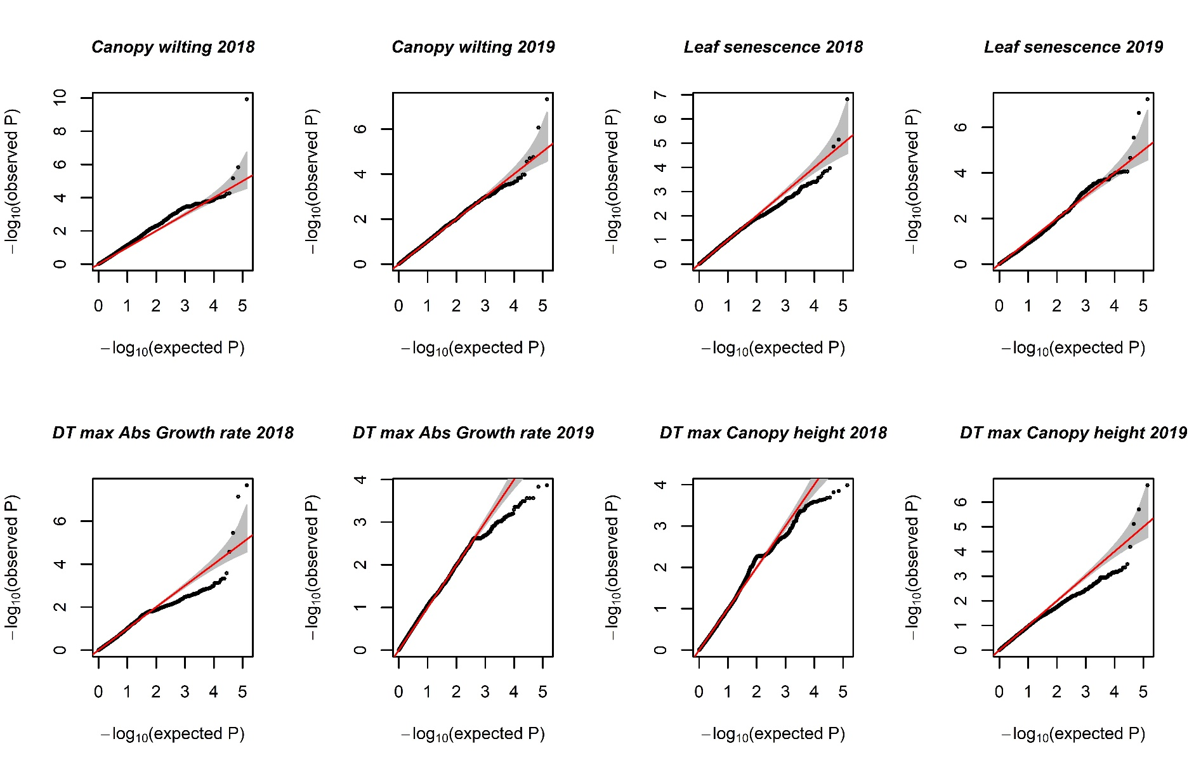
Figure A1 : Q-Q plots of GWAS analysis using the BLINK model.
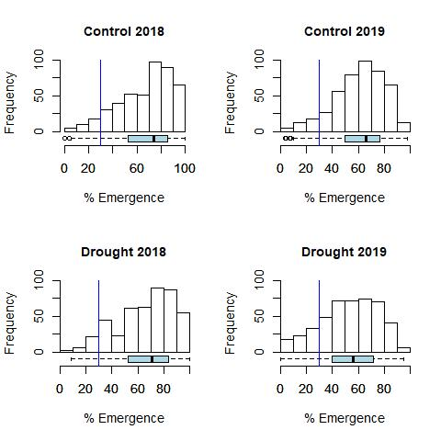
Figure A2: Seedling emergence percentage in control and drought treatments of 2018 and 2019. and ‘% Emergence’ on X-axis is the data of seedling emergence percentage and ‘Frequency’ on Y-axis represents the number of plots.

