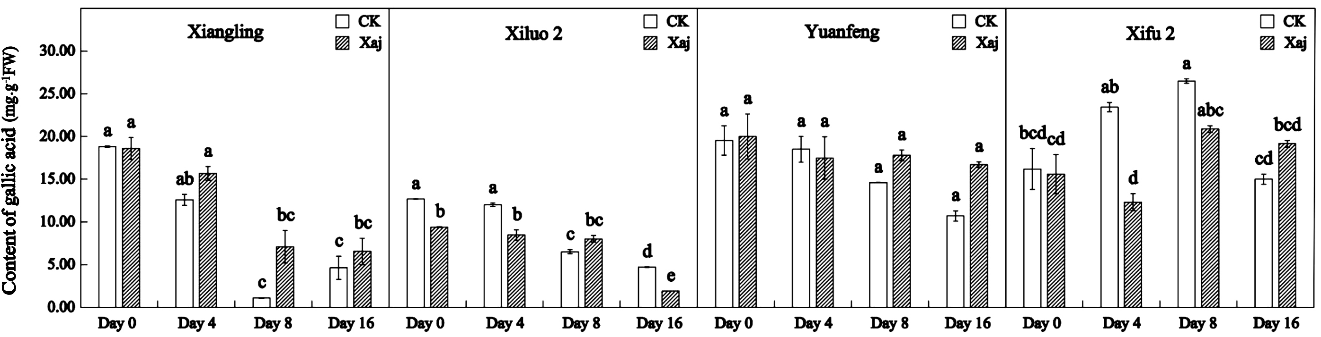

Supplementary Figure 1. Gallic acid content in the control (CK) and inoculated walnut fruits (Xaj) during 0-16 days. And the values are expressed as the mean ± standard deviation of three biological replicate. Letters indicated significant differences at a level of p < 0.05.

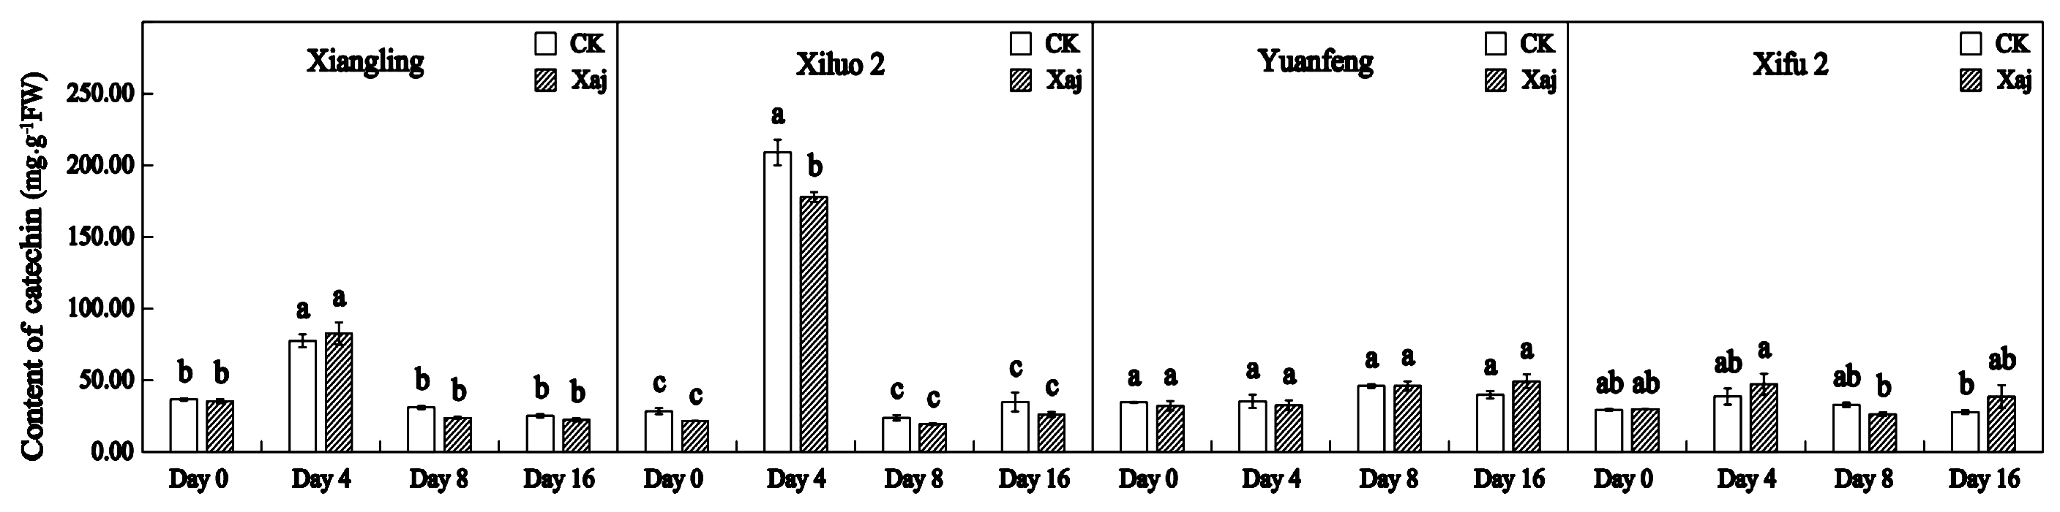

Supplementary Figure 2. Catechin content in the control (CK) and inoculated walnut fruits (Xaj) during 0-16 days. And the values are expressed as the mean ± standard deviation of three biological replicate. Letters indicated significant differences at a level of p < 0.05.

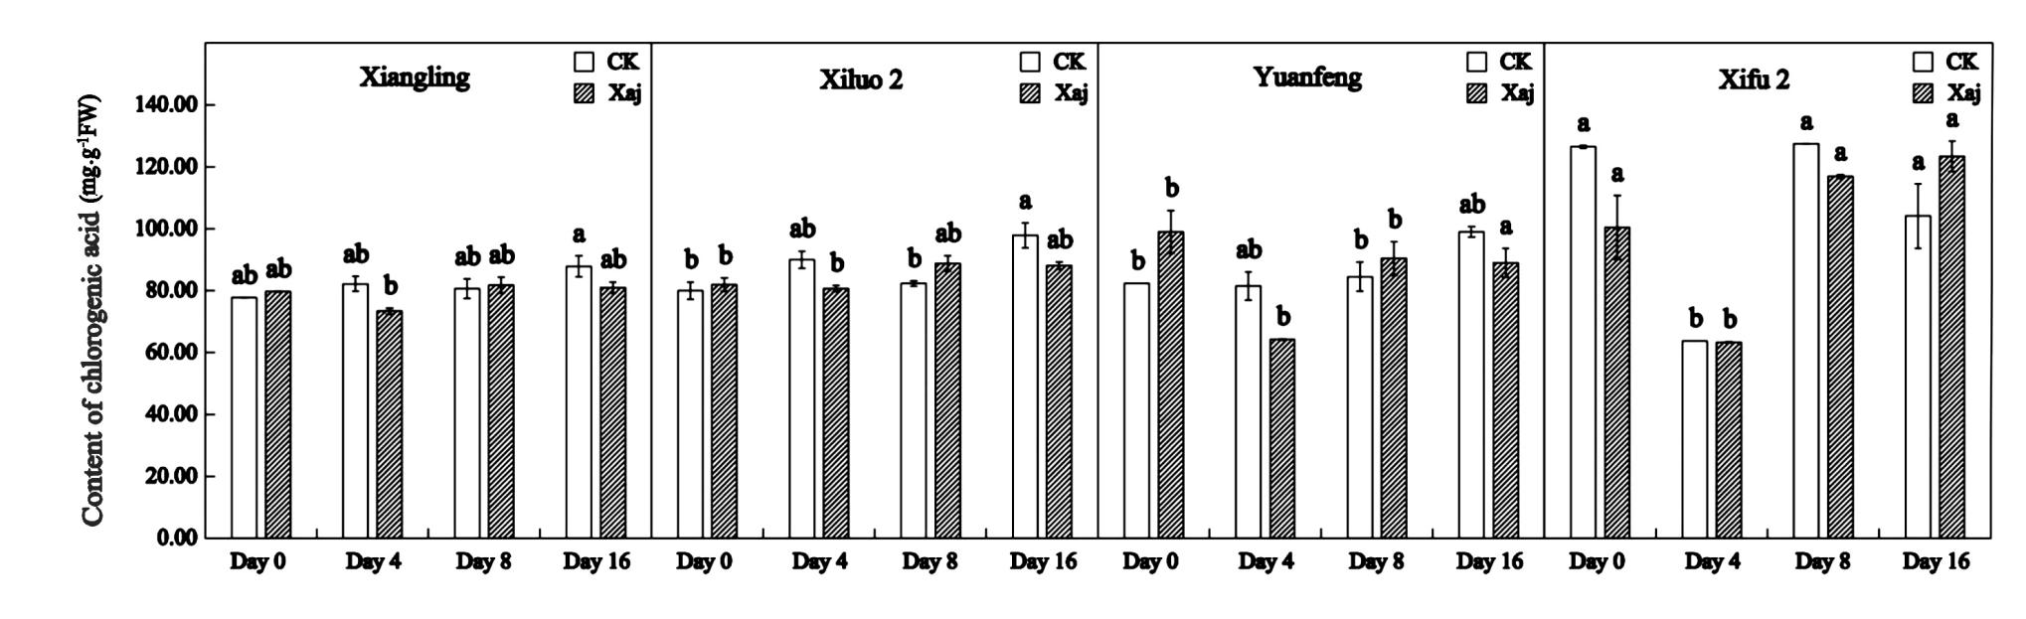

Supplementary Figure 3. Chlorogenic acid content in the control (CK) and inoculated walnut fruits (Xaj) during 0-16 days. And the values are expressed as the mean ± standard deviation of three biological replicate. Letters indicated significant differences at a level of p < 0.05.

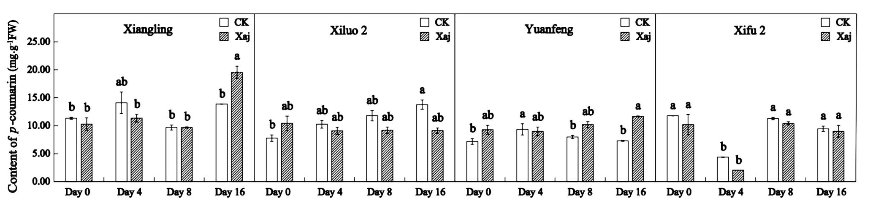

Supplementary Figure 4. P-coumarin acid content in the control (CK) and inoculated walnut fruits (Xaj) during 0-16 days. And the values are expressed as the mean ± standard deviation of three biological replicate. Letters indicated significant differences at a level of p < 0.05.

