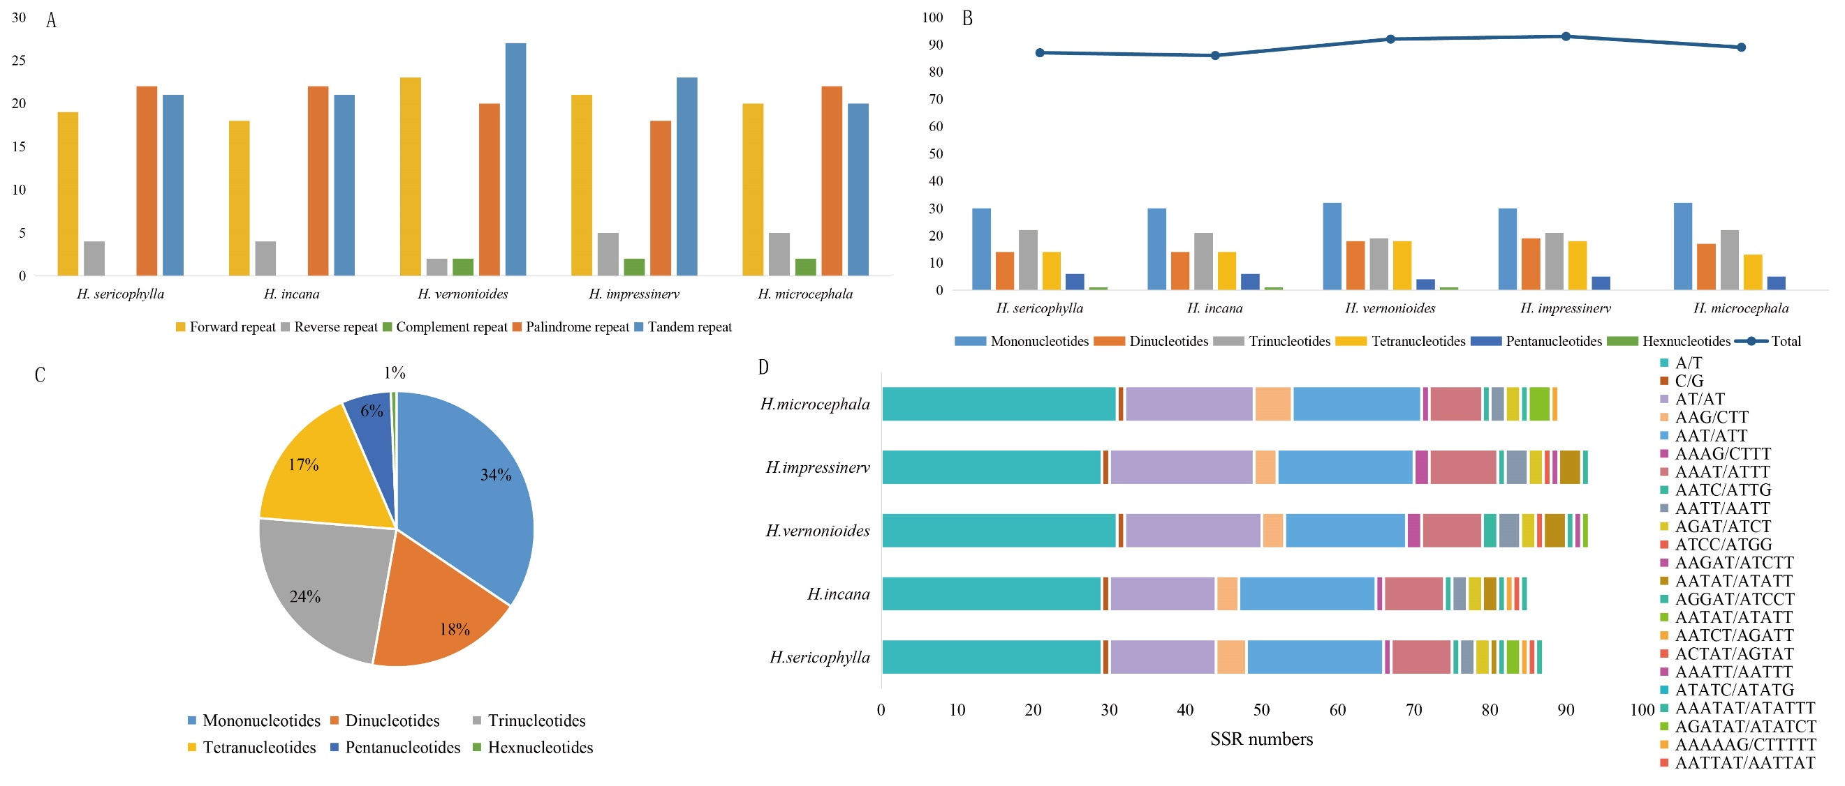
Figure S1. Quantitative analysis of various repeat types in Heteroplexis chloroplast genomes. (A) The number of Dispersed repeat and Tandem repeat (F: positive; R: reverse; C: Complement; P: Palindromic; T: tandem); (B) Number of various repeat types; (C) The proportion of repeat types in each species; (D) Number of SSRs.

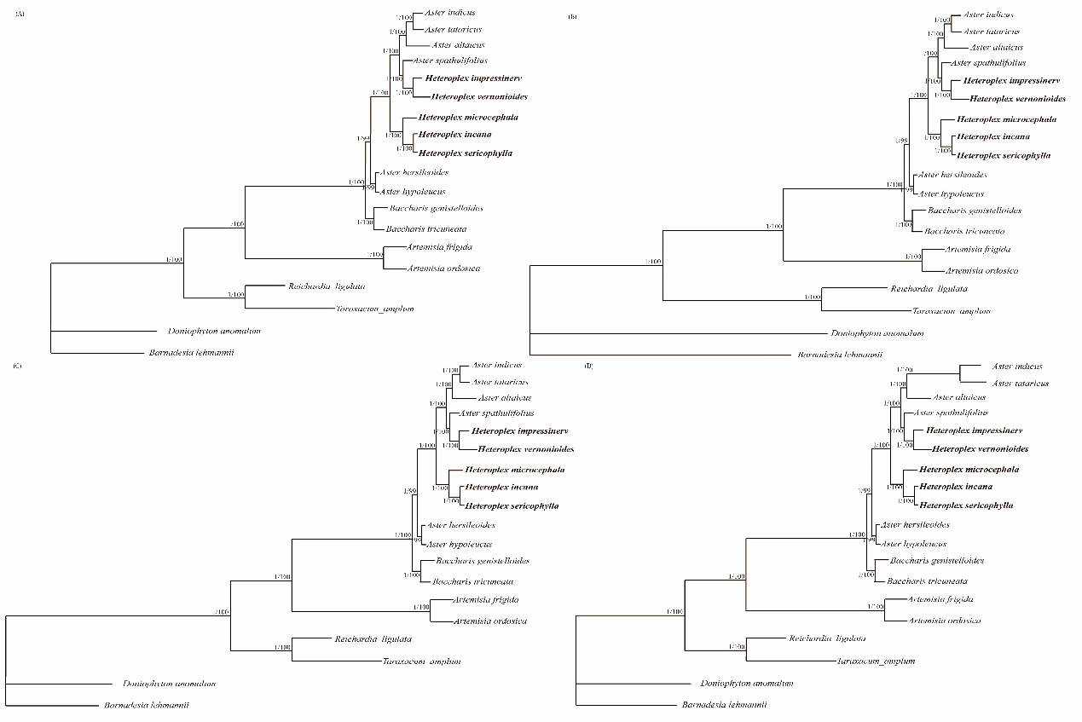
Figure S2. Phylogenetic tree of chloroplast genomes of Heteroplexis based on different data partitions. Support values are shown for nodes as Bayesian inference posterior probability/maximum likelihood bootstrap. (A) LSC regions, (B) IR regions, (C)SSC regions, (D) intergenic regions.

