Additional file 1. The original images of RT-PCR and EMSA assays.
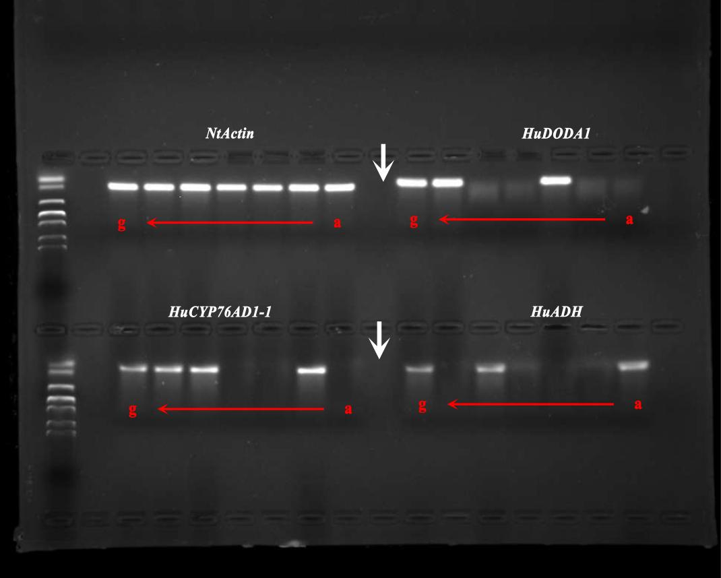
Figure S1. Full-length gel of Figure 1B.

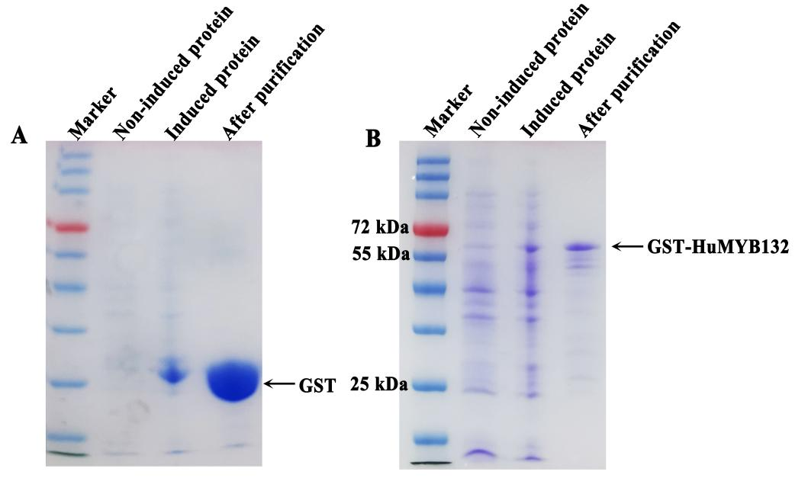
Figure S2. The SDS-PAGE gel stained with Coomassie brilliant blue, presenting affinity purification of the GST (A) amd GST-HuMYB132 (B) proteins. The molecular size of GST and GST-HuMYB132 were respectively 26 kDa and 58 kDa.

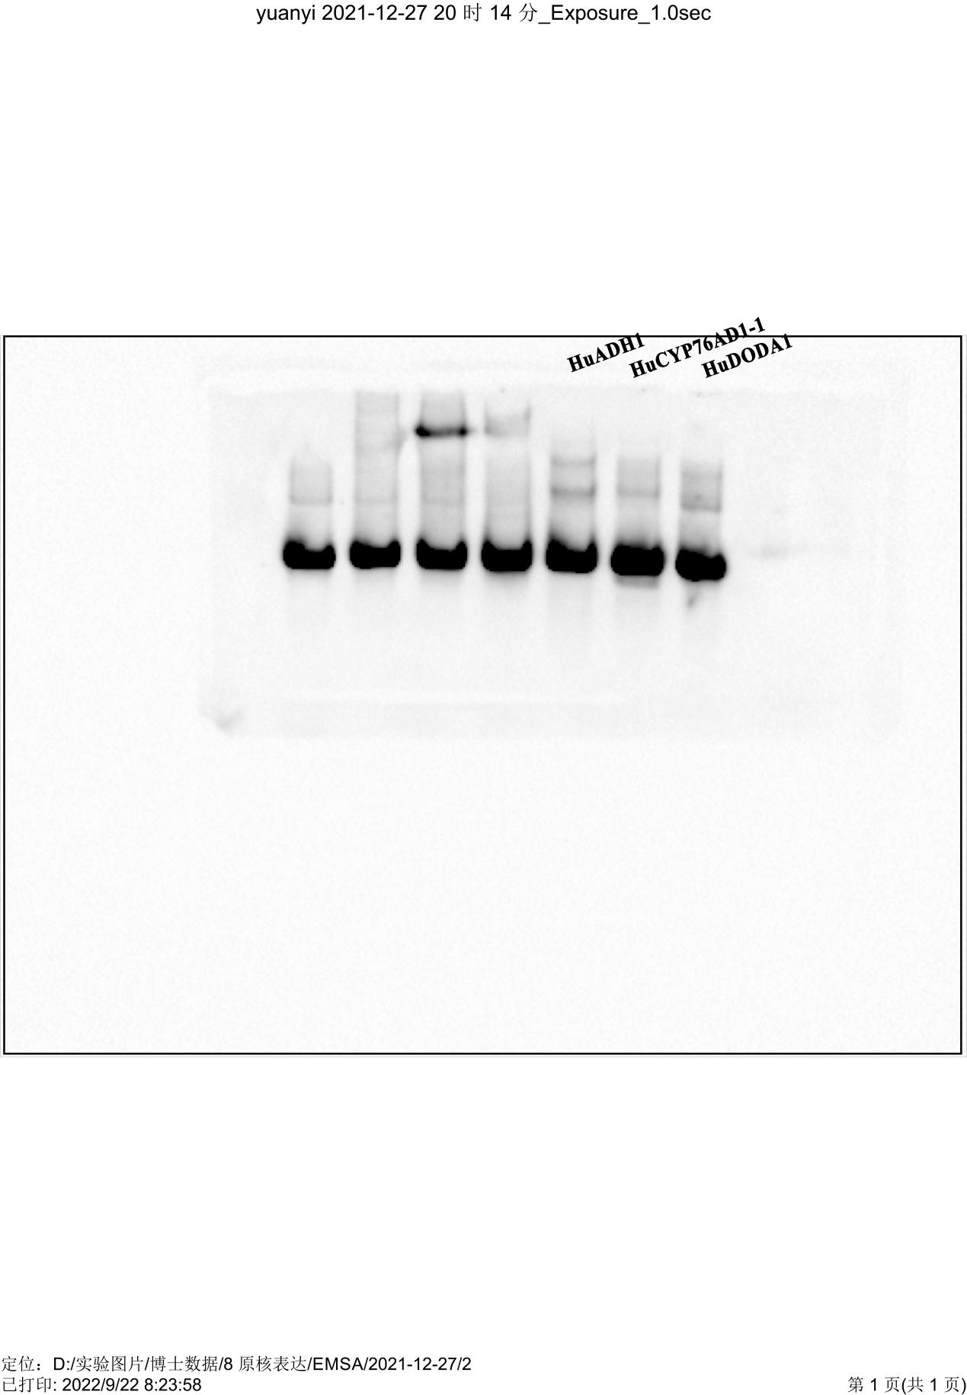
Figure S3. The unprocessed blots of the biotin probe of HuADH1, HuCYP76AD1-1 and HuDODA1 promoters.

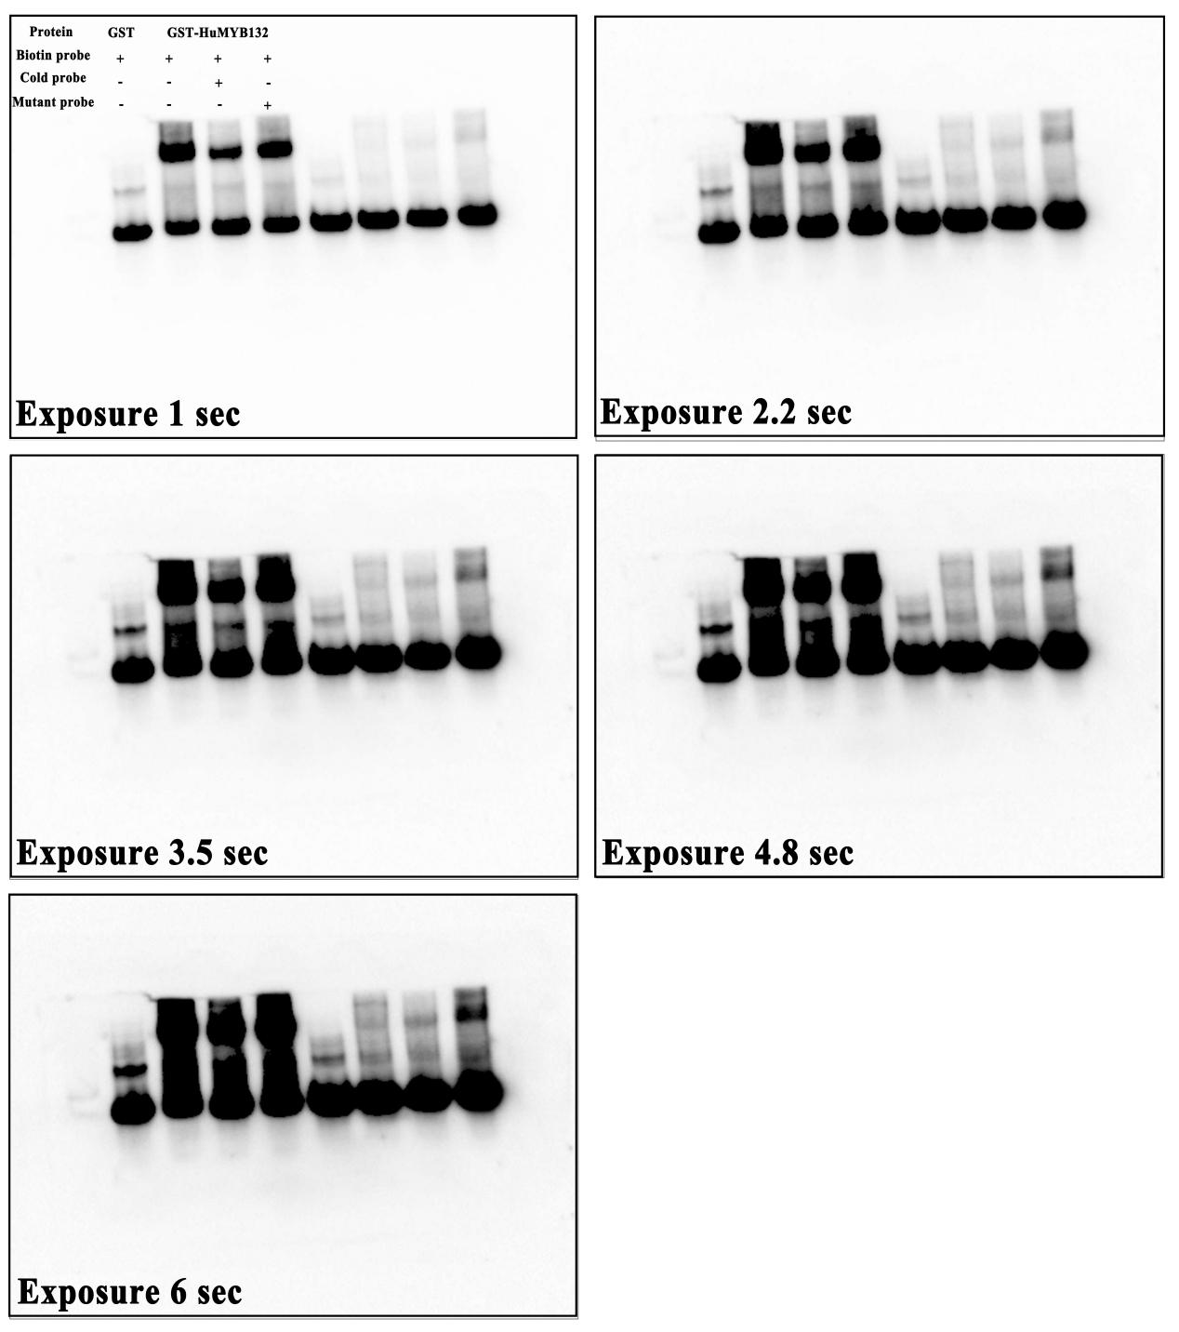
Figure S4. The original images of HuMYB132 binding to the HuADH1 promoter in EMSA assay.

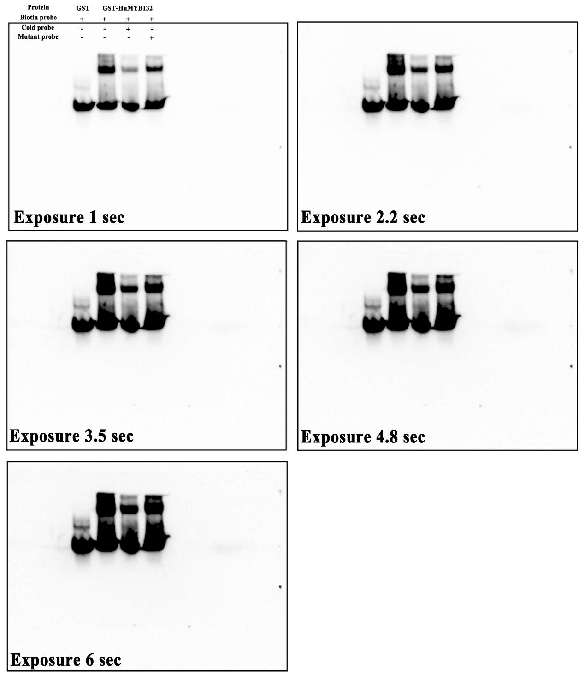
Figure S5. The original images of HuMYB132 binding to the HuCYP76AD1-1 promoter in EMSA assay.

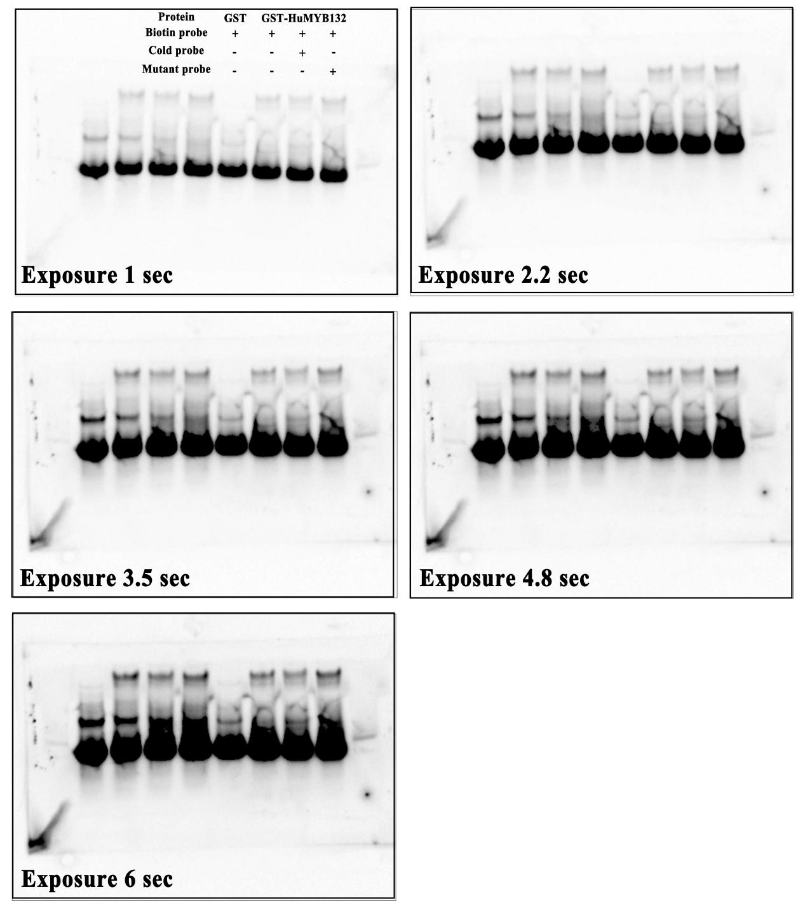
Figure S6. The original images of HuMYB132 binding to the HuDODA1 promoter in EMSA assay.

