Supplementary Information 1A: Principal Component Analysis of TI samples
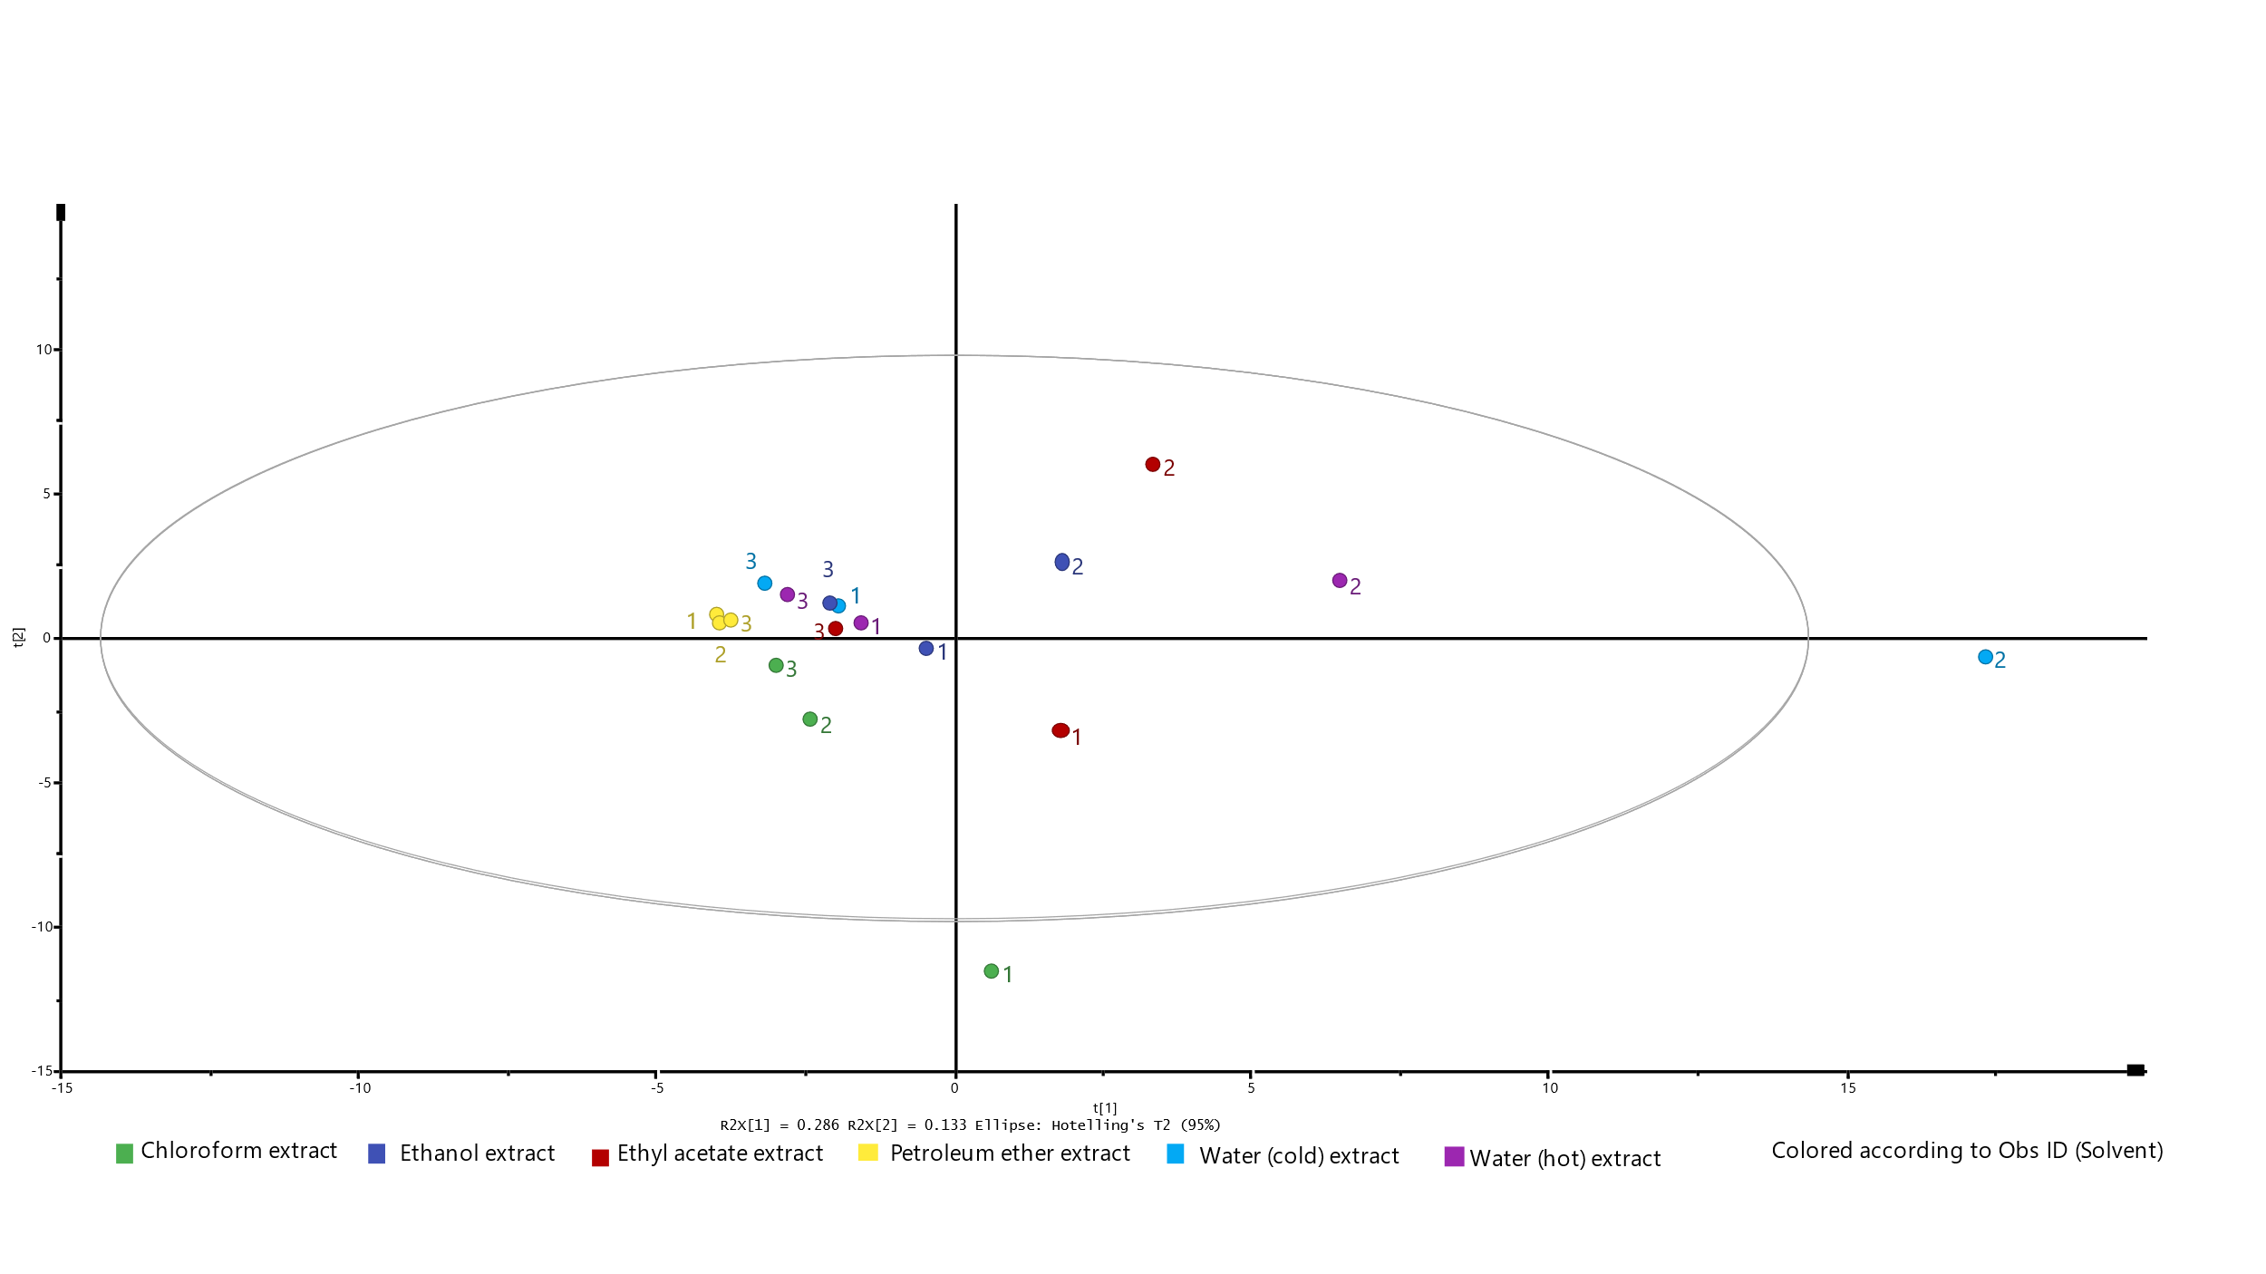Figure 1A: Principal components analysis of TI samples obtained in September 2014 (represented as 1), February 2018 (represented as 2) and September 2018 (represented as 3) which were extracted with different organic solvents or water (hot or cold).

