Supplementary Figure 9B.
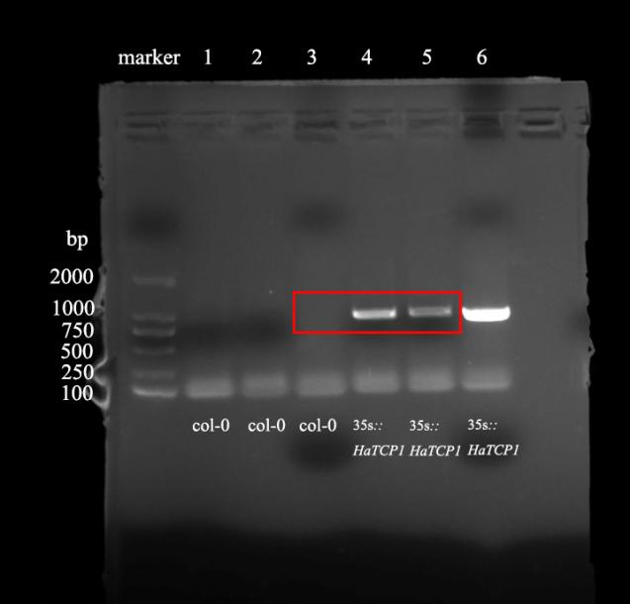
In-gel electrophoresis detection of HaTCP1 expression from the leaves of Arabidopsis Col-0 plants and HaTCP1-overexpressing transgenic plants.
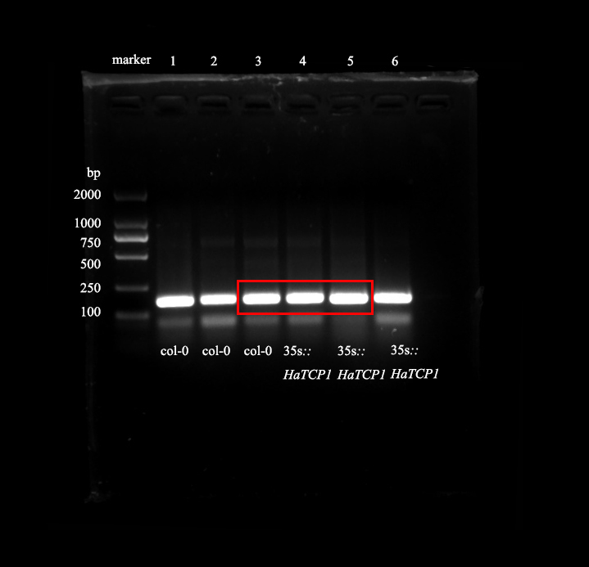
In-gel electrophoresis detection of Tubulin expression from the leaves of Arabidopsis Col-0 plants and HaTCP1-overexpressing transgenic plants.

