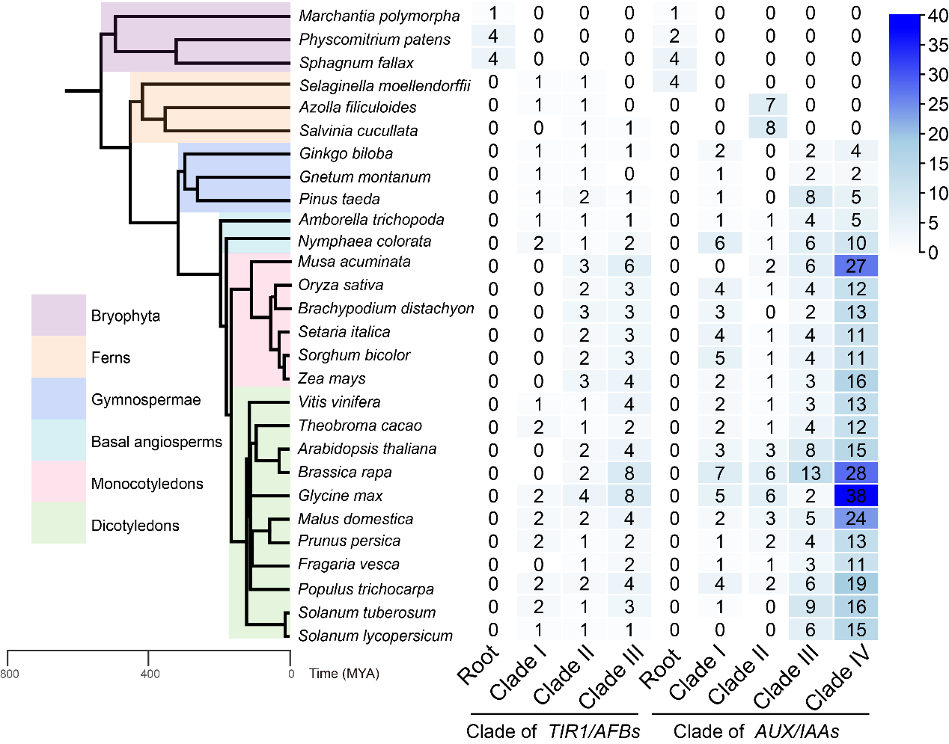
Supplementary figure 1. The distribution of TIR1/AFBs and AUX/IAAs in phylogenetic tree. Deep blue indicates a large number of values. Different background colors represent different plant groups. The clades are consistent with that in Fig. 2.

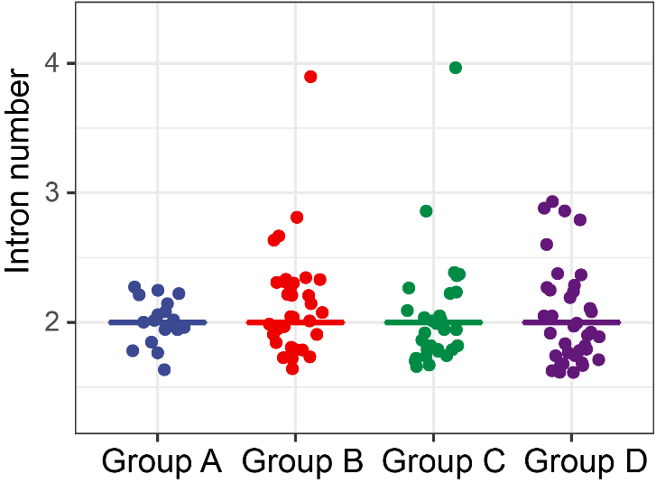
Supplementary figure 2. Intron number statistics of four groups of TIR1/AFBs. The groups are consistent with that in Fig. 4.

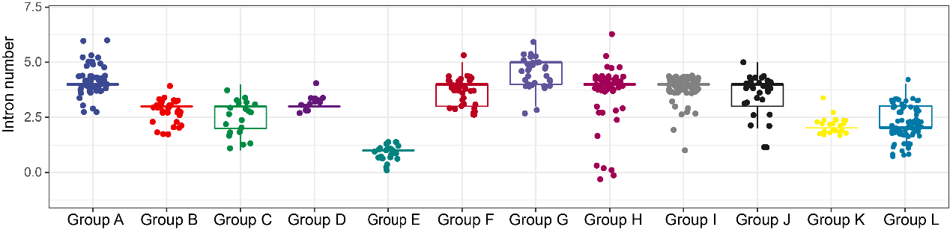
Supplementary figure 3. Intron number statistics of 12 groups of AUX/IAAs. The groups are consistent with that in Fig. 4.

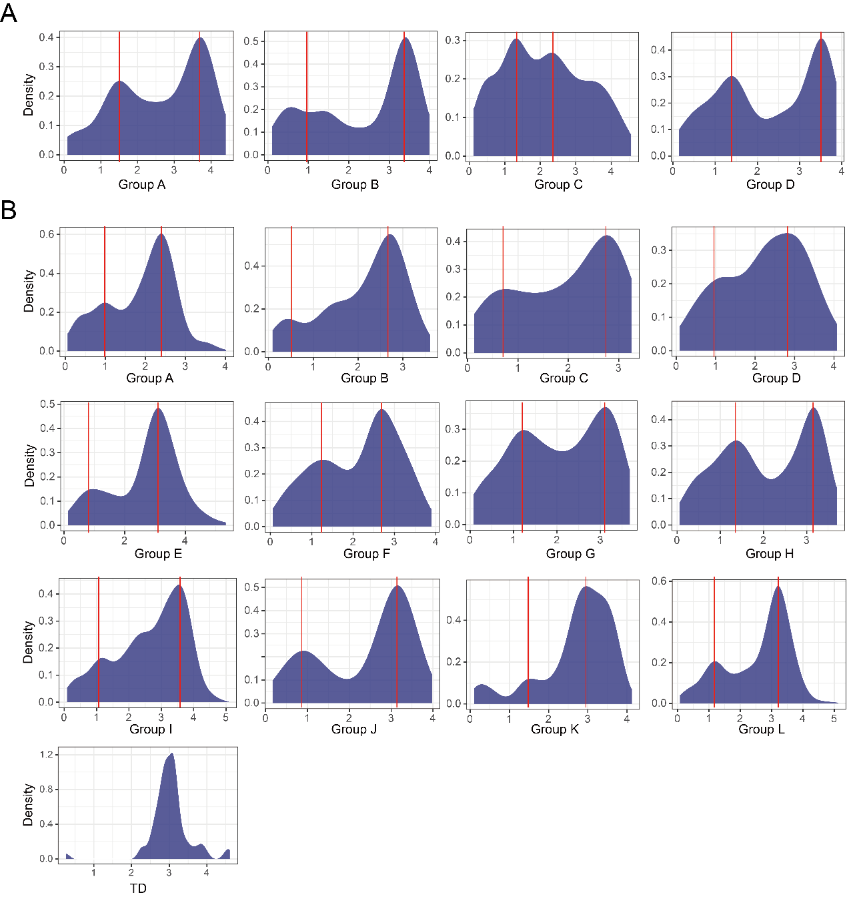
Supplementary figure 4. The gene pairs synonymous substitution (Ks) distribution of TIR1/AFB and AUX/IAA gene families. A: Gene pairs Ks distribution of TIR1/AFB gene families; B: Gene pairs Ks distribution of AUX/IAA gene families. The red line represents the whole genome duplication event. The groups are consistent with that in Fig. 4.

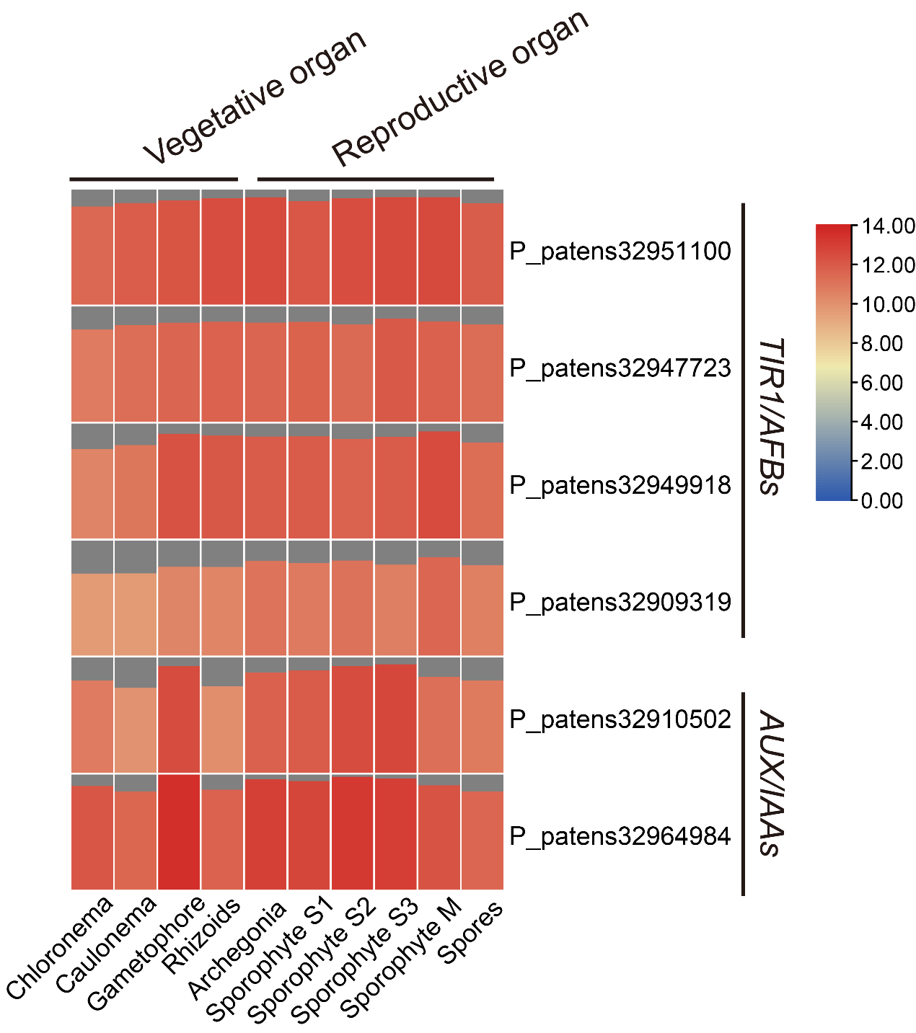
Supplementary figure 5. Expression profile of Physcomitrium patens TIR1/AFBs and AUX/IAAs.
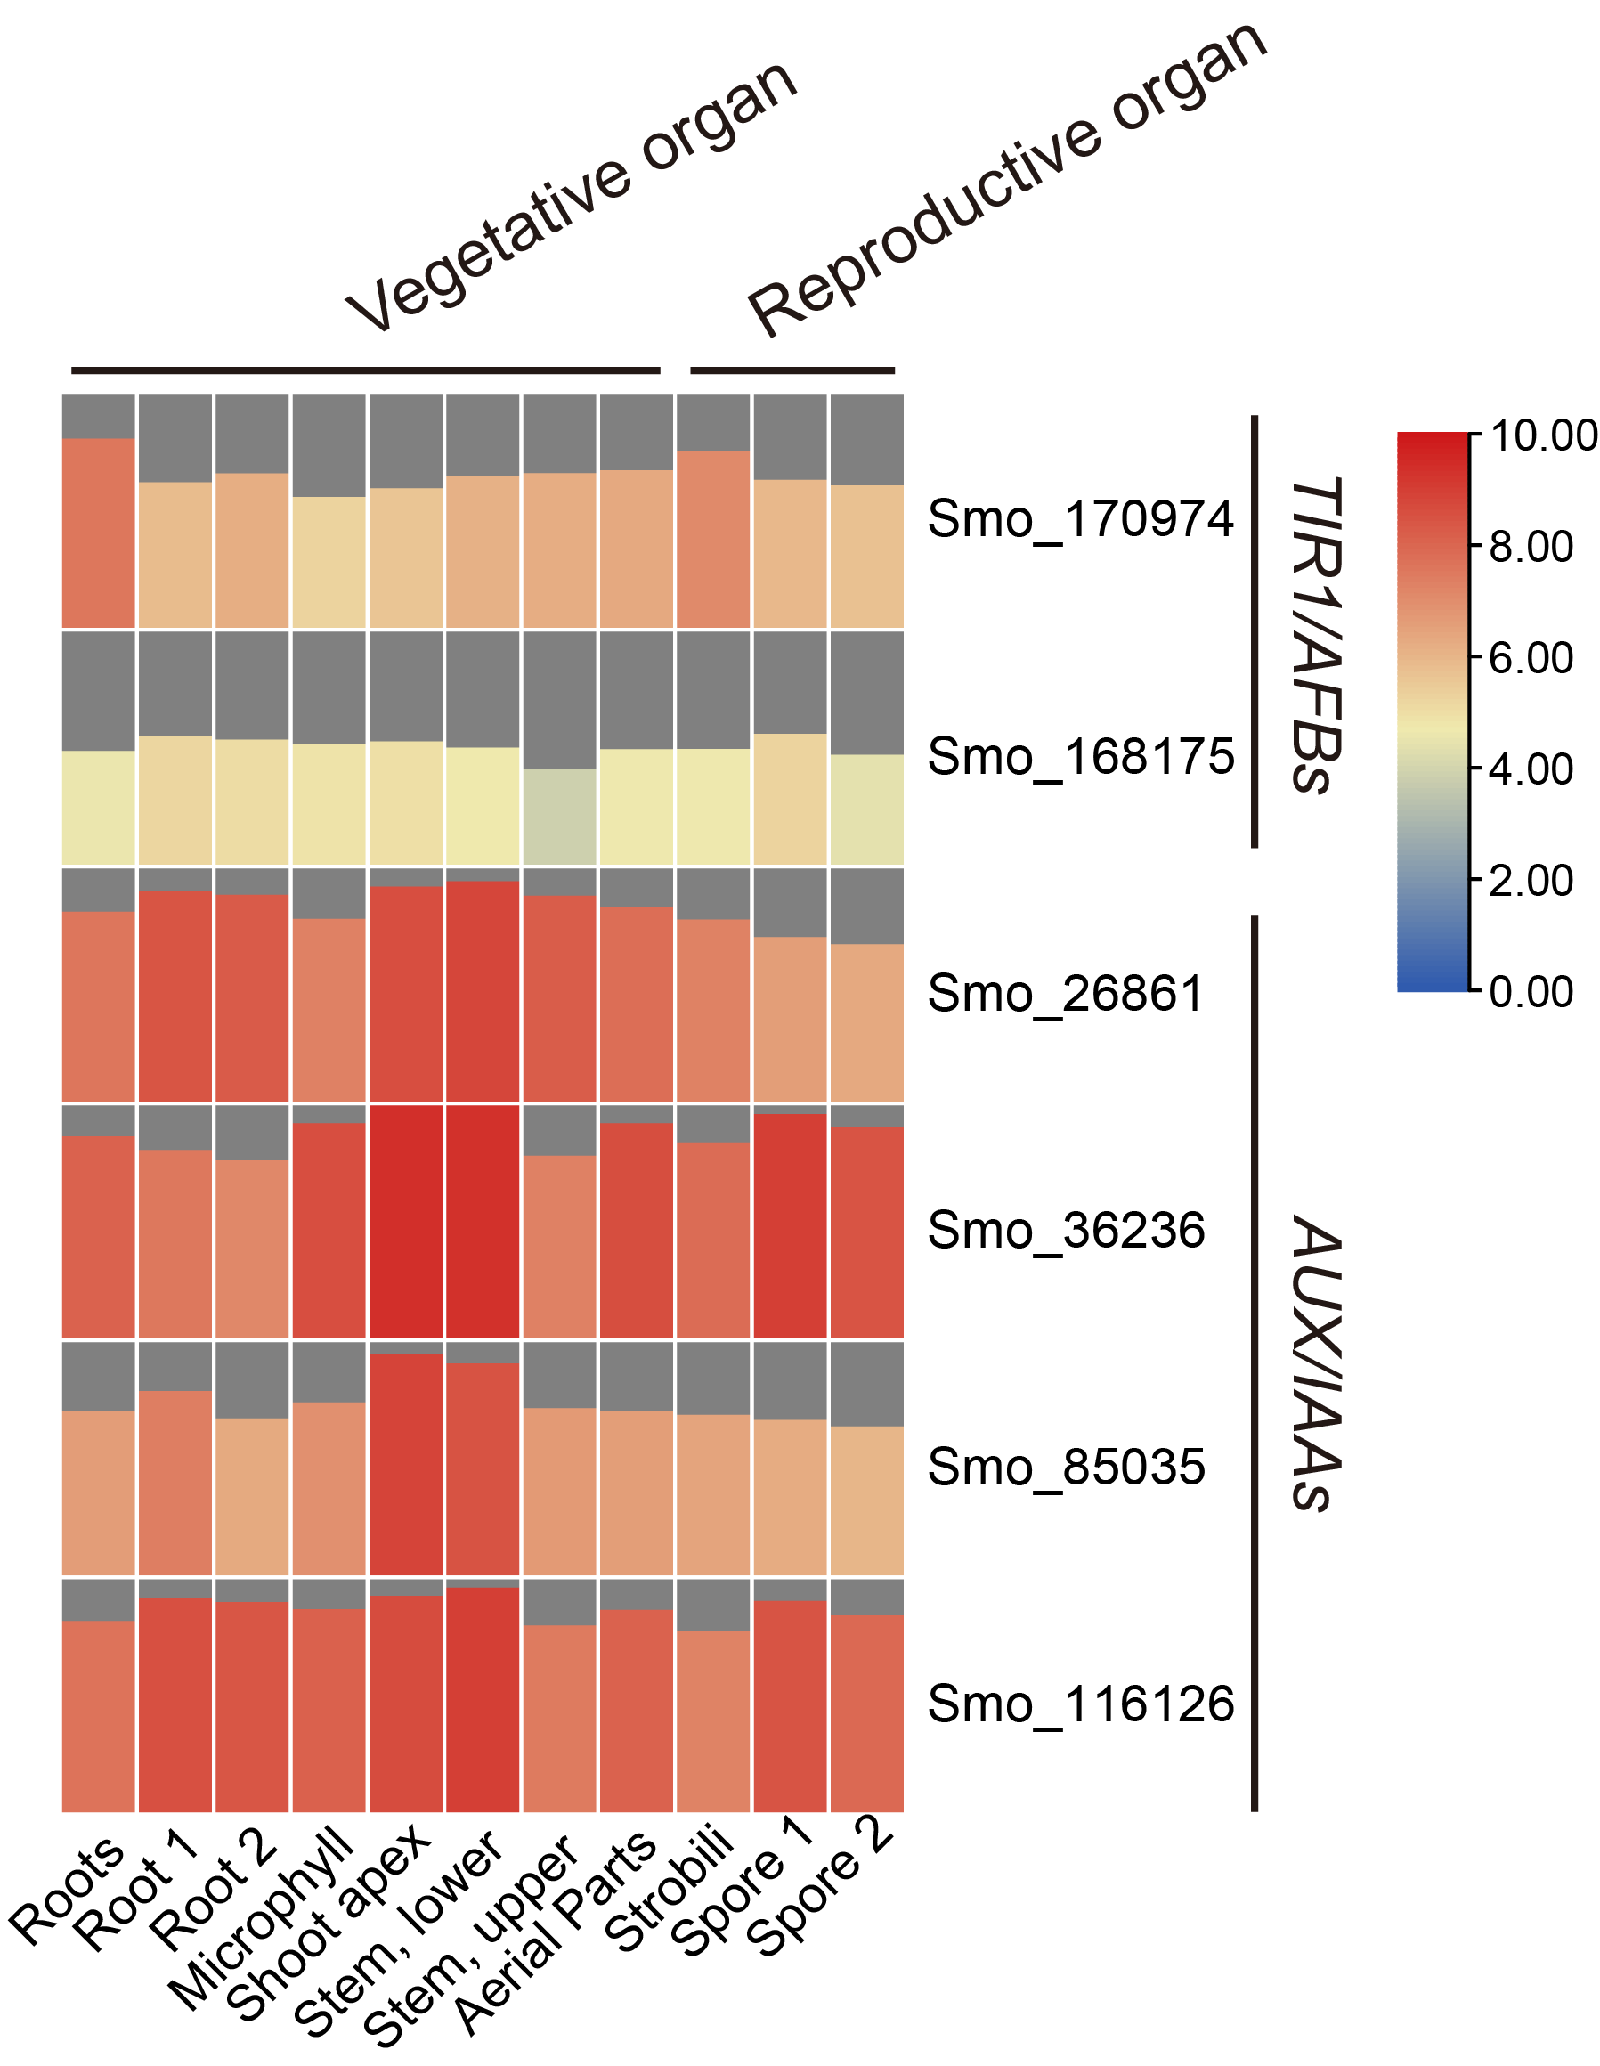
Supplementary figure 6. Expression profile of Selaginella moellendorffii TIR1/AFBs and AUX/IAAs.

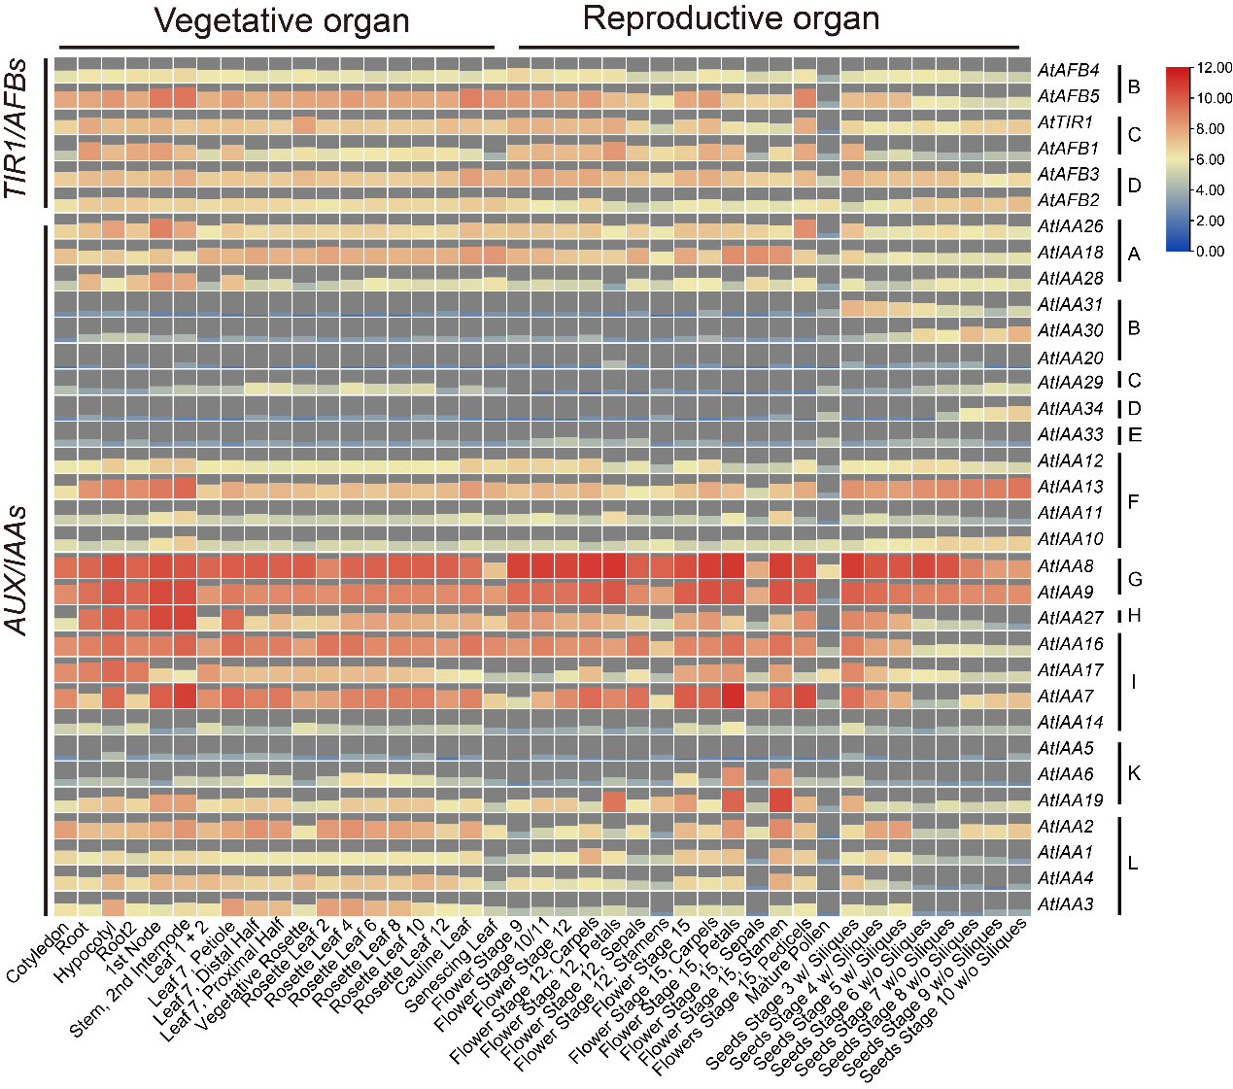
Supplementary figure 7. Expression profile of Arabidopsis thaliana TIR1/AFBs and AUX/IAAs.

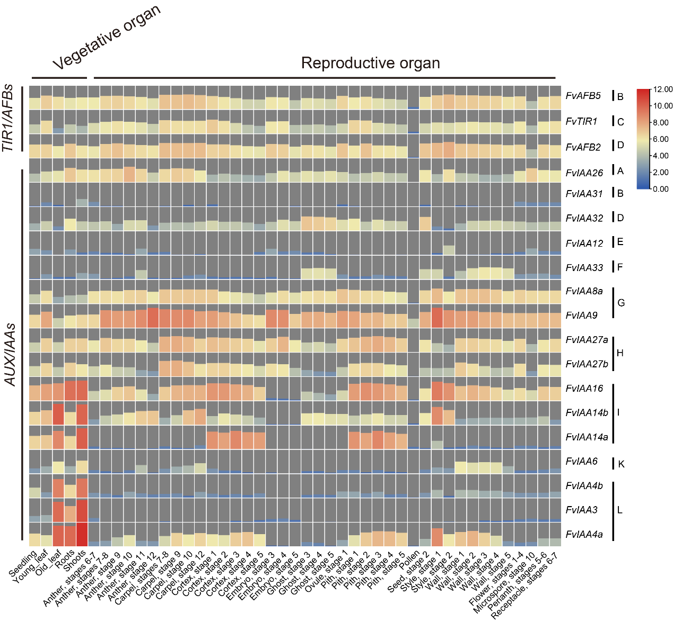
Supplementary figure 8. Expression profile of F. vesca TIR1/AFBs and AUX/IAAs.
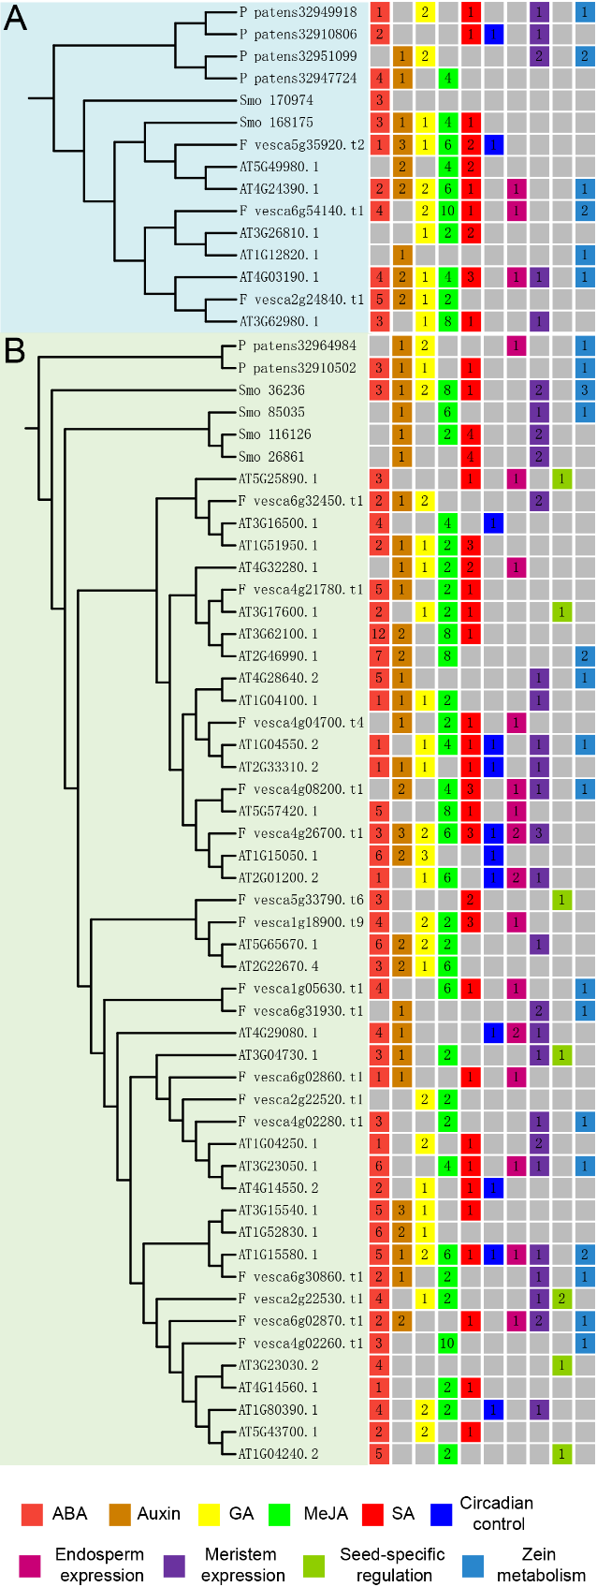
Supplementary figure 9. Detailed information of the growth and development related cis-elements of TIR1/AFB (A) and AUX/IAA (B) gene families in P. Patens, S. moellendorfii, A. thaliana and F. vesca. ABA, Abscisic acid; GA, Gibberellin; MeJA, Methyl jasmonate; SA, Salicylic acid. The value represents the number of cis-elements in the promoter.
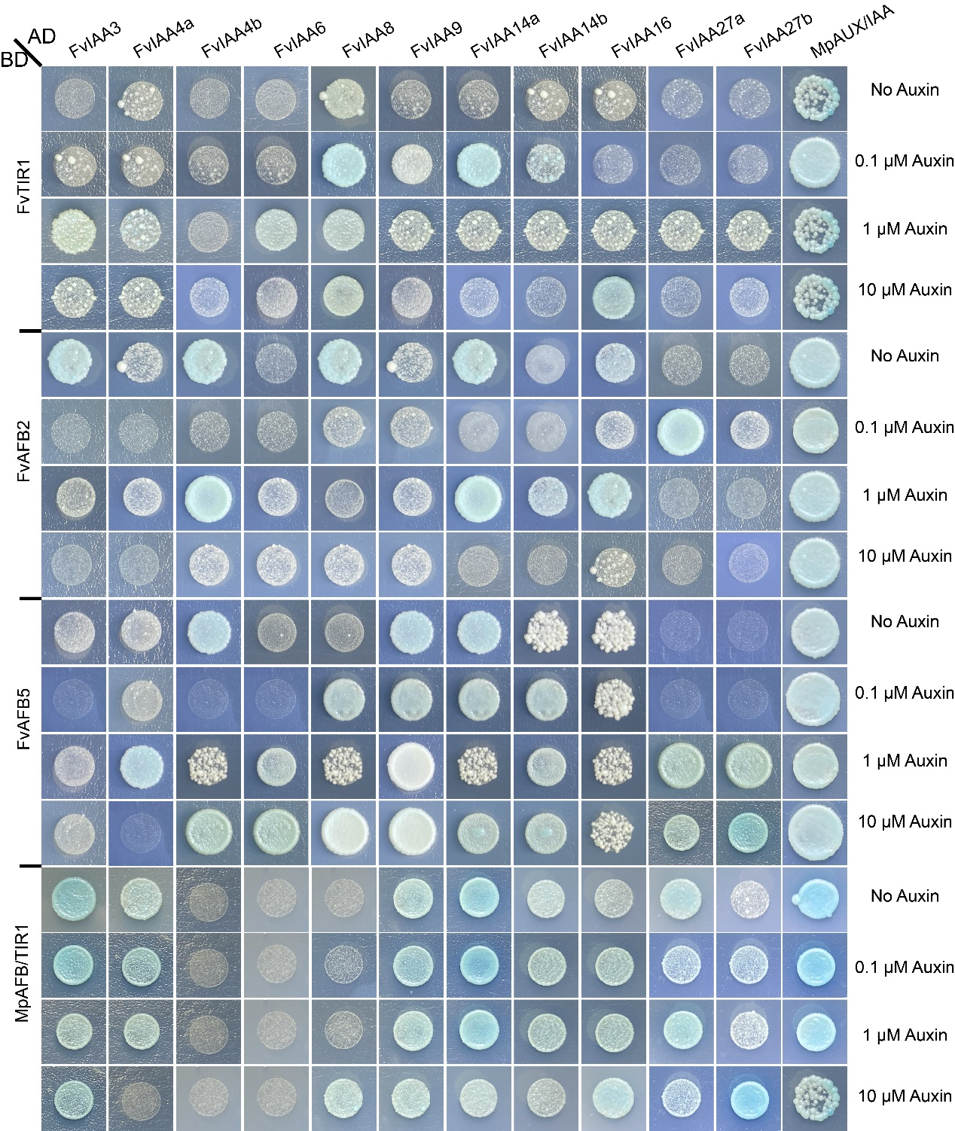
Supplementary figure 10. Interaction pattern of TIR1/AFBs and AUX/IAAs in F. vesca and M. polymorpha by the yeast two-hybrid interaction assays in SD-Leu-Trp-His+X-α-Gal medium.

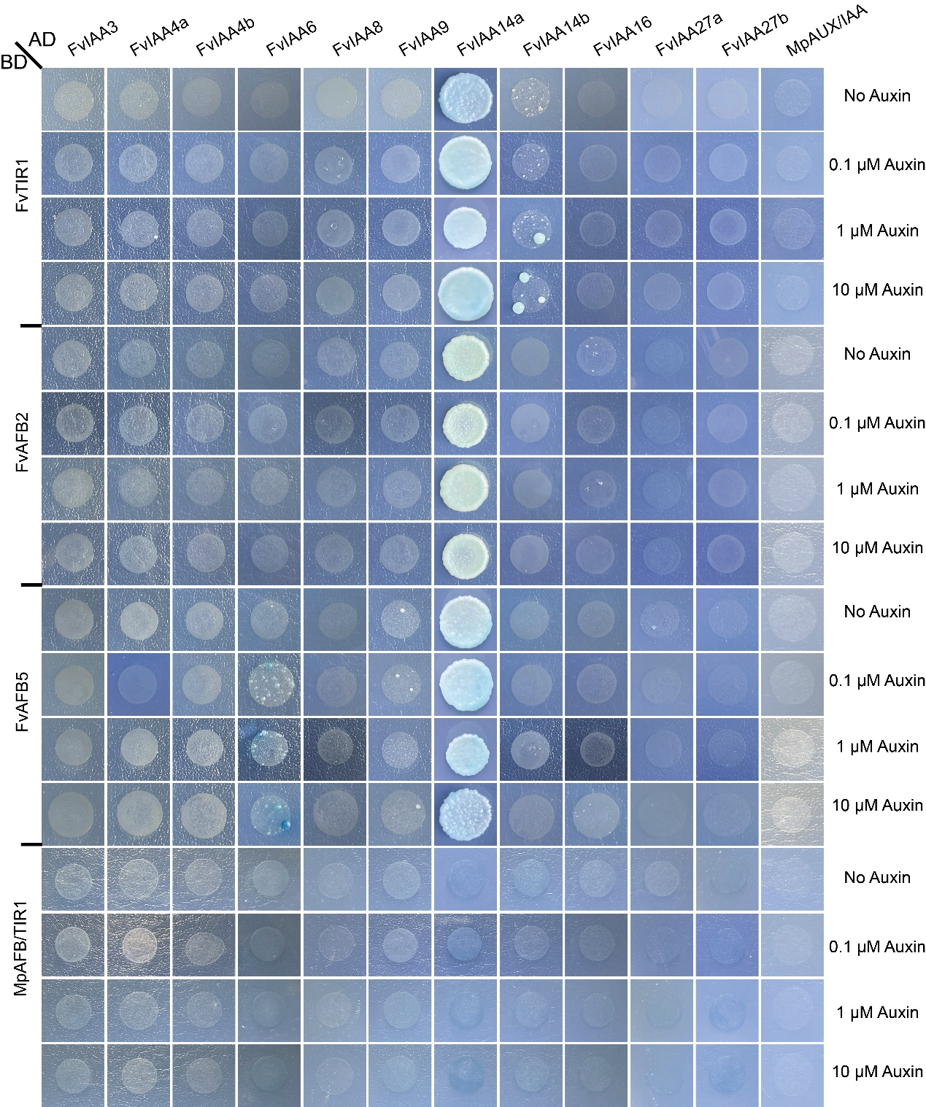
Supplementary figure 11. Interaction pattern of TIR1/AFBs and AUX/IAAs in F. vesca and M. polymorpha by the yeast two-hybrid interaction assays in SD -Leu-Trp-His-Ade +X-α-Gal medium.

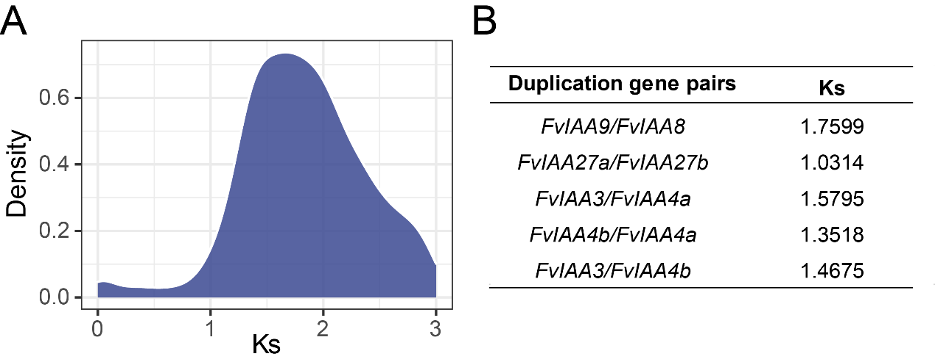
Supplementary figure 12. Ks distribution of F. vesca and ks value of duplication gene pairs.

Supplementary table 1. Genome data used in this study
Species | Link and genome annotation version
Porphyridium purpureum | http://cyanophora.rutgers.edu/porphyridium
Cyanidioschyzon merolae | http://plants.ensembl.org; V1
Micromonas pusilla | https://jgi.doe.gov; C3V2
Chlamydomonas reinhardtii | https://jgi.doe.gov; V5
Klebsormidium nitens | http://www.plantmorphogenesis.bio.titech.ac.jp/~algae_genome_project/klebsormidium; V1.1
Chara braunii | https://www.ncbi.nlm.nih.gov/
Marchantia polymorpha | http://marchantia.info; V3.1
Physcomitrium patens | https://genome.jgi.doe.gov; V3
Sphagnum fallax | https://phytozome.jgi.doe.gov; V0.5
Selaginella moellendorffii | https://phytozome.jgi.doe.gov; V1.0
Azolla filiculoides | https://www.fernbase.org; V1.1
Salvinia cucullata | https://www.fernbase.org; V1.2
Ginkgo biloba | https://figshare.com/articles/dataset/annotation_of_Ginkgo_biloba/14759223
Gnetum montanum | DRYAD website
Pinus taeda | http://congenie.org/start; V1.0
Amborella trichopoda | https://phytozome.jgi.doe.gov; V1.0
Nymphaea colorata | https://www.ncbi.nlm.nih.gov/
Musa acuminata | https://phytozome.jgi.doe.gov; V1
Oryza sativa | http://rice.plantbiology.msu.edu; IRGSP-1.0
Brachypodium distachyon | https://phytozome.jgi.doe.gov; V3.1
Setaria italica | https://phytozome.jgi.doe.gov; V2.2
Sorghum bicolor | https://phytozome.jgi.doe.gov; V3.1
Zea mays | https://phytozome.jgi.doe.gov; V4
Vitis vinifera | https://phytozome.jgi.doe.gov; V2.1
Theobroma cacao | https://phytozome.jgi.doe.gov; V2.1
Arabidopsis thaliana | https://www.arabidopsis.org; TAIR10
Brassica rapa | https://phytozome.jgi.doe.gov; V1.3
Malus domestica | https://phytozome.jgi.doe.gov; V1.1
Prunus persica | Genome Database for Rosaceae, V2.0.a1
Fragaria vesca | Genome Database for Rosaceae, V4.2
Glycine max | https://phytozome.jgi.doe.gov; V4.1
Populus trichocarpa | https://phytozome.jgi.doe.gov; V4.1
Solanum tuberosum | https://phytozome.jgi.doe.gov; V6.1
Solanum lycopersicum | https://phytozome.jgi.doe.gov; V4.0

Supplementary table 2. The primer used in this study.
Name of primers | Sequences (5’-3’) | Annotation
FvTIR1-F | TGGCCATGGAGGCCGAATTCATGCTGAGAATGGCGAGCTCGTTC | Vectors construction
FvTIR1-R | CGCTGCAGGTCGACGGATCCTCAAGTGAGCCTCACTGCAGAGTG | Vectors construction
FvAFB2-F | TGGCCATGGAGGCCGAATTCATGAATTATTTCCCAGACGAGG | Vectors construction
FvAFB2-R | CGCTGCAGGTCGACGGATCCCTACAGAGTCCACACATACT | Vectors construction
FvAFB5-F | TGGCCATGGAGGCCGAATTCATGGGAGACGACCCTTCTTCGT | Vectors construction
FvAFB5-R | CGCTGCAGGTCGACGGATCCCTACAGGATATCAACAAACTTTGG | Vectors construction
MpTIR1-F | TGGCCATGGAGGCCGAATTCATGCCCTCTCCCTTTCCTGACGA | Vectors construction
MpTIR1-R | CGCTGCAGGTCGACGGATCCTCATTGTGCTATTTCGACA | Vectors construction
FvIAA14a-F | CCATGGAGGCCAGTGAATTCATGGAAGTTGTTATCCGGAAGA | Vectors construction
FvIAA14a-R | AGCTCGAGCTCGATGGATCCTCAGCTTCTGTTCTTGCATTTC | Vectors construction
FvIAA14b-F | CCATGGAGGCCAGTGAATTCATGGAGACAGAGCTCAGGCTAG | Vectors construction
FvIAA14b-R | AGCTCGAGCTCGATGGATCCTCAGCTTCTGTTCTTGCATTTC | Vectors construction
FvIAA16-F | CCATGGAGGCCAGTGAATTCATGACTAGTACTGTAGCCATGG | Vectors construction
FvIAA16-R | AGCTCGAGCTCGATGGATCCTCAACTTCTGTTCTTGAACTTC | Vectors construction
FvIAA27a-F | CCATGGAGGCCAGTGAATTCATGTCTATGTCCTTGGAGCATG | Vectors construction
FvIAA27a-R | AGCTCGAGCTCGATGGATCCCTAATTACTATTTTTGCACTTCTG | Vectors construction
FvIAA27b-F | CCATGGAGGCCAGTGAATTCATGTCTGTACCACTGGAACATG | Vectors construction
FvIAA27b-R | AGCTCGAGCTCGATGGATCCCTAGTTGCGGTTCCTGCACTTC | Vectors construction
FvIAA3-F | CCATGGAGGCCAGTGAATTCATGGAAAGCAAGGGCTATGAG | Vectors construction
FvIAA3-R | AGCTCGAGCTCGATGGATCCTCATACACCACAACCCAAGCCT | Vectors construction
FvIAA4a-F | CCATGGAGGCCAGTGAATTCATGGCATTCCAAGCAGAAGATC | Vectors construction
FvIAA4a-R | AGCTCGAGCTCGATGGATCCTCATACCGCACAACCTAAGCC | Vectors construction
FvIAA4b-F | CCATGGAGGCCAGTGAATTCATGGAAGGGTCGGTGAGCTA | Vectors construction
FvIAA4b-R | AGCTCGAGCTCGATGGATCCTCAGAGACAAGCCAGTCCTCTA | Vectors construction
FvIAA6-F | CCATGGAGGCCAGTGAATTCATGGAGAAAGAAGGTCTAGG | Vectors construction
FvIAA6-R | AGCTCGAGCTCGATGGATCCTTATTTAGGCTCGTCTTTCATC | Vectors construction
FvIAA8-F | CCATGGAGGCCAGTGAATTCATGTCACAACCACAGGTCGGT | Vectors construction
FvIAA8-R | AGCTCGAGCTCGATGGATCCCTAGTTCCTGTTCCTGCACTT | Vectors construction
FvIAA9-F | CCATGGAGGCCAGTGAATTCATGTCTCCACCACTGCTGGGTG | Vectors construction
FvIAA9-R | AGCTCGAGCTCGATGGATCCCTAGTTCCGGATCTTGGATTTC | Vectors construction
MpIAA-F | CCATGGAGGCCAGTGAATTCATGAGTCAAAATGCGCATGCTG
MpIAA-R | AGCTCGAGCTCGATGGATCCTCACACGTTCGGTTGAGTCGTCTTG

Supplementary table 3. All amplified genes in this experiment.
Original ID | ID for this study | Annotation | Genome annotation version
FvH4_1g18900.t9 | F_vesca1g18900.t9 | FvIAA8 | Genome Database for Rosaceae, V4.2
FvH4_5g33790.t6 | F_vesca5g33790.t6 | FvIAA9 | Genome Database for Rosaceae, V4.2
FvH4_1g05630.t1 | F_vesca1g05630.t1 | FvIAA27a | Genome Database for Rosaceae, V4.2
FvH4_6g31930.t1 | F_vesca6g31930.t1 | FvIAA27b | Genome Database for Rosaceae, V4.2
FvH4_2g22520.t1 | F_vesca2g22520.t1 | FvIAA14b | Genome Database for Rosaceae, V4.2
FvH4_4g02280.t1 | F_vesca4g02280.t1 | FvIAA14a | Genome Database for Rosaceae, V4.2
FvH4_6g02860.t1 | F_vesca6g02860.t1 | FvIAA16 | Genome Database for Rosaceae, V4.2
FvH4_6g30860.t1 | F_vesca6g30860.t1 | FvIAA6 | Genome Database for Rosaceae, V4.2
FvH4_2g22530.t1 | F_vesca2g22530.t1 | FvIAA4b | Genome Database for Rosaceae, V4.2
FvH4_4g02260.t1 | F_vesca4g02260.t1 | FvIAA3 | Genome Database for Rosaceae, V4.2
FvH4_6g02870.t1 | F_vesca6g02870.t1 | FvIAA4a | Genome Database for Rosaceae, V4.2
FvH4_5g35920.t2 | F_vesca5g35920.t2 | FvAFB5 | Genome Database for Rosaceae, V4.2
FvH4_2g24840.t1 | F_vesca2g24840.t1 | FvTIR1 | Genome Database for Rosaceae, V4.2
FvH4_6g54140.t1 | F_vesca6g54140.t1 | FvAFB2 | Genome Database for Rosaceae, V4.2
Mapoly0035s0062.1p | Mapoly0035s0062.1p | MpAUX/IAA | http://marchantia.info; V3.1
Mapoly0034s0017.1p | Mapoly0034s0017.1p | MpTIR1/AFB | http://marchantia.info; V3.1

