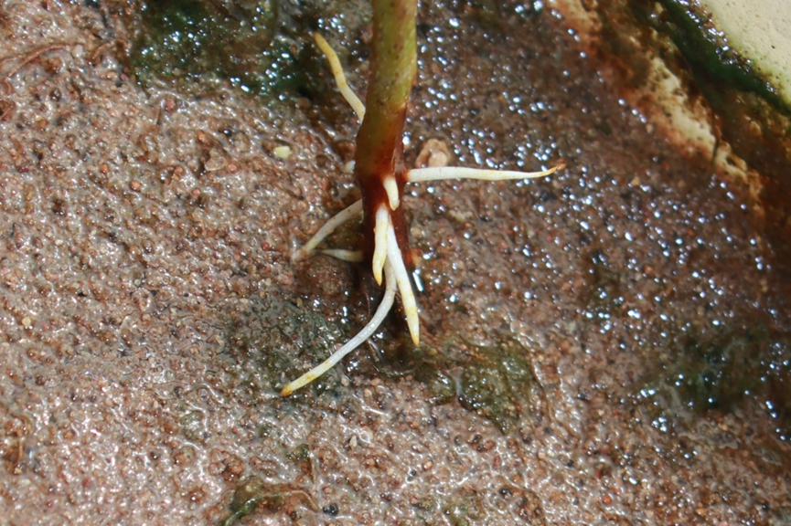
Fig. S1 ARs formation of ZNL2067 after being submerged for 3 days.

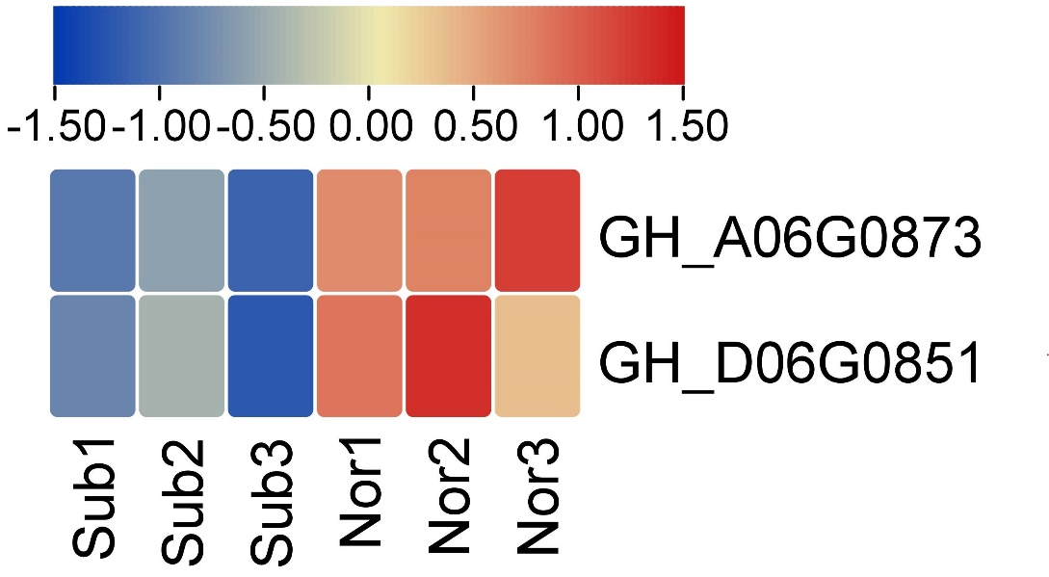
Fig. S2 Heat map of sucrose synthase. Red and blue represent high and low expression levels, respectively (FPKM).
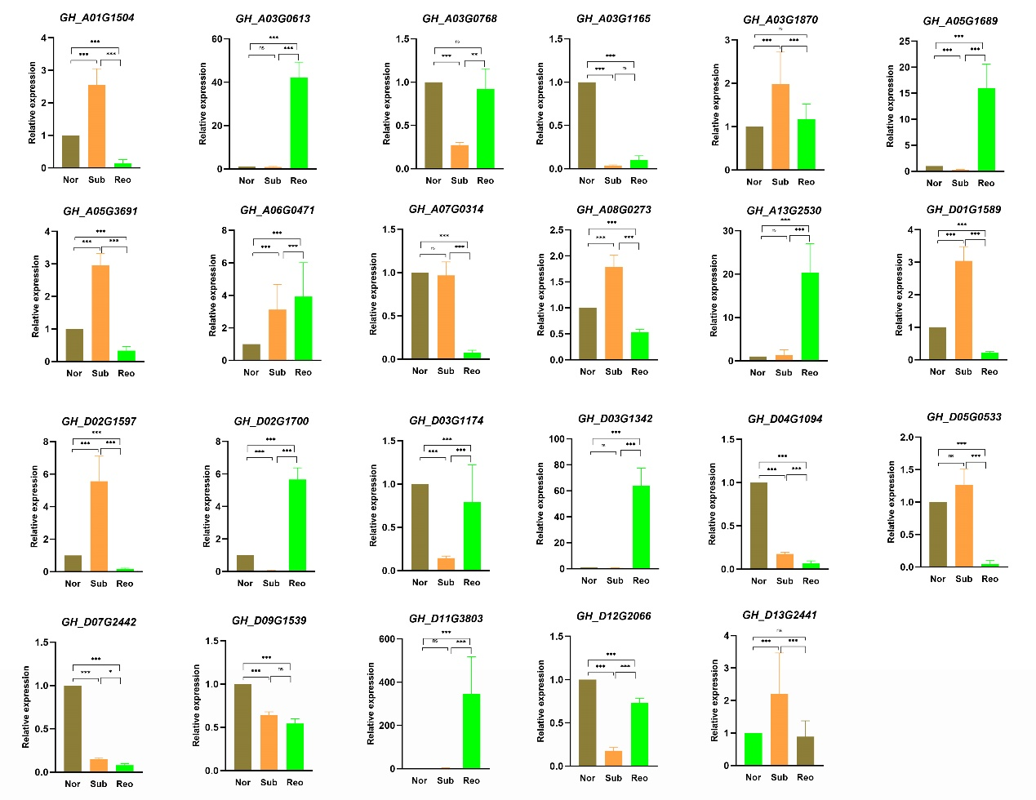
Fig. S3 Expression of 23 DEGs. Error bars are the standard deviation (SD) of three biological replicates in each treatment group. *: P < 0.05, **: P < 0.01, ***: P < 0.001.

