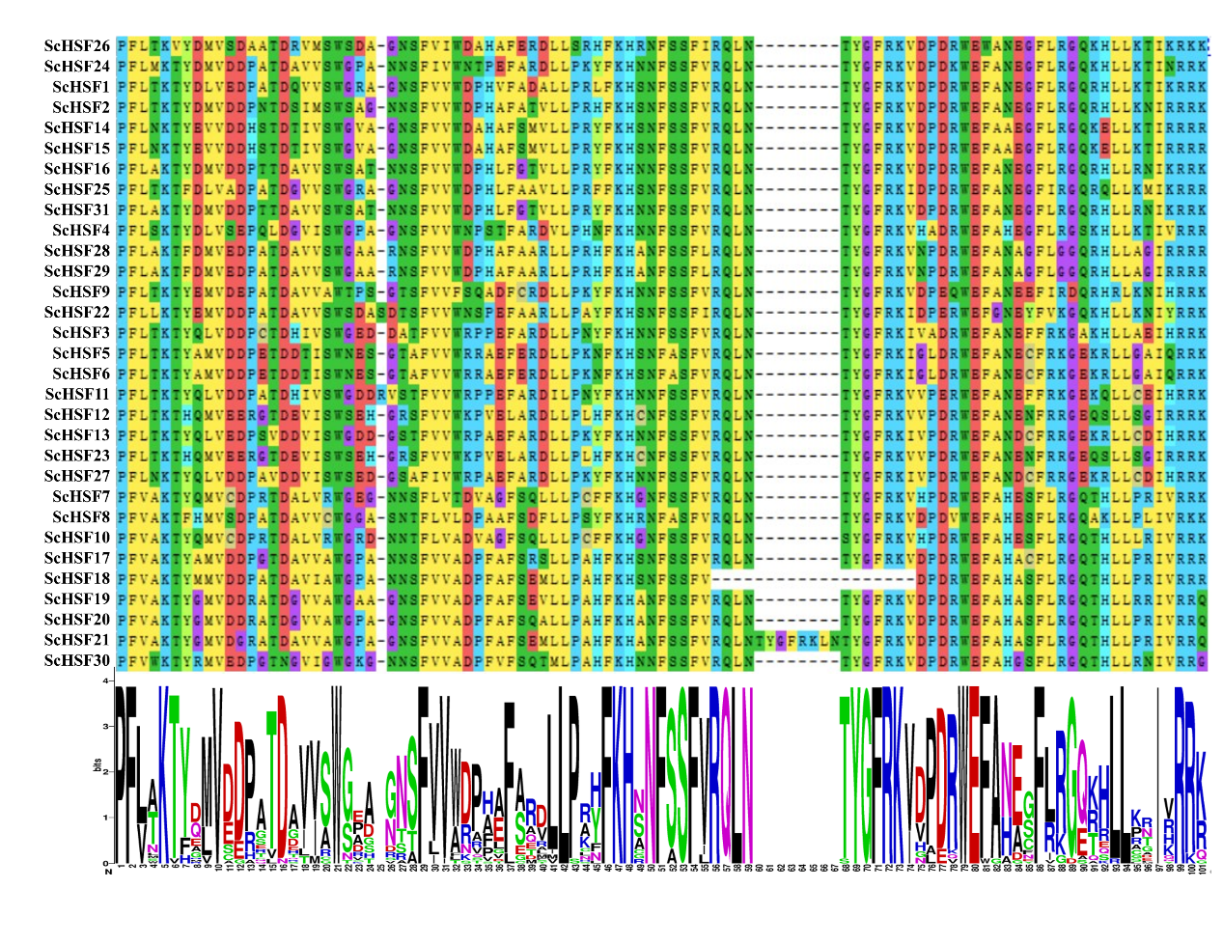
Additional file 2 Figure S1: Alignment of multiple ScHSF and select DBD domain amino acid sequences

