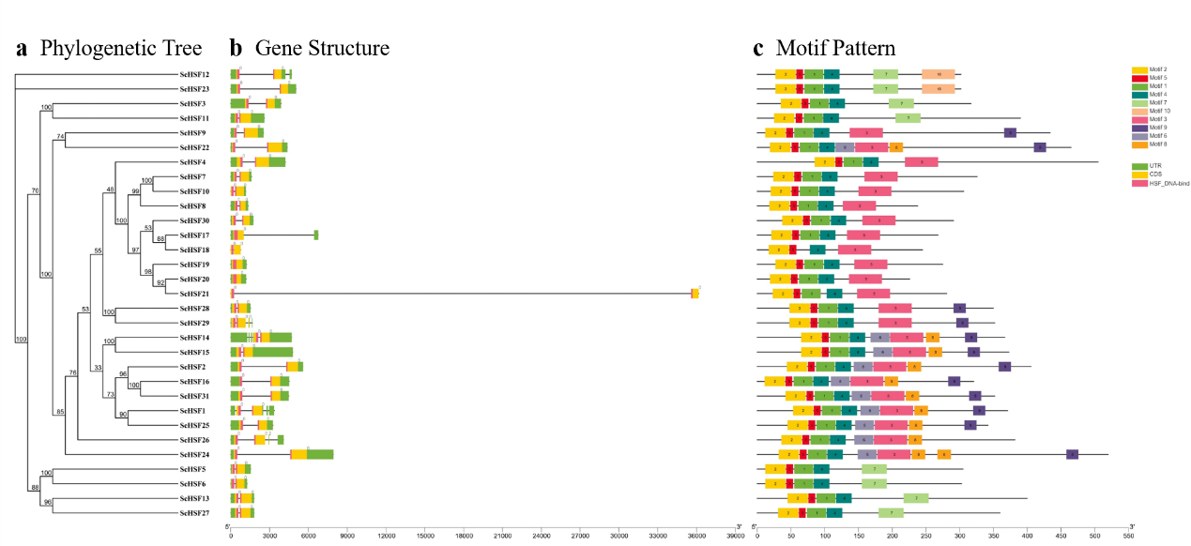
Additional file 3 Figure S2: Analysis of conserved motifs and gene structures in the phylogenetic tree of 31 ScHSF genes.

