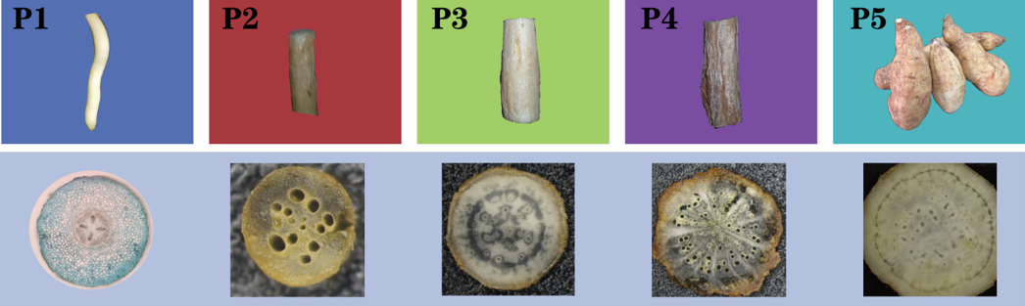
Figure S1. Root composition and cross section of different root types of ‘Tuershao’
P1：primary young root；P2：fibrous root；P3：initial tuber root；P4：stem root；P5：mature tuber root

Table S1. Quantification of differences in anatomical structure of different types of roots
Root type | Primary root | Fibrous root | Stem root | Early tuber | Mature tuber
Number of xylem bundles | 4～6 | 4 | 4～6 | 5 ~ 6 | 5 ~ 6
diameter/mm | 1.5～2.5 | 1～5 | 5～20 | 10～20 | 20～500
Periderm ratio/% | 0 | 17.2 | 35 | 21.1 | 18.2
Proportion of secondary xylem/% | 0 | 32.3 | 30 | 31.3 | 19.1
Proportion of secondary phloem/% | 0 | 50.5 | 35 | 47.5 | 62.7
Mean area of catheter/μm² | 680.8 | 25945.8 | 26860.2 | 23324.2 | 11028.8
Parenchymal cell area/μm² | 225.8 | 1801.5 | 773.9 | 5164 | 58283.9
Starch accumulation in phloem | - | precious few | a little | many | many
Starch accumulation in xylem | - | - | - | precious few | many
Table S2. Coefficient of variables in PCA
Variables | Codes | PC1 | PC2 | PC3 | PC4 | PC5
Diameter | X1 | 0.26878 | 0.03799 | -0.0242 | 0.01225 | -0.04885
Water content | X2 | -0.15352 | 0.20206 | 0.01355 | 0.29982 | -0.21494
Starch | X3 | 0.26662 | 0.01714 | -0.0142 | 0.05649 | 0.12459
Amylopectin | X4 | 0.21015 | 0.19476 | -0.01673 | -0.12181 | 0.094
Amylose | X5 | -0.21015 | -0.19476 | 0.01673 | 0.12181 | -0.094
Sucrose | X6 | -0.23666 | 0.11303 | -0.16232 | 0.04317 | -0.1122
Reducing sugar | X7 | -0.06745 | 0.31436 | -0.04765 | 0.0771 | -0.04447
Glucose | X8 | 0.13185 | 0.19378 | 0.1289 | 0.41239 | -0.20541
Fructose | X9 | -0.16113 | 0.24037 | -0.13642 | -0.17153 | 0.07844
Soluble sugar | X10 | -0.13302 | 0.14936 | 0.17573 | -0.34488 | -0.26592
Soluble protein | X11 | 0.12169 | 0.21424 | -0.34978 | -0.00842 | 0.35222
SUS | X12 | 0.02798 | 0.31159 | -0.09898 | 0.21332 | 0.08446
SPS | X13 | -0.26873 | -0.0163 | 0.00917 | -0.02037 | 0.17417
CWIN | X14 | -0.23216 | 0.12091 | -0.15373 | 0.19823 | 0.0934
VIN | X15 | -0.08846 | 0.29707 | -0.18123 | -0.06944 | 0.14583
CIN | X16 | -0.14822 | 0.15741 | 0.40636 | 0.23707 | 0.18144
APX | X17 | 0.18796 | 0.23185 | 0.01724 | 0.14621 | 0.01045
Soluble pectin | X18 | 0.23749 | -0.12333 | -0.01985 | -0.20316 | 0.11355
Protopectin | X19 | 0.03365 | 0.26259 | 0.40015 | -0.01805 | -0.0791
Total pectin | X20 | 0.10234 | 0.23714 | 0.36882 | -0.03186 | 0.31027
Crude fibre | X21 | -0.17896 | -0.07473 | 0.36784 | -0.29636 | 0.29981
Flavonoid | X22 | -0.13375 | -0.24193 | -0.11895 | 0.2717 | 0.25268
Total phenol | X23 | -0.21958 | -0.11274 | 0.05979 | 0.16249 | 0.48972
Ca | X24 | 0.26458 | -0.04903 | 0.06437 | 0.07821 | 0.07496
K | X25 | -0.16113 | 0.24037 | -0.13642 | -0.17153 | 0.07844
Fe | X26 | 0.26215 | 0.03377 | 0.14082 | -0.01425 | 0.09028
Zn | X27 | 0.15652 | -0.2157 | 0.07656 | 0.33023 | 0.07894
Se | X28 | 0.24705 | 0.05112 | -0.22714 | -0.08772 | 0.15787
Proportion of variations（%） |  | 47.9763 | 31.81469 | 7.32829 | 7.0029 | 2.3713

