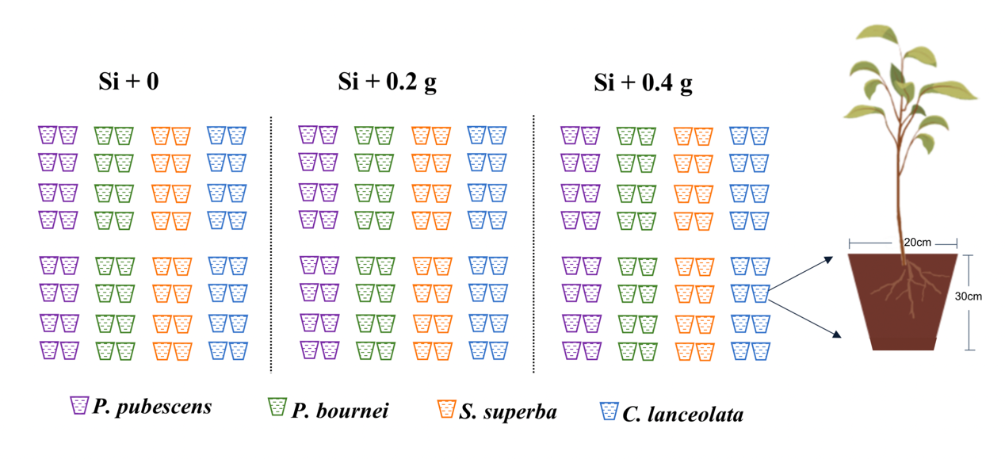
Figure S1. Conceptual diagram of the pot experiment, including three levels of Si supply: 0 (control), 0.2 g, and 0.4 g Si addition per pot.

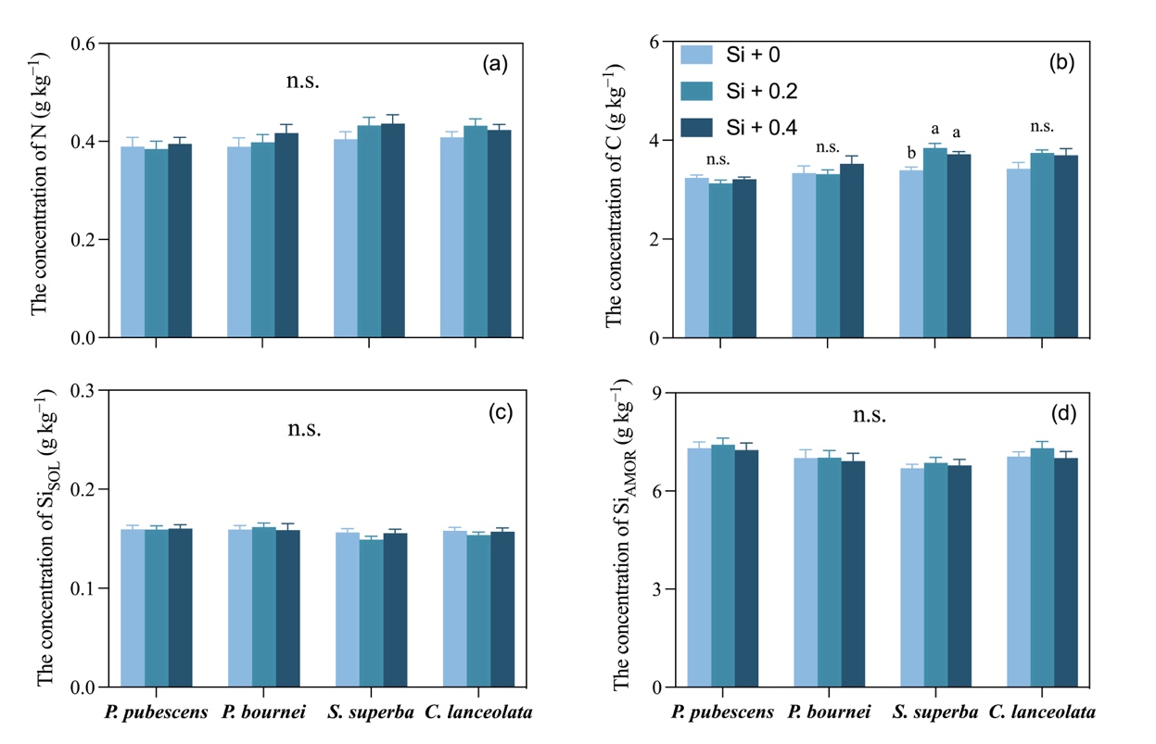
Figure S2. The concentration of nitrogen (N, g kg⁻¹), carbon (C, g kg⁻¹), soluble silicon (Si_{SOL}, g kg⁻¹), and amorphous silicon (Si_{AMOR}, g kg⁻¹) in soils under three levels of silicon supply. Error bars depict means with standard errors (n = 8). Different letters above bars reflect significant differences among groups (P < 0.05).

