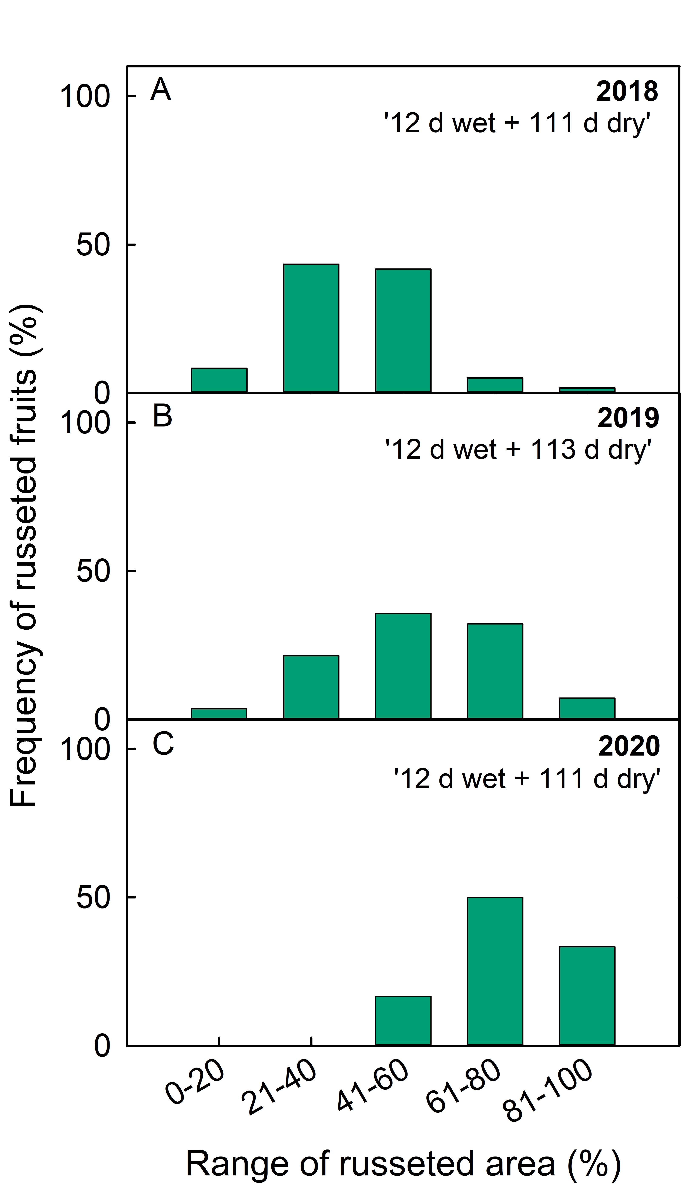
Figure S2 Frequency distribution of russeting of ‘Pinova’ apples in the 2018 (n = 60) (A), 2019 (n = 28) (B) and 2020 growing seasons (n = 12) (C). Russeting was induced by exposure to surface moisture for 12 d (Phase I) beginning at 21-31 DAFB. After termination of moisture exposure, the fruit skin patches remained dry (Phase II). The portion of the russeted surface area exposed to moisture was quantified at maturity.

