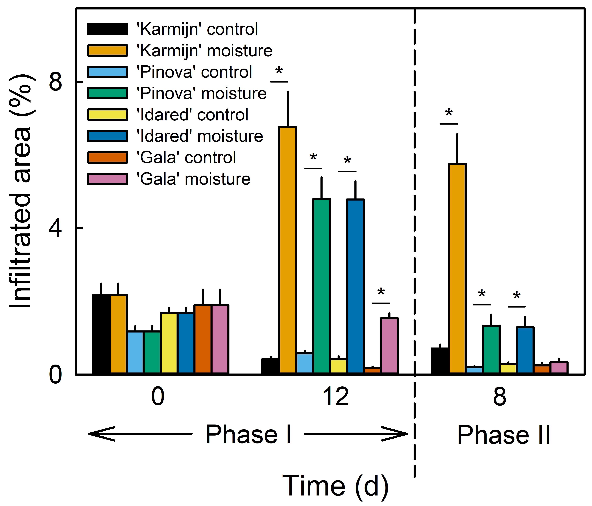
Figure S5 Microcrack formation in the cuticle of apples in four cultivars following exposure to moisture. Fruit skin patches of ‘Karmijn’, ‘Pinova’, ‘Idared’, and ‘Gala’ were exposed to surface moisture beginning at 28-32 days after full bloom (DAFB) for 12 d (Phase I). Afterwards, moisture was removed and the treated fruit skin patch remained dry (Phase II). The nonexposed surface of the same fruit served as a control. Microcracking was indexed by quantifying the area infiltrated with acridine orange. Data represent the means ± SEs of ten fruits. ‘*’ indicates a significant difference between ’Moisture’ and ‘Control’ within each cultivar at p ≤ 0.05 (Student’s t test).

