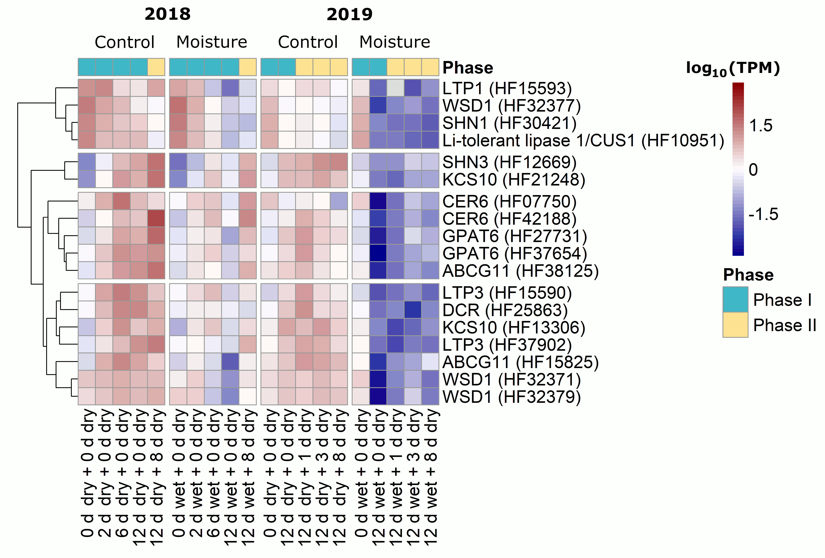
Figure S7 Heatmap of cutin and wax-related genes expression during moisture-induced russeting in ‘Pinova’ apple. Russeting was induced in a two-phase experiment. During Phase I, skin patches of ‘Pinova’ apples were exposed to moisture for 2, 6 or 12 d (‘x d wet’). After termination of moisture exposure (Phase II), the treated skin patch was exposed to the ambient atmosphere for 1, 3 or 8 d (‘y d dry’). The nontreated control (‘Control’) remained dry during Phase I and Phase II (‘x d dry + y d dry’). Cuticle-related genes (based on literature information) were downregulated during Phase I. Expression values are shown as the mean log₁₀(TPM) (transcripts per million) values of three independent replicates comprising six (season 2018) or ten (season 2019) fruits each.

