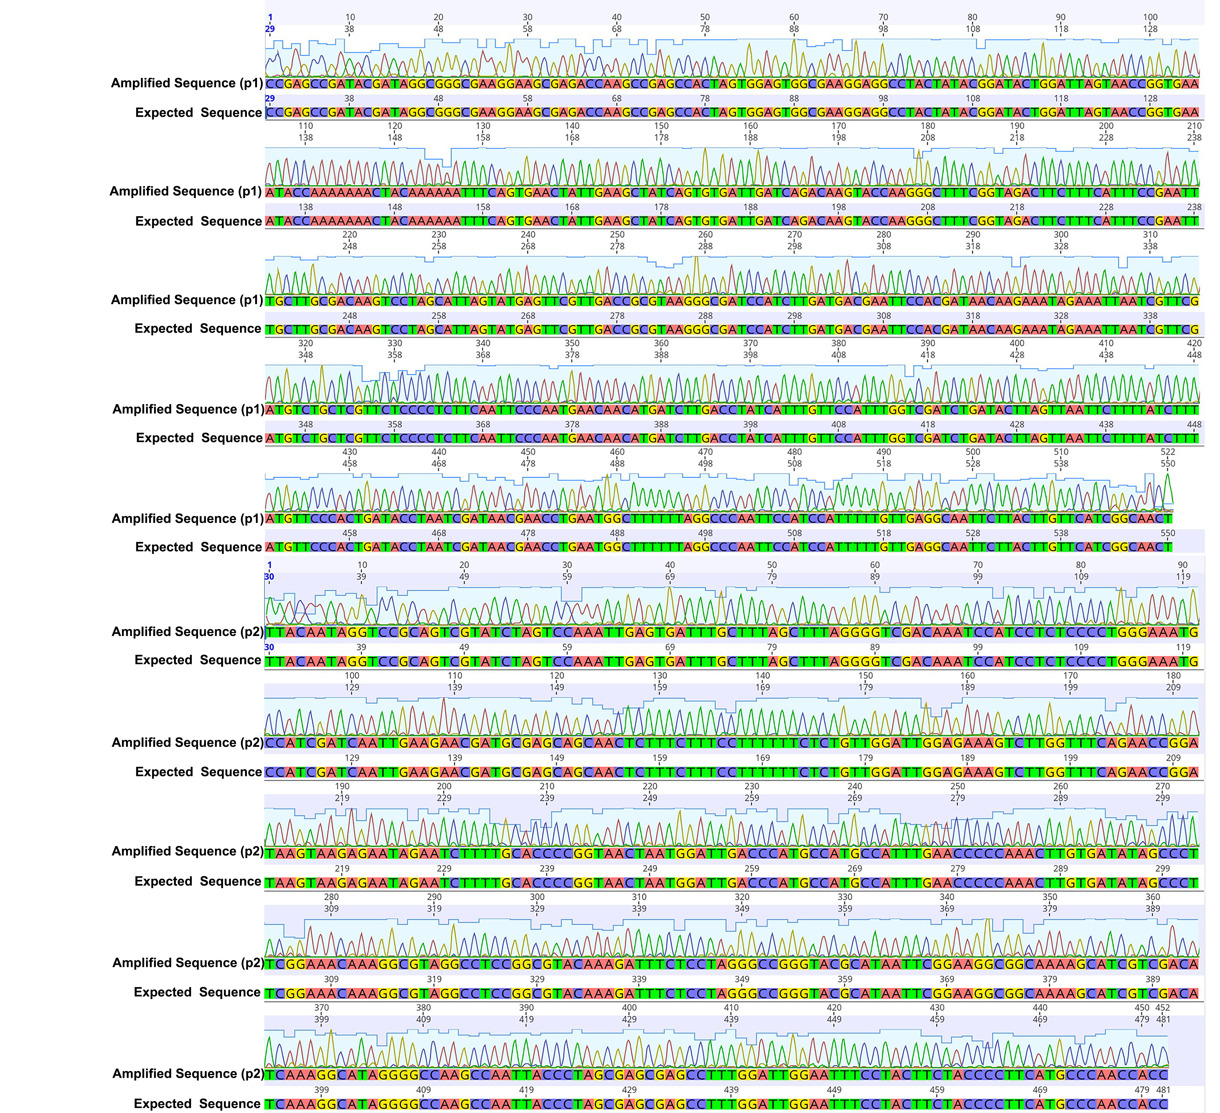

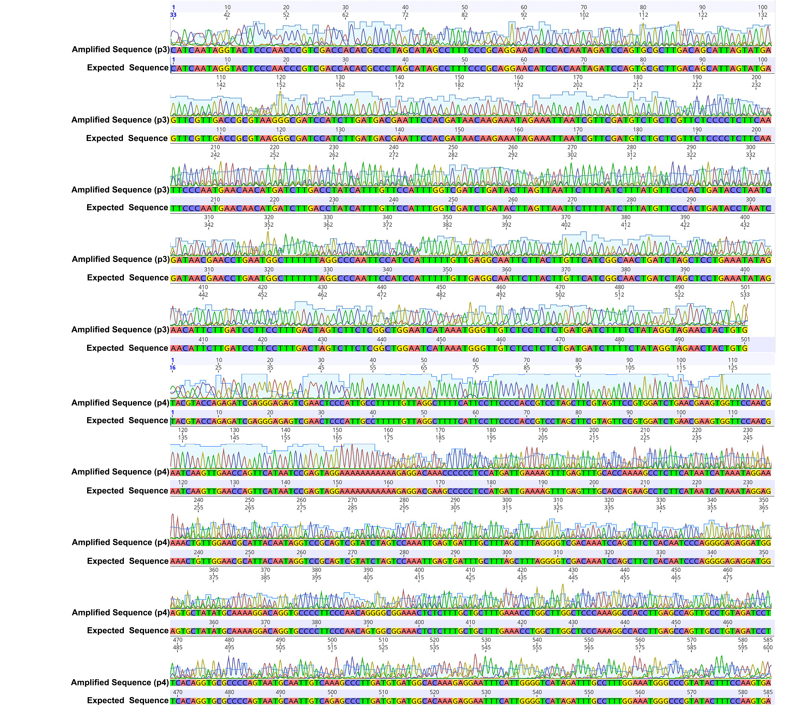
Figure S1. The full alignment of Sanger sequencing reads.
p1, p2, p3, and p4 represent path 1, path 2, path 3 and path 4 respectively.

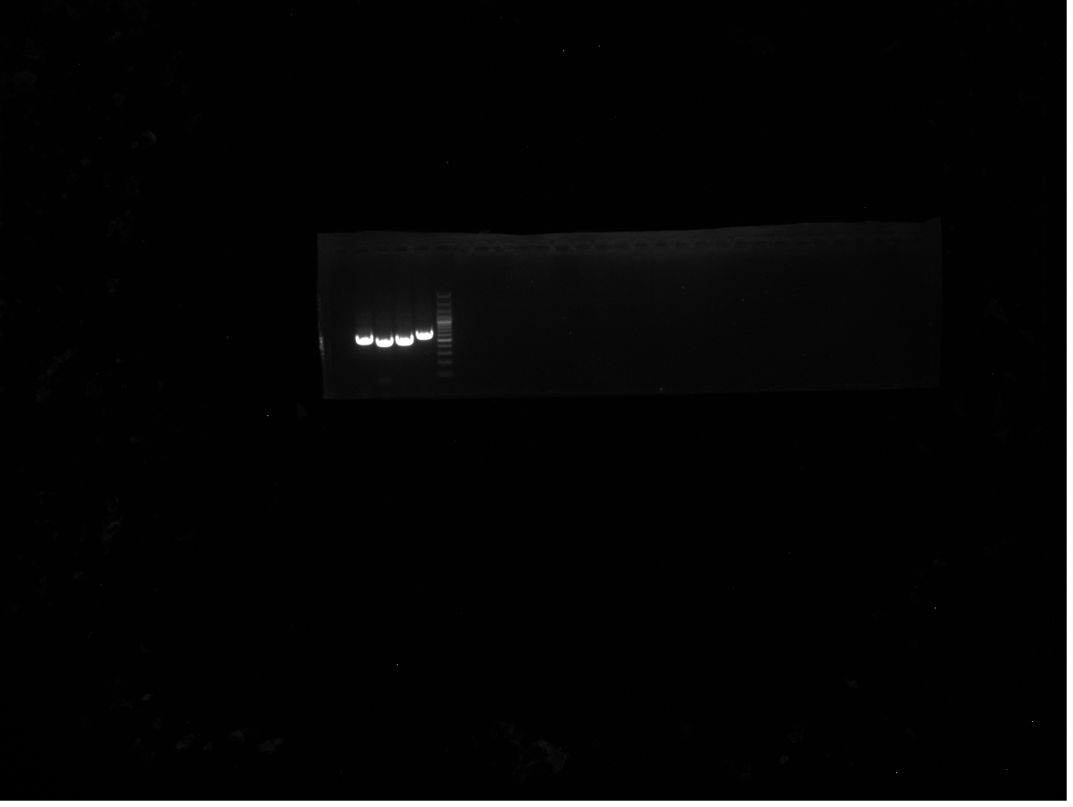
Figure S2. The original uncut electropherogram.

