Physiological and Transcriptomic Analysis Reveals the Potential Mechanism of Morinda officinalis How in Response to Freezing Stress

Zhenhua Luo, Xiaoying Che, Panpan Han, Zien Chen, Zeyu Chen, Jinfang Chen, Sishi Xiang, Ping Ding*
School of Pharmaceutical Sciences, Guangzhou University of Chinese Medicine, Guangzhou 510006, China
* Correspondence: Ping Ding
dingping@gzucm.edu.cn

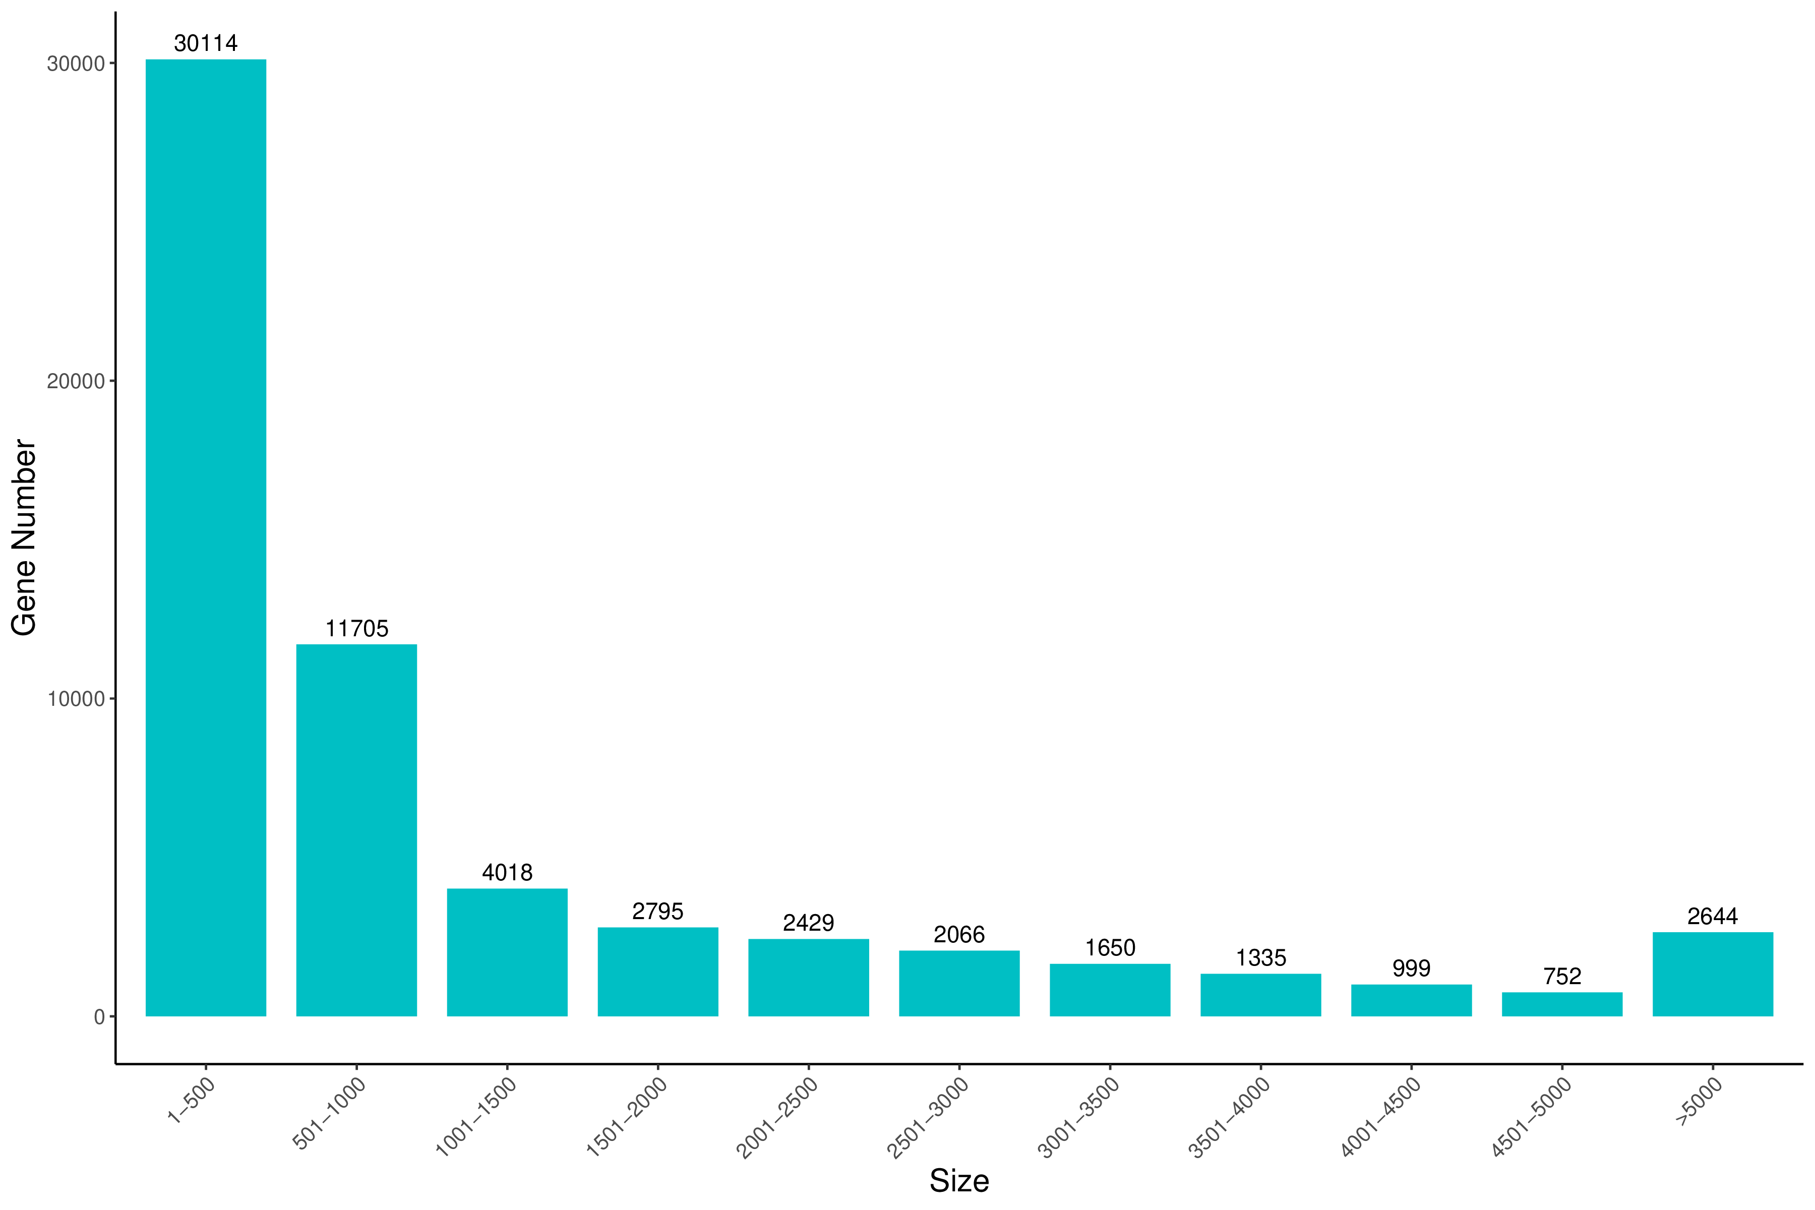
Fig. S1 The distribution of unigenes sequence length.

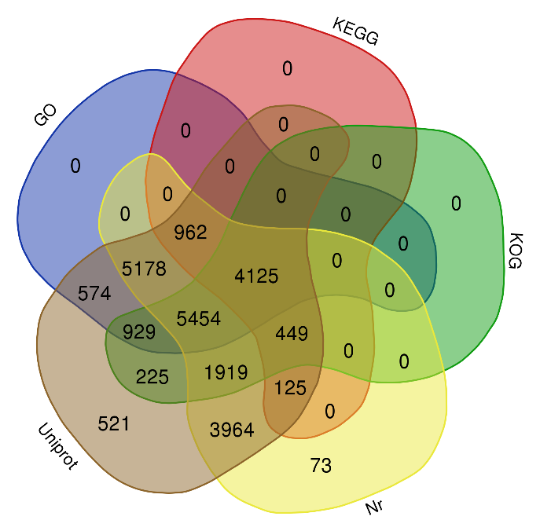
Fig. S2 Number of gene annotations among different databases.

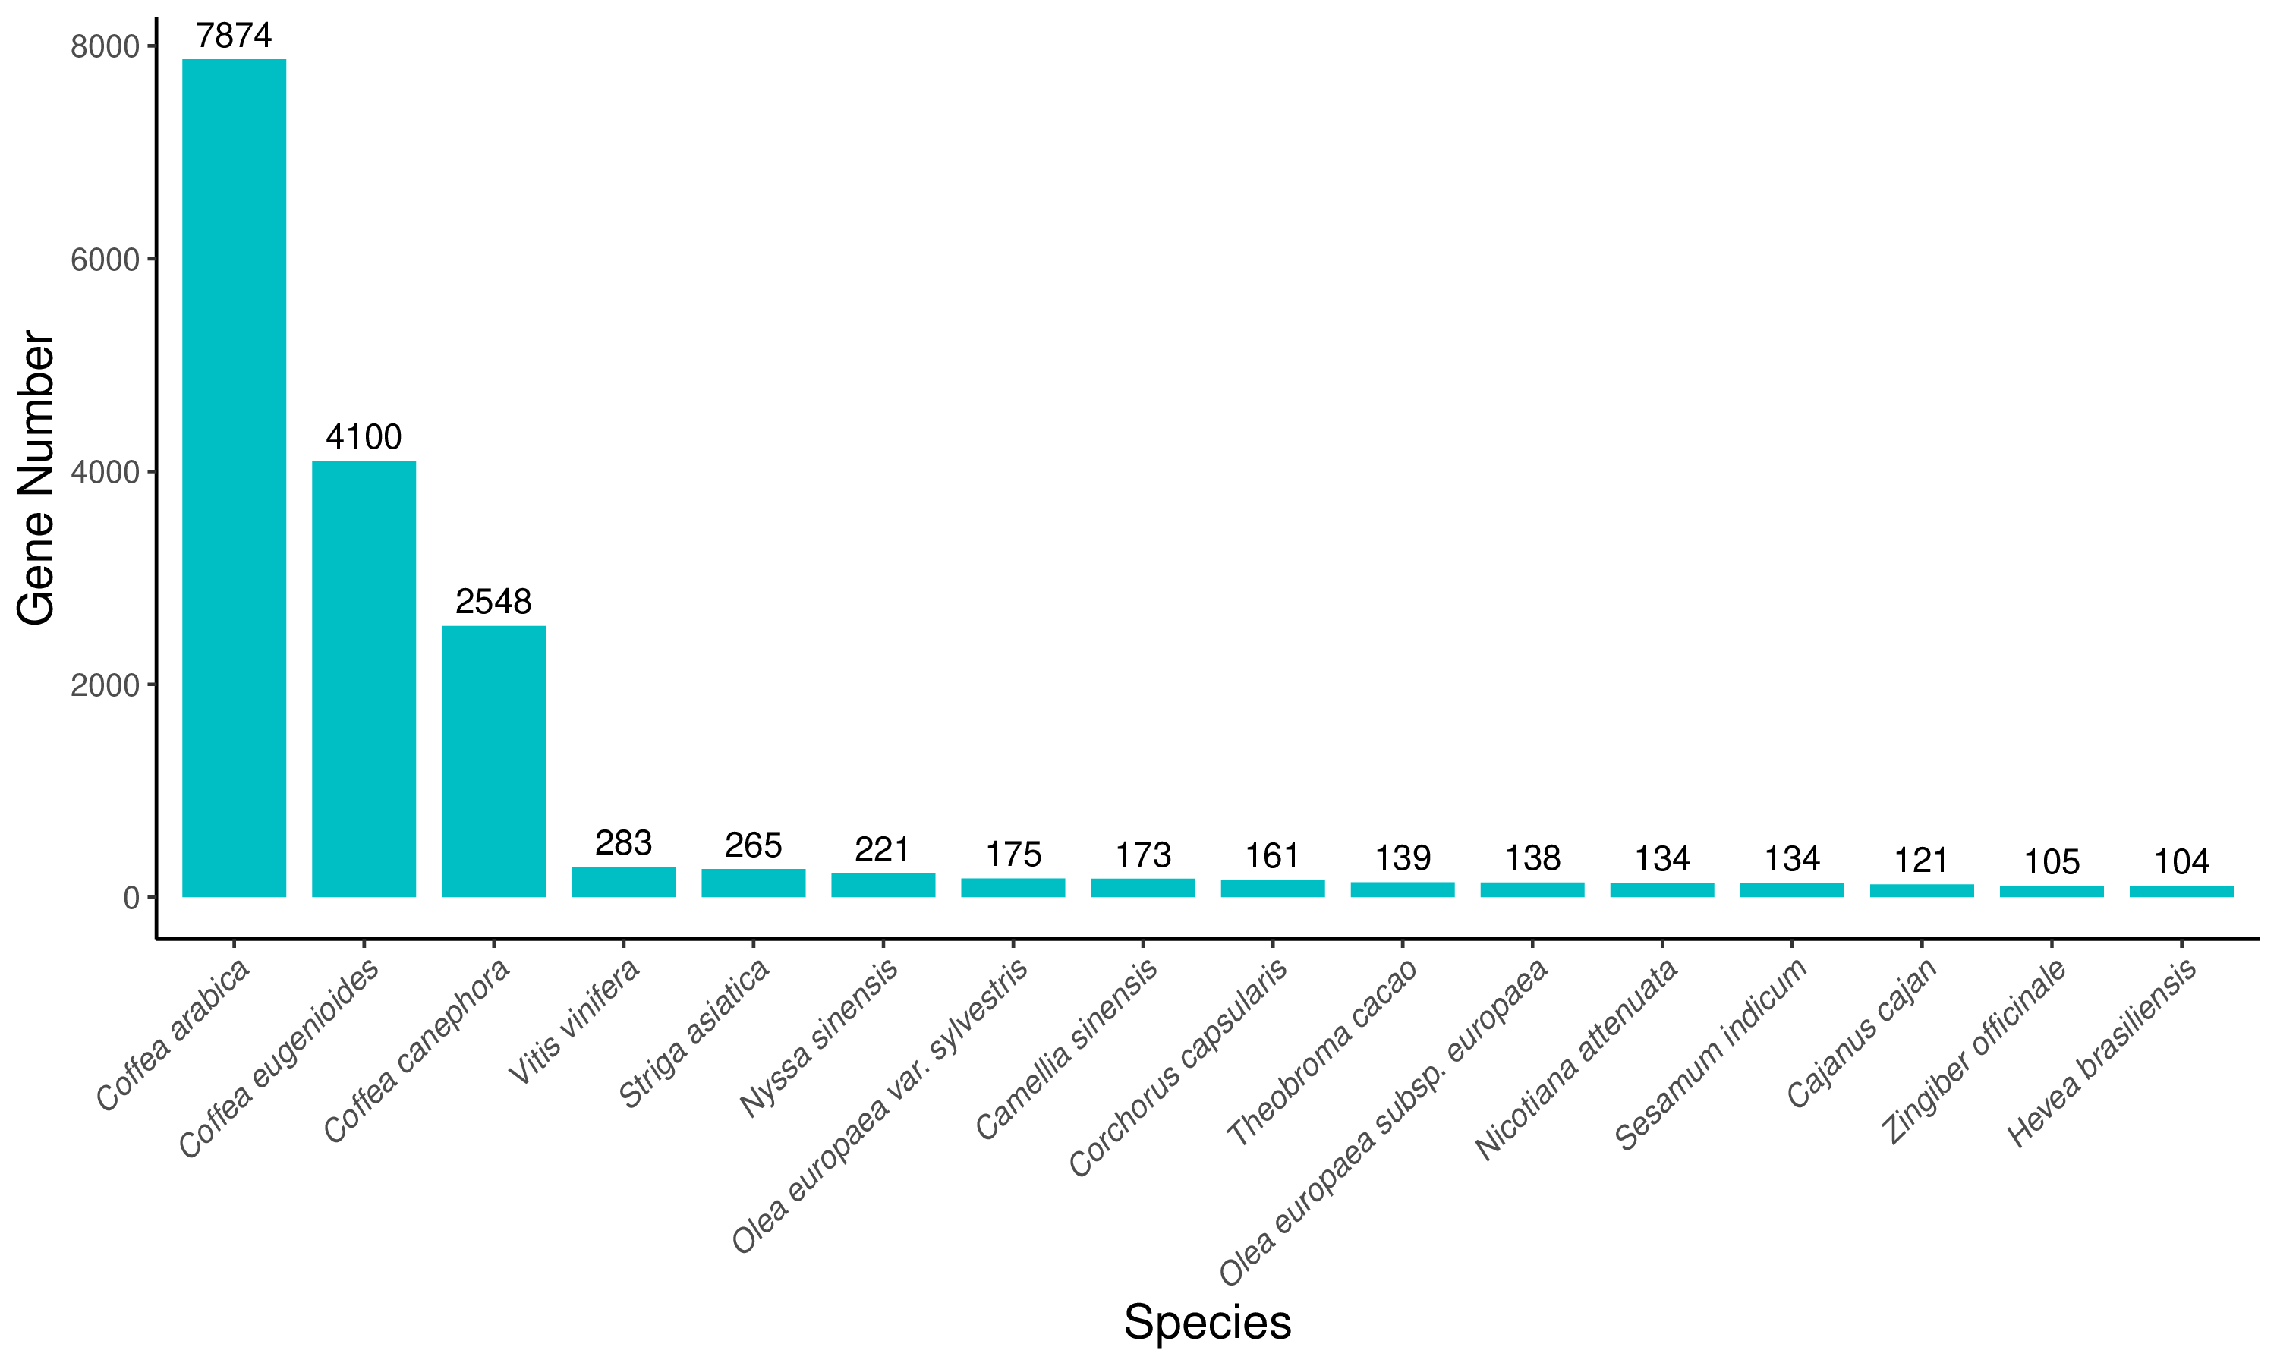
Fig. S3 Gene quantity distribution of each species.

