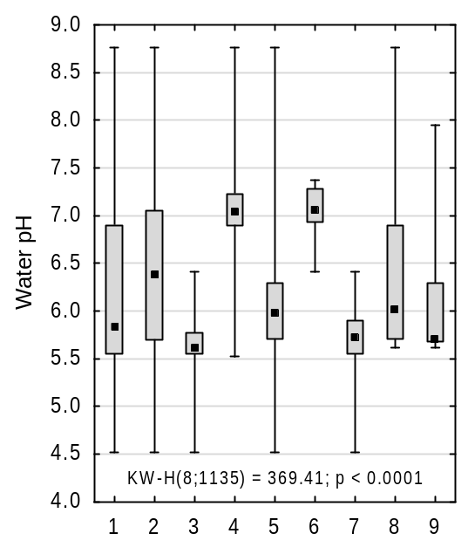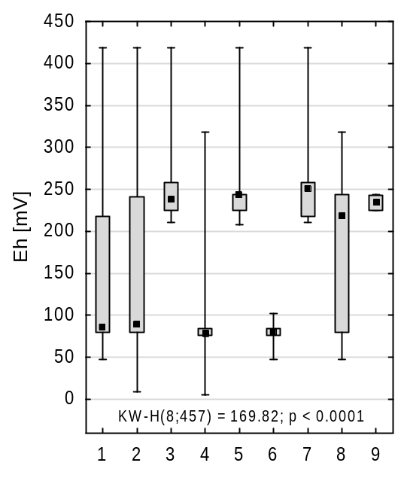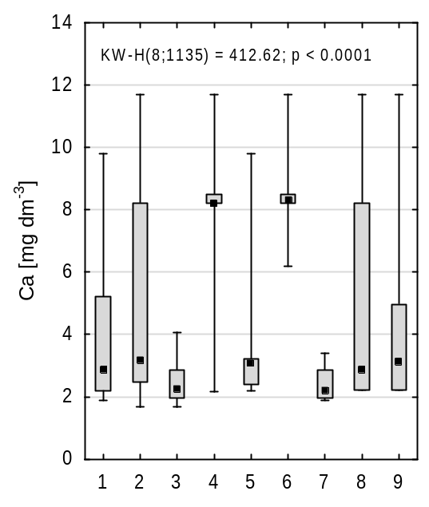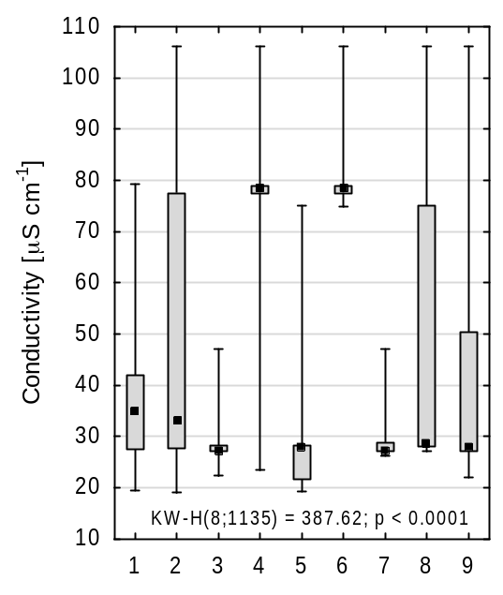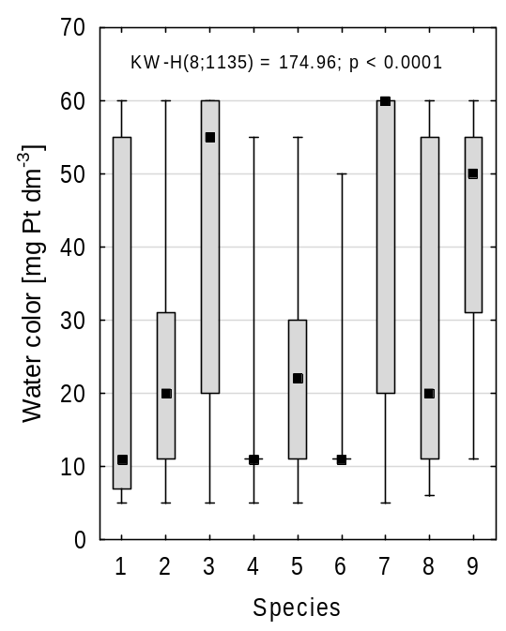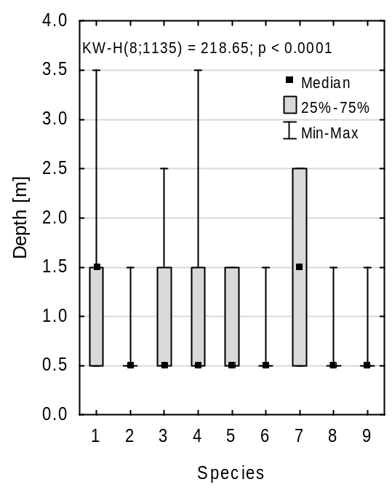
Fig. S1. Water conditions in the Luronium natans community with species with a frequency > 5%. Explanations: 1- I. lacustris, 2- L. dortmanna, 3- S. denticulatum, 4- M. alterniflorum, 5- J. bulbosus, 6- E. canadensis, 7- W. exannulata, 8-L. uniflora. 9- E. palustris.
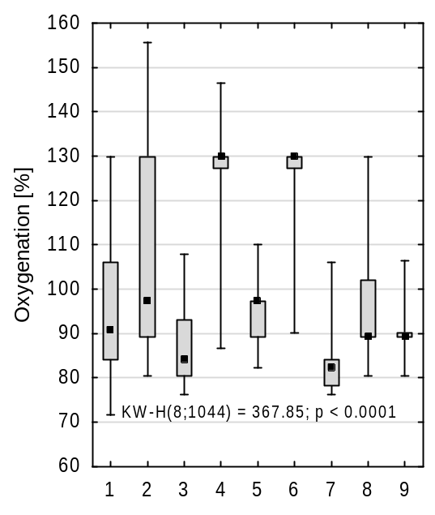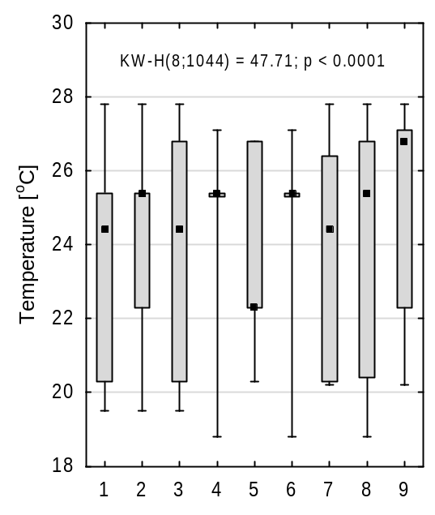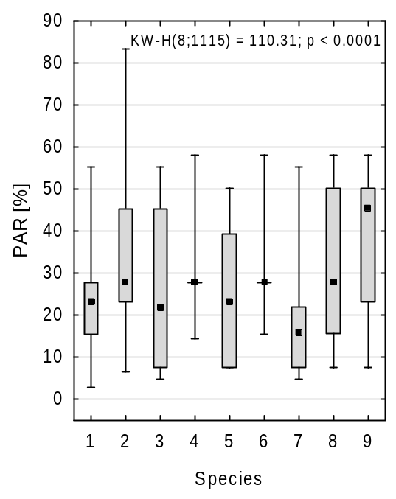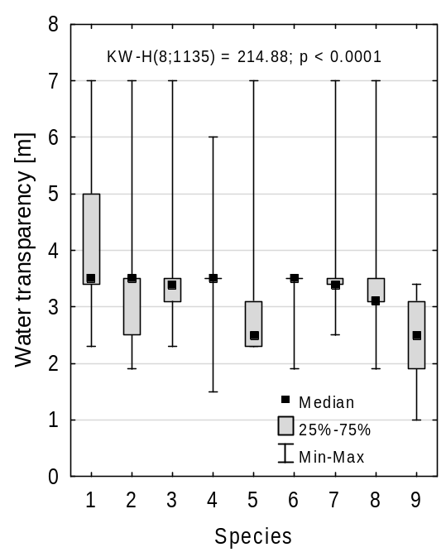
Fig. S2. Oxygenation and water temperature, PAR light intensity and water transparency in the Luronium community with species with a frequency > 5%.
Explanations see Fig. A.1.

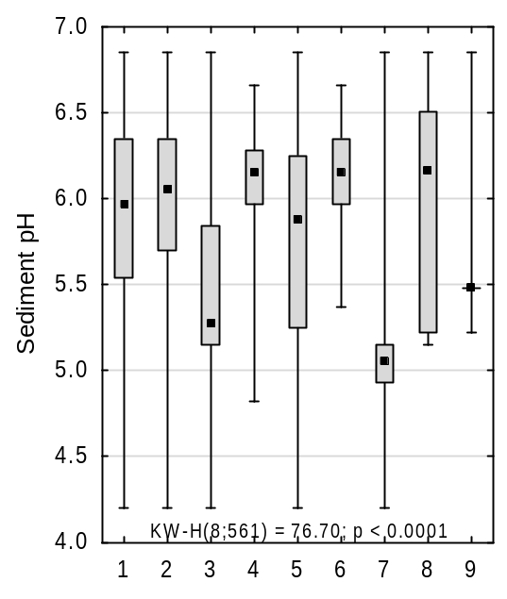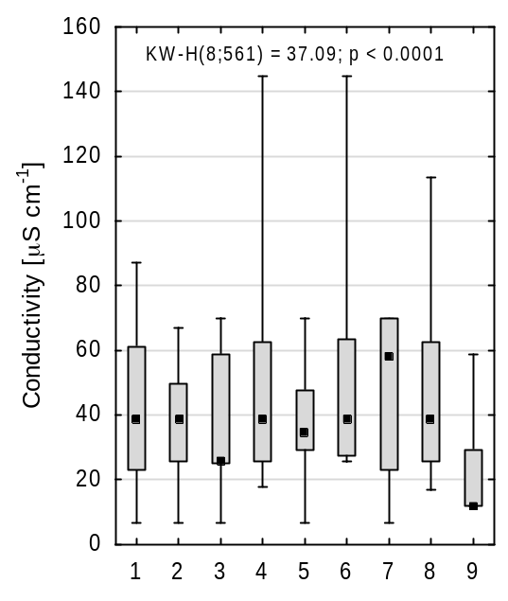
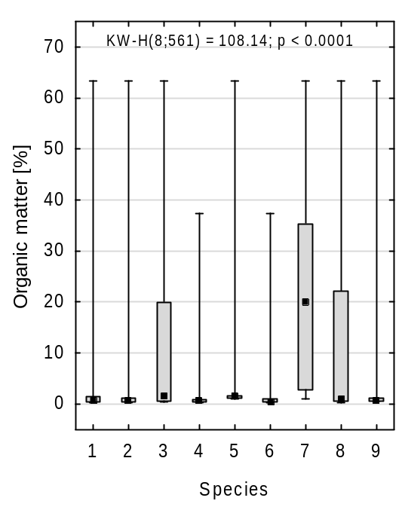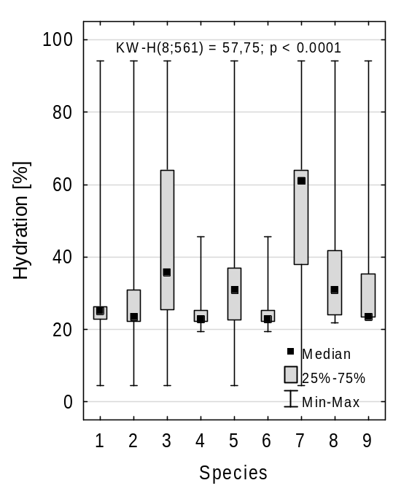
Fig. S3. Environmental conditions in the sediment in Luronium community with species with a frequency > 5%.
Explanations see Fig. A.1.

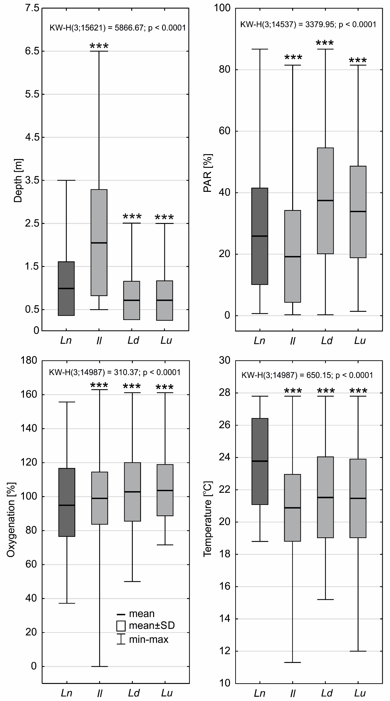
Fig. S4. Differences in the depth of occurrence, PAR intensity, water oxygenation and temperature between habitats of L. natans (Ln) and other isoetids (Il - I. lacustris, Ld - L. dortmanna and Lu - L. uniflora). Statistically significant differences were determined with p<0.001 - ***, p<0.01 - **, p<0.05 - *.

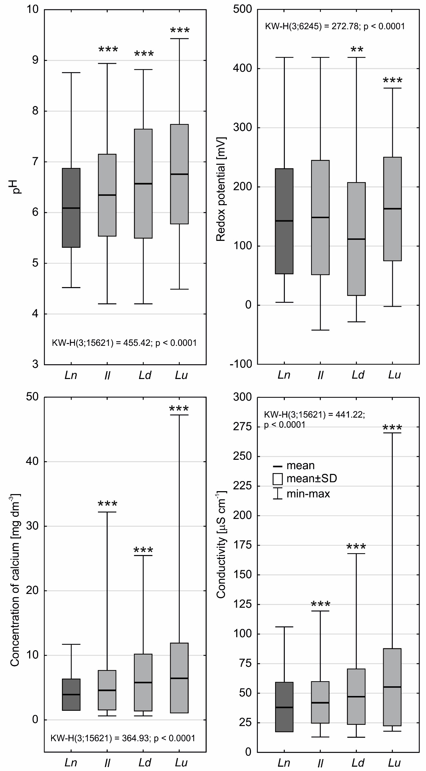
Fig. S5. Difference in pH, redox potential, calcium concentration and water conductivity between habitats of L. natans (Ln) and other isoetids (Il - I. lacustris, Ld - L. dortmanna and Lu - L. uniflora). Statistically significant differences were determined with p<0.001 - ***, p<0.01 - **, p<0.05 - *.

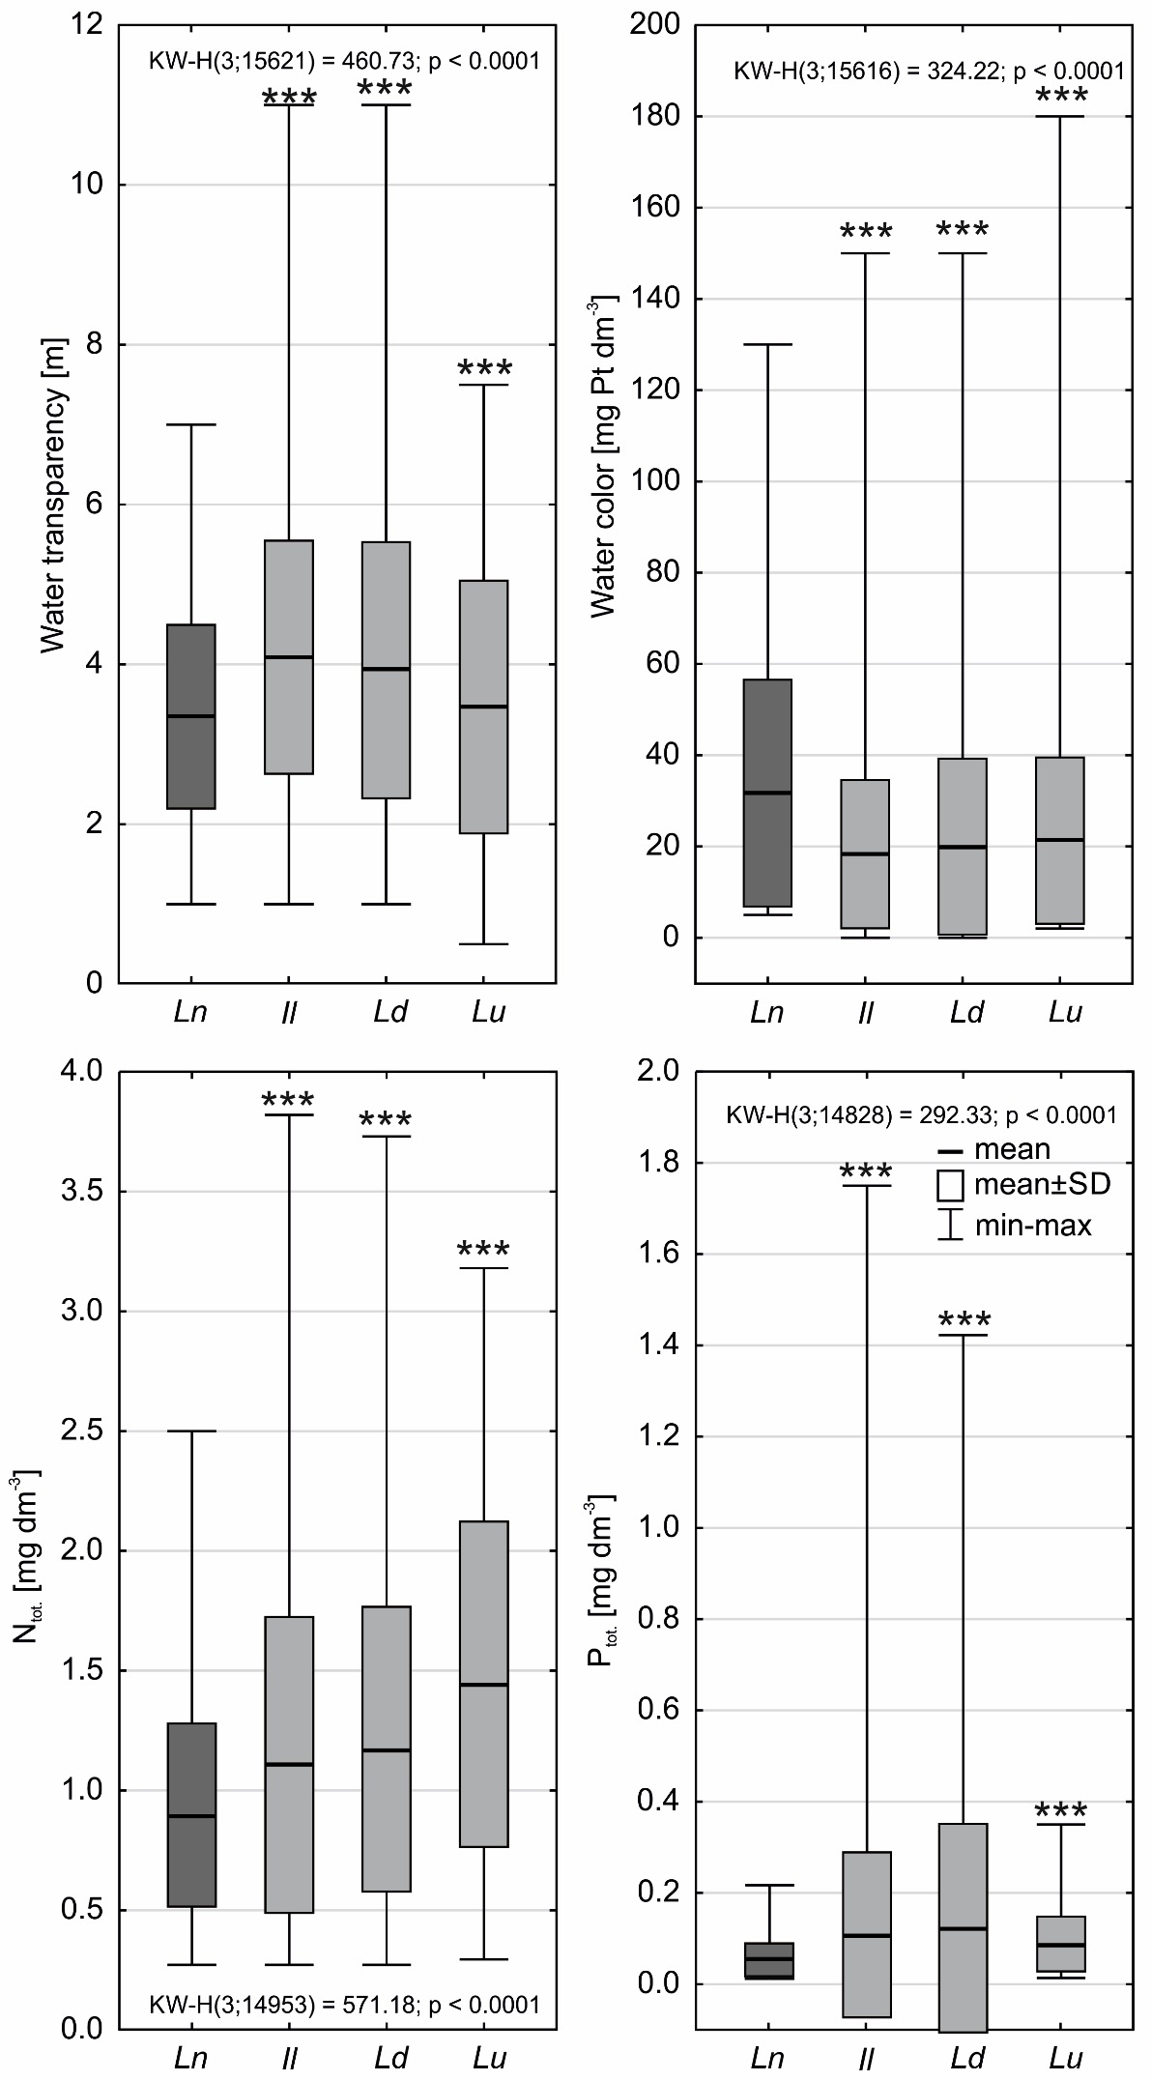
Fig. S6. Differences in water transparency and color, nitrogen and phosphorus concentration between habitats of L. natans (Ln) and other isoetids (Il - I. lacustris, Ld - L. dortmanna and Lu - L. uniflora). Statistically significant differences were determined with p<0.001 - ***, p<0.01 - **, p<0.05 - *.

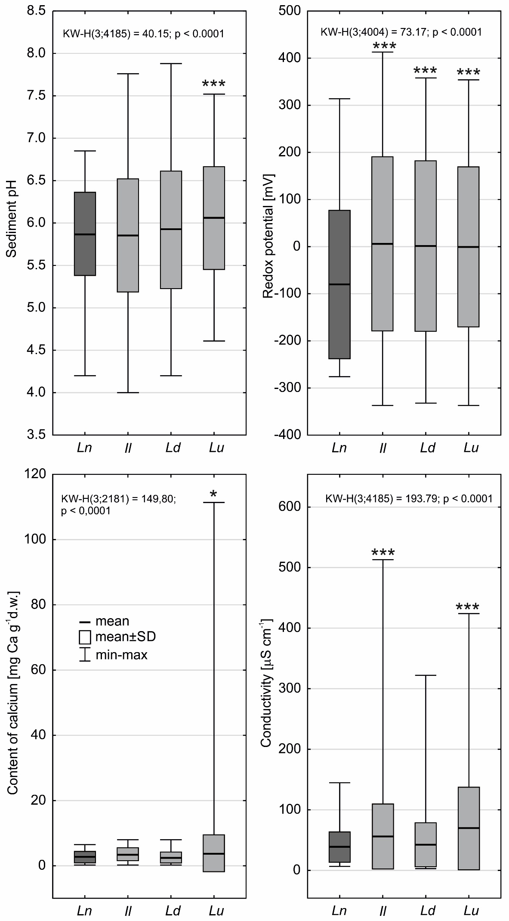
Fig. S7. Differences in pH, redox potential, calcium concentration and sediment conductivity between habitats of L. natans (Ln) and other isoetids (Il - I. lacustris, Ld - L. dortmanna and Lu - L. uniflora). Statistically significant differences were determined with p<0.001 - ***, p<0.01 - **, p<0.05 - *.
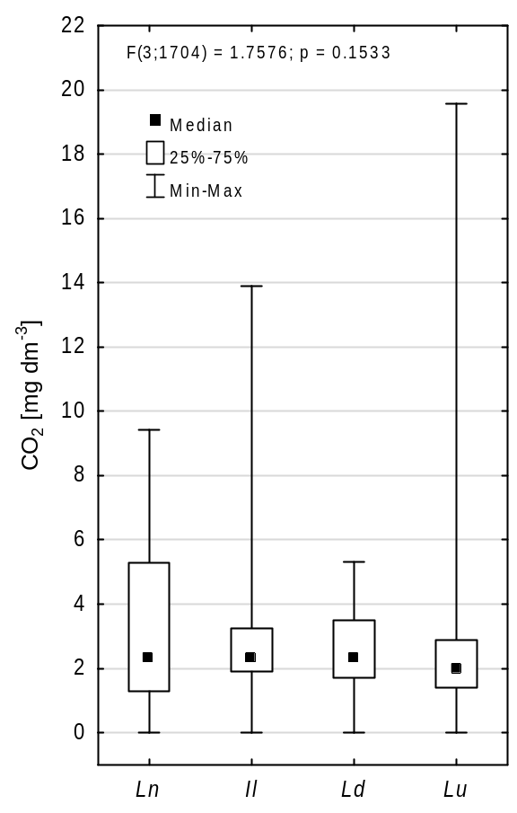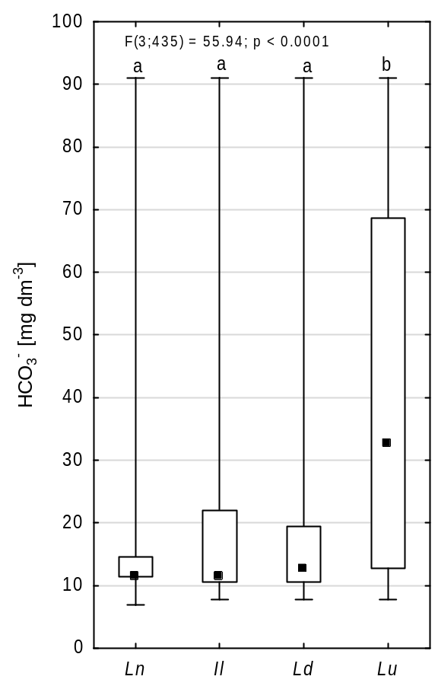
Fig. S8. Differences in nitrogen and phosphorus concentration, organic matter and sediment hydration between habitats of L. natans (Ln) and other isoetids (Il - I. lacustris, Ld - L. dortmanna and Lu - L. uniflora). Statistically significant differences were determined with p<0.001 - ***, p<0.01 - **, p<0.05 - *.

