Supplementary Material
Enhancing cold and drought tolerance in cotton: A protective role of SikCOR413PM1
Mei Wang¹, Lepeng Wang¹, Xiangxue Yu¹, Jingyi Zhao¹, Zhijia Tian¹, Xiaohong Liu³, Guoping Wang⁴, Li Zhang² & Xinyong Guo¹*
¹College of Life Science, Shihezi University, Shihezi 832000, Xinjiang, People’s Republic of China.
²Department of Preventive Medicine, School of Medicine, Shihezi University, Shihezi 832000, Xinjiang, People’s Republic of China.
³Xinjiang Agricultural Development Group Crop Hospital Co. LTD, Tumushuke 844000, Xinjiang, People’s Republic of China.
⁴Agricultural Science Institute of the seventh division of Xinjiang Corps, Kuitun 833200, Xinjiang, People’s Republic of China.
†Mei Wang and Lepeng Wang contributed equally as co-first authors.
*Corresponding author: Xinyong Guo & Li Zhang
College of Life Science, Shihezi University, Shihezi 832000, Xinjiang, People’s Republic of China.
Department of Preventive Medicine, School of Medicine, Shihezi University, Shihezi 832000, Xinjiang, People’s Republic of China.
* Correspondence: guoxinyong2013@163.com & zl491191385@163.com

Supplementary Figure
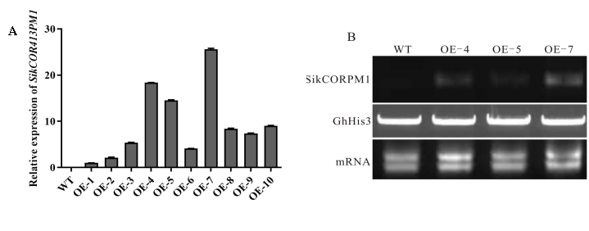
Fig 1.Expression levels of SikCOR413PM1 in WT and transgenic cotton lines. (A) Quantitative real-time PCR analysis of relative expression of SikCOR413PM1 in WT and ten transgenic lines; (B) Semi-quantitative PCR analyses of SikCOR413PM1 expression in WT and three transgenic lines (OE-4, OE-5 and OE-7).

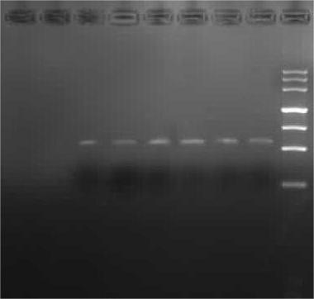
WT OE-4 OE-5 OE-7 Marker MMMarker

SikCOR413PM1
Fig S1.Semi-quantitative PCR analyses of SikCOR413PM1 expression in WT and three transgenic lines (OE-4, OE-5 and OE-7).
Note: Since the first gel electrophoresis pattern was too bright to accurately assess the levelof gene expression in different transgenic strains, we repeated the the electrophoresis by recovering the initial gel product. Consequently, we obtained a gel electrophoresis image displaying noticeable differences in gene expression, as depicted in the Supplementary Figure S1. This figure presents the results of semi-quantitative PCR analyses, specifically examining the expression of SikCOR413PM1 in the WT, OE-4, OE-5, and OE-7 strains.

WT OE-4 OE-5 OE-7


GhHis3
Fig S2. Electrophoretic plot of the reference gene GhHis3 in wild type and three transgenic lines (OE-4, OE-5 and OE-7).
Note:Supplementary Figure 2 provides additional illustration of the gel electrophoresis pattern for the reference gene GhHis3 as shown in Figure 1-B.GhHis3 was used as the reference gene due to its relatively constant expression in the cells. This allowed for the correction of sample size and any errors in the sample loading process, ensuring the accuracy of the experimental results

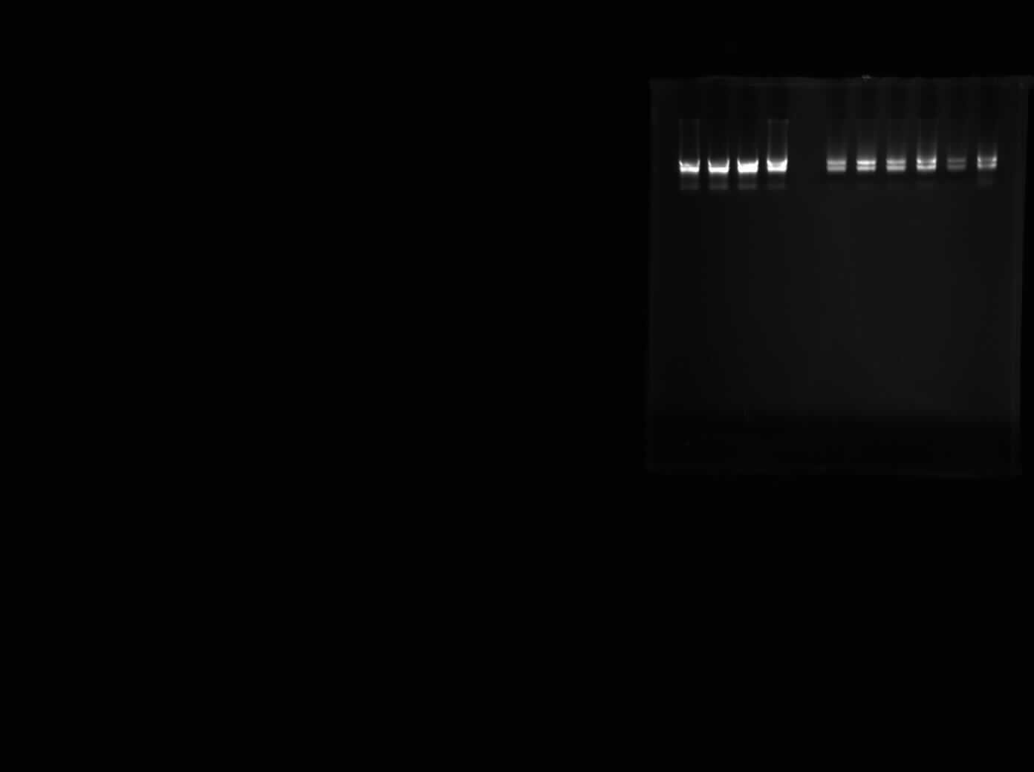

WT OE-4 OE-5 OE-7
mRNA
Fig S3. Gel electrophoresis plot of SikCOR413PM1 gene mRNA extraction.
Note:Supplementary Figure 3 is a further illustration of the mRNA gel electrophoresis pattern in Figure 1- B. Gel electrophoresis picture of SikCOR413PM1 gene mRNA extraction from wild type, OE-4, OE-5, and OE-7 different lines.

Supplementary Table
Table S1. Agronomic characteristics of WT and transgenic cotton lines under drought stress.
Processing mode | Normal irrigation |  |  | Natural drought
Genotype | WT | OE-4 | OE-7 | WT | OE-4 | OE-7
Plant height (cm) | 70.3±0.93 | 71.5±1.07 | 72.7±1.14 | 43±1.11 | 46.1±0.86* | 47.4±0.92**
Number of branches | 7.2±0.2 | 8.2±0.29** | 8.8±0.13** | 3.7±0.21 | 4.5±0.17* | 4.7±0.3**
Number of bolls | 7.1±0.31 | 8.4±0.16** | 9.1±0.18** | 2.7±0.15 | 3.7±0.21** | 4.2±0.25**
Boll weight (g) | 3.61±0.1 | 3.62±0.1 | 3.57±0.05 | 2.16±0.03 | 2.26±0.03 | 2.29±0.06
Lint cotton yield (g/boll) | 1.38±0.07 | 1.36±0.02 | 1.37±0.01 | 0.65±0.01 | 0.67±0.02 | 0.71±0.01
Unginned cotton  yield (g/plant) | 25.65±1.31 | 30.48±1.12** | 32.43±0.72** | 5.82±0.33 | 8.35±0.5* | 9.54±0.5**
Lint cotton yield (g/plant) | 9.95±0.99 | 11.44±0.28* | 12.44±0.23** | 1.75±0.11 | 2.48±0.15 | 2.97±0.17*
Lint percentage (%) | 38.54±2.47 | 37.86±1.29 | 38.45±0.69 | 30.05±0.71 | 29.9±1.12 | 31.06±0.59
Unginned cotton  yield (Kg/plot) | 6.16±0.31 | 7.32±0.27** | 7.78±0.17** | 1.4±0.08 | 2±0.12* | 2.29±0.12**
Lint cotton yield (kg/plot) | 2.39±0.24 | 2.75±0.07* | 2.99±0.05** | 0.42±0.03 | 0.6±0.04 | 0.71±0.04*
Table S2. List of primers used in this study.
Primer name | Primer sequence (5′-3′) | Purpose
SikCOR413PM1 (BamH Ⅰ)-F | GGATCCATGATGAAGGGAGTAAAGAAC | Cloning
SikCOR413PM1 (SalⅠ)-R | GTCGACCTAAAATATTAAGCCGATCAAAGC | Cloning
SikCOR413PM1-qF | TGTGGTGGAGCAGATCAAGG | qPCR
SikCOR413PM1-qR | TATGTCCATCGGCGACACCATGA | qPCR
SikGAPDH-qF | TAGCAAGGATGCTCCCATGTT | qPCR
SikGAPDH-qR | GGAGCAAGGCAGTTGGTTGTG | qPCR
GhDREB1A-qF | GGATTTGGCTTGGAACTTTCCCGAA | qPCR
GhDREB1A-qR | CATCGTTTCTAGAATTCCCGCTCGA | qPCR
GhDREB1B-qF | CCGACCCAAAGGATATCCAAAAGAC | qPCR
GhDREB1B-qR | CGCTTCTTCGTCCAAGTAAAACCCTT | qPCR
GhDREB1C-qF | CTCAGATCCTTTTAGTGCGGAGTTG | qPCR
GhDREB1C-qR | GATAGTTACAGAACCCTTGTTCTGAG | qPCR
GhERF2-qF | GAGGAAGAACCAGTATCGTGGAATC | qPCR
GhERF2-qR | GCGGAGTCTCGTTAGGGAAG TTCA | qPCR
GhRD22-qF | AGGAGGTGGTGGTGTAAACGTCAA | qPCR
GhRD22-qR | ATGAAACACGGATCTCCTCCCGAA | qPCR
GhNAC3-qF | GTAAATGTGCGTCTCAGTCTAT | qPCR
GhNAC3-qR | GGTCCACGTCGGCTAATC | qPCR
GhSOD-qF | ATGATGGTCCTACAACTGTGAATGT | qPCR
GhSOD-qR | GCGTACTTCA TCCTCAGGAGCA | qPCR
GhPOD-qF | CACATTGTTGCTCTTTCTGGTG | qPCR
GhPOD-qR | GGATCTGACAGGAGAACTTTGT | qPCR
GhCAT-qF | TATCTGCAACTCCCAGCCAAT | qPCR
GhCAT-qR | TTCTCTCGCC TTCCAGTGCA A | qPCR
GhGST-qF | GTTGCTAGCTCTGTTGGGTATTTC | qPCR
GhGST-qR | AGGGAAGTAGTTTGTCTCTTGGAG | qPCR
GhHis3-qR | TGGGAAGGCTCCAAGGAAGCA | qPCR
GhHis3-qF | CGAGCCAACTGGATGTCCTTG | qPCR
The primer sequences for stress-related genes and reference genes are referenced from the literature of Zhang et al. and HAO et al [1,2].

Reference
- HAO, Yu-qiong, et al. Overexpression of AmDUF1517 enhanced tolerance to salinity, drought, and cold stress in transgenic cotton. Journal of Integrative Agriculture 17.10 (2018): 2204-2214.
- Zhang L, Tian W, Huang G, Liu B, Wang A, Zhu J, Guo X. The SikCuZnSOD3 gene improves abiotic stress resistance in transgenic cotton. Mol Breed. 2021 Mar 10;41(3):26.

