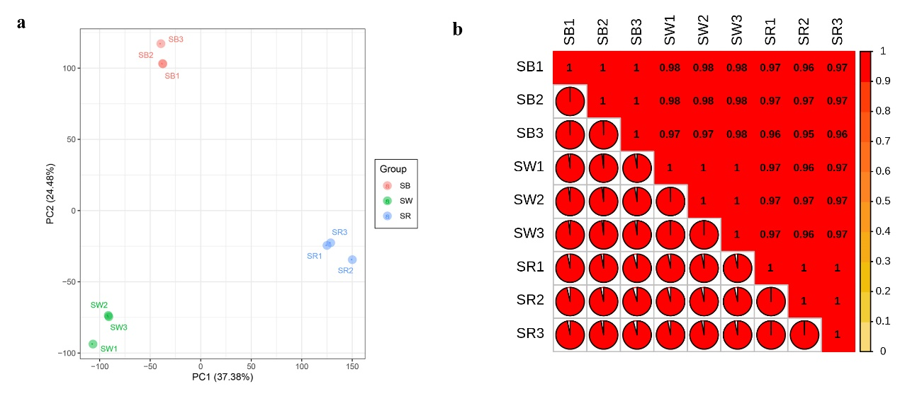
Additional file 4: Figure S3. Principal component analysis and correlation analysis of transcriptome data
a. Principal component analysis among samples. b. Correlation analysis among samples.

