Supplemental Table S1. H2AX genes expression in wild-type and dme endosperm

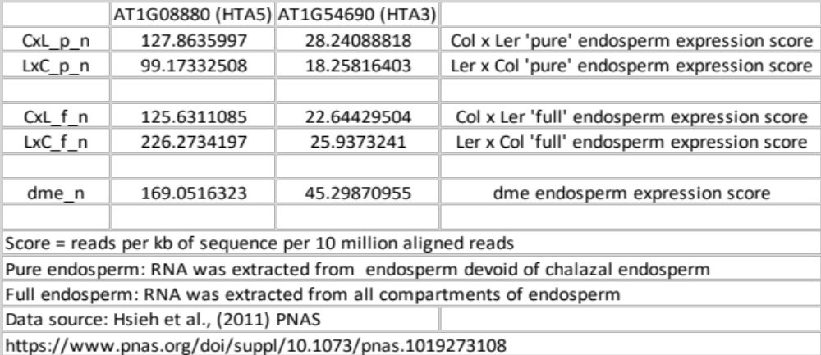

Supplemental Table S2. BS-seq dataset information

