Table S5: The structural features of motif 1-8
Name | E-value | Sites | Width | Amino acid sequence | Logo
Motif 1 | 2.8e-27 | 54 | 21 | WRKYGQKVVKGNPYPRSYYRC | 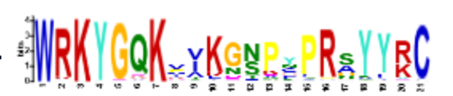
Motif 2 | 3.6e-21 | 40 | 19 | RASEDPSIVITTYEGEHNH | 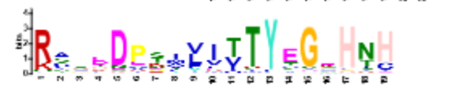
Motif 3 | 1.0e-20 | 48 | 29 | KAKSZKTVREPRVVVQTRSEVDILDDGYR | 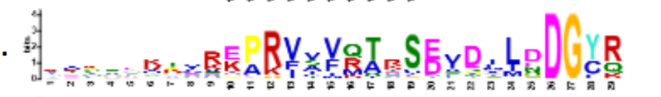
Motif 4 | 1.6e-12 | 44 | 11 | APGCPVRKQVZ | 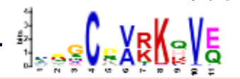
Motif 5 | 4.6e-51 | 53 | 43 | KASDDGYNWRKYGQKQVKGSEFPRSYYKCTHPNCPVKKKVERS
Motif 6 | 4.3e-409 | 54 | 40 | LDGQITEIIYKGTHNHPKPQPSRRNSSSSSMSVSEERSSD | 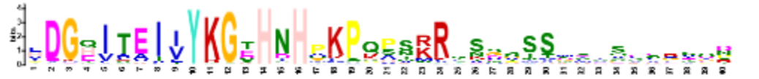
Motif 7 | 3.3e-403 | 51 | 41 | QLEQLQTELKRVKSENKKLKZMLSEVTKNYTALQMQLVALM | 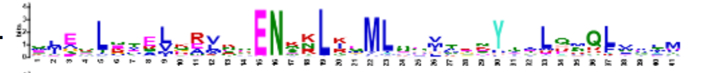
Motif 8 | 7.4e-277 | 30 | 26 | VSAATAAITADPNFTAALAAAISSJI | 