Additional file 2
Fig. S1. Maximum likelihood tree of Impatiens sect. Impatiens inferred from concatenated nucleotide sequences of 80 plastid coding genes. Numbers above the branches are the bootstrap values.
Fig. S2. Bayesian inference tree of Impatiens sect. Impatiens inferred from concatenated nucleotide sequences of 80 plastid coding genes. Numbers above the branches are the bootstrap values.
Fig. S3. ML tree of Impatiens sect. Impatiens obtained from IQ-TREE. Numbers above the branches are the SH-aLRT test value (SH-aLRT) and the ultrafast bootstrap value (UFboot).
Fig. S4. Chronogram of Impatiens. Numbers above the branches are the divergence time. Blue bars indicate the 95% highest posterior density intervals. Q.=Quatemary, P.=Pliocene.
Fig. S5. Lineage-through-time plot for Impatiens sect. Impatiens.
Fig. S6. Diversification rates of clades of Impatiens sect. Impatiens. (A) Clade I; (B) Clade II; (C) Clade III; (D) Clade IV; (E) Clade V; (F) Clade VI; (G) Clade VII.
Fig. S7. Distribution pattern of the species richness of Impatiens sect. Impatiens.
Fig. S8. Principal component analysis of the environmental factors relevant to Impatiens sect. Impatiens.
Fig. S9. Gravel diagram of principal component analysis.
Fig. S10. Five geographical regions of Impatiens sect. Impatiens (A) Northwest China; (B) Hengduan Mountains; (C) Southeast China; (D) temperate Eurasia; (E) North America.
Fig. S1. Maximum likelihood tree of Impatiens sect. Impatiens inferred from concatenated nucleotide sequences of 80 plastid coding genes. Numbers above the branches are the bootstrap values.
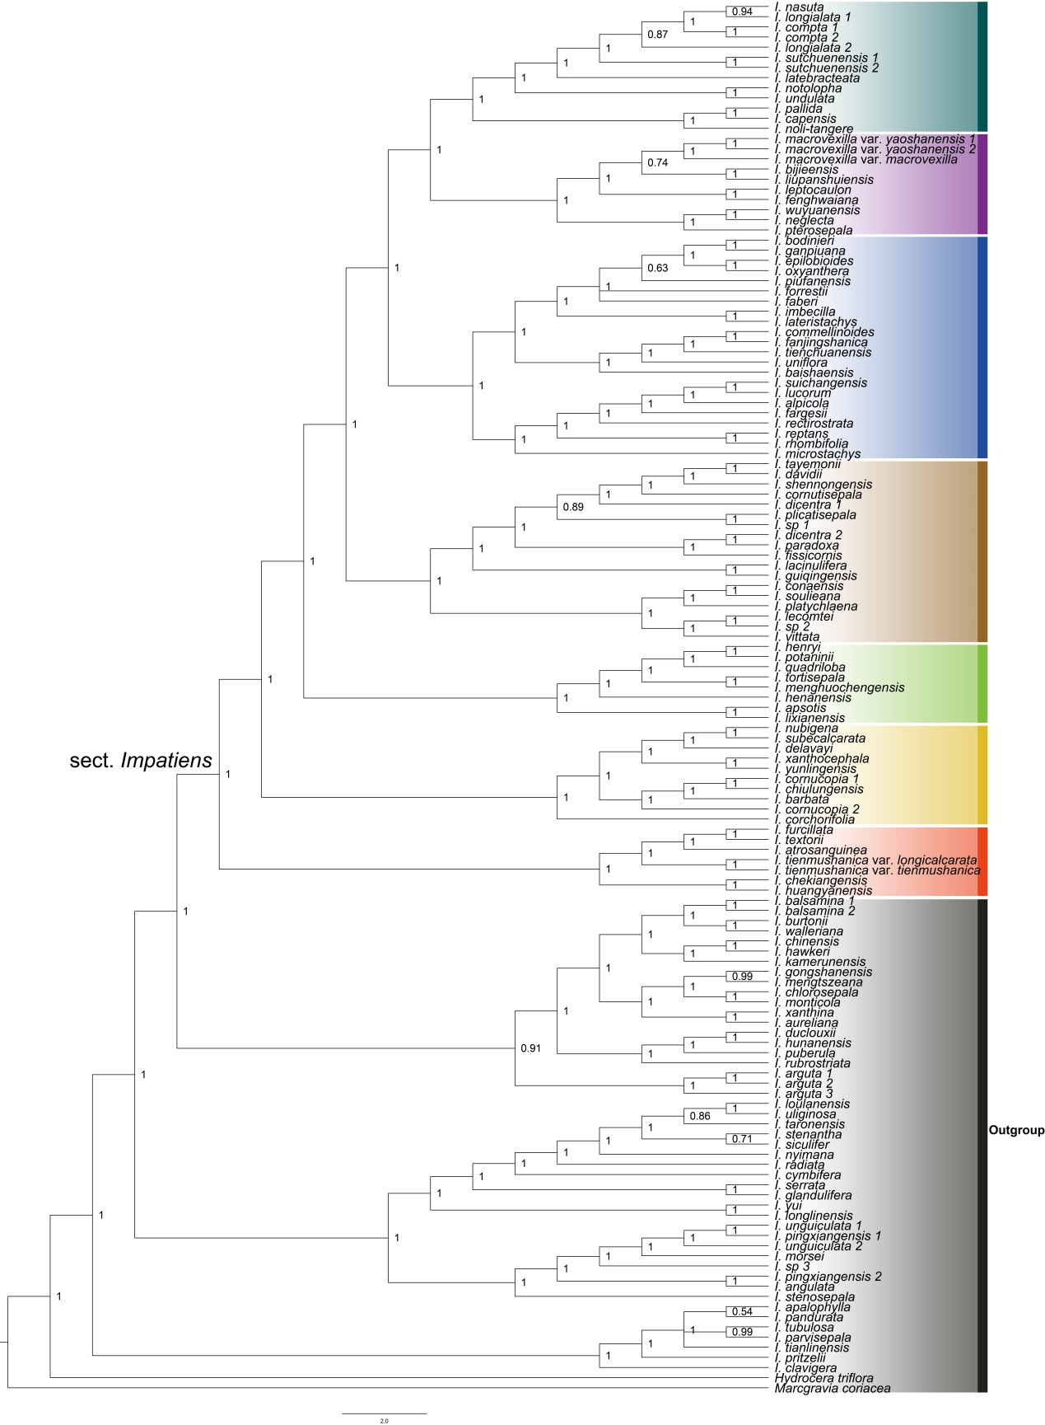
Fig. S2. Bayesian inference tree of Impatiens sect. Impatiens inferred from concatenated nucleotide sequences of 80 plastid coding genes. Numbers above the branches are the bootstrap values.
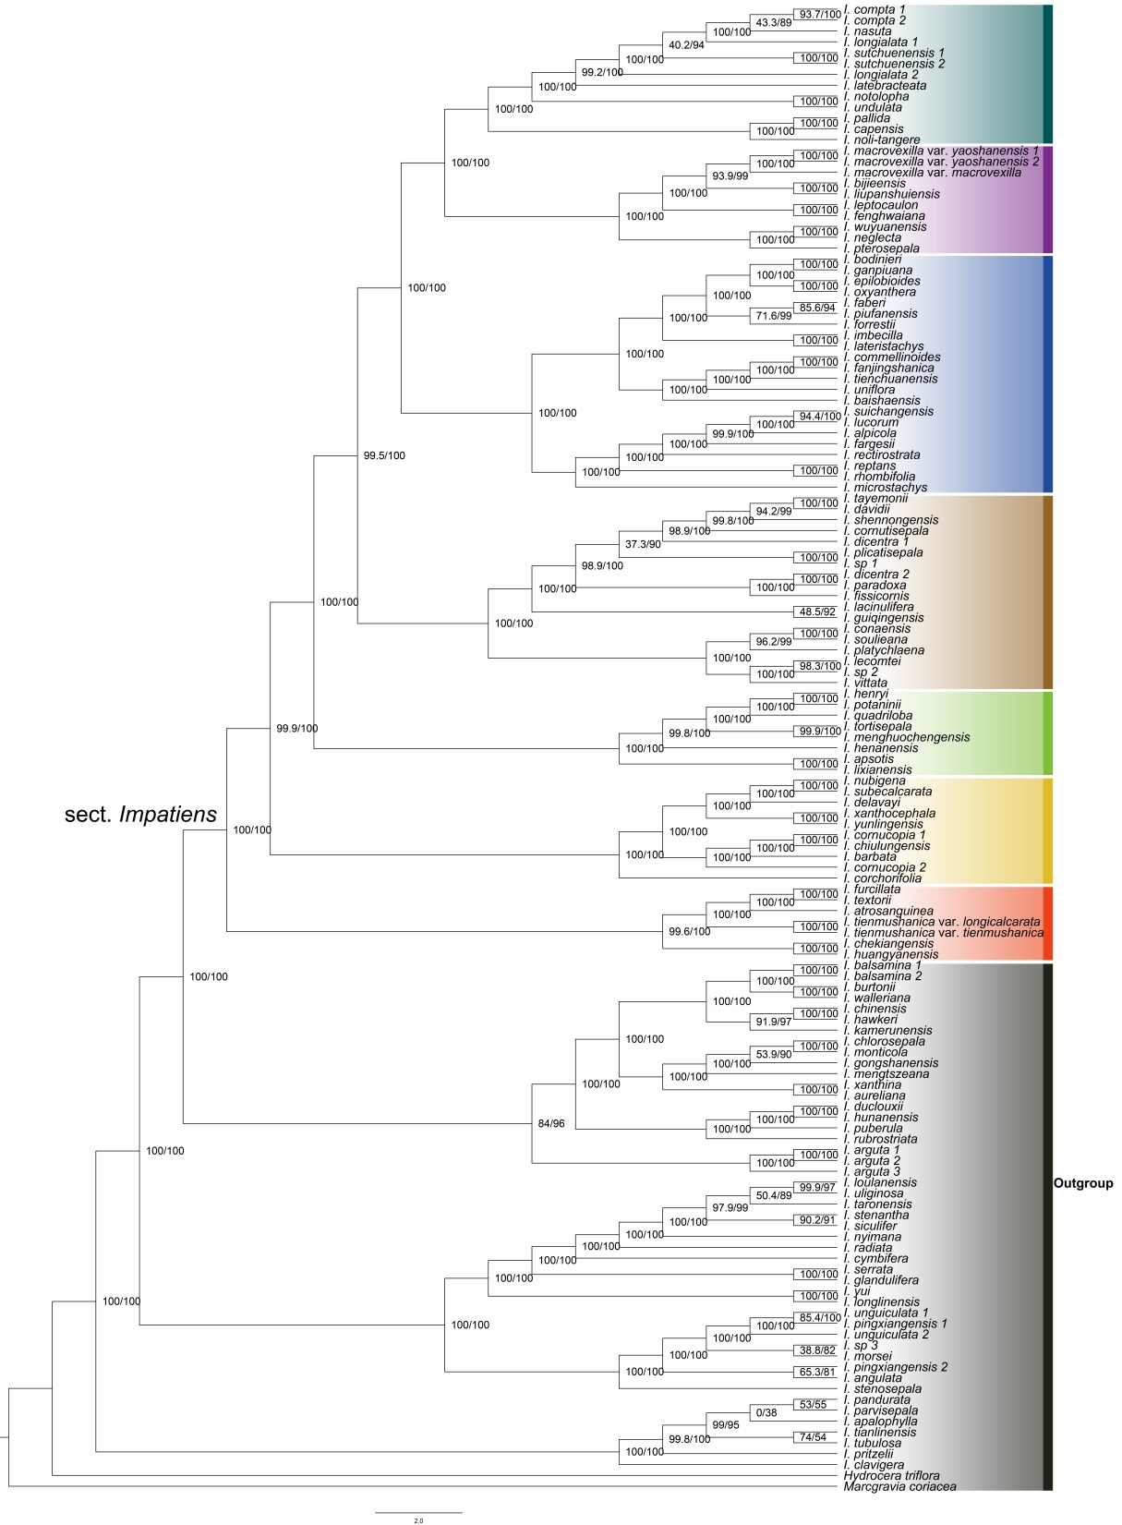
Fig. S3. ML tree of Impatiens sect. Impatiens obtained from IQ-TREE. Numbers above the branches are the SH-aLRT test value (SH-aLRT) and the ultrafast bootstrap value (UFboot).
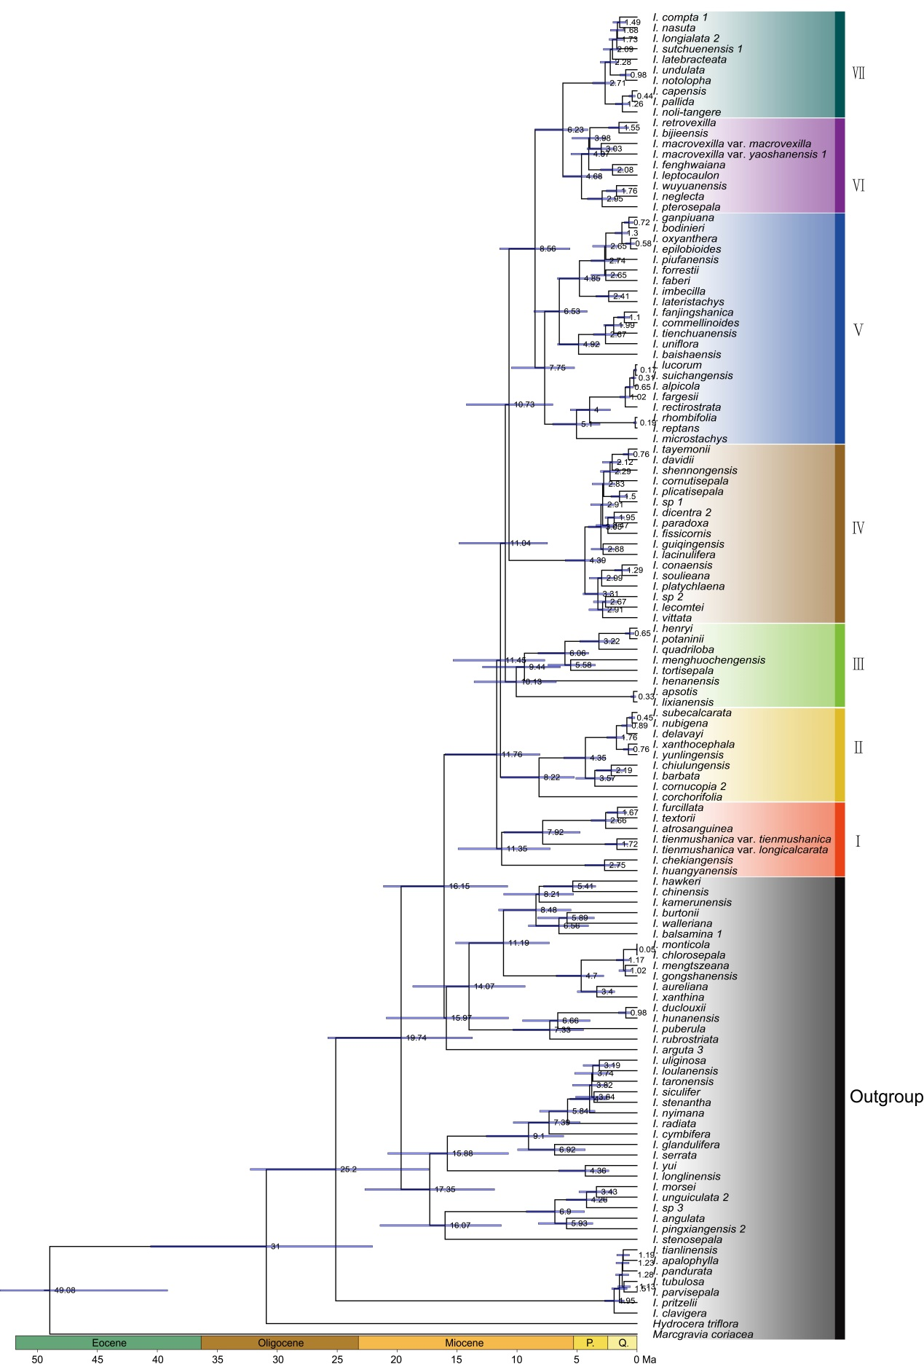
Fig. S4. Chronogram of Impatiens. Numbers above the branches are the divergence time. Blue bars indicate the 95% highest posterior density intervals. Q.=Quatemary, P.=Pliocene.
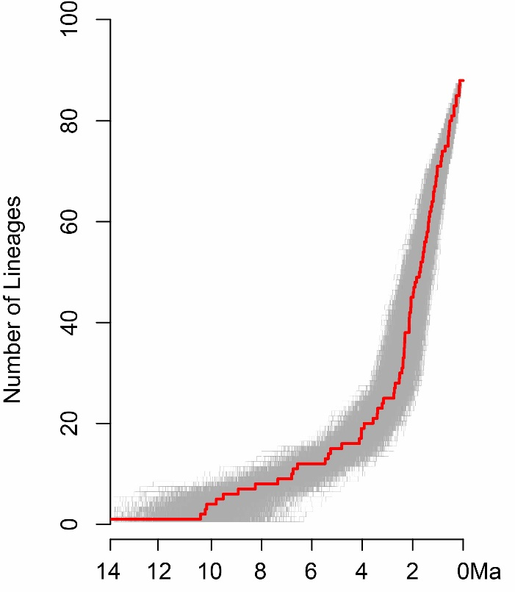
Fig. S5. Lineage-through-time plot for Impatiens sect. Impatiens.
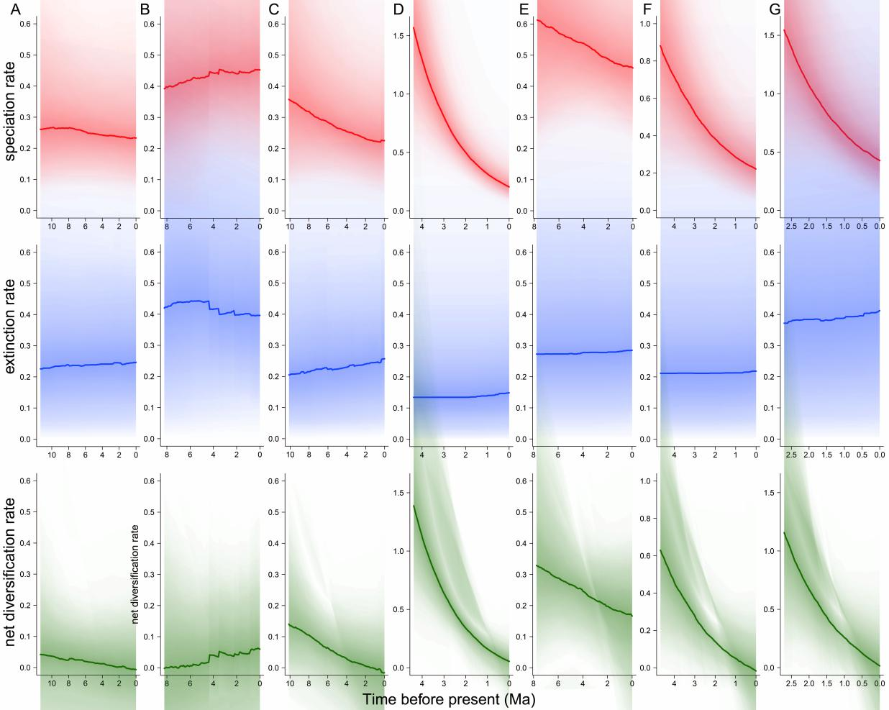
Fig. S6. Diversification rates of clades of Impatiens sect. Impatiens. (A) Clade I; (B) Clade II; (C) Clade III; (D) Clade IV; (E) Clade V; (F) Clade VI; (G) Clade VII.
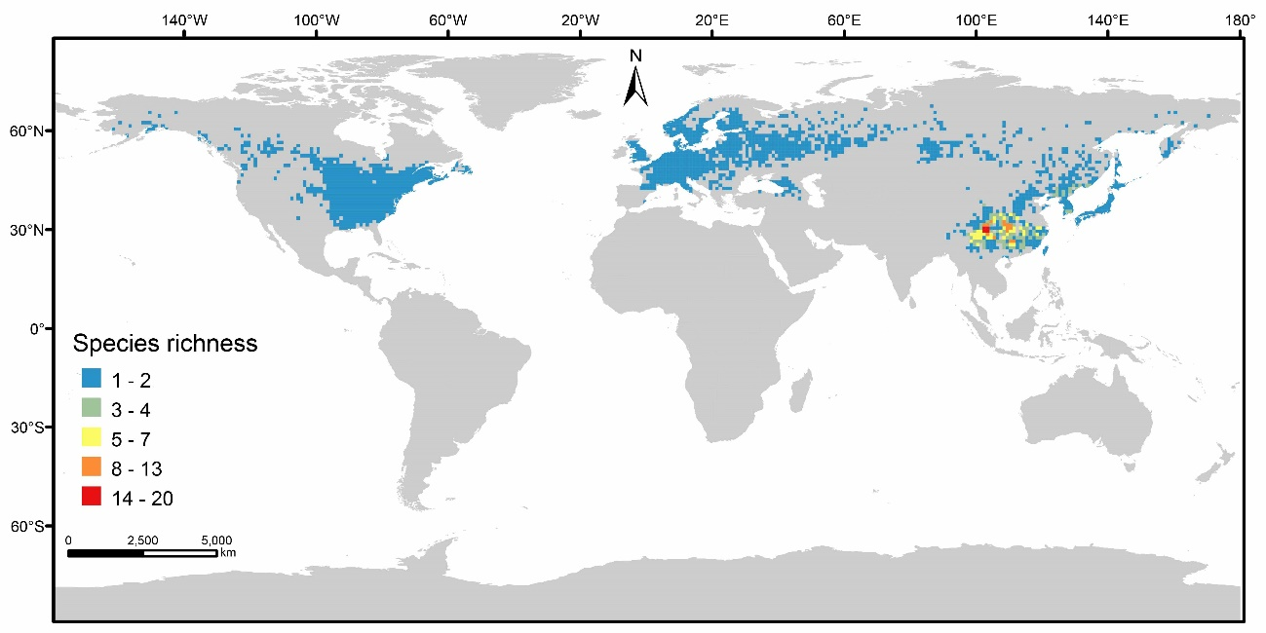
Fig. S7. Distribution pattern of the species richness of Impatiens sect. Impatiens. The map used in this study was downloaded from DIVA-GIS (http://www.diva-gis.org/Data).
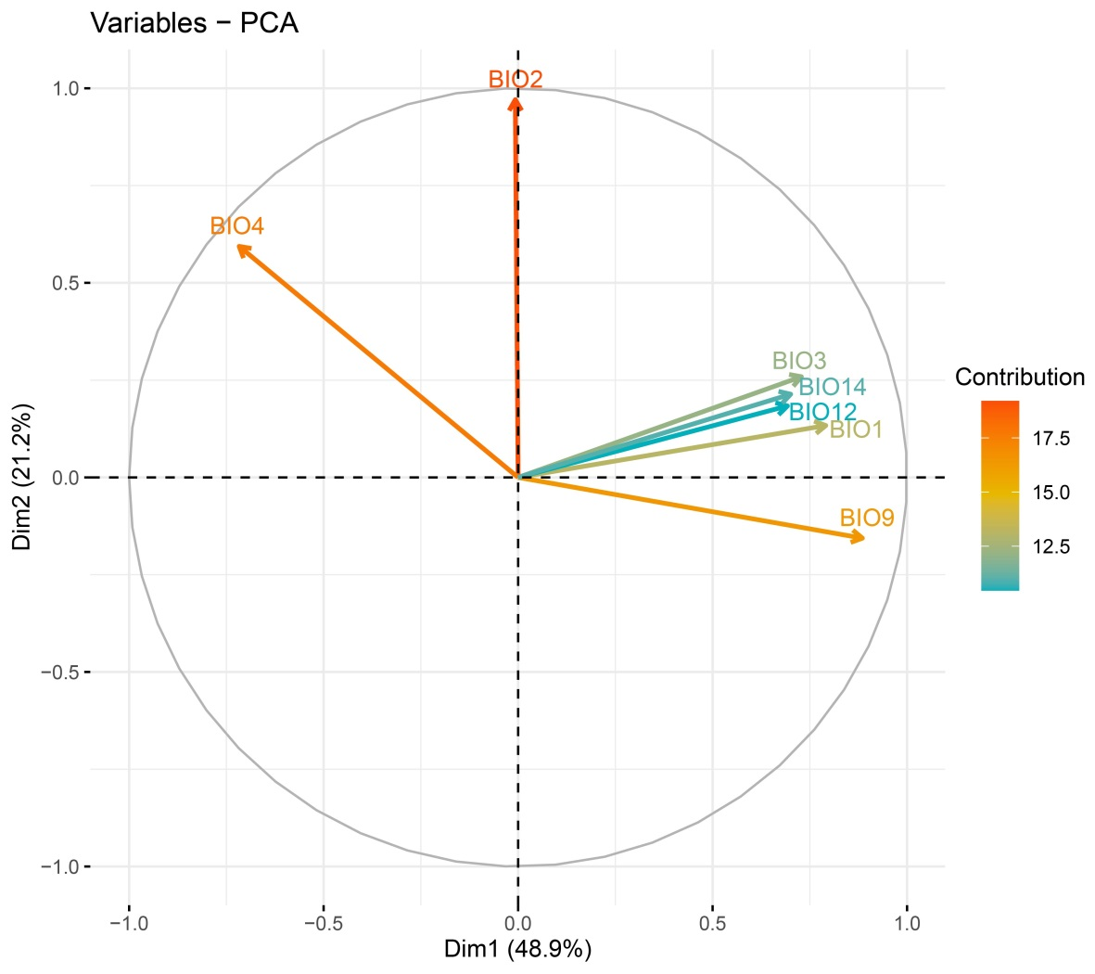
Fig. S8. Principal component analysis of the environmental factors relevant to Impatiens sect. Impatiens.
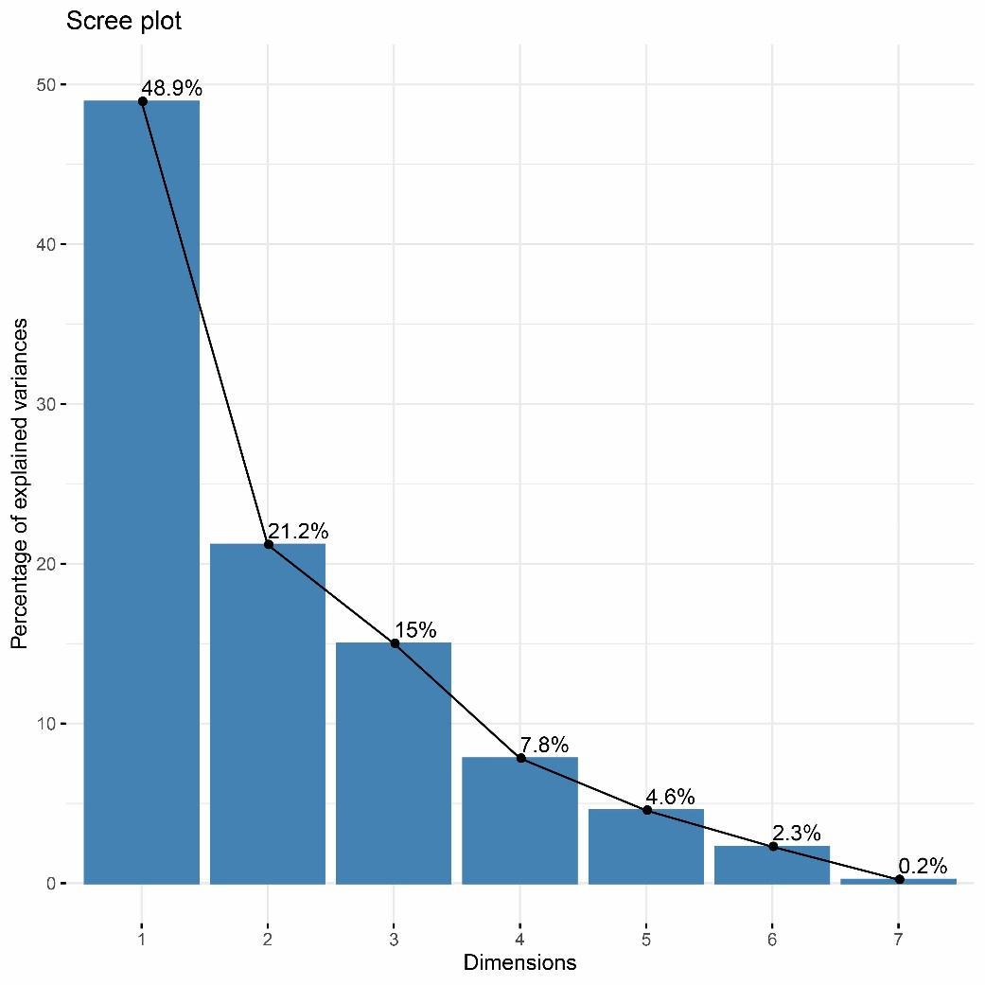
Fig. S9. Gravel diagram of principal component analysis.
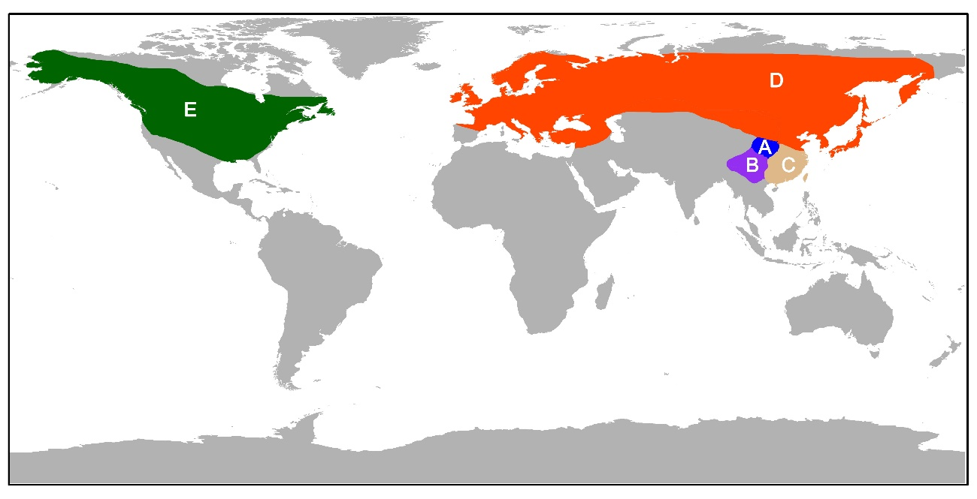
Fig. S10. Five geographical regions of Impatiens sect. Impatiens (A) Northwest China; (B) Hengduan Mountains; (C) Southeast China; (D) temperate Eurasia; (E) North America. The map used in this study was downloaded from DIVA-GIS (http://www.diva-gis.org/Data).

