Supplementary Material

Plastome phylogenomics and morphological traits analyses provide new insights into the phylogenetic position, species delimitation and speciation of Triplostegia (Caprifoliaceae)

Running title: Plastome phylogenomics of Triplostegia (Caprifoliaceae)

Qing-Li Fu¹, Zhi-Qiong Mo², Xiao-Guo Xiang^{1, 3}, Richard I. Milne⁴, Hans Jacquemyn⁵, Kevin S. Burgess⁶, Ya-Nan Sun¹, Hua Yan^{1, 3}, Li Qiu¹, Bo-Yun Yang¹, Shao-Lin Tan¹*

¹ Jiangxi Province Key Laboratory of Plant Resources, School of Life Sciences, Nanchang University, Nanchang, Jiangxi, 330031, China
² CAS Key Laboratory for Plant Diversity and Biogeography of East Asia, Kunming Institute of Botany, Chinese Academy of Sciences, Kunming, Yunnan, 650201, China
³ Jiangxi Province Key Laboratory of Watershed Ecosystem Change and Biodiversity, Institute of Life Science, Nanchang University, Nanchang, Jiangxi, 330031, China
⁴ Institute of Molecular Plant Sciences, School of Biological Sciences, University of Edinburgh, Edinburgh EH9 3JH, UK
⁵ KU Leuven, Department of Biology, Plant Conservation and Population Biology, B-3001 Leuven, Belgium
⁶ College of Letters and Sciences, Columbus State University, University System of Georgia, Columbus, GA 31907-5645, USA

*Author for correspondence: Shao-Lin Tan
E-mail: tanshaolin@ncu.edu.cn, ORCID: https://orcid.org/0000-0001-9977-7773

We compared the IR/SSC and IR/LSC junction regions of the 33 Triplostegia plastid genomes (Fig. S4). These junction regions contain seven genes: rpl2, rpl23, trnN, ndhF, ycf1, trnI, and trnH. Specifically, the rpl2 gene was located in the LSC region, approximately 152 bp from the LSC/IRb junction (JLB) in all three species. The length of the rpl2 gene ranged from 1506 to 1508 bp in T. glandulifera and 1505 bp in both Triplostegia sp. A and T. grandiflora. The rpl23 gene spanned the JLB, with 134bp in the LSC region and 151bp in the IRb region in all three species. The trnN gene was located in the IRb region, approximately 957–1034 bp (T. glandulifera), 1104–1109bp (Triplostegia sp. A), and 1335 bp (T. grandiflora) away from the IRb/SSC junction (JSB) in all three species. The ndhF gene was located in the SSC region, positioned around 268–289 bp (T. glandulifera), 258 bp (Triplostegia sp. A), and 187 bp (T. grandiflora) away from the IRb/SSC junction (JSB). The ycf1 gene spanned the SSC/IRa junction (JSA), with 4734–4753 bp (T. glandulifera), 4671–4680 bp (Triplostegia sp. A), and 4511 bp (T. grandiflora) in the SSC region, and 173–459 bp (T. glandulifera), 255–504 bp (Triplostegia sp. A), and 685–730 bp (T. grandiflora) in the IRa region. The trnN gene was located in the IRa region, positioned approximately 957–1034 bp (T. glandulifera), 1104–1109 bp (Triplostegia sp. A), and 1335 bp (T. grandiflora) away from the JSA. The trnI gene was located in the IRa region, approximately 316 bp from the LSC/IRa junction (JLA) in all three species. Finally, the trnH gene was found in the LSC region, with a distance of 75–84bp away from the JLA for T. glandulifera, and 69 bp away from the JLA for both Triplostegia sp. A and T. grandiflora.
Table S1. Sampling information of the 33 Triplostegia plastid genomes analyzed in this study, including 11 recently published plastid genomes.
Species | Locality | Accession No. | Voucher | Longitude(°E) | latitude(°N) | Altitude(m) | References
T. glandulifera | Shennongjia, Hubei | SRS3196653 | Lu289 | 110.0378 | 31.5176 | 1839 | Niu et al. 2018
T. glandulifera | Luding, Sichuan | SRS3196654 | Lu165 | 101.9816 | 29.5692 | 3256 | Niu et al. 2018
T. glandulifera | Hehuanxibudao, Taiwan | SRS3196655 | Zhong463 | 121.2943 | 24.1544 | 2600 | Niu et al. 2018
T. glandulifera | Nantou, Taiwan | SRS3196656 | Chen2011056 | 121.2979 | 24.5424 | 3100 | Niu et al. 2018
T. glandulifera | Leibo, Sichuan | SRS3196657 | Chen20110804294 | 103.1794 | 28.2471 | 2500 | Niu et al. 2018
T. glandulifera | Wolong, Sichuan | SRS3196658 | WL0142 | 103.2275 | 31.0774 | 2900 | Niu et al. 2018
T. glandulifera | Cuona, Xizang | SRS3196663 | Yu34 | 91.8066 | 27.8752 | 2600 | Niu et al. 2018
T. grandiflora | Shangri-La, Yunnan | OP554470 | TSL20893 | 100.1190833 | 27.39090833 | 2975 | This study
T. grandiflora | Shangri-La, Yunnan | OP562874 | TSL201082 | 100.0904511 | 27.6128252 | 3105 | This study
T. grandiflora | Deqin, Yunnan | OP562875 | TSL201385 | 99.4219864 | 27.8260989 | 3052 | This study
T. grandiflora | Deqin, Yunnan | OP562876 | TSL201482 | 99.3748208 | 27.7898489 | 2751 | This study
T. grandiflora | Yulong, Yunnan | OP562877 | TSL201602 | 99.67214722 | 27.160025 | 2990 | This study
T. grandiflora | Yulong, Yunnan | OP562878 | TSL201740 | 99.83834722 | 26.81063611 | 2102 | This study
T. grandiflora | Yulong, Yunnan | OP562879 | TSL201772 | 99.75290524 | 26.81161218 | 2856 | This study
T. grandiflora | Yulong, Yunnan | OP562880 | TSL202291 | 100.1974743 | 26.99848295 | 2713 | This study
T. grandiflora | Muli, Sichuan | SRS3196659 | Lu102 | 101.0355 | 28.0563 | 2400 | Niu et al. 2018
Triplostegia sp. A | Yulong, Yunnan | OP562881 | TSL20213 | 100.347125 | 27.432468 | 3373 | This study
Triplostegia sp. A | Shangri-La, Yunnan | OP583908 | TSL20552 | 100.0619 | 27.24074167 | 3436 | This study
Triplostegia sp. A | Shangri-La, Yunnan | OP583909 | TSL20785 | 100.0921889 | 27.39576389 | 3391 | This study
Triplostegia sp. A | Shangri-La, Yunnan | OP583910 | TSL20922 | 100.0192556 | 27.55766389 | 3392 | This study
Triplostegia sp. A | Shangri-La, Yunnan | OP583911 | TSL201048 | 100.110559 | 27.6237001 | 3062 | This study
Triplostegia sp. A | Shangri-La, Yunnan | OP583912 | TSL201190 | 99.620946 | 27.7321188 | 3571 | This study
Triplostegia sp. A | Deqin, Yunnan | OP583913 | TSL201430 | 99.3435751 | 27.793723 | 3411 | This study
Triplostegia sp. A | Yulong, Yunnan | OP583914 | TSL201546 | 99.41807778 | 27.43534722 | 3143 | This study
Triplostegia sp. A | Yulong, Yunnan | OP583915 | TSL201623 | 99.67224167 | 27.16029444 | 3038 | This study
Triplostegia sp. A | Yulong, Yunnan | OP583916 | TSL201785 | 99.7523988 | 26.81373906 | 2914 | This study
Triplostegia sp. A | Ninglang, Yunnan | OP583917 | TSL201851 | 100.5500982 | 27.77732832 | 3566 | This study
Triplostegia sp. A | Ninglang, Yunnan | OP583918 | TSL202113 | 100.712959 | 27.34112669 | 3087 | This study
Triplostegia sp. A | Ninglang, Yunnan | OP583919 | TSL202158 | 100.5658402 | 27.15988362 | 2773 | This study
Triplostegia sp. A | Yulong, Yunnan | OP583920 | TSL202293 | 100.1974948 | 27.99814193 | 2737 | This study
T. glandulifera | Linzhi, Xizang | SRS3196660 | Chen20110804086 | 94.4939 | 29.5765 | 3200 | Niu et al. 2018
T. glandulifera | Jilong, Xizang | SRS3196661 | CMTTE937 | 85.305 | 28.859 | 3200 | Niu et al. 2018
T. glandulifera | Gesala, Yunnan | SRS3196662 | Lu53 | 101.2487 | 27.1578 | 2876 | Niu et al. 2018

Table S2. NCBI accession numbers for the 57 plastid genomes used in the phylogenetic reconstruction of Dipsacales in this study.
Families | Species | NCBI accession numbers
Caprifoliaceae | Dipsacus asper Wall. ex DC. | NC039748
Caprifoliaceae | Dipsacus japonicus Miq. | MZ934745
Caprifoliaceae | Scabiosa tschiliensis Grüning | NC045050
Caprifoliaceae | Scabiosa comosa Fisch. ex Roem. & Schult. | NC065840
Caprifoliaceae | Pterocephalus hookeri (C.B.Clarke) Airy Shaw & M.L.Green | NC045049
Caprifoliaceae | Triplostegia glandulifera Wall. ex DC. SRS3196654 | SRS3196654
Caprifoliaceae | Triplostegia glandulifera Wall. ex DC. SRS3196656 | SRS3196656
Caprifoliaceae | Triplostegia glandulifera Wall. ex DC. SRS3196657 | SRS3196657
Caprifoliaceae | Triplostegia grandiflora Gagnep. TSL201772 | OP562879
Caprifoliaceae | Triplostegia grandiflora Gagnep. TSL201602 | OP562877
Caprifoliaceae | Triplostegia grandiflora Gagnep. TSL202291 | OP562880
Caprifoliaceae | Triplostegia sp. A TSL201190 | OP583912
Caprifoliaceae | Triplostegia sp. A TSL20552 | OP583908
Caprifoliaceae | Triplostegia sp. A TSL202158 | OP583919
Caprifoliaceae | Valeriana officinalis L. | NC045052
Caprifoliaceae | Valeriana jatamansi Jones | NC067975
Caprifoliaceae | Patrinia heterophylla Bunge | NC045047
Caprifoliaceae | Patrinia monandra C. B. Clarke | NC061006
Caprifoliaceae | Kolkwitzia amabilis Graebn. | NC029874
Caprifoliaceae | Diabelia sanguinea (Makino) Landrein | NC045193
Caprifoliaceae | Dipelta yunnanensis Franch. | NC042201
Caprifoliaceae | Abelia chinensis R. Br. | NC_045043
Caprifoliaceae | Linnaea borealis L. | MN548092
Caprifoliaceae | Acanthocalyx alba (Hand.-Mazz.) M.J.Cannon | NC045055
Caprifoliaceae | Acanthocalyx nepalensis (D. Don) M. Cannon | MW053690
Caprifoliaceae | Morina longifolia Wall. ex DC | NC045046
Caprifoliaceae | Morina chinensis Y.Y.Pai | NC069295
Caprifoliaceae | Zabelia dielsii (Graebn.) Makino | NC046599
Caprifoliaceae | Zabelia biflora (Turcz.) Makino ex Hisauti & H.Hara | NC045063
Caprifoliaceae | Lonicera ferdinandi Franch. | NC040963
Caprifoliaceae | Lonicera japonica Thunb. | MZ779026
Caprifoliaceae | Lonicera tangutica Maxim. | OP388442
Caprifoliaceae | Lonicera confusa DC. | NC045045
Caprifoliaceae | Symphoricarpos sinensis Rehder | NC054265
Caprifoliaceae | Leycesteria formosa Wall. | NC057000
Caprifoliaceae | Triosteum pinnatifidum Maxim. | NC037952
Caprifoliaceae | Triosteum himalayanum Wall. | NC045219
Caprifoliaceae | Heptacodium miconioides Rehd. | NC042739
Caprifoliaceae | Weigela florida (Bunge) A. DC. | NC037950
Caprifoliaceae | Diervilla sessilifolia Buckley | NC064360
Adxoxaceae | Viburnum dilatatum Thunb. | NC057163
Adxoxaceae | Viburnum cylindricum Buch-Ham. ex D. Don | ON881798
Adxoxaceae | Viburnum opulus L. | LT996894
Adxoxaceae | Viburnum carlesii Hemsl. | MN985820
Adxoxaceae | Viburnum utile Hemsl. | NC032296
Adxoxaceae | Tetradoxa omeiensis (H.Hara) C.Y.Wu | NC034793
Adxoxaceae | Adoxa moschatellina L. | NC034792
Adxoxaceae | Sinadoxa corydalifolia C.Y.Wu, Z.L.Wu & R.F.Huang | NC032040
Adxoxaceae | Sambucus nigra L. | NC045061
Adxoxaceae | Sambucus javanica Reinw. ex Blume | MT457822
Adxoxaceae | Sambucus williamsii Hance | NC033878
Adxoxaceae | Sambucus adnata Wall. | MW007718
Paracryphiaceae | Quintinia verdonii F.Muell. | NC041281
Apiaceae | Apium graveolens L. | NC041087
Pittosporaceae | Pittosporum kerrii Craib | NC046847
Pedaliaceae | Sesamum indicum L. | NC016433
Lamiaceae | Mentha spicata L. | NC037247

Table S3. NCBI accession numbers of plastid genomes used to estimate the divergence time of Dipsacales.
Families | Species | NCBI accession numbers
Caprifoliaceae | Linnaea borealis L. | MN548092
Caprifoliaceae | Kolkwitzia amabilis Graebn. | NC029874
Caprifoliaceae | Dipelta yunnanensis Franch. | NC042201
Caprifoliaceae | Diabelia sanguinea (Makino) Landrein | NC045193
Caprifoliaceae | Zabelia dielsii (Graebn.) Makino | NC046599
Caprifoliaceae | Dipsacus asper Wall. ex DC | NC039748
Caprifoliaceae | Scabiosa tschiliensis Grüning | NC045050
Caprifoliaceae | Pterocephalus hookeri (C. B. Clarke) Airy Shaw & M.L.Green | NC045049
Caprifoliaceae | Triplostegia glandulifera Wall. ex DC. | SRS3196654
Caprifoliaceae | Triplostegia sp. A | OP583912
Caprifoliaceae | Triplostegia grandiflora Gagnep. | OP562877
Caprifoliaceae | Patrinia heterophylla Bunge | NC045047
Caprifoliaceae | Valeriana officinalis L. | NC045052
Caprifoliaceae | Morina longifolia Wall. ex DC. | NC045046
Caprifoliaceae | Acanthocalyx alba (Hand.-Mazz.) M.J.Cannon | NC045055
Caprifoliaceae | Triosteum pinnatifidum Maxim. | NC037952
Caprifoliaceae | Symphoricarpos sinensis Rehder | NC054265
Caprifoliaceae | Leycesteria formosa Wall. | NC057000
Caprifoliaceae | Lonicera ferdinandi Franch. | NC040963
Caprifoliaceae | Heptacodium miconioides Rehder | NC042739
Caprifoliaceae | Weigela florida (Bunge) A.DC. | NC037950
Caprifoliaceae | Diervilla sessilifolia Buckley | NC064360
Adoxaceae | Sinadoxa corydalifolia C.Y.Wu, Z.L.Wu & R.F.Huang | NC032040
Adoxaceae | Adoxa moschatellina L. | NC034792
Adoxaceae | Tetradoxa omeiensis (H.Hara) C. Y. Wu | NC034793
Adoxaceae | Sambucus nigra L. | NC045061
Adoxaceae | Viburnum dilatatum Thunb. | NC057163
Apiaceae | Apium graveolens L. | NC041087
Pittosporaceae | Pittosporum kerrii Craib | NC046847
Pedaliaceae | Sesamum indicum L. | NC016433
Lamiaceae | Mentha spicata L. | NC037247

Table S4. Selection of the best-fit nucleotide substitution model using ModelTest v.3.7 based on the Akaike information criterion (AIC).
Model | -lnL | K | AIC | delta | Weight | CumWeight
GTR+I+G | 232760.6 | 10 | 465541.2 | 0 | 1 | 1
GTR+G | 232907.7 | 9 | 465833.5 | 292.3125 | 0.00E+00 | 1
GTR+I | 233179.5 | 9 | 466377 | 835.875 | 0.00E+00 | 1
HKY+I+G | 233868.7 | 6 | 467749.4 | 2208.281 | 0.00E+00 | 1
HKY+G | 234022.9 | 5 | 468055.7 | 2514.563 | 0.00E+00 | 1
HKY+I | 234266.5 | 5 | 468543.1 | 3001.906 | 0.00E+00 | 1
SYM+I+G | 234340.3 | 7 | 468694.6 | 3153.406 | 0.00E+00 | 1
SYM+G | 234509.9 | 6 | 469031.8 | 3490.656 | 0.00E+00 | 1
SYM+I | 234761 | 6 | 469534.1 | 3992.906 | 0.00E+00 | 1
K80+I+G | 235068.9 | 3 | 470143.8 | 4602.594 | 0.00E+00 | 1
K80+G | 235242.4 | 2 | 470488.8 | 4947.594 | 0.00E+00 | 1
K80+I | 235490.9 | 2 | 470985.8 | 5444.625 | 0.00E+00 | 1
F81+I+G | 237832.3 | 5 | 475674.6 | 10133.41 | 0.00E+00 | 1
F81+G | 237985.1 | 4 | 475978.1 | 10436.97 | 0.00E+00 | 1
F81+I | 238224.4 | 4 | 476456.8 | 10915.66 | 0.00E+00 | 1
GTR | 238886.1 | 8 | 477788.2 | 12247.03 | 0.00E+00 | 1
JC+I+G | 238898.6 | 2 | 477801.2 | 12260.03 | 0.00E+00 | 1
JC+G | 239061.7 | 1 | 478125.4 | 12584.22 | 0.00E+00 | 1
JC+I | 239305.6 | 1 | 478613.2 | 13072.03 | 0.00E+00 | 1
HKY | 240109.9 | 4 | 480227.8 | 14686.59 | 0.00E+00 | 1
SYM | 240678.9 | 5 | 481367.9 | 15826.72 | 0.00E+00 | 1
K80 | 241500.1 | 1 | 483002.3 | 17461.09 | 0.00E+00 | 1
F81 | 244064.4 | 3 | 488134.8 | 22593.59 | 0.00E+00 | 1
JC | 245236.9 | 0 | 490473.8 | 24932.69 | 0.00E+00 | 1
Note: -lnL: negative log likelihood, K: number of estimated (free) parameters, AIC: Akaike Information Criterion, delta: Akaike difference, weight: Akaike weight, cumWeight: cumulative Akaike weight

Table S5. The environmental variables used in MaxEnt model.
Code | Description | Units
Bio1 | Annual mean temperature | ℃
Bio2 | Mean monthly temperature difference | ℃
Bio3 | Isothermality（Bio2/Bio7）(*100) | –
Bio4 | Temperature Seasonality (standard deviation*100) | –
Bio5 | Maximum temperature of warmest month | ℃
Bio6 | Minimum temperature of coldest month | ℃
Bio7 | Temperature annual range | ℃
Bio8 | Mean temperature of wettest quarter | ℃
Bio9 | Mean temperature of driest quarter | ℃
Bio10 | Mean temperature of warmest quarter | ℃
Bio11 | Mean temperature of coldest quarter | ℃
Bio12 | Annual precipitation | mm
Bio13 | Precipitation of wettest period | mm
Bio14 | Precipitation of driest period | mm
Bio15 | Precipitation seasonality | –
Bio16 | Precipitation of wettest quarter | mm
Bio17 | Precipitation of driest quarter | mm
Bio18 | Precipitation of warmest quarter | mm
Bio19 | Precipitation of coldest quarter | mm

Table S6. Chloroplast genes of Triplostegia.
Category | Gene Groups | Gene Names
RNA genes | Ribosomal RNA genes (rRNA) | rrn16ª、rrn23 ª、rrn4.5 ª、rrn5 ª
RNA genes |  | trnH-GUG trnK-UUU⁺ trnQ-UUG trnS-GCU trnG-GCC trnR-UCU trnC-GCA trnD-GUC trnY-GUA trnE-UUC trnT-GGU trnS-UGA trnG-UCC trnfM-CAU trnS-GGA trnT-GUG trnL-UAA⁺ trnF-GAA trnV-UAC⁺ trnM-CAU trnW-CCA trnP-UGG trnI-CAUª trnL-CAAª trnV-GACª trnI-GAU^{+,a} trnA-UGC^{+,a} trnR-ACGª trnN-GUUª trnL-UAG
RNA genes | Transfer RNA genes (tRNA)
Ribosomal proteins | Small ribosomal subunit | rps16⁺ rps2 rps14 rps4 rps18 rps12^{+,a} rps11 rps8 rps3 rps19 rps7ª rps15
Transcription | Large ribosomal subunit | rpl33 rpl20 rpl36 rpl14 rpl16⁺ rpl22 rpl2⁺ rpl23ª rpl32
Transcription | DNA dependent RNA polymerase | rpoC2 rpoC1⁺ rpoB rpoA
Protein-coding genes | Photosystem I | psaB psaA psaI psaJ psaC
Protein-coding genes | Photosystem II | psbA psbK psbI psbM psbD psbC psbZ psbJ psbL psbF psbE psbB psbT psbN psbH
Protein-coding genes | Subunit of cytochrome | petN petA petL petG petB⁺ petD⁺
Protein-coding genes | Subunit of synthase | atpA atpF⁺ atpH atpI atpE atpB
Protein-coding genes | Large subunit of Rubisco | rbcL
Protein-coding genes | NADH dehydrogenase | ndhJ ndhK ndhC ndhB^{+,a} ndhF ndhD ndhE ndhG ndhI ndhA⁺ ndhH
Other genes | ATP dependent protease subunit P | clpP⁺⁺
Other genes | Chloroplast envelope membrane protein | cemA
Other genes | Maturase | matK
Other genes | Subunit of acetyl-CoA carboxylase | accD
Other genes | C-type cytochrome synthesis | ccsA
Other genes | Translation initiation factor | infA
Other genes | Conserved open reading frames | ycf3⁺⁺ ycf4 ycf2^{+,a} ycf1 ª
Note: +, Gene with one intron; ++, gene with two introns and a gene with multiple copies; a, gene with two copies.

Table S7. Species discrimination rates of Triplostegia based on highly variable plastid DNA regions and standard plant DNA barcodes using distance-based analysis. Pairwise interspecific and intraspecific genetic distances were calculated based on the Kimura 2-parameter (k2p) mode.
DNA Regions | T. glandulifera |  |  | T. grandiflora |  |  |  | Triplostegia sp. A |  | Percent species  discrimination
DNA Regions | intra k2p | inter k2p |  |  | intra k2p | inter k2p |  | intra k2p | inter k2p | Percent species  discrimination
ndhF | 0-0.0035 | 0.0044-0.0067 |  |  | 0 | 0.0004-0.0067 |  | 0 | 0.0004-0.0067 | 100
ndhF-trnN | 0-0.0078 | 0.0133-0.0440 |  |  | 0-0.0007 | 0.0239-0.0440 |  | 0 | 0.0133-0.0247 | 100
rpoB-trnC | 0-0.0063 | 0.0119-0.0151 |  |  | 0 | 0.0023-0.0151 |  | 0-0.0008 | 0.0023-0.0151 | 100
ycf1 | 0-0.0063 | 0.0076-0.0092 |  |  | 0-0.0004 | 0.0014-0.0092 |  | 0-0.0004 | 0.0014-0.0086 | 100
rbcL | 0-0.0021 | 0.0014-0.0042 |  |  | 0 | 0-0.0035 |  | 0-0.0007 | 0-0.0042 | 0
matK | 0-0.0033 | 0.0033-0.0060 |  |  | 0 | 0-0.0053 |  | 0-0.0007 | 0-0.0060 | 0
trnH-psbA | 0-0.0172 | 0-0.0172 |  |  | 0 | 0-0.0115 |  | 0-0.0057 | 0-0.0172 | 0
ITS | 0-0.0199 | 0.0132-0.0285 |  |  | 0 | 0.0133-0.0285 |  | 0-0.0065 | 0.0132-0.0266 | 66.7
Note: intra k2p, intraspecific k2p distance; inter k2p, interspecific k2p distance. A species was considered successfully discriminated if the minimum interspecific k2p distance involving this species was larger than the maximum intraspecific k2p distance of this species.

Table S8. Principle component analysis (PCA) of ten morphological traits of three Triplostegia species and their contribution to PC1, PC2, PC3, and PC4. These ten traits were measured from specimens.
Principle component |  | PC 1 | PC 2 | PC 3 | PC 4
Eigenvalues % of Variance |  | 35.95 | 23.52 | 12.51 | 7.62
Contribution of  morphological  traits to  different  components | Plant height | 0.13 | 0.38 | -0.14 | -0.69
 | Corolla length | 0.44 | 0.28 | -0.06 | 0.05
 | Leaf fission depth | -0.25 | 0.45 | 0.04 | 0.22
 | Petiole length | -0.45 | 0.10 | 0.12 | 0.08
 | Leaf length | -0.26 | 0.42 | 0.15 | < 0.01
 | Leaf width | -0.17 | 0.52 | 0.13 | 0.10
 | Root length | -0.31 | -0.14 | 0.15 | -0.67
 | Root width | 0.43 | 0.25 | -0.10 | -0.06
 | Fruit length | 0.09 | -0.11 | 0.81 | -0.05
 | Fruit width | 0.38 | 0.11 | 0.48 | 0.01

Table S9. Comparison of elevation range and eight functional traits between coexisting Triplostegia sp. A and T. grandiflora in northwest Yunnan, southwest China. Data obtained from field measurements in 2020.
Elevation and Traits | T. grandiflora |  | Triplostegia sp. A |  | W | P value
Elevation and Traits | Range | Mean ± SD | Range | Mean ± SD | W | P value
Elevation (m) | 2066-3128 | 2787 ± 312 | 2651-3954 | 3073 ± 306 | 12729 | <0.001 ***
Plant height (cm) | 14-70 | 36 ± 12 | 6-69 | 32 ± 13 | 7058.5 | 0.002 **
Chlorophyll content | 32.10-66.25 | 47.70 ± 5.93 | 18.20-44.30 | 29.83 ± 5.67 | 282 | < 0.001 ***
Leaf area (cm²) | 1.33-12.92 | 4.78 ± 2.31 | 1.89-46.56 | 8.74 ± 5.47 | 14246 | < 0.001 ***
Leaf thickness (mm) | 0.195-0.415 | 0.313 ± 0.05 | 0.125-0.300 | 0.179 ± 0.030 | 298 | < 0.001 ***
Leaf dry mass (g) | 0.007-0.078 | 0.029 ± 0.0137 | 0.005-0.151 | 0.031 ± 0.017 | 10063 | 0.1005
SLA (cm² / g) | 102.46-284.76 | 169.72 ± 34.85 | 173.40-489.09 | 281.96 ± 72.49 | 17005 | < 0.001 ***
Corolla length (mm) | 3.43-10.70 | 6.19 ± 1.52 | 1.06-2.075 | 1.573 ± 0.252 | 0 | < 0.001 ***
Corolla width (mm) | 1.94-5.95 | 3.73 ± 0.98 | 0.96-2.65 | 1.614 ± 0.335 | 16.5 | < 0.001 ***
Note: W is the Wilcoxon rank sum test value.

Table S10. Principle component analysis (PCA) of eight functional traits of coexisting T. grandiflora and Triplostegia sp. A in northwestern Yunnan, and their contribution to PC1 and PC2.
Principle component |  | PC 1 | PC 2
Eigenvalues % of Variance |  | 54.88 | 25.68
Contribution of  morphological  traits to  different  components | Plant height | 0.10 | 0.52
 | Chlorophyll concentration | 0.43 | 0.11
 | Leaf thickness | 0.43 | 0.08
 | Leaf area | -0.27 | 0.53
 | Leaf dry matter content | -0.07 | 0.65
 | Specific leaf area | -0.40 | < 0.01
 | Flower length | 0.45 | 0.06
 | Flower width | 0.44 | 0.06

Table S11. AUC mean values of simulated distribution for T. glandulifera, T. grandiflora, and Triplostegia sp. A in different time periods and future climate change scenarios.
Species |  | paleoclimatic |  |  | Current | 2090s
 |  | Last Interglacial | Last Glacial Maximum | Mid Holocene |  | SSP2-4.5 | SSP5-8.5
T. glandulifera | AUC | 0.995 | 0.995 | 0.995 | 0.996 | 0.995 | 0.995
T. grandiflora | AUC | 0.998 | 0.998 | 0.998 | 0.998 | 0.998 | 0.997
Triplostegia sp. A | AUC | 0.996 | 0.996 | 0.996 | 0.996 | 0.996 | 0.996

Table S12. Contribution (%) of environmental variables to the distribution of T. glandulifera.
Time | Bio18 | Bio11 | Bio15 | Bio10 | Bio2 | Bio3
Last Interglacial | 51.6 | 28.1 | 11.4 | 6.2 | 2.2 | 0.4
Last Glacial Maximum | 51 | 28.3 | 11.9 | 6.2 | 1.9 | 0.6
Mid Holocene | 50 | 27 | 12.8 | 6.3 | 3.2 | 0.7
Current | 51.1 | 27.1 | 12.3 | 6.6 | 2.3 | 0.6
2090s SSPs 2-4.5  2090s SSPs 5-8.5 | 53.1 | 25.9 | 12.1 | 5.3 | 2.5 | 1.2
2090s SSPs 2-4.5  2090s SSPs 5-8.5 | 51.4 | 28 | 11.8 | 5.6 | 2.2 | 1

Table S13. Contribution (%) of environmental variables to the distribution of T. grandiflora.
Time | Bio18 | Bio11 | Bio3 | Bio15 | Bio14 | Bio2 | Bio5 | Bio7
Last Interglacial | 40 | 20.4 | 21 | 8.1 | 5.3 | 3.5 | 1.1 | 0.5
Last Glacial Maximum | 39.5 | 21.7 | 19.1 | 8.4 | 5.9 | 2.9 | 1.7 | 0.8
Mid Holocene | 42.7 | 21.7 | 18.6 | 7.4 | 4.6 | 3.6 | 0.4 | 1.1
Current | 43 | 21.6 | 20.7 | 7.9 | 3.1 | 3.3 | 0.1 | 0.2
2090s SSPs 2-4.5  2090s SSPs 5-8.5 | 40 | 20.5 | 20 | 8.3 | 5.6 | 3.6 | 1.6 | 0.4
2090s SSPs 2-4.5  2090s SSPs 5-8.5 | 42.5 | 22 | 19.2 | 8.3 | 4.5 | 2.5 | 0.8 | 0.2

Table S14. Contribution (%) of environmental variables to the distribution of Triplostegia sp. A.
Time | Bio18 | Bio11 | Bio3 | Bio15 | Bio2 | Bio7
Last Interglacial | 38.1 | 24 | 22.4 | 10.5 | 4.2 | 0.7
Last Glacial Maximum | 37 | 25.4 | 23.3 | 10.7 | 3.4 | 0.2
Mid Holocene | 38.4 | 24.3 | 23 | 11.2 | 2.6 | 0.4
Current | 37.6 | 25.8 | 23.4 | 10.9 | 2.2 | 0.2
2090s SSPs 2-4.5  2090s SSPs 5-8.5 | 38.3 | 23.7 | 23.9 | 10.3 | 3.3 | 0.5
2090s SSPs 2-4.5  2090s SSPs 5-8.5 | 39.9 | 24.4 | 22.1 | 10.7 | 2.7 | 0.2

Table S15. Changes of suitable habitat area for T. glandulifera, Triplostegia sp. A, and T. grandiflora in different time periods and future climate change scenarios.
Time periods | Area gained ( × 10⁴km²) |  |  |  |  | Area lost ( × 10⁴km²) |  |  |  | Area change ( × 10⁴km²)
Time periods | GL | SP | GR |  |  | GL | SP | GR |  | GL | SP | GR
LIG-Current | 99.38 | 46.59 | 46.4 |  |  | 0 | 0 | 0 |  | 99.38 | 46.59 | 46.4
LGM-Current | 101.09 | 46.61 | 46.4 |  |  | 0 | 0 | 0 |  | 101.09 | 46.61 | 46.4
MH-Current | 100.76 | 46.61 | 46.4 |  |  | 0 | 0 | 0 |  | 100.76 | 46.61 | 46.4
Current-Future (SSP2-4.5) | 25.74 | 4.35 | 5.37 |  |  | 45.14 | 10.84 | 14.5 |  | -19.4 | -6.49 | -9.13
Current-Future (SSP5-8.5) | 45.34 | 9.2 | 6.86 |  |  | 62.88 | 18.57 | 27.65 |  | -17.54 | -9.37 | -20.79
Note: LIG: Last Interglacial; LGM, Last Glacial Maximum; MH, Mid Holocene; GL, T. glandulifera; SP, Triplostegia sp. A; GR, T. grandiflora.

Table S16. Niche overlap between Triplostegia species measured using Warren’s I and Schoener’s D indices in different time periods.
Niche overlap index | Pairwise species |  |  |  | Time period
Niche overlap index | Pairwise species | LI | LGM | MH | Current | 2090s SSP2-4.5 | 2090s  SSP5-8.5
Schoener’s D | T. glandulifera & T. grandiflora | 0.07 | 0.10 | 0.19 | 0.46 | 0.47 | 0.37
Schoener’s D | T. glandulifera & Triplostegia sp. A | 0.11 | 0.14 | 0.12 | 0.51 | 0.52 | 0.48
Schoener’s D | T. grandiflora & Triplostegia sp. A | 0.14 | 0.27 | 0.33 | 0.60 | 0.62 | 0.59
Warren’s I | T. glandulifera & T. grandiflora | 0.17 | 0.23 | 0.36 | 0.74 | 0.73 | 0.64
Warren’s I | T. glandulifera & Triplostegia sp. A | 0.37 | 0.41 | 0.38 | 0.80 | 0.79 | 0.76
Warren’s I | T. grandiflora & Triplostegia sp. A | 0.35 | 0.53 | 0.62 | 0.86 | 0.87 | 0.84
Note: LI, Last Interglacial; LGM, Last Glacial Maximum; MH, Middle Holocene; current, 1970-2000.

Figure S1. Map of the chloroplast genomes of the Triplostegia species. Genes located outside the circle are transcribed in a counter-clockwise direction, while those inside are transcribed clockwise. Genes belonging to different functional groups are color-coded following the legend. The dark shading in the inner circle indicates GC content. LSC represents large single copy, SSC represents small single copy, and IR represents inverted repeat regions.

Figure S2. Comparison of plastid genomes among 33 Triplostegia samples using mVISTA under Shuffle-LAGAN mode. Gray arrows above the alignment indicate the gene direction. The dark blue regions represent exons, the light-blue regions represent untranslated regions (UTRs), and the pink regions represent conserved non-coding sequences (CNS). The y-axis represents the percent identity ranging from 50% to 100%.

Figure S3. Comparison of complete chloroplast genomes among 33 Triplostegia samples using MAUVE algorithm.
Figure S4. Comparative analysis of chloroplast genome boundaries among 33 samples of Triplostegia.
Figure S5. Phylogenetic relationships of 33 samples of Triplostegia species based on the plastid CDS dataset. The phylogenetic tree was constructed using both maximum likelihood (ML) and Bayesian inference (BI) methods. The maximum likelihood (ML) tree is presented. Numbers along the branch indicate bootstrap support values from ML analysis (based on 1000 replicates) and Bayesian posterior probabilities from BI analysis.

Figure S6. Phylogenetic relationships of 33 samples of Triplostegia species based on the nrDNA sequences. The phylogenetic tree was constructed using both maximum likelihood (ML) and Bayesian inference (BI) methods. The maximum likelihood (ML) tree is presented. Numbers along the branch indicate bootstrap support values from ML analysis (based on 1000 replicates) and Bayesian posterior probabilities from BI analysis.

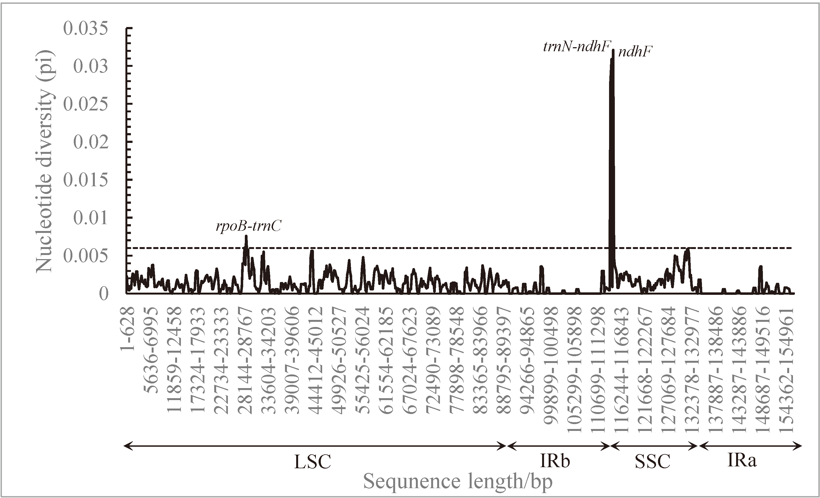
Figure S7. Sliding window analysis of the 33 chloroplast genomes of Triplostegia. The X-axis represents the position of the midpoint of a window, while the Y-axis represents the nucleotide diversity (Pi) of each window. Mutational hotspots and highly divergent loci are marked.

Figure S8. (a) Morphology comparison of T. grandiflora (left) and Triplostegia sp. A (right) co-distributed in northwestern Yunnan, the Hengduan Mountains Region. (b) Principal component analysis (PCA) of eight functional traits of T. grandiflora and Triplostegia sp. A co-distributed in northwestern Yunnan.

Figure S9. Box plot depicting the elevation ranges (a) and functional traits (b-i) of T. grandiflora and Triplostegia sp. A co-distributed in northwestern Yunnan.
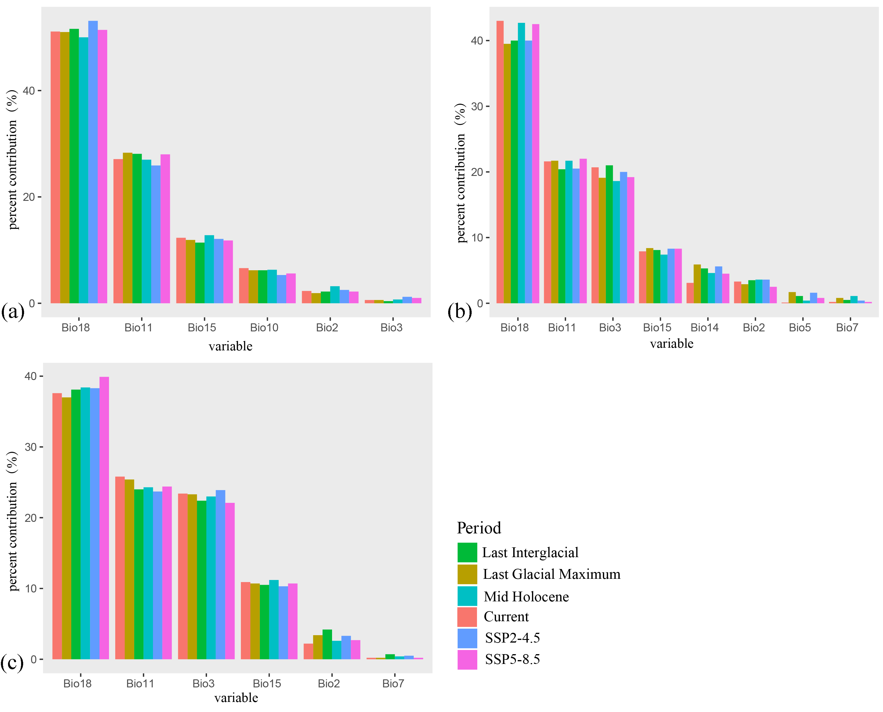
Figure S10. Bar plot illustrating the percent contribution of climatic variables to the distribution of T. glandulifera (a), T. grandiflora (b), and Triplostegia sp. A (c) in different time periods and future climate scenarios.

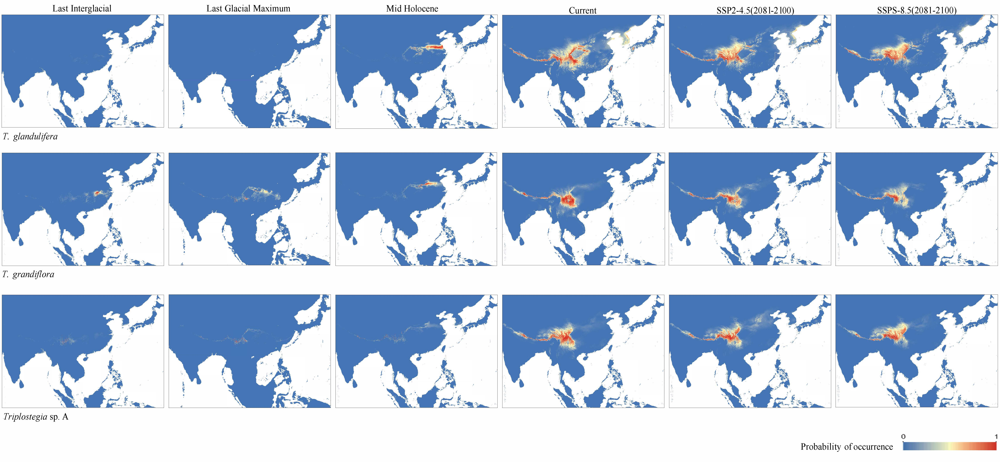
Figure S11. Distribution of suitable areas for T. glandulifera, T. grandiflora and Triplostegia sp. A in different time periods and future climate change scenarios. (The maps are created by authors using ArcGIS software)

Figure S12. Changes in suitable habitat for T. glandulifera (a, SSP2-4.5; b, SSP5-8.5; c, bar plot of range changes), T. grandiflora (d, SSP2-4.5; e, SSP5-8.5; f, bar plot of range changes), and Triplostegia sp. A (g, SSP2-4.5; h, SSP5-8.5; i, bar plot of range changes) under two future climate scenarios. The red area represents potential range contraction, blue area represents potential range expansion, and green area represents overlap between current and projected future ranges. In the bar plots, red indicates area contraction, and blue indicates area expansion. (The maps are created by authors using ArcGIS software)

