Supplementary Materials

Additional file 1 List of cultivars and growth habit in this study

code | cultivars | growth habit
1 | Hong jin gou | indeterminate viny
2 | Xiang jiao you dou | indeterminate viny
3 | Sheng feir | indeterminate viny
4 | Qi ji | indeterminate viny
5 | Zao feng | indeterminate viny
6 | Kuai jian | indeterminate viny
7 | Da zi pao | indeterminate viny
8 | Di dou | determinate brush
9 | Jiu yue | determinate brush
10 | Jia you dou | determinate brush
11 | Yi ke song | determinate brush
12 | Dan se qiu | determinate brush
13 | Aug-73 | determinate brush
14 | May-97 | indeterminate viny
15 | 923 | indeterminate viny
16 | Te nen | indeterminate viny
17 | Tai man | indeterminate viny
18 | Wu jin 6 | indeterminate viny
19 | F0119 | indeterminate viny
20 | F0678 | determinate brush
21 | F0705 | determinate brush
22 | F1736 | determinate brush
23 | F2320 | determinate brush
24 | F3420 | indeterminate viny
25 | F4150 | indeterminate viny
26 | F4226 | indeterminate viny
27 | BE221-1 | determinate brush
28 | Shuang feng NO.3 | indeterminate viny
29 | D6 | determinate brush
30 | D8 | determinate brush
31 | D10 | determinate brush
32 | D11 | determinate brush
33 | D13 | determinate brush
34 | Zao wu jin | indeterminate viny
35 | Chao shang si ji dou | indeterminate viny
36 | Shi li chang | indeterminate viny
37 | Da ma zhang | indeterminate viny
38 | 851-923-9 | indeterminate viny
39 | May-97 | indeterminate viny
40 | Yin bai tiao | indeterminate viny
41 | Zao man jia | indeterminate viny
42 | Qing feng di dou | determinate brush
43 | Qing dao dou | determinate brush
44 | Jun-81 | determinate brush
45 | Shuang sheng jia dou | determinate brush
46 | Tian ma di dou | determinate brush
47 | Shuang sheng di dou | determinate brush
48 | 5991（81-6） | determinate brush
49 | No. 16 | indeterminate viny
50 | 4月10日 | indeterminate viny
51 | Tu zi fan bai yan | indeterminate viny
52 | 1996/9/17 | indeterminate viny
53 | 96-8-50 | indeterminate viny
54 | 1996/8/14 | indeterminate viny
55 | 1996/8/7 | indeterminate viny
56 | 1996/8/4 | indeterminate viny
57 | 1996/8/2 | indeterminate viny
58 | Chao chang si ji dou | indeterminate viny
59 | San dao mei | indeterminate viny
60 | Da you dou | indeterminate viny
61 | Hei huang dou | indeterminate viny
62 | Ya ta jia | indeterminate viny
63 | Ji dou jiao | indeterminate viny
64 | Ha cai dou NO. 8 | indeterminate viny
65 | Di you dou | determinate brush
66 | You dou | indeterminate viny
67 | Chao chang jia dou | indeterminate viny
68 | Ju feng | indeterminate viny
69 | Bo li cui | indeterminate viny
70 | 2504Jia dou | indeterminate viny
71 | Lv long dou | indeterminate viny
72 | Ha cai dou NO.1 | indeterminate viny
73 | Jin long | indeterminate viny
74 | Yi chuan feng | indeterminate viny
75 | Fan bai yan | indeterminate viny
76 | Zi hua you dou | indeterminate viny
77 | Yu dou | indeterminate viny
78 | Mar-78 | indeterminate viny
79 | Mao yan | indeterminate viny
80 | Lian pu | indeterminate viny
81 | Renaya | determinate brush
82 | A18 | determinate brush
83 | P18039 | determinate brush
84 | P16071 | determinate brush
85 | P16133 | indeterminate viny
86 | P16152 | indeterminate viny
87 | P16158 | indeterminate viny
88 | P16157 | indeterminate viny
89 | P16156 | determinate brush
90 | P16079 | determinate brush
91 | P18017 | indeterminate viny
92 | P18009 | indeterminate viny
93 | P18084 | indeterminate viny
94 | P19011 | indeterminate viny
95 | P19002 | indeterminate viny
96 | P18051 | indeterminate viny
97 | P19030 | indeterminate viny
98 | P16009 | indeterminate viny
99 | P19024 | determinate brush
100 | P16024-8 | determinate brush
101 | Hacaidou | determinate brush
102 | P18016 | determinate brush
103 | A24-4 | determinate brush
104 | P16038 | determinate brush
105 | Hayousan | indeterminate viny
106 | P18041 | indeterminate viny
107 | P16203-16 | indeterminate viny
108 | P16030 | indeterminate viny
109 | P18012 | determinate brush
110 | P16314 | determinate brush
111 | P19023 | indeterminate viny
112 | P19006 | determinate brush
113 | P16070 | determinate brush
114 | P18045 | determinate brush
115 | P18037 | determinate brush
116 | P18002 | determinate brush
117 | P16028 | indeterminate viny
118 | P16333 | indeterminate viny
119 | P18014 | indeterminate viny
120 | P18069 | indeterminate viny

Additional file 2 Basic growth index of material
Variety | Relative growth | Variable coefficient | Relative root-shoot ratio | Variable coefficient | Relative plant height | Variable coefficient | Relative leaf area | Variable coefficient | Relative net photosynthesis | Variable coefficient
Renaya | 0.18 | 69.11% | 1.33 | 14.32% | 0.55 | 29.22% | 0.37 | 45.93% | 0.59 | 25.57%
A18 | 0.09 | 83.55% | 0.73 | 15.52% | 0.68 | 18.78% | 0.37 | 45.62% | 0.20 | 66.41%
P18039 | 0.31 | 53.21% | 1.34 | 14.41% | 0.78 | 12.59% | 0.56 | 28.54% | 0.27 | 57.02%
P16071 | 0.03 | 94.72% | 0.70 | 17.73% | 0.91 | 4.81% | 0.61 | 24.12% | 0.32 | 50.99%
P16133 | 0.10 | 81.97% | 0.80 | 11.34% | 0.77 | 13.11% | 0.44 | 39.27% | 0.36 | 46.54%
P16152 | 0.11 | 79.40% | 0.77 | 12.73% | 1.59 | 22.74% | 0.58 | 26.55% | 0.31 | 52.43%
P16158 | -0.23 | 158.82% | 0.73 | 15.35% | 0.68 | 18.99% | 0.36 | 46.88% | 0.26 | 59.16%
P16157 | 0.26 | 58.31% | 0.87 | 7.13% | 0.76 | 13.49% | 0.54 | 29.47% | 0.32 | 51.43%
P16156 | 0.21 | 65.92% | 0.93 | 3.81% | 0.96 | 2.24% | 0.60 | 24.93% | 0.35 | 47.91%
P16079 | 0.44 | 39.23% | 1.09 | 4.39% | 0.55 | 29.00% | 0.71 | 16.74% | 0.44 | 39.30%
P18017 | -0.32 | 192.80% | 1.30 | 13.09% | 0.54 | 29.71% | 0.46 | 37.02% | 0.69 | 18.55%
P18009 | 0.42 | 41.08% | 1.24 | 10.76% | 0.88 | 6.58% | 0.54 | 29.51% | 0.69 | 18.31%
P18084 | 0.10 | 81.18% | 0.96 | 1.80% | 0.58 | 26.38% | 0.43 | 40.07% | 0.41 | 42.21%
P19011 | 0.06 | 89.12% | 1.13 | 6.32% | 0.55 | 29.31% | 0.41 | 42.34% | 0.26 | 58.81%
P19002 | 0.11 | 79.75% | 0.92 | 4.31% | 0.60 | 25.00% | 0.90 | 5.41% | 0.27 | 57.32%
P18051 | 0.27 | 57.75% | 1.75 | 27.19% | 0.46 | 36.77% | 0.48 | 35.59% | 0.86 | 7.53%
P19030 | -0.05 | 110.66% | 0.85 | 8.27% | 0.61 | 23.90% | 0.26 | 58.14% | 0.25 | 60.57%
P16009 | 0.23 | 62.78% | 0.97 | 1.31% | 0.59 | 25.94% | 0.45 | 37.81% | 0.56 | 27.80%
P19024 | 0.16 | 71.95% | 1.23 | 10.40% | 0.79 | 11.51% | 0.39 | 44.17% | 0.30 | 54.16%
P16024-8 | 0.15 | 74.46% | 1.34 | 14.48% | 0.90 | 5.31% | 0.42 | 40.55% | 0.28 | 56.10%
Hacaidou | -0.03 | 106.25% | 0.88 | 6.29% | 0.63 | 22.43% | 0.35 | 48.29% | 0.33 | 50.10%
P18016 | 0.10 | 82.55% | 1.19 | 8.80% | 0.50 | 33.10% | 0.41 | 41.72% | 0.31 | 53.24%
A24-4 | 0.13 | 76.25% | 1.53 | 21.04% | 0.63 | 22.39% | 0.31 | 52.22% | 0.41 | 42.24%
P16038 | 0.19 | 67.99% | 1.18 | 8.19% | 0.81 | 10.38% | 0.39 | 44.02% | 0.44 | 38.58%
Hayousan | 0.44 | 38.43% | 1.04 | 1.93% | 0.78 | 12.45% | 0.41 | 41.75% | 0.47 | 36.07%
P18041 | -0.19 | 148.06% | 0.97 | 1.67% | 0.69 | 18.37% | 0.37 | 45.70% | 0.27 | 57.69%
P16203-16 | 0.17 | 70.97% | 1.00 | 0.04% | 0.66 | 20.70% | 0.42 | 40.75% | 0.61 | 24.17%
P16030 | 0.58 | 26.29% | 1.04 | 1.78% | 0.60 | 24.86% | 0.43 | 39.90% | 0.50 | 33.53%
P18012 | 0.62 | 23.52% | 1.15 | 6.76% | 0.82 | 10.12% | 0.70 | 17.71% | 0.60 | 25.04%
P16314 | 0.27 | 57.79% | 1.00 | 0.15% | 0.83 | 9.40% | 0.67 | 19.78% | 0.10 | 81.51%
P19023 | 0.44 | 38.46% | 1.05 | 2.59% | 0.98 | 1.06% | 0.64 | 21.84% | 0.51 | 32.22%
P19006 | -0.68 | 522.22% | 0.98 | 0.97% | 1.04 | 1.75% | 0.29 | 54.67% | 0.06 | 88.37%
P16070 | -0.05 | 110.67% | 0.99 | 0.32% | 0.71 | 17.09% | 0.28 | 56.31% | 0.31 | 52.23%
P18045 | -1.87 | -328.69% | 1.12 | 5.68% | 0.83 | 9.50% | 0.28 | 56.44% | 0.45 | 37.56%
P18037 | -0.46 | 273.47% | 0.67 | 19.50% | 0.77 | 13.30% | 0.52 | 31.41% | 0.44 | 38.89%
P18002 | 0.27 | 57.23% | 0.77 | 12.75% | 0.76 | 13.72% | 0.44 | 38.64% | 0.58 | 26.84%
P16028 | -0.67 | 500.00% | 0.82 | 9.77% | 0.85 | 7.90% | 0.32 | 50.97% | 0.10 | 81.90%
P16333 | -0.64 | 461.02% | 0.74 | 15.23% | 0.53 | 30.78% | 0.54 | 29.85% | 0.21 | 64.98%
P18014 | 0.27 | 56.90% | 1.04 | 1.74% | 0.59 | 25.96% | 0.67 | 19.73% | 0.45 | 38.15%
P18069 | -0.07 | 114.92% | 0.93 | 3.54% | 0.92 | 4.43% | 0.57 | 27.33% | 0.36 | 46.96%
Maximum value | 0.62 | 522.22% | 1.75 | 27.19% | 1.59 | 36.77% | 0.90 | 58.14% | 0.86 | 88.37%
Minimum value | -1.87 | -328.69% | 0.67 | 0.04% | 0.46 | 1.06% | 0.26 | 5.41% | 0.06 | 7.53%
Mean value | 0.04 | 103.75% | 1.03 | 8.59% | 0.74 | 17.38% | 0.47 | 36.94% | 0.39 | 46.21%
Standard deviation | 0.43 | 1.36 | 0.23 | 0.07 | 0.20 | 0.10 | 0.14 | 0.12 | 0.17 | 0.17

Additional file 3 Weight of each indicator
Index | µ Relative growth | µ Relative root-shoot ratio | µ Relative plant height | µ Relative leaf area | µ Relative net photosynthesis
Mean value | 0.69 | 0.32 | 0.25 | 0.30 | 0.41
Standard deviation | 0.16 | 0.22 | 0.17 | 0.20 | 0.21
CV/% | 0.23 | 0.68 | 0.71 | 0.67 | 0.52
weight /W | 0.08 | 0.24 | 0.25 | 0.24 | 0.18

Additional file 4 Correlation between each indicator and D value
 | Relative growth | Relative root-shoot ratio | Relative plant height | Relative leaf area | Relative net photosynthesis | D值
Relative growth | 1
Relative root-shoot ratio | 0.213 | 1
Relative plant height | -0.062 | -0.275 | 1
Relative leaf area | 0.416** | -0.087 | 0.129 | 1
Relative net photosynthesis | 0.304 | 0.480** | -0.247 | 0.117 | 1
D值 | 0.527** | 0.578** | 0.252 | 0.581** | 0.627** | 1
Note: * Significant，** Extremely significant
Additional file 5 KEGG pathway classification (The x-axis represents level-2 terms of the KEGG pathway and the y-axis represents the number of metabolites)

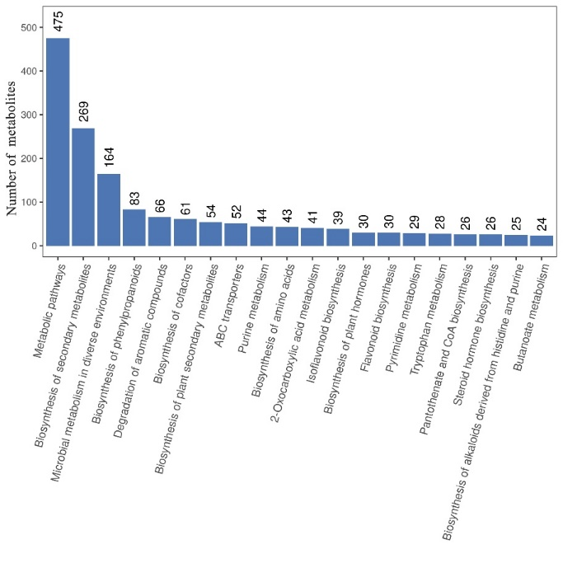
Additional file 6 Identified metabolites classified into the top 20 KEGG pathways. The x-axis represents the top 20 KEGG pathways and the y-axis represents number of identified metabolites involved in this pathway.

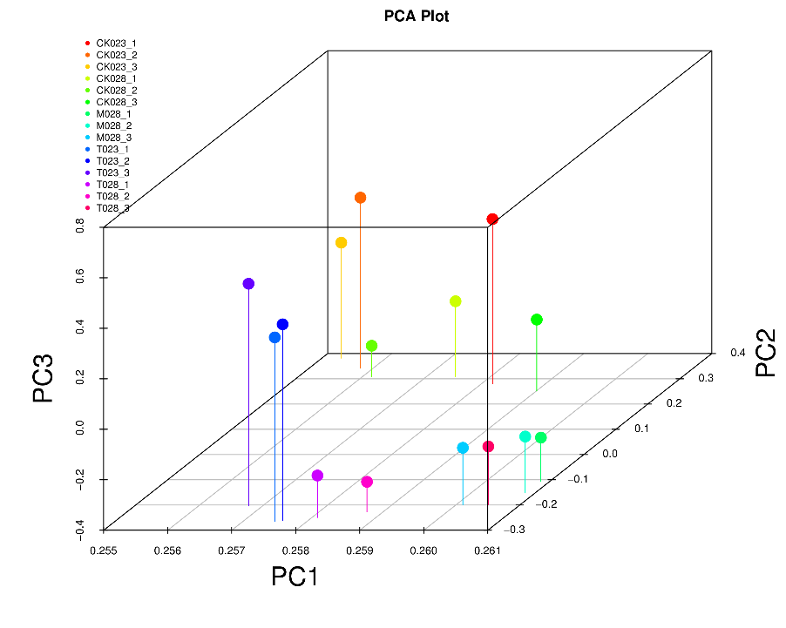
Additional file 7 PCA analysis among samples (PCA score plots were derived from DEGs )

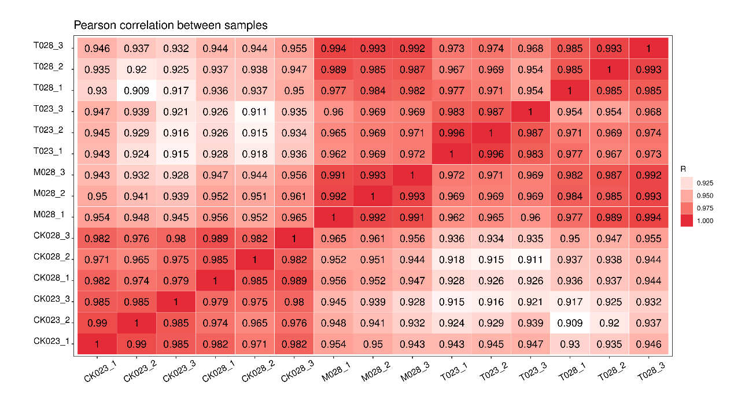
Additional file 8 Pearson correlation coefficients among samples (FPKM expression was used for correlation coefficients)

A B
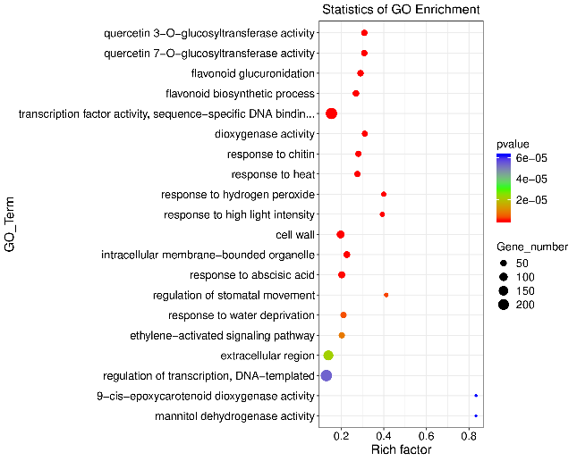
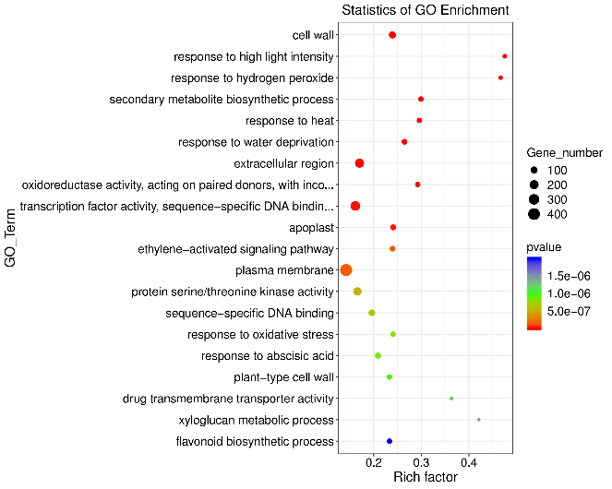
C
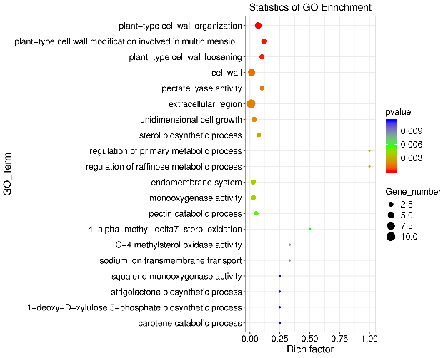
Additional file 9 Selected gene ontology (GO) terms enriched among DEGs identified in common bean plant (A: Heihu-T vs Heihu-C, B: F4226-T vs F4226-C, C: F4226-MN vs F4226-T).

Additional file 10 Key gene expression levels of salt stress resistance in Common bean in KEGG pathway

Additional file 11 Expression levels of key genes resistant to salt stress in common bean in KEGG pathway

