Supplementary Table S1 NCBI GenBank accession numbers of cloned GPAT9-A1-, A10-, C1-, and C9-encoding gene sequences from commercial varieties and advanced lines
Gene | NCBI GenBank Accession Number
SUB13814607 BnaGPAT9-A1-CDS | OR521147
SUB13814607 BnaGPAT9-A10-CDS | OR521148
SUB13814607 BnaGPAT9-C1-CDS | OR521149
SUB13828414 BnaGPAT9-C9-CDS | OR536417
SUB13828414 20CP75-BnaGPAT9-C1-CDS | OR536418
SUB13828414 634-BnaGPAT9-C1-CDS | OR536419
SUB13828414 Qinyou2-BnaGPAT9-C1-CDS | OR536420
SUB13828414 Zheyou50-BnaGPAT9-C1-CDS | OR536421
SUB13828414 Zhongshuang11-BnaGPAT9-C1-CDS | OR536422

Supplementary Table S2 Seed fatty acid composition of 44 commercial varieties/advanced lines
Line No. | Palmitic acid  (C16:0) | Stearic acid  (C18:0) | Oleic acid  (C18:1) | Linoleic acid  (C18:2) | Linolenic acid  (C18:3) | Arachidonic acid  (C20:0) | Eicosenoic acid  (C20:1) | Erucic acid  (C22:1)
634 | 4.16±0.69 | 2.78±0.18 | 49.42±1.19 | 12.86±0.26 | 5.87±0.41 | 0.85±0.11 | 11.9±0.59 | 12.16±1.49
941 | 4.54±1.27 | 2.44±0.80 | 36.42±1.19 | 14.36±0.30 | 8.34±0.15 | 0.56±0.03 | 14.72±0.47 | 18.63±1.44
20CP75 | 4.84±1.17 | 2.16±0.91 | 11.98±0.89 | 15.44±0.47 | 8.77±0.27 | 0.69±0.06 | 3.83±1.35 | 52.29±1.58
20CP86 | 6.14±2.33 | 3.72±1.58 | 13.4±0.92 | 13.26±0.82 | 9.13±0.84 | 0.92±0.14 | 7.09±0.89 | 46.32±3.71
20CP102 | 5.45±2.98 | 3.43±1.93 | 30.82±5.14 | 13.34±0.59 | 8.18±0.85 | 0.82±0.09 | 13.22±2.90 | 24.74±8.64
20CP103 | 5.71±1.92 | 3.48±1.94 | 24.09±3.10 | 14.86±0.37 | 7.94±0.48 | 1.06±0.50 | 11.56±1.76 | 31.30±5.28
21L10 | 7.50±4.72 | 4.57±3.19 | 16.27±1.89 | 13.74±1.08 | 9.65±1.20 | 0.91±0.15 | 7.63±1.27 | 39.72±3.00
4095-2 | 8.25±1.21 | 6.03±0.34 | 33.32±1.40 | 9.66±0.87 | 6.27±0.43 | 0.97±0.10 | 15.77±0.52 | 19.72±1.71
4099 | 5.32±1.68 | 3.48±1.36 | 30.9±1.12 | 11.22±0.17 | 6.02±0.26 | 0.94±0.11 | 15.06±1.12 | 27.06±2.96
612 | 4.18±0.60 | 1.64±0.16 | 43.08±0.78 | 14.39±0.19 | 8.65±0.11 | 0.53±0.02 | 13.97±1.68 | 13.56±1.20
Zhongyou 821 | 4.33±0.46 | 2.21±0.33 | 45.56±13.68 | 15.42±1.24 | 8.84±0.81 | 0.68±0.07 | 12.58±6.08 | 10.38±2.92
Zhongyou 828 | 4.27±0.79 | 3.00±0.52 | 37.12±5.01 | 13.61±0.94 | 8.48±0.15 | 0.93±0.01 | 16.58±1.74 | 16.01±5.75
Fengyou 737 | 5.47±1.61 | 3.81±0.89 | 37.57±3.53 | 12.05±0.84 | 7.20±0.28 | 0.93±0.09 | 14.97±1.75 | 17.99±1.97
Zhengyou 1 | 3.89±0.45 | 2.50±0.41 | 33.31±6.63 | 12.36±0.37 | 8.64±0.30 | 0.73±0.05 | 18.02±2.09 | 20.56±9.93
Zhengyouza 1 | 4.74±1.01 | 2.45±0.13 | 49.62±9.46 | 14.80±1.83 | 8.33±0.03 | 0.54±0.02 | 7.20±5.25 | 12.31±2.57
4017 | 4.45±0.96 | 2.26±0.35 | 30.07±1.15 | 12.05±0.17 | 7.49±0.59 | 0.69±0.03 | 14.74±0.33 | 28.26±2.48
4023 | 4.06±0.23 | 2.61±0.52 | 36.16±1.74 | 14.73±0.30 | 6.55±0.27 | 0.63±0.07 | 14.79±1.18 | 20.46±2.64
4054 | 4.28±0.35 | 2.20±0.10 | 31.94±4.01 | 14.82±0.31 | 8.43±0.19 | 0.71±0.05 | 15.86±0.16 | 21.76±4.07
4064 | 4.39±1.21 | 2.37±0.66 | 27.13±3.86 | 13.73±0.74 | 7.42±0.86 | 0.90±0.10 | 17.77±0.49 | 26.30±5.03
4066 | 3.63±0.11 | 2.28±0.19 | 45.51±7.46 | 13.55±1.20 | 7.06±0.21 | 0.74±0.09 | 14.16±4.19 | 13.07±5.05
4067 | 4.27±0.21 | 2.39±0.07 | 45.86±3.76 | 13.98±0.48 | 7.14±0.24 | 0.57±0.02 | 12.70±1.42 | 13.08±1.78
4068 | 4.67±0.69 | 3.39±0.66 | 56.71±4.56 | 15.05±0.45 | 7.70±0.44 | 0.72±0.05 | 6.52±0.55 | 5.23±2.40
4088 | 3.38±0.09 | 1.78±0.11 | 27.29±0.79 | 11.33±0.20 | 9.13±0.12 | 0.81±0.02 | 15.96±0.64 | 30.32±1.48
4089 | 4.49±0.97 | 2.31±0.70 | 24.82±0.59 | 10.05±0.23 | 6.91±0.01 | 0.83±0.07 | 13.93±0.82 | 36.67±1.25
4097-2 | 3.31±0.19 | 1.97±0.30 | 37.25±1.27 | 11.60±0.45 | 5.94±0.29 | 0.99±0.10 | 18.73±0.16 | 20.20±0.59
4111-2 | 3.46±0.11 | 1.60±0.06 | 23.64±1.70 | 12.73±0.19 | 7.70±0.05 | 0.65±0.03 | 12.47±0.45 | 37.74±2.18
768 | 5.43±0.58 | 3.23±0.71 | 44.61±7.55 | 14.98±1.19 | 6.39±0.14 | 0.51±0.07 | 12.78±2.79 | 12.09±5.58
873 | 4.25±0.29 | 2.71±0.34 | 72.58±0.49 | 14.52±0.13 | 4.70±0.23 | 0.41±0.01 | 0.68±0.05 | 0.15±0.05
891 | 6.07±0.34 | 4.00±0.01 | 64.92±0.58 | 15.59±0.30 | 7.47±0.19 | 0.60±0.06 | 1.15±0.02 | 0.20±0.18
8339 | 5.49±0.78 | 3.04±0.54 | 66.13±1.01 | 17.10±0.54 | 6.84±0.17 | 0.43±0.03 | 0.77±0.03 | 0.20±0.08
974-1 | 4.68±0.16 | 2.18±0.34 | 72.51±0.92 | 13.28±0.34 | 5.68±0.30 | 0.48±0.03 | 1.06±0.08 | 0.12±0.06
974-2 | 5.22±1.19 | 2.7±0.81 | 70.09±1.21 | 13.33±0.57 | 6.77±0.31 | 0.50±0.04 | 1.02±0.07 | 0.38±0.09
9005 | 6.53±1.75 | 4.02±1.37 | 47.22±3.65 | 14.59±0.56 | 5.95±0.31 | 0.51±0.10 | 12.93±2.92 | 8.26±3.11
9009 | 4.57±0.73 | 2.53±0.27 | 58.29±7.20 | 15.79±0.60 | 6.29±1.30 | 0.44±0.02 | 7.61±3.79 | 4.47±2.52
9007-1 | 4.02±0.43 | 1.82±0.11 | 61.62±2.89 | 17.81±0.17 | 7.64±0.59 | 0.46±0.04 | 4.43±1.82 | 2.20±1.15
Zhongshuang 11 | 4.10±0.05 | 2.25±0.22 | 65.14±0.91 | 18.81±0.13 | 8.13±1.05 | 0.58±0.04 | 0.97±0.03 | 0.02±0.00
Zheshuang 72 | 4.43±0.67 | 2.42±0.68 | 57.47±3.63 | 18.04±0.74 | 7.74±0.09 | 0.48±0.08 | 3.99±2.34 | 5.44±1.93
Zheyou 50 | 5.51±0.78 | 3.83±0.67 | 65.47±1.27 | 17.09±0.27 | 6.83±0.33 | 0.42±0.02 | 0.74±0.06 | 0.11±0.08
Zheyou 51 | 5.29±0.34 | 3.08±0.12 | 64.01±0.27 | 17.73±0.50 | 8.54±0.21 | 0.43±0.06 | 0.74±0.05 | 0.17±0.16
Qinyou 2 | 5.06±1.37 | 3.03±0.85 | 56.81±3.12 | 14.42±0.29 | 7.86±0.43 | 0.55±0.03 | 6.61±1.60 | 5.64±2.33
Zhongyouza 19 | 4.00±0.29 | 2.65±0.39 | 66.01±0.54 | 17.54±0.06 | 8.33±0.15 | 0.51±0.01 | 0.90±0.03 | 0.07±0.03
Jiayou 1 | 4.69±0.33 | 2.91±0.39 | 58.98±5.96 | 16.60±0.31 | 8.20±0.35 | 0.54±0.05 | 4.17±2.77 | 3.91±3.54
Shanyouza 1 | 4.41±0.41 | 3.35±0.22 | 68.28±2.00 | 15.80±1.09 | 6.73±0.77 | 0.47±0.04 | 0.90±0.03 | 0.06±0.03
Youyan 818 | 4.41±0.41 | 2.97±0.33 | 67.28±1.95 | 15.58±1.24 | 7.84±0.66 | 0.62±0.04 | 1.11±0.03 | 0.19±0.16

Supplementary Table S3 Information on 44 genotypes in this study
Number | Name | Origin | Haplotype
1 | 634 | Prof. Weijun Zhou | A
2 | 941 | Prof. Weijun Zhou | A
3 | 20CP75 | Dr. Qi Peng | A
6 | 20CP86 | Dr. Qi Peng | A
4 | 20CP102 | Dr. Qi Peng | A
5 | 20CP103 | Dr. Qi Peng | A
7 | 21L10 | Inbred line | A
8 | 4095-2 | Prof. Weijun Zhou | A/T
9 | 4099 | Prof. Weijun Zhou | A/T
10 | 612 | Prof. Weijun Zhou | A/T
11 | Zhongyou 821 | Commercial varieties | A/T
12 | Zhongyou 828 | Commercial varieties | A/T
13 | Fengyou 737 | Commercial varieties | A/T
14 | Zhengyou 1 | Commercial varieties | A/T
15 | Zhengyouza 1 | Commercial varieties | A/T
16 | 4017 | Prof. Weijun Zhou | T
17 | 4023 | Prof. Weijun Zhou | T
18 | 4054 | Prof. Weijun Zhou | T
19 | 4064 | Prof. Weijun Zhou | T
20 | 4066 | Prof. Weijun Zhou | T
21 | 4067 | Prof. Weijun Zhou | T
22 | 4068 | Prof. Weijun Zhou | T
23 | 4088 | Prof. Weijun Zhou | T
24 | 4089 | Prof. Weijun Zhou | T
25 | 4097-2 | Prof. Weijun Zhou | T
26 | 4111-2 | Prof. Weijun Zhou | T
27 | 768 | Prof. Weijun Zhou | T
28 | 873 | Prof. Weijun Zhou | T
29 | 891 | Prof. Weijun Zhou | T
30 | 8339 | Prof. Weijun Zhou | T
31 | 974-1 | Prof. Weijun Zhou | T
32 | 974-2 | Prof. Weijun Zhou | T
33 | 9005 | Prof. Weijun Zhou | T
34 | 9009 | Prof. Weijun Zhou | T
35 | 9007-1 | Prof. Weijun Zhou | T
36 | Zhongshuang 11 | Commercial varieties | T
37 | Zheshuang 72 | Commercial varieties | T
38 | Zheyou 50 | Commercial varieties | T
39 | Zheyou 51 | Commercial varieties | T
40 | Qinyou 2 | Commercial varieties | T
41 | Zhongyouza 19 | Commercial varieties | T
42 | Jiayou 1 | Commercial varieties | T
43 | Shanyouza 1 | Commercial varieties | T
44 | Youyan 818 | Commercial varieties | T

Supplementary Table S4 Information on primer sequences (the restriction enzyme sites are underlined)
Gene | Primer sequence 5’-3’ | Length (bp) | Application
BnaGPAT9-A1 | FP: ATGAGCAGCA CGGCAGGAAA | 1131 | Gene clone for BnaGPAT9-A1
 | RP: TCACTTGTCT TCCAATCTAG CCAGG
 | FP: AGGAGAATTCAACATGAGCAGCACGG |  | Construction of yeast genetic complementation vector
 | RP: CGTCCTCGAGTCACTTGTCTTCCAATC
 | FP: AGACAAACCCAAAACAAGCG | 120 | qRT‒PCR for detecting tissue-specific expression of BnaGPAT9-A1
 | RP: GGTGTCTGGTTTTGTACCTCAAGA
BnaGPAT9-A10 | FP: ACTACCACAACCAATTCACCC | 1116 | Gene clone for BnaGPAT9-A10
 | RP: CGTTTACGTTCACTTCTCTTCC
 | FP: GAAATCTAGAAACATGAGCAGTACGGCG |  | Construction of yeast genetic complementation vector
 | RP: CATCGGTACCTCACTTCTCTTCCAATCTAG
BnaGPAT9-C1 | FP: CGATCGGAAGCGAGAGAGAGAGAG | 1131 | Gene clone for BnaGPAT9-C1
 | RP: GTCTTGTCTAGCAGATTAATGAAACACCAC
BnaGPAT9-C1^{1124T} | FP: GACCTCTAGAAACATGAGCAGTAC |  | Construction of yeast genetic complementation vector
 | RP: CATCGGTACCTCACTTGACTTCCAATCT
 | FP: ATCTCCGGCGATCGGAAGCGAGC | 278 | qRT‒PCR for detecting tissue-specific expression of BnaGPAT9-C1
 | RP: CAGTTCCAAGGCTCTGGAGG
BnaGPAT9-C1^{1124A} | FP: GACCTCTAGAAACATGAGCAGTAC |  | Construction of yeast genetic complementation vector
 | RP: TAGCCTCGAGTCACTTGTCCTCCAATCT
BnaGPAT9-C9 | FP: ATGAGCAGTA CGGCGGGGAA | 1116 | Gene clone for BnaGPAT9-C9
 | RP: TCACTTCTCT TCCAATCTAG CAAGGAGG
 | FP: GAAAGGTACCAACATGAGCAGTACGGC |  | Construction of yeast genetic complementation vector
 | RP: GTCCCTCGAGTCACTTCTCTTCCAATC
BnaGPAT9-C1^{1124T} | FP: GCTCGAATTCCTAACAAGACTTGG | 119 | PARMS for haplotype identification
 | RP: GAAGGTCGGAGTCAACGGATTGAAATGATCTTTTGCATTCACTTGA
BnaGPAT9-C1^{1124A} | FP: GCTCGAATTCCTAACAAGACTTGG | 119 | PARMS for haplotype identification
 | RP: GAAGGTGACCAAGTTCATGCTTGAAATGATCTTTGCATTCACTTGT
Napin-BnaGPAT9-C1^{1124A} | FP: GCATGAGCTCATGAGCAGCAC | 1131 | Construction of p1300-Napin-Nos vector
 | RP: CCGACTGCAGTCACTTGTCTTCCAA
Napin-BnaGPAT9-C1^{1124A} | FP: CCGAGCTTGAATTGGATCACCC | 117 | Determination of expression level of BnaGPAT9-C1^{1124A} in transformants
 | RP: AGTGAGCGTTGGAGAAATGTCTAGC
Napin-BnaGPAT9-C1^{1124A} | FP: GTGATCGCCATGCAAATCTCC | 1027 | Transformants identification
 | RP: GCCCACGATGTCATGAGTTGC
BnaUBC9 | FP: GCATCTGCCTCGACATCTTGA | 68 | Reference gene in qRT‒PCR
 | RP: CGATAGCAGCACCTTGGAGATA

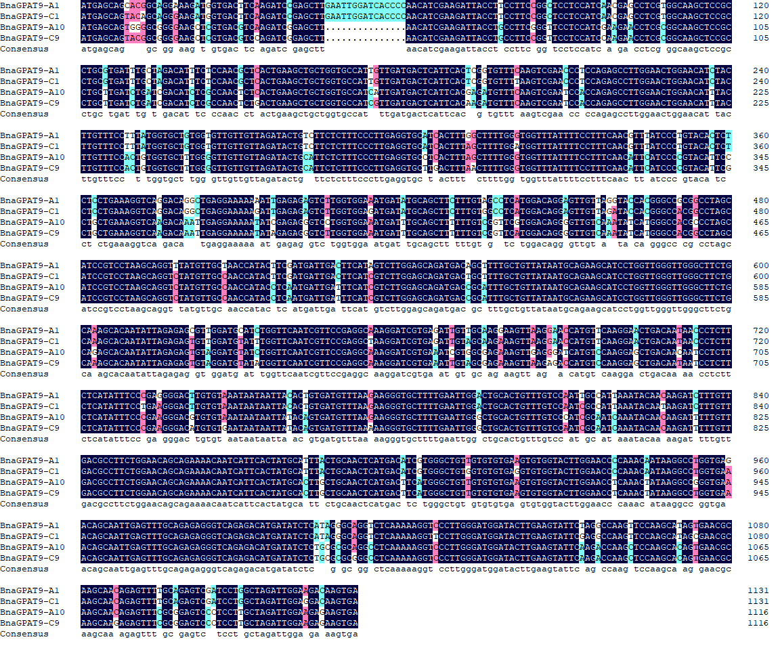
Supplementary Figure S1 Full-length cDNA sequence alignment of the four homologous GPAT9 genes in Brassica napus. Identical and similar nucleotides are shown in the same colour.

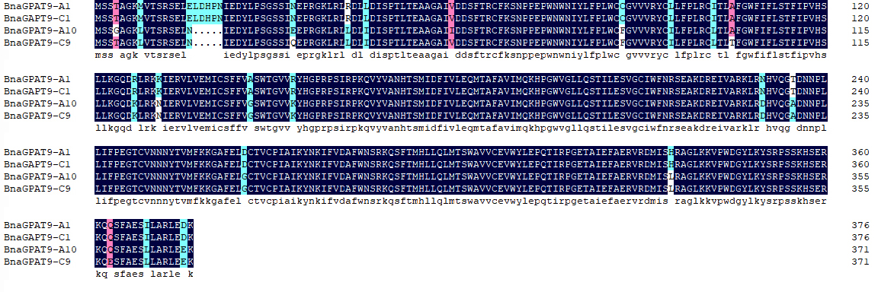
Supplementary Figure S2 Deduced amino acid sequence alignment of the four homologous GPAT9 proteins in Brassica napus. Identical and similar amino acid residues are shown in the same colour.

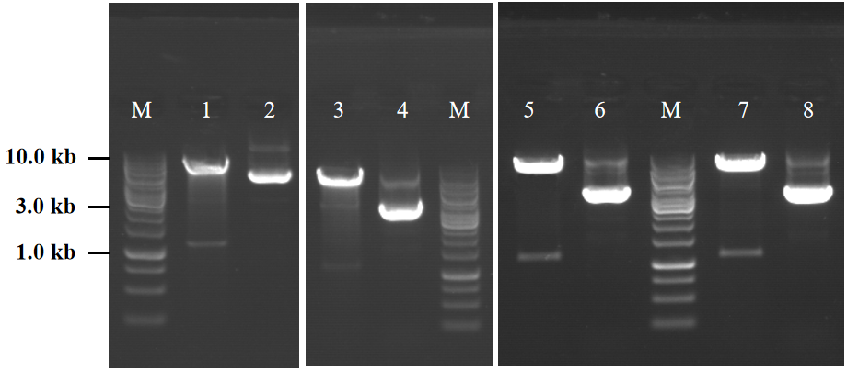
Supplementary Figure S3 Identification of the recombinant pYES2-Kan-yADH1 V2 vector plus BnaGPAT9s by double enzyme digestion. Lanes 1, 3, 5, and 7: digestion of recombinant vector plus BnaGPAT9-A1, C1, A10, and C9, respectively; lanes 2, 4: 6, and 8: no digestion of recombinant vector plus BnaGPAT9-A1, C1, A10, and C9, respectively; M: 1-kb DNA ladder.

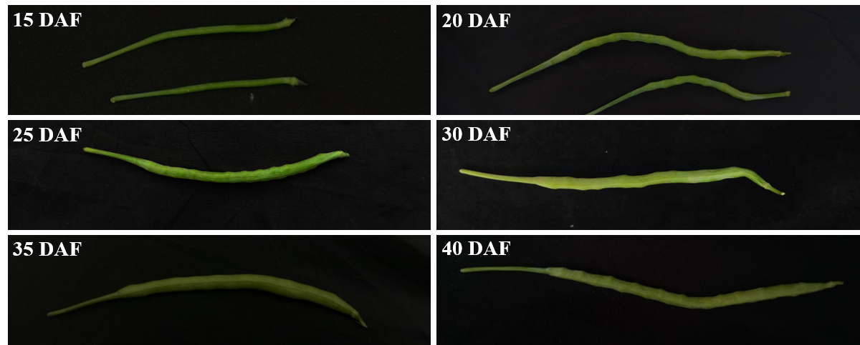
Supplementary Figure S4 Phenotype of ‘Zhongshuang 11’ developing seeds at 15, 20, 25, 30, 35, and 40 days after flowering (DAF).

Supplementary Figure S5 Distribution of erucic acid in 44 commercial varieties/advanced lines of three haplotypes.

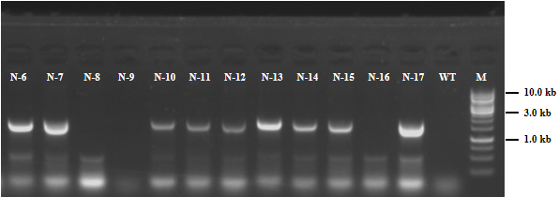
Supplementary Figure S6 PCR identification of pNapin-BnaGPAT9-C1^{1124A}-Nos-independent T₀ transgenic lines. The target fragment of specific PCR was 1027 bp. N-6, 7, 10, 11, 12, 13, 14, 15, 17: positive plants; N-8, 9, 16: negative plants; WT: ‘Zhongshuang 11’.

