Table S1 Endophytic Bacterial characterization Isolated from Viburnum grandiflorum roots
 | Plant/colony | Color | Size | Margin | Texture | Gram staining | Types of bacteria | IAA | PSB | HCN
 | Vibernum grandiflorum  (a)colony Bacillus mycoides MIU (Acc MW979613) | White | Small | irregular | Flate | +ve | Bacilli | + | + | +
 | Vibernum grandiflorum  (b)colony  Vibernum grandiflorum  (c)colony  Vibernum grandiflorum  (d)colony  Agrococcus terreus (MW 979614) | White  Yellow  Yellow | Large  Small  Large | Irregular  Smooth  Smooth | Flate  Flate  Flate | +ve  +ve  +ve | Bacilli  Bacilli  Bacilli | -  -  + | +  -  + | -  -  +

Soil physiochemical characteristics
Soil physicochemical characteristics such as texture, pH, organic matter were determined using the method as described by Jackson (1964).
Soil physicochemical characteristics
Soil physicochemical characteristics are present in Table 1. The pH of the soil is 6.5 and The organic matter was 0.874% in the soil . The total Phosphorus was 0.71 and Nitrate-Nitrogen was 2.11 with EC 51.4
Table S2. Soil physicochemical properties

physicochemical properties
pH | 6.5
EC (dS cm⁻¹) | 51.4
Color (Hue-value/chroma) | 7.5YR-7/6-Reddish yellow
Nitrate-Nitrogen (mg/kg) | 2.11
Total Phosphorus (mg/kg) | 0.71
Organic matter (%) | 0.774

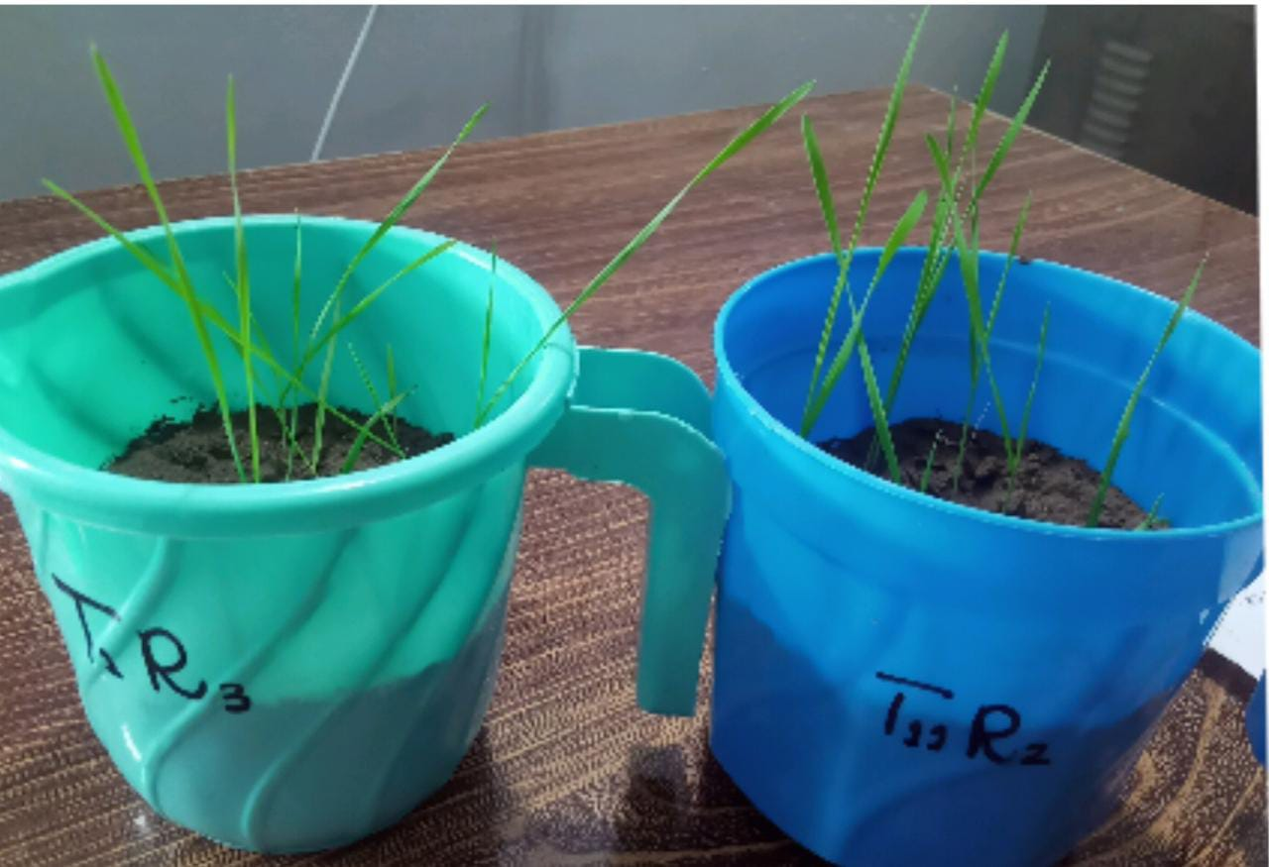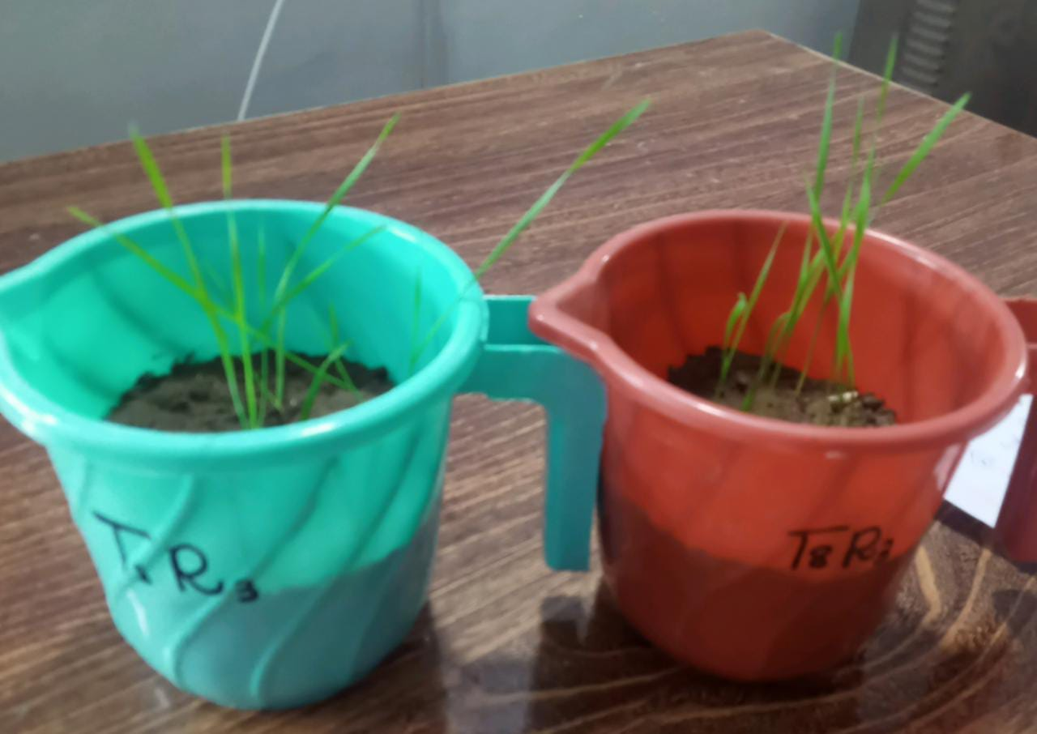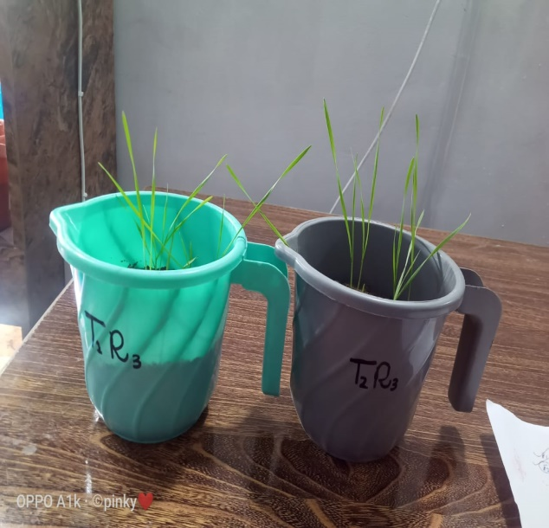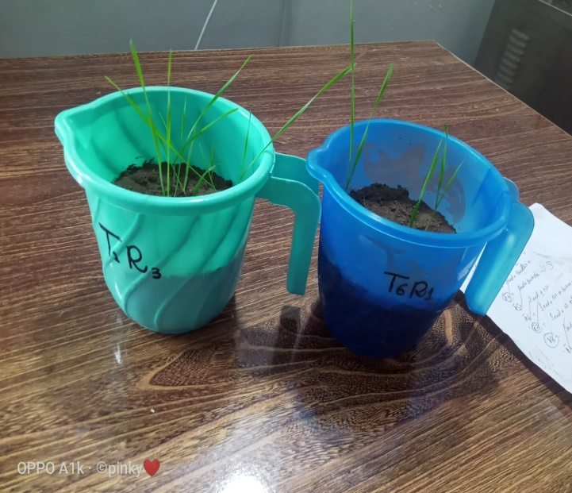

Figure S1 . Pot experiment showing plant growth in different treatment applications

