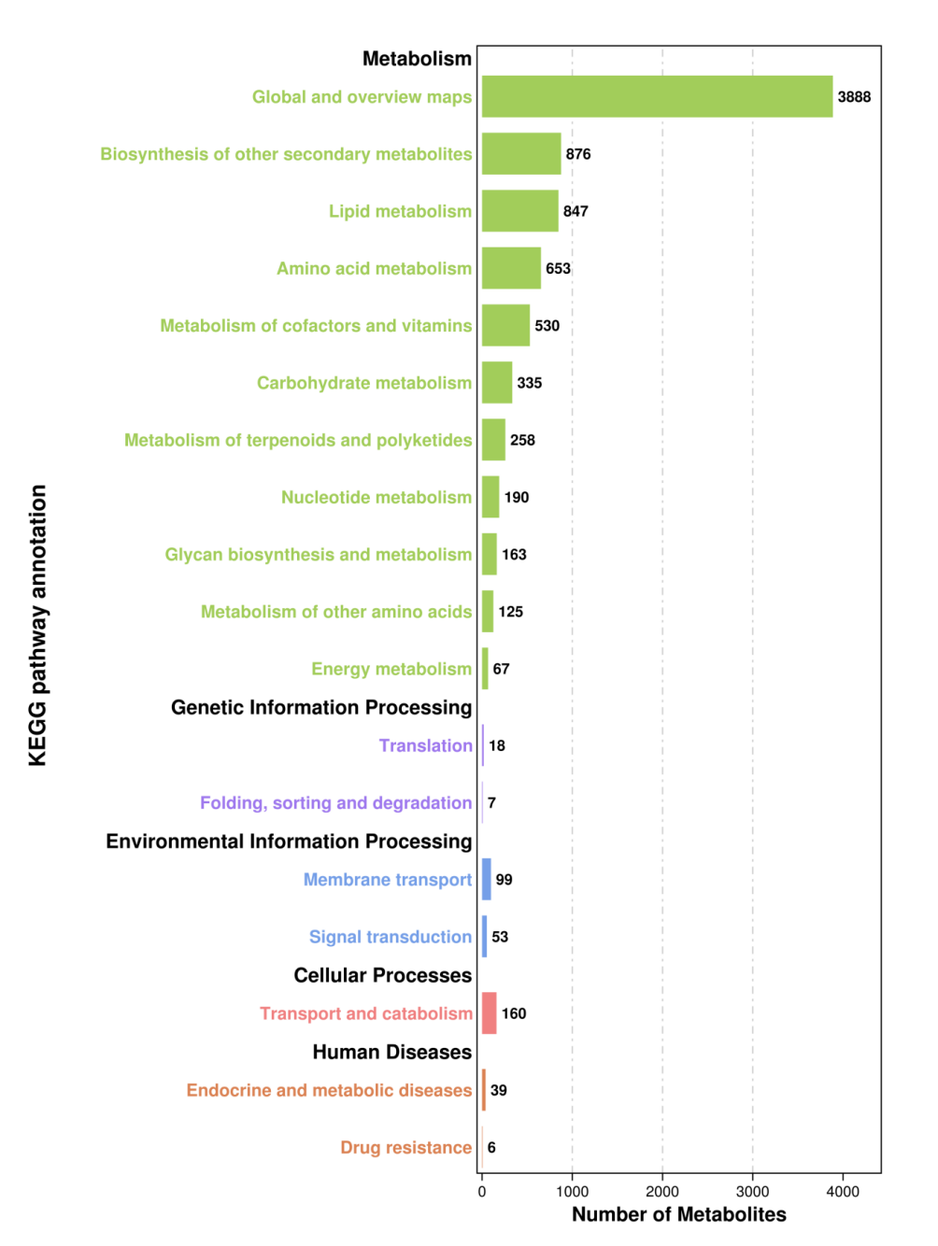
Supplementary Figure 3. Histogram of number metabolite enrichment of KEGG pathway. The horizontal coordinate is the number of metabolites enriched by each component. The ordinate is enriched to KEGG pathways annotation.

