Supplementary Fig. S1: The intensity (a) and quality (b) of the main light without far-red supplementation.
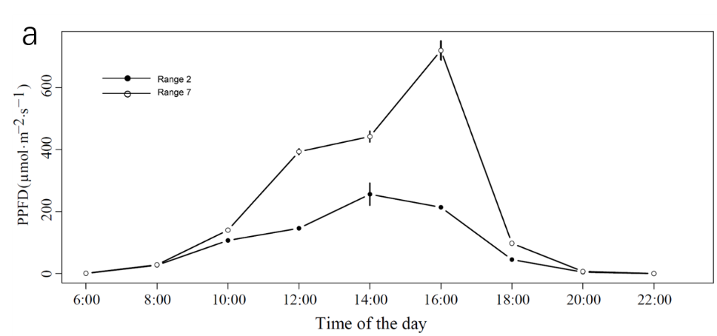
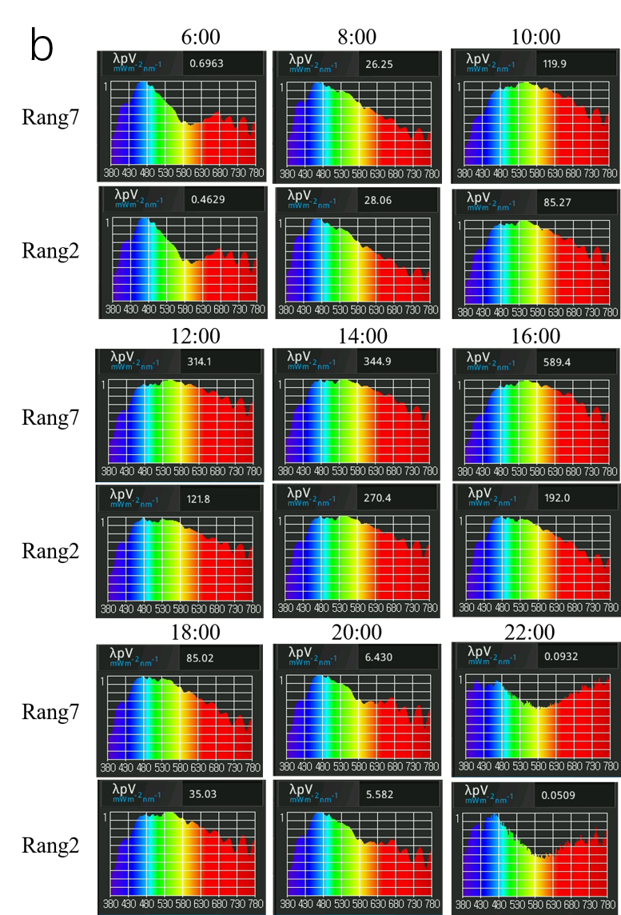

Supplementary Fig. S2: light response curve of leaf gas exchange in comparison between range 2 and range 7 leaf under white light supplementation (a-d) and far-red light supplementation (e-h).

Supplementary Fig. S3: GO functional enrichment of DEGs in stems (a) and roots (b).
a
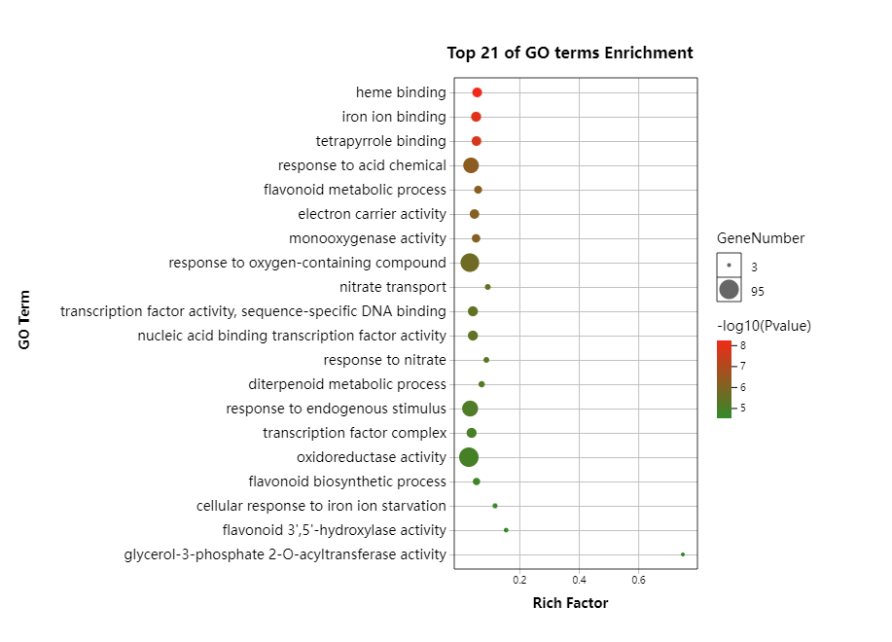
b
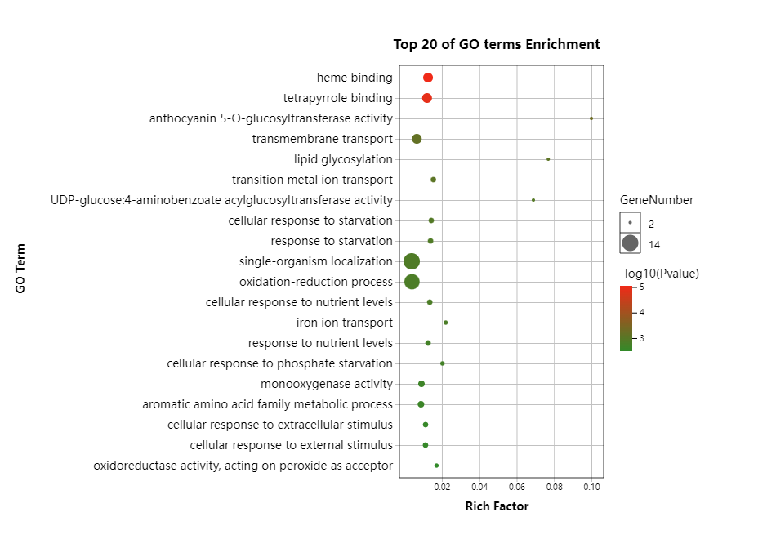
Supplementary Fig. S4: GO functional enrichment of the top 50 up- and down-regulated DEGs in leaves (a: downregulated, b: upregulated), stems (c: downregulated, d: upregulated) and roots (e: downregulated, f: upregulated).
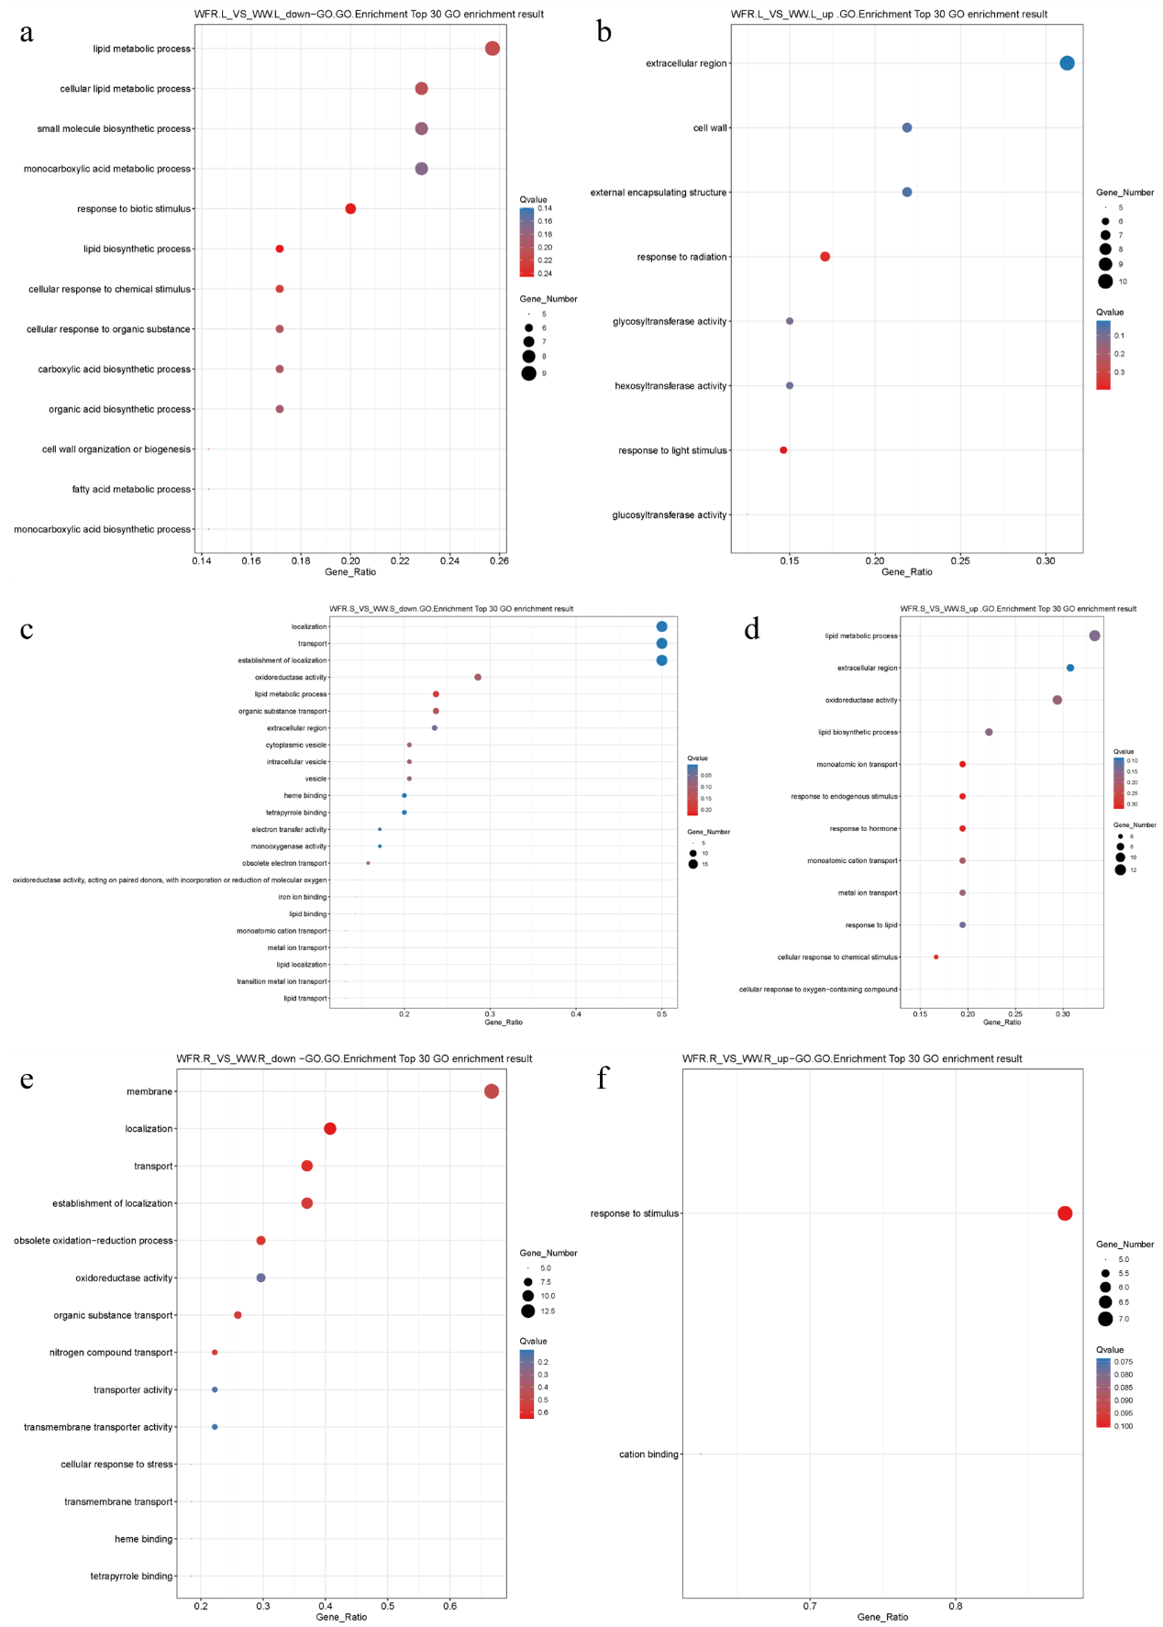

Supplementary Fig. S5: Expression of genes related to redox balance.
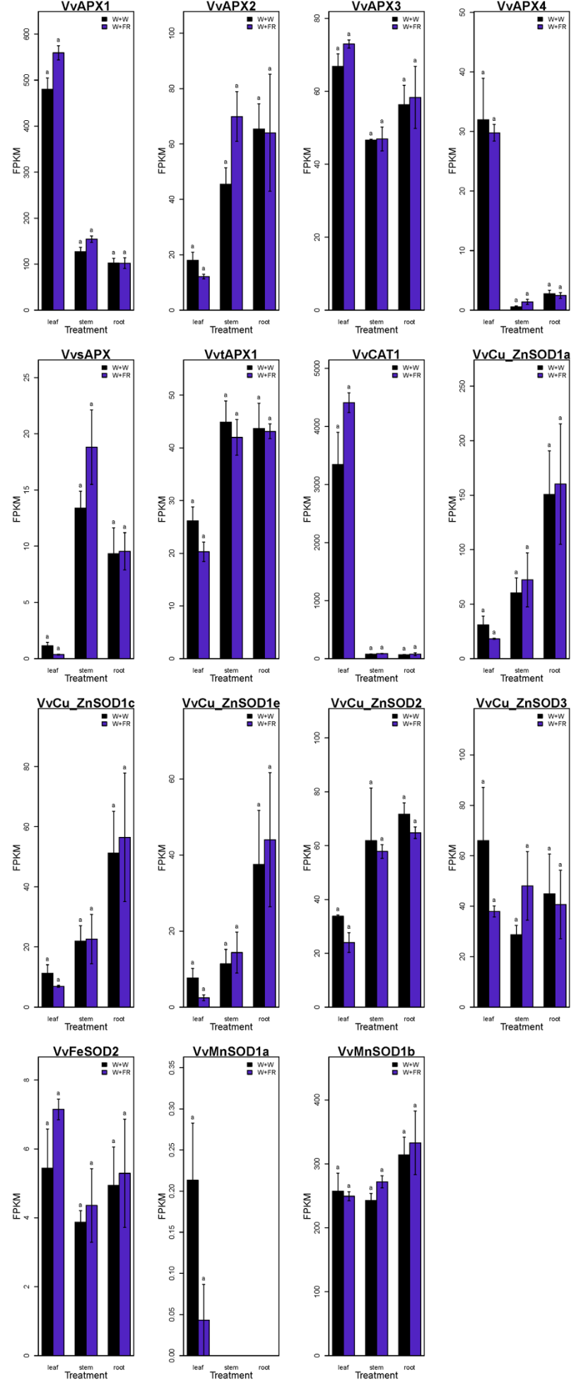

Supplementary Fig. S6: Gene annotation in correlation network in leaves(a), correlation plot between trait and DEGs in leaves(b).

a: Gene annotation in correlation network in leaves
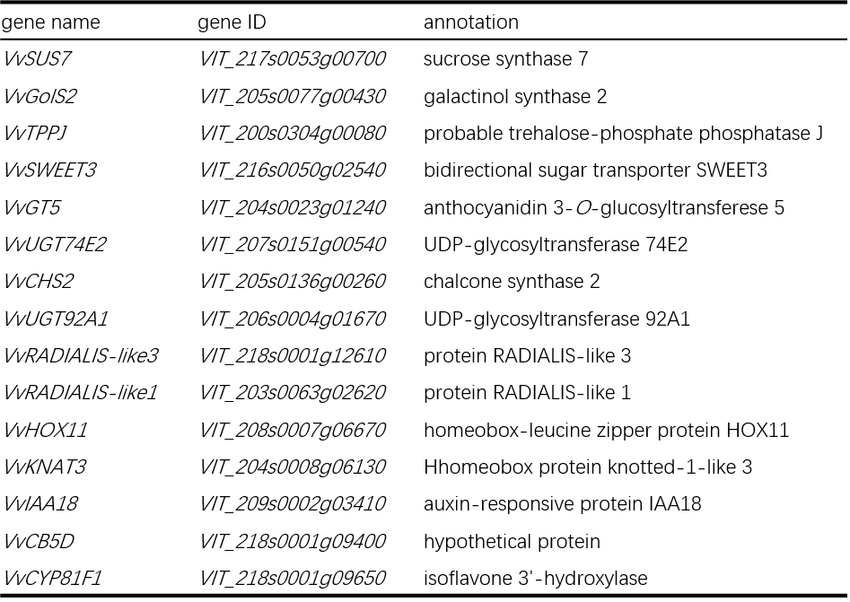

b: Correlation plot between trait and DEGs in leaves
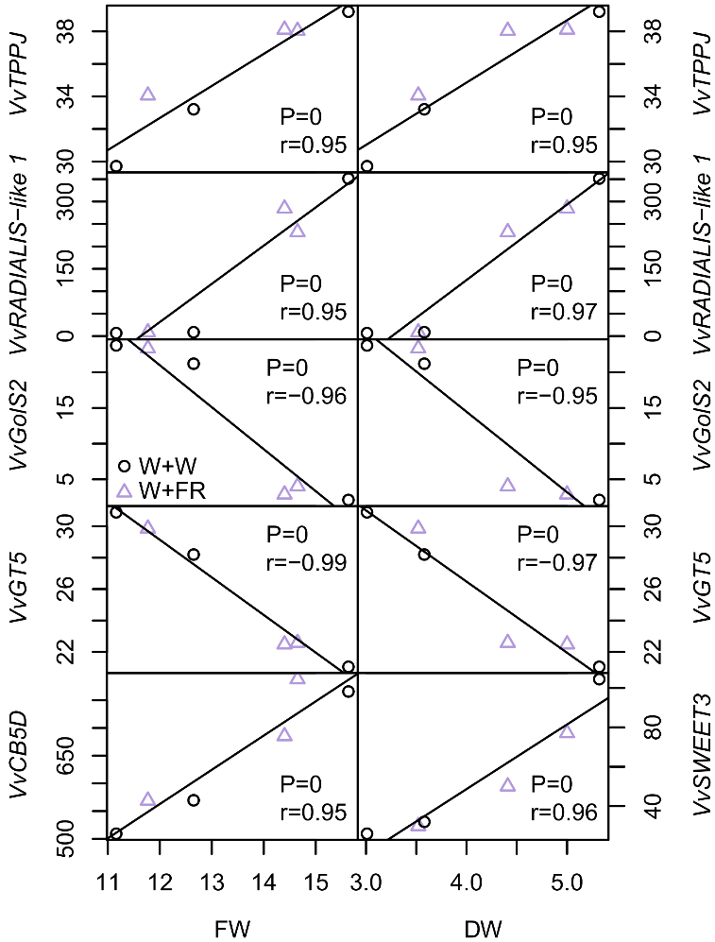

Supplementary Fig. S7: Correlation network between traits and DEGs in stems.
