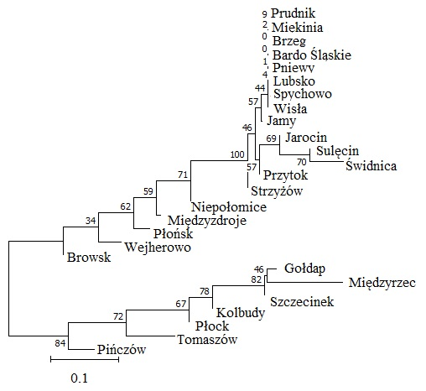
Figure S1. Neighbor-joining tree calculated using the Nei distance based on chloroplast microsatellite loci.

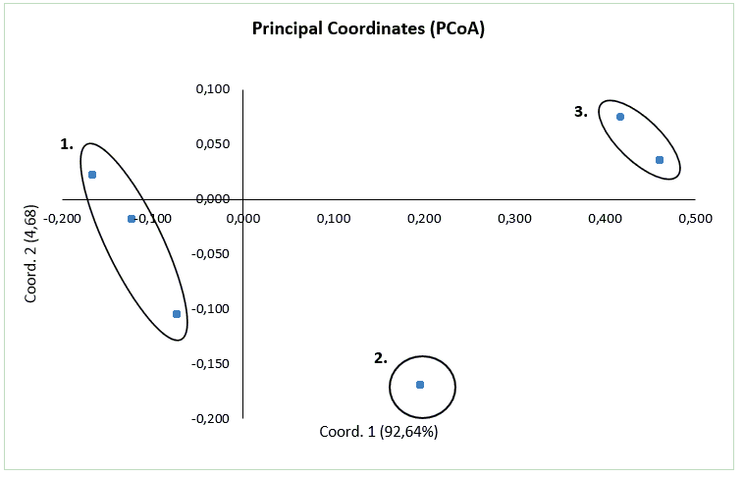
Figure S2. Principal coordinates analysis (PCoA) plot.
a  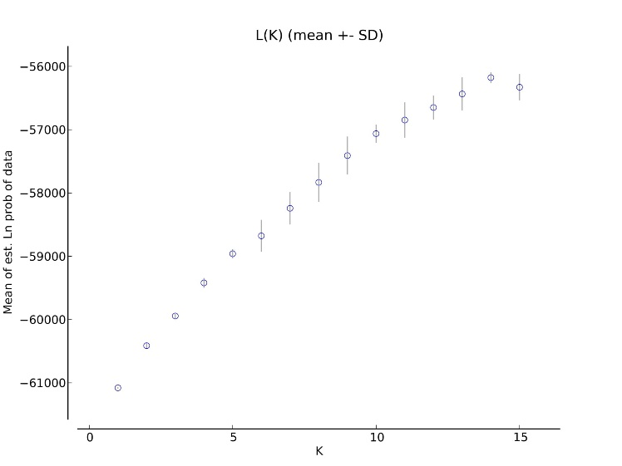 |  | b  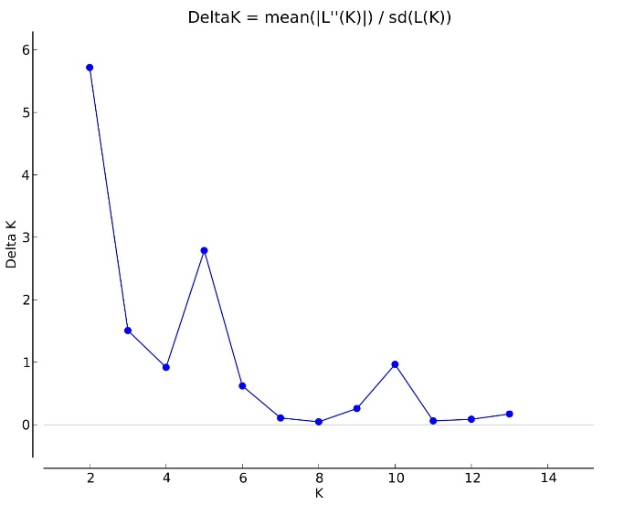
c  K = 2 | 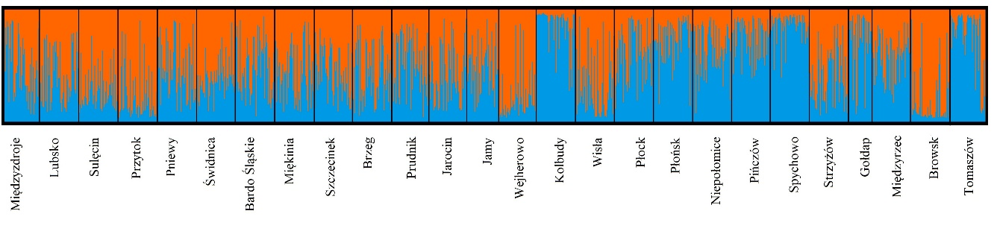
K = 5 | 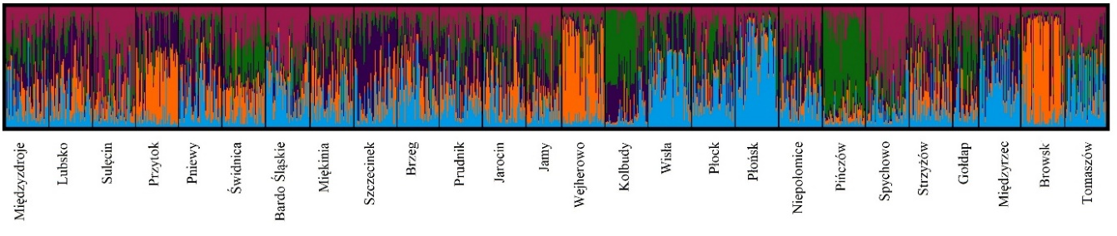
K =10 | 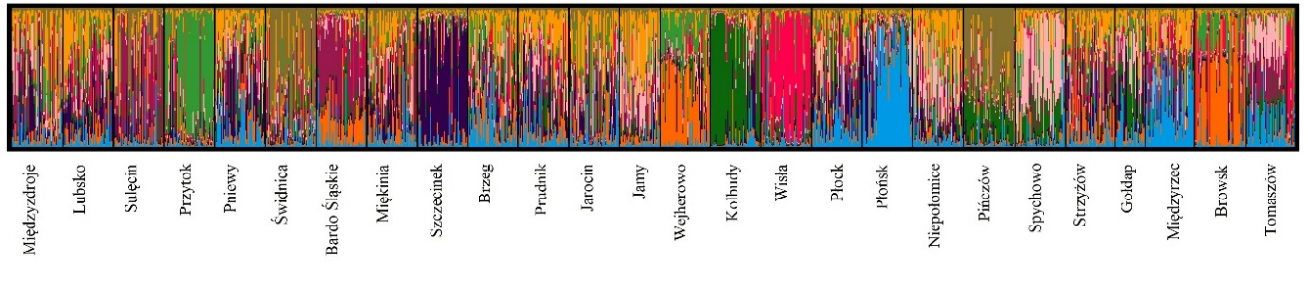
Figure S3. Bayesian clustering (STRUCTURE) results for 26 populations of Fraxinus excelsior based on nuclear microsatellite loci. (a) The posterior probability of data given each K (20 replicates) (mean ± SD), (b) the distribution of delta K, (c) assignment plots for K = 2, 5 and 10.

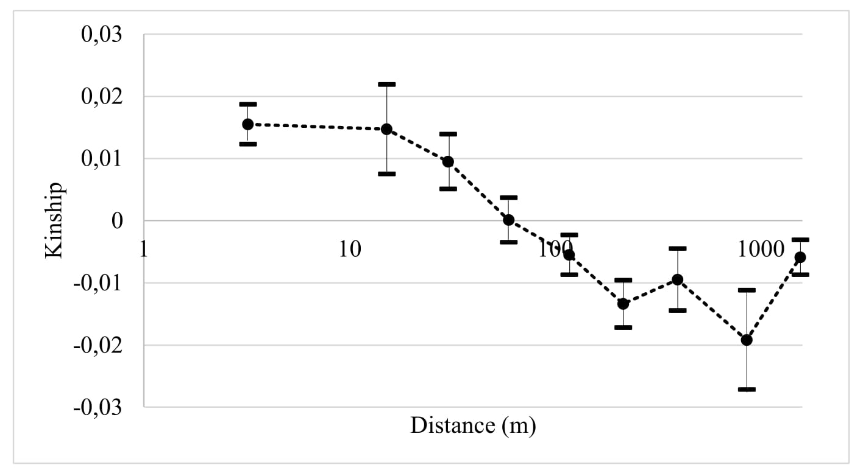
Figure S4. Kinship coefficient plotted against the geographical distance between individuals for overall sample. Dots show averages across populations and whiskers indicate the 95% confidence interval estimated based on the standard error (computed using the jackknife across loci).

