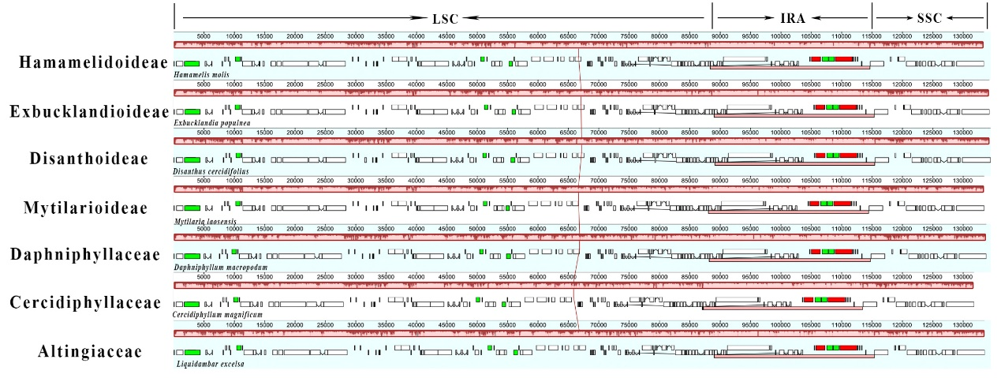
Supplementary Material 2: Fig. S2. Mauve alignment of plastomes for the “woody clade” in Saxifragales, with Hamamelis mollis (Hamamelidoideae) as the reference.

