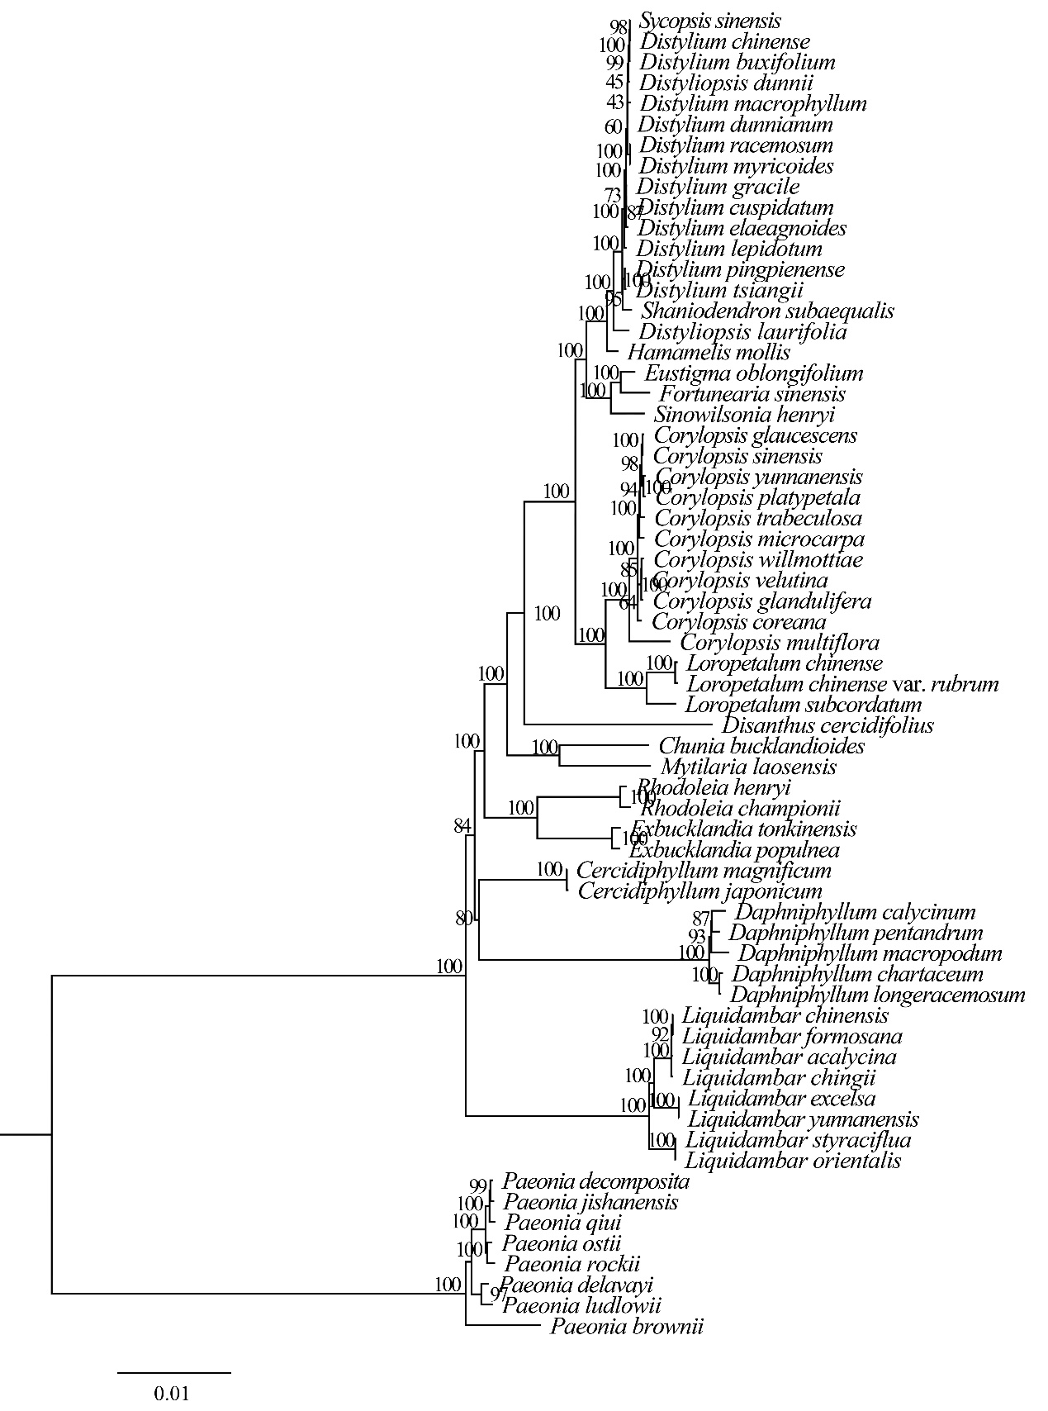
Supplementary Material 3: Fig. S3. Phylogenetic tree of the “woody clade” in Saxifragales based on maximum likelihood (ML) with 78 common protein coding genes of 64 species.

