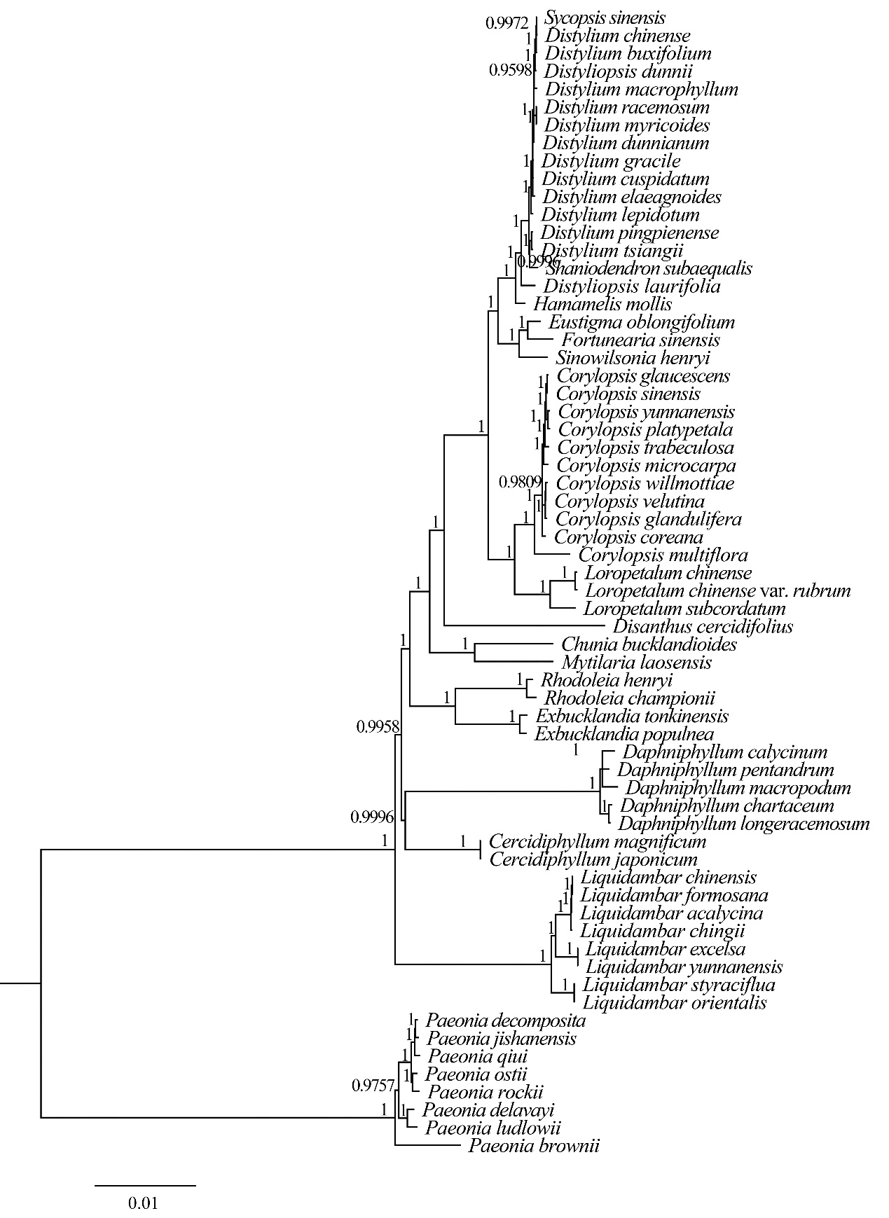
Supplementary Material 4: Fig. S4. Phylogenetic tree of the “woody clade” in Saxifragales based on Bayesian inference (BI) with 78 common protein coding genes of 64 species.

