Fig. S1. Prediction of subcellular localization of OsDUF6 protein
Fig. S2. Secondary domain analysis of OsDUF6 protein.
Fig. S3. Prediction of tertiary structure of OsDUF6 encoded protein.
Fig. S4. PCR detection of overexpressing positive plants.
Table. S1. The list of primer sequence.

Fig. S1. Prediction of subcellular localization of OsDUF6 protein
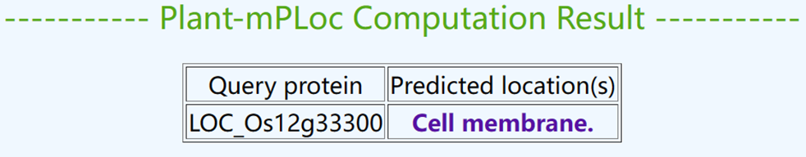

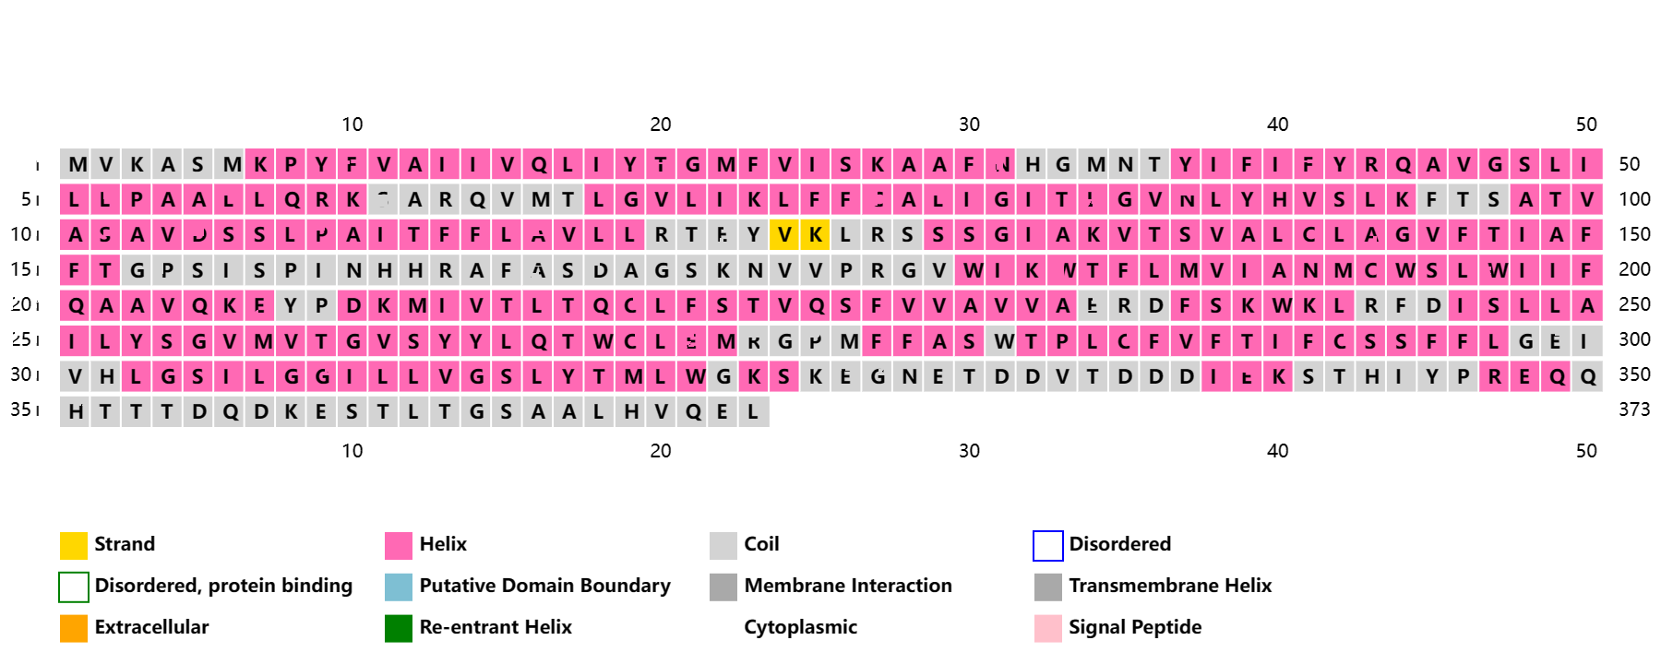
Fig. S2. Secondary domain analysis of OsDUF6 protein.
Fig. S3. Prediction of tertiary structure of OsDUF6 encoded protein. AlphaFold produces a per-residue confidence score (pLDDT) between 0 and 100. Some regions with low pLDDT may be unstructured in isolation
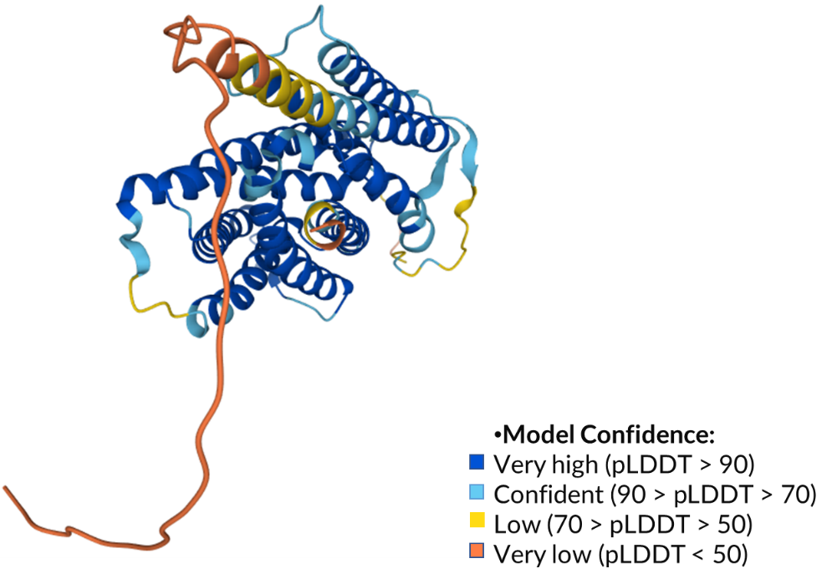

Fig. S4. PCR detection of overexpressing positive plants. Lane M: DNA molecular weight standard. Lanes 1-12: rice samples.
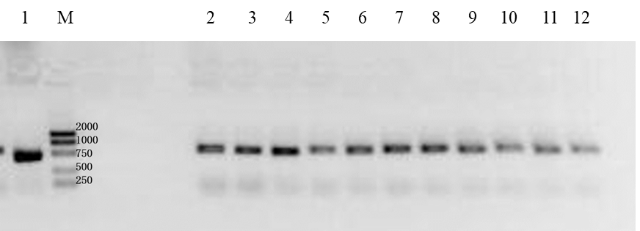

Table. S1. The list of primer sequence.
Gene name | Primer sequence | Description | Product size (bp) | purpose
LOC_Os11g26790 | F: CTCGTCTGAGGATGATGGAATG | dehydrin | 224 | RT-qPCR
LOC_Os11g26790 | R: TGTCCATGATGCCCTTCTTC | dehydrin | 224 | RT-qPCR
LOC_Os01g08320 | F: GGTGAACGGGACGGAGTA | OsIAA1 - Auxin-responsive Aux/IAA gene family member | 151 | RT-qPCR
LOC_Os01g08320 | R: GGCTCTTGGTGCTAAGTTGA | OsIAA1 - Auxin-responsive Aux/IAA gene family member | 151 | RT-qPCR
LOC_Os02g56120 | F: TTGATTTGGCCCTCCATTCC | OsIAA9 - Auxin-responsive Aux/IAA gene family member | 190 | RT-qPCR
LOC_Os02g56120 | R: AAATCATCCCATGGCACGTC | OsIAA9 - Auxin-responsive Aux/IAA gene family member | 190 | RT-qPCR
LOC_Os08g10290 | F: CAAGGTTACTACGGACCAATGA | SHR5-receptor-like kinase | 197 | RT-qPCR
LOC_Os08g10290 | R: CCACCTTCTCCCACCATATTT | SHR5-receptor-like kinase | 197 | RT-qPCR
LOC_Os02g42150 | F: GCCTACTCTTGGAGCAACTAAT | OsWAK14 - OsWAK receptor-like protein kinase | 166 | RT-qPCR
LOC_Os02g42150 | R: ACACGCTGGTCAGATAGAATG | OsWAK14 - OsWAK receptor-like protein kinase | 166 | RT-qPCR
LOC_Os04g51040 | F: CAAGGCTAGTCCCTTCCAATC | OsWAK50 - OsWAK receptor-like protein kinase | 189 | RT-qPCR
LOC_Os04g51040 | R: TCCCTTCCTCTTGCCTATGA | OsWAK50 - OsWAK receptor-like protein kinase | 189 | RT-qPCR
LOC_Os04g30240 | F: GCGCCTATGCTTGTCTATGAA | OsWAK60 - OsWAK receptor-like protein kinase | 194 | RT-qPCR
LOC_Os04g30240 | R: AGGATGTTGGCTGGCTTTAC | OsWAK60 - OsWAK receptor-like protein kinase | 194 | RT-qPCR
LOC_Os04g32480 | F: CTCCGATGACGCTCTTCTAC | zinc-finger protein | 163 | RT-qPCR
LOC_Os04g32480 | R: GTTCTTGTGAGTGGCTCTTTG | zinc-finger protein | 163 | RT-qPCR
LOC_Os01g19800 | F: CACGTTCACGGCTGTTCT | zinc finger, C3HC4 type | 178 | RT-qPCR
LOC_Os01g19800 | R: GTATTGCCTCTGACCCTTCTG | zinc finger, C3HC4 type | 178 | RT-qPCR
LOC_Os04g51830 | F: GCTCTTCGTCCTCATGATGTAT | OsHKT1;4 - Na+ transporter | 186 | RT-qPCR
LOC_Os04g51830 | R: AGCTTTCTTCTCTCGGTGATG | OsHKT1;4 - Na+ transporter | 186 | RT-qPCR
OE-OsDUF6 | F: TTCATTTGGAGAGAACACGGGG GAC | - | 712 | overexpression identification
OE-OsDUF6 | R: GACTGCACCGTGCTGAAC | - | 712 | overexpression identification

